Supplementary Material

Table S1 Partial correlation coefficients between undirected edges at T1.
 | MDS1 | MDS2 | MDS3 | MDS4 | MDS5 | MDS6 | MDS7 | MDS8 | MDS9 | CMD1 | CMD2 | CMD3 | CMD4 | CMD5 | CMD6 | CMD7 | CMD8 | CMD9
MDS1
MDS2 | 0.31
MDS3 | 0.12 | 0.14
MDS4 | 0.23 | 0.16 | 0.21
MDS5 | 0.21 | 0.05 | 0.11 | 0.14
MDS6 | 0.00 | 0.16 | 0.05 | 0.10 | 0.10
MDS7 | 0.11 | 0.01 | 0.04 | 0.05 | 0.11 | 0.22
MDS8 | 0.00 | 0.06 | 0.06 | 0.00 | 0.10 | 0.17 | 0.34
MDS9 | 0.00 | 0.05 | 0.00 | 0.00 | 0.05 | 0.18 | 0.00 | 0.18
CMD1 | 0.00 | 0.00 | 0.00 | 0.01 | 0.00 | 0.00 | 0.02 | 0.00 | 0.00
CMD2 | 0.00 | 0.07 | 0.00 | 0.01 | 0.00 | 0.00 | 0.00 | 0.00 | 0.00 | 0.29
CMD3 | 0.00 | 0.00 | 0.00 | 0.00 | 0.00 | 0.00 | 0.00 | 0.01 | 0.01 | 0.02 | 0.13
CMD4 | 0.00 | 0.00 | 0.00 | 0.05 | 0.00 | 0.00 | 0.00 | 0.00 | 0.00 | 0.32 | 0.19 | 0.18
CMD5 | 0.00 | 0.00 | 0.00 | 0.01 | 0.03 | 0.00 | 0.00 | 0.00 | 0.00 | 0.10 | 0.00 | 0.11 | 0.08
CMD6 | 0.00 | 0.00 | 0.00 | 0.00 | 0.00 | 0.00 | 0.00 | 0.00 | 0.00 | 0.06 | 0.32 | 0.03 | 0.11 | 0.08
CMD7 | 0.00 | 0.00 | 0.00 | 0.00 | 0.00 | 0.00 | 0.06 | 0.00 | 0.00 | 0.11 | 0.06 | 0.06 | 0.03 | 0.16 | 0.04
CMD8 | 0.00 | 0.00 | 0.00 | 0.00 | 0.01 | 0.04 | 0.00 | 0.04 | 0.00 | 0.06 | 0.02 | 0.00 | 0.04 | 0.08 | 0.10 | 0.27
CMD9 | 0.00 | 0.00 | 0.00 | 0.02 | 0.00 | 0.00 | -0.01 | 0.00 | 0.00 | 0.00 | 0.06 | 0.11 | 0.03 | 0.09 | 0.11 | 0.02 | 0.17
Note. MDS1–MDS9 denote maternal responses to the nine items of the PHQ-9 at the given time point. CMD1–CMD9 (or CDS1–CDS9, depending on the table) represent child responses to the corresponding PHQ-9 items. PHQ-9 items assess the following depressive symptoms: Little interest or pleasure in doing things; Feeling down, depressed, or hopeless; Trouble falling or staying asleep, or sleeping too much; Feeling tired or having little energy; Poor appetite or overeating; Feeling bad about yourself—or that you are a failure or have let yourself or your family down; Trouble concentrating on things, such as reading or watching television; Moving or speaking slowly, or being unusually fidgety or restless; Thoughts that you would be better off dead, or thoughts of self-harm. For example, MDS1 reflects the mother’s report on Item 1 (“Little interest or pleasure in doing things”), while CDS9 reflects the child’s response to Item 9 (“Thoughts of being better off dead or self-harm”).
Table S2 Partial correlation coefficients between undirected edges at T2.
 | MDS1 | MDS2 | MDS3 | MDS4 | MDS5 | MDS6 | MDS7 | MDS8 | MDS9 | CDS1 | CDS2 | CDS3 | CDS4 | CDS5 | CDS6 | CDS7 | CDS8 | CDS9
MDS1
MDS2 | 0.32
MDS3 | 0.09 | 0.03
MDS4 | 0.30 | 0.22 | 0.26
MDS5 | 0.12 | 0.06 | 0.11 | 0.16
MDS6 | 0.07 | 0.12 | 0.07 | 0.05 | 0.07
MDS7 | 0.06 | 0.06 | 0.17 | 0.01 | 0.13 | 0.19
MDS8 | 0.00 | 0.09 | 0.01 | 0.00 | 0.13 | 0.19 | 0.28
MDS9 | 0.00 | 0.00 | 0.00 | 0.00 | 0.04 | 0.15 | 0.05 | 0.36
CDS1 | 0.00 | 0.03 | 0.00 | 0.00 | 0.00 | 0.00 | 0.00 | 0.00 | 0.00
CDS2 | 0.00 | 0.00 | 0.00 | 0.01 | 0.00 | 0.00 | 0.00 | 0.00 | 0.00 | 0.34
CDS3 | 0.00 | 0.00 | 0.00 | 0.00 | 0.00 | 0.00 | 0.00 | 0.00 | 0.00 | 0.08 | 0.18
CDS4 | 0.00 | 0.00 | 0.00 | 0.02 | 0.00 | 0.00 | 0.00 | 0.00 | 0.00 | 0.25 | 0.29 | 0.15
CDS5 | 0.02 | 0.00 | 0.00 | 0.01 | 0.00 | 0.00 | 0.00 | 0.00 | 0.00 | 0.17 | 0.00 | 0.10 | 0.14
CDS6 | 0.00 | 0.00 | 0.00 | 0.00 | 0.00 | 0.01 | 0.00 | 0.00 | 0.00 | 0.00 | 0.17 | 0.06 | 0.09 | 0.17
CDS7 | 0.01 | 0.00 | 0.00 | 0.00 | 0.00 | 0.00 | 0.00 | 0.00 | 0.00 | 0.11 | 0.03 | 0.06 | 0.00 | 0.15 | 0.21
CDS8 | 0.00 | 0.00 | 0.00 | 0.00 | 0.01 | 0.00 | 0.00 | 0.04 | 0.01 | 0.02 | 0.01 | 0.09 | 0.05 | 0.09 | 0.09 | 0.42
CDS9 | 0.00 | 0.00 | 0.00 | 0.00 | 0.00 | 0.00 | 0.00 | 0.00 | 0.00 | 0.00 | 0.06 | 0.21 | 0.00 | 0.01 | 0.21 | 0.00 | 0.17
Note. Abbreviations in the Table 2 are the same as those in Table 1.

Table S3 Centrality metrics values of the contemporaneous networks at T1 and T2.
Variables | T1 |  | T2
Variables | EI | Bridge EI | EI | Bridge EI
MDS1 | 0.99 | 0.00 | 1.00 | 0.03
MDS2 | 1.03 | 0.08 | 0.94 | 0.03
MDS3 | 0.74 | 0.00 | 0.74 | 0.00
MDS4 | 0.98 | 0.09 | 1.04 | 0.04
MDS5 | 0.92 | 0.04 | 0.84 | 0.01
MDS6 | 1.02 | 0.04 | 0.93 | 0.01
MDS7 | 0.95 | 0.07 | 0.94 | 0.00
MDS8 | 0.96 | 0.05 | 1.10 | 0.04
MDS9 | 0.47 | 0.00 | 0.62 | 0.00
CDS1 | 0.98 | 0.03 | 0.99 | 0.03
CDS2 | 1.16 | 0.09 | 1.09 | 0.01
CDS3 | 0.65 | 0.01 | 0.93 | 0.00
CDS4 | 1.03 | 0.05 | 0.99 | 0.02
CDS5 | 0.74 | 0.04 | 0.86 | 0.04
CDS6 | 0.85 | 0.00 | 1.03 | 0.01
CDS7 | 0.82 | 0.06 | 0.98 | 0.01
CDS8 | 0.83 | 0.08 | 1.00 | 0.06
CDS9 | 0.59 | 0.01 | 0.67 | 0.00
Note. Abbreviations in the Table 3 are the same as those in Table 1.

Table S4 Partial directed correlations (standardized beta coefficients)) of temporal network.
 | MDS1 | MDS2 | MDS3 | MDS4 | MDS5 | MDS6 | MDS7 | MDS8 | MDS9 | CDS1 | CDS2 | CDS3 | CDS4 | CDS5 | CDS6 | CDS7 | CDS8 | CDS9
MDS1 | 0.08 | 0.00 | 0.00 | 0.00 | 0.00 | 0.01 | 0.00 | 0.00 | 0.00 | 0.00 | 0.00 | 0.00 | 0.00 | 0.02 | 0.00 | 0.00 | 0.00 | 0.00
MDS2 | 0.06 | 0.08 | 0.00 | 0.04 | 0.00 | 0.00 | 0.08 | 0.02 | 0.01 | 0.05 | 0.02 | 0.10 | 0.03 | 0.02 | 0.03 | 0.00 | 0.00 | 0.02
MDS3 | 0.07 | 0.05 | 0.35 | 0.10 | 0.08 | 0.08 | 0.00 | 0.03 | 0.00 | 0.00 | 0.00 | 0.00 | 0.00 | 0.00 | 0.00 | 0.00 | 0.00 | 0.02
MDS4 | 0.13 | 0.07 | 0.00 | 0.20 | 0.03 | 0.02 | 0.00 | 0.00 | 0.00 | 0.02 | 0.02 | 0.02 | 0.06 | 0.00 | 0.01 | 0.00 | 0.00 | 0.00
MDS5 | 0.00 | 0.00 | 0.00 | 0.00 | 0.10 | 0.05 | 0.06 | 0.04 | 0.00 | -0.03 | 0.00 | -0.10 | 0.00 | 0.00 | 0.00 | 0.00 | 0.00 | 0.00
MDS6 | 0.01 | 0.02 | 0.00 | 0.00 | 0.12 | 0.21 | 0.05 | 0.09 | 0.06 | 0.00 | 0.01 | 0.00 | 0.00 | 0.00 | 0.00 | 0.00 | 0.00 | 0.00
MDS7 | 0.08 | 0.08 | 0.06 | 0.05 | 0.04 | 0.00 | 0.17 | 0.00 | 0.00 | 0.04 | 0.00 | 0.05 | 0.00 | 0.00 | 0.00 | 0.02 | 0.00 | 0.00
MDS8 | 0.00 | 0.05 | 0.00 | 0.02 | 0.05 | 0.03 | 0.02 | 0.19 | 0.11 | 0.04 | 0.03 | 0.03 | 0.03 | 0.06 | 0.05 | 0.00 | 0.11 | 0.01
MDS9 | 0.05 | 0.06 | 0.00 | 0.00 | 0.02 | 0.00 | 0.00 | 0.01 | 0.05 | 0.00 | 0.00 | 0.00 | 0.00 | 0.00 | 0.00 | 0.00 | 0.00 | 0.00
CDS1 | 0.04 | 0.08 | 0.00 | 0.06 | 0.02 | 0.00 | 0.00 | 0.00 | 0.00 | 0.19 | 0.13 | 0.11 | 0.10 | 0.13 | 0.05 | 0.10 | 0.07 | 0.06
CDS2 | 0.00 | 0.00 | 0.00 | 0.00 | 0.00 | -0.06 | 0.00 | -0.03 | 0.00 | 0.05 | 0.12 | 0.04 | 0.12 | 0.04 | 0.13 | 0.13 | 0.04 | 0.04
CDS3 | 0.00 | -0.02 | 0.00 | 0.00 | 0.00 | 0.00 | 0.00 | 0.00 | 0.00 | 0.04 | 0.06 | 0.17 | 0.02 | 0.07 | 0.03 | 0.05 | 0.02 | 0.03
CDS4 | 0.00 | 0.01 | 0.01 | 0.00 | 0.01 | 0.04 | 0.06 | 0.04 | 0.01 | 0.02 | 0.00 | 0.00 | 0.09 | 0.01 | 0.00 | 0.00 | 0.00 | 0.00
CDS5 | -0.03 | -0.01 | 0.00 | 0.00 | 0.00 | 0.00 | 0.00 | 0.00 | 0.00 | 0.03 | 0.00 | 0.01 | 0.00 | 0.01 | 0.00 | 0.00 | 0.00 | 0.00
CDS6 | 0.02 | 0.06 | 0.00 | 0.00 | 0.05 | 0.08 | 0.01 | 0.02 | 0.00 | 0.00 | 0.01 | 0.00 | 0.02 | 0.00 | 0.06 | 0.00 | 0.00 | 0.00
CDS7 | 0.00 | 0.00 | 0.00 | 0.00 | 0.00 | 0.01 | 0.00 | 0.01 | 0.00 | 0.00 | 0.00 | 0.00 | 0.00 | 0.01 | 0.00 | 0.04 | 0.02 | 0.00
CDS8 | 0.00 | 0.00 | 0.03 | 0.00 | 0.00 | 0.00 | 0.00 | 0.00 | 0.00 | 0.00 | 0.00 | -0.06 | 0.00 | 0.00 | 0.00 | 0.04 | 0.04 | 0.00
CDS9 | 0.04 | 0.04 | 0.00 | 0.00 | 0.00 | 0.03 | 0.03 | 0.00 | 0.00 | 0.21 | 0.23 | 0.20 | 0.17 | 0.15 | 0.19 | 0.07 | 0.16 | 0.35
Note. Abbreviations in the Table 4 are the same as those in Table 1.

Table S5 Centrality metrics (in-EI and out-EI) of temporal network fromT1 to T2.
Variables | Out-EI | In-strength
MDS1 | 0.04 | 0.47
MDS2 | 0.48 | 0.50
MDS3 | 0.43 | 0.10
MDS4 | 0.40 | 0.26
MDS5 | 0.02 | 0.41
MDS6 | 0.37 | 0.28
MDS7 | 0.41 | 0.31
MDS8 | 0.62 | 0.23
MDS9 | 0.14 | 0.19
CDS1 | 0.94 | 0.47
CDS2 | 0.48 | 0.53
CDS3 | 0.32 | 0.39
CDS4 | 0.21 | 0.55
CDS5 | 0.01 | 0.51
CDS6 | 0.26 | 0.49
CDS7 | 0.05 | 0.41
CDS8 | 0.01 | 0.43
CDS9 | 1.53 | 0.18
Note. Abbreviations in the Table 5 are the same as those in Table 1.

Figure S1 Expected influence for contemporaneous networks.
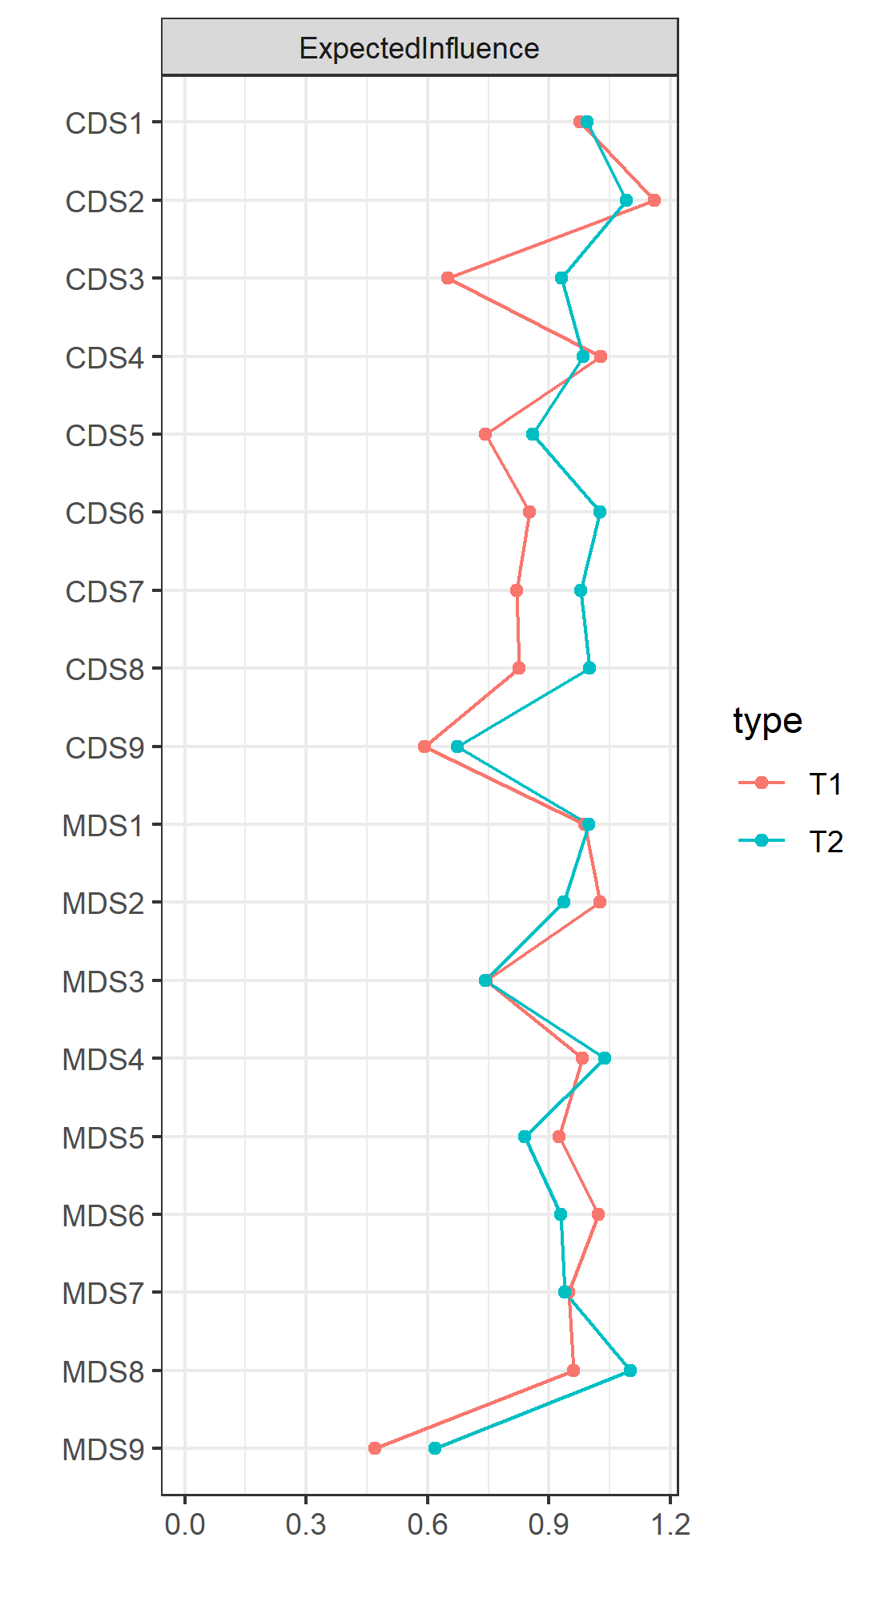
Note. Abbreviations are the same as those in Table 1.

Figure S2 Bridge expected influence for contemporaneous networks.
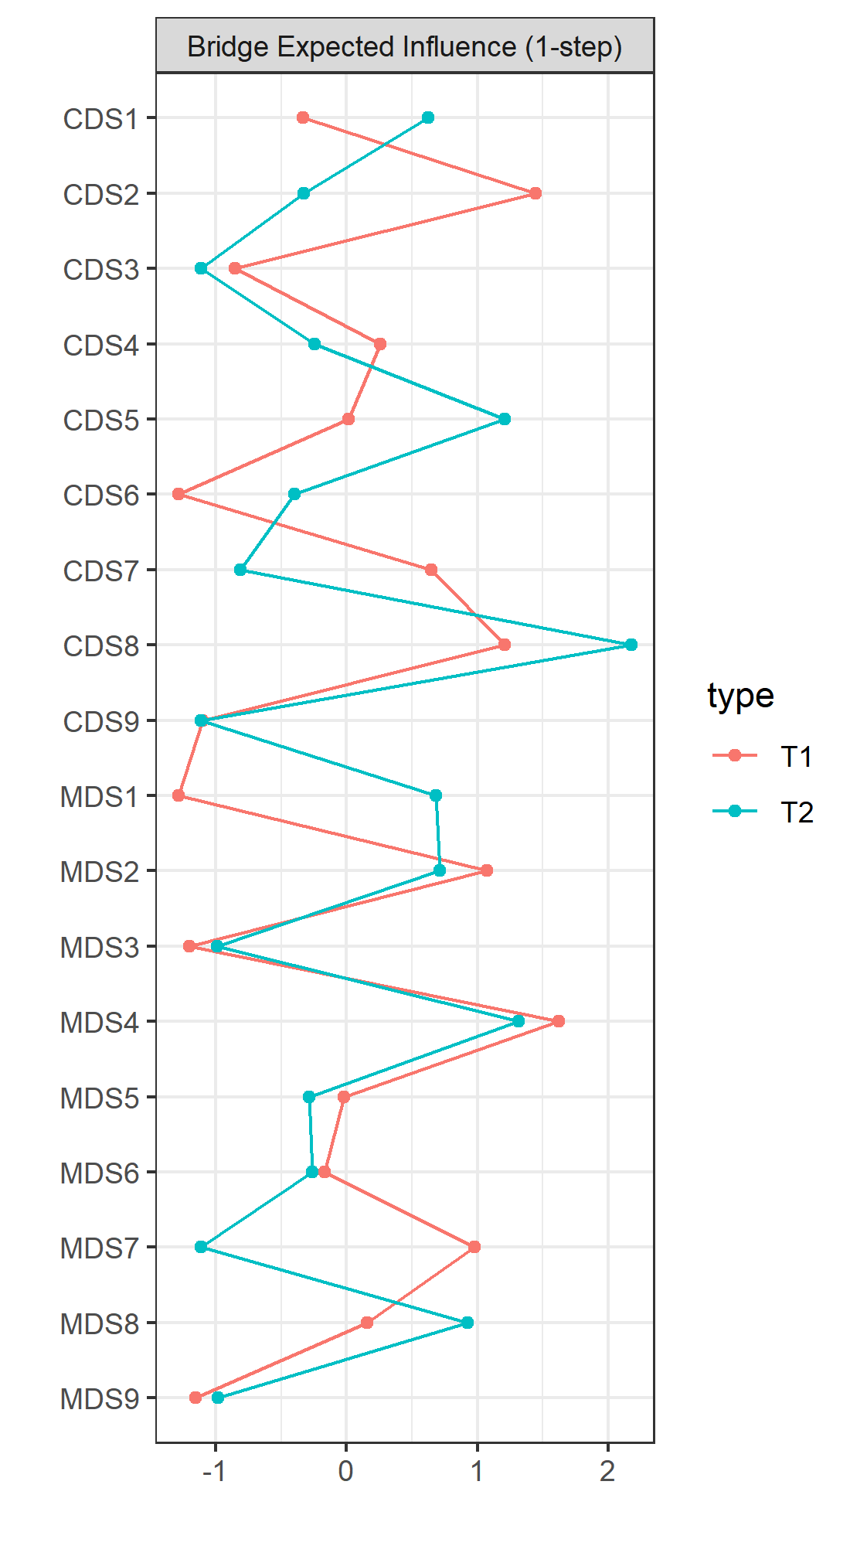
Note. Abbreviations are the same as those in Table 1.

Figure S3 Accuracy of the edge estimates of the contemporaneous networks at T1 and T2.
T1 | 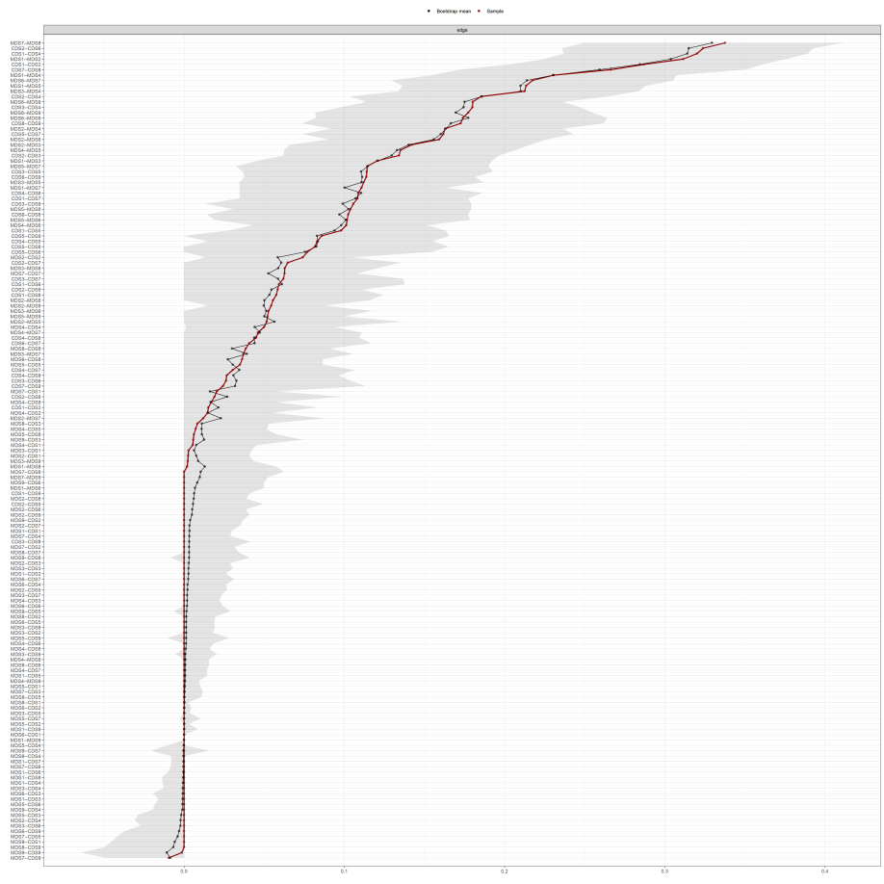
T2 | 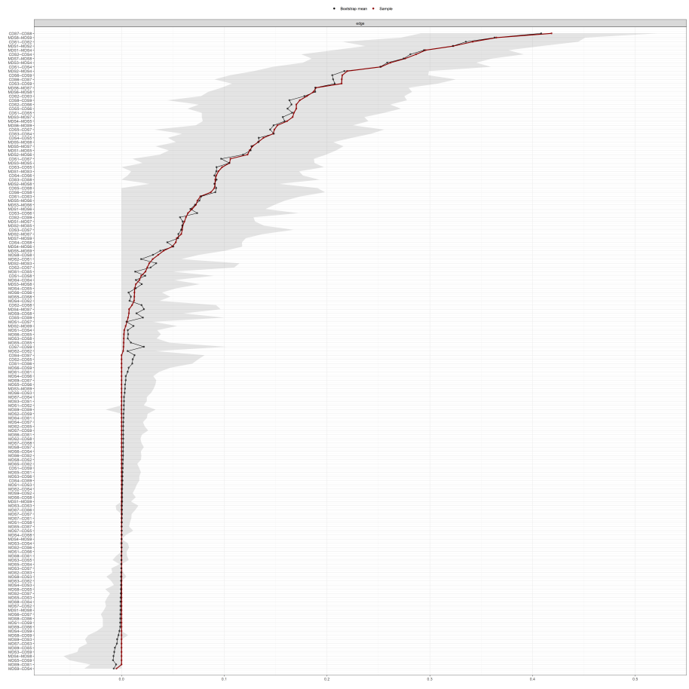

Figure S4 Stability of central indices of the contemporaneous networks at T1 and T2.
T1 | 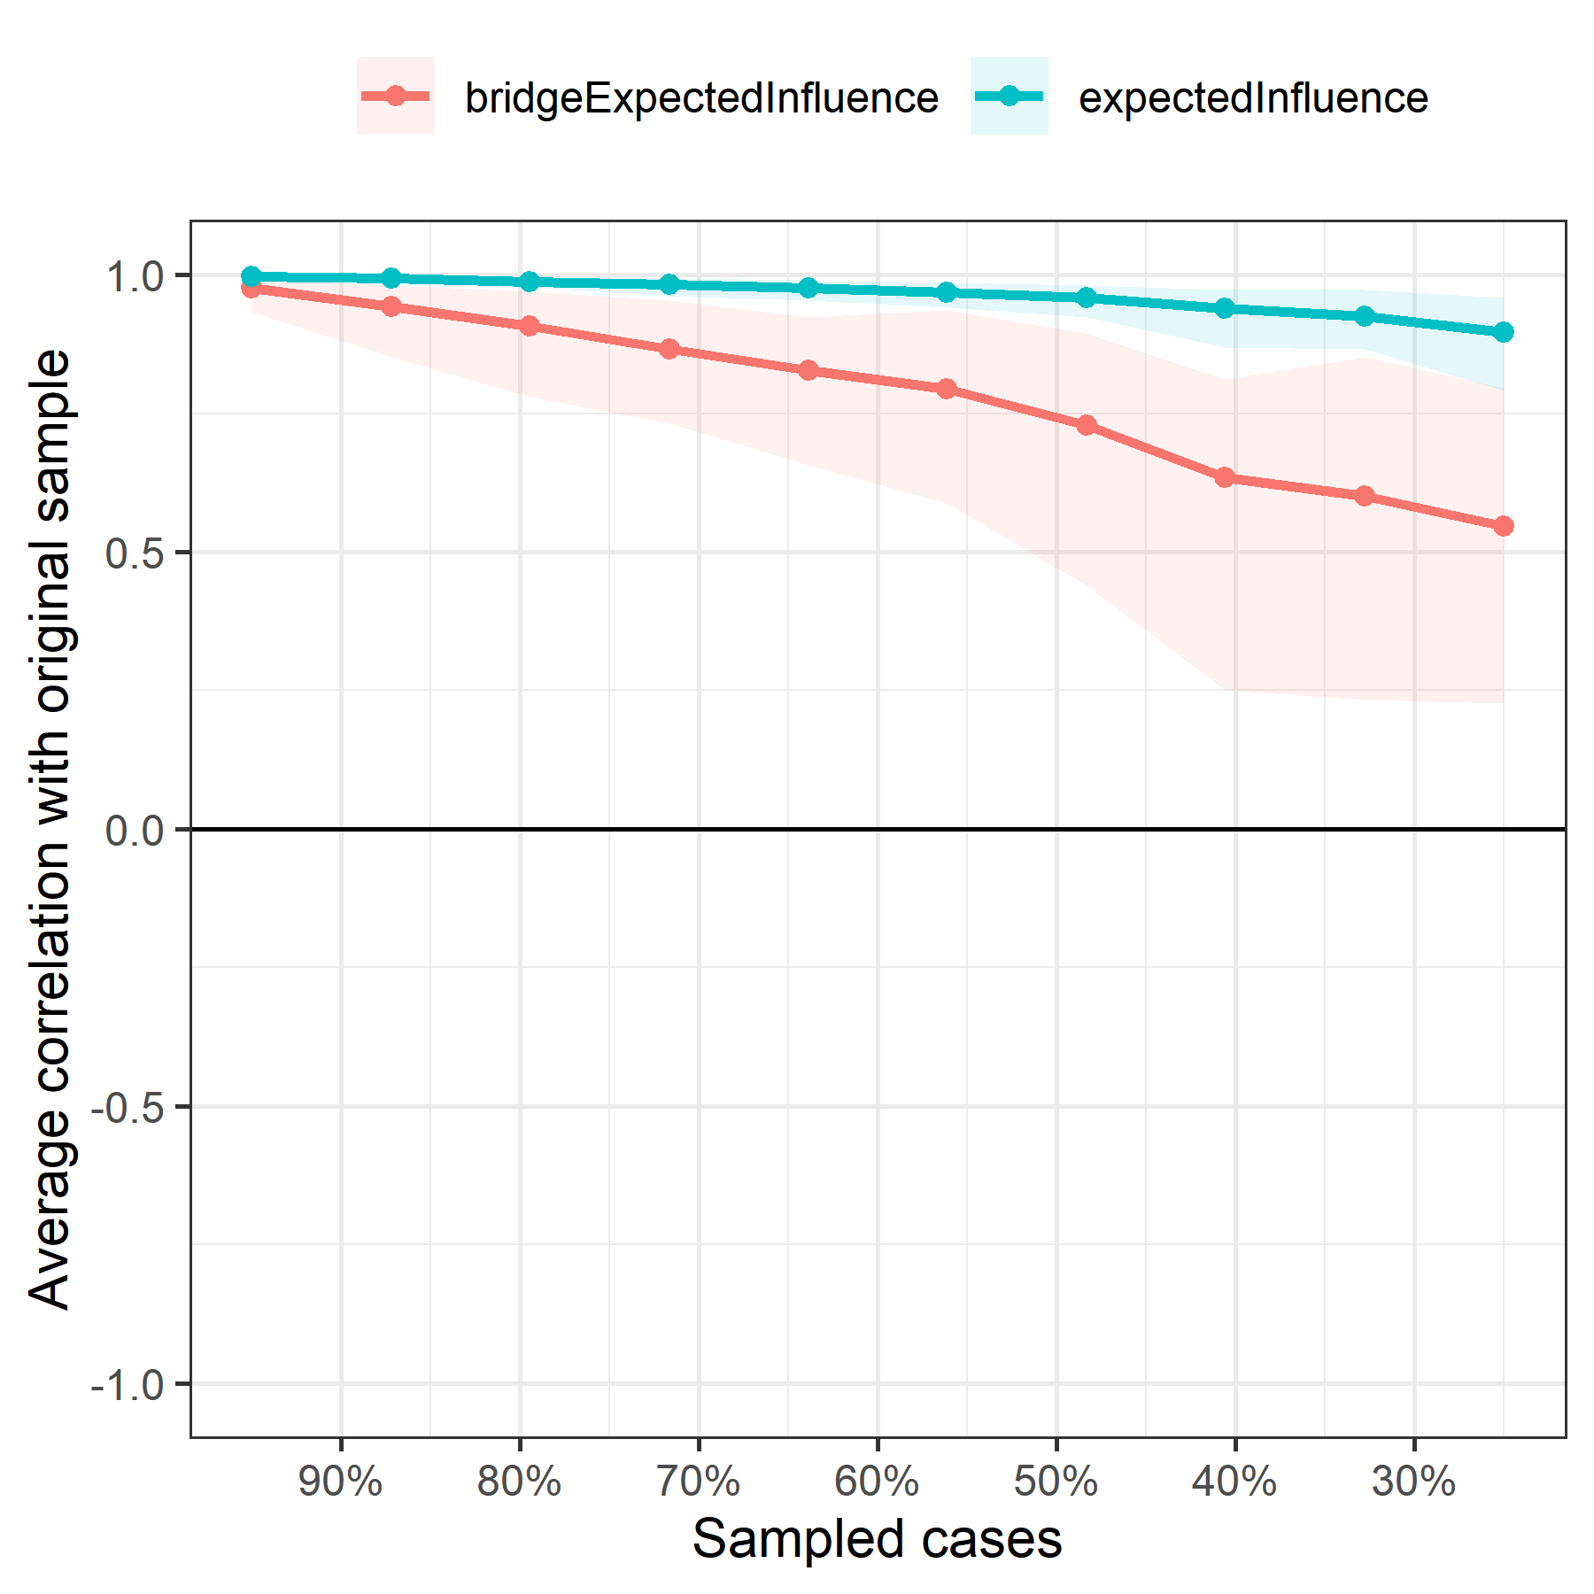
T2 | 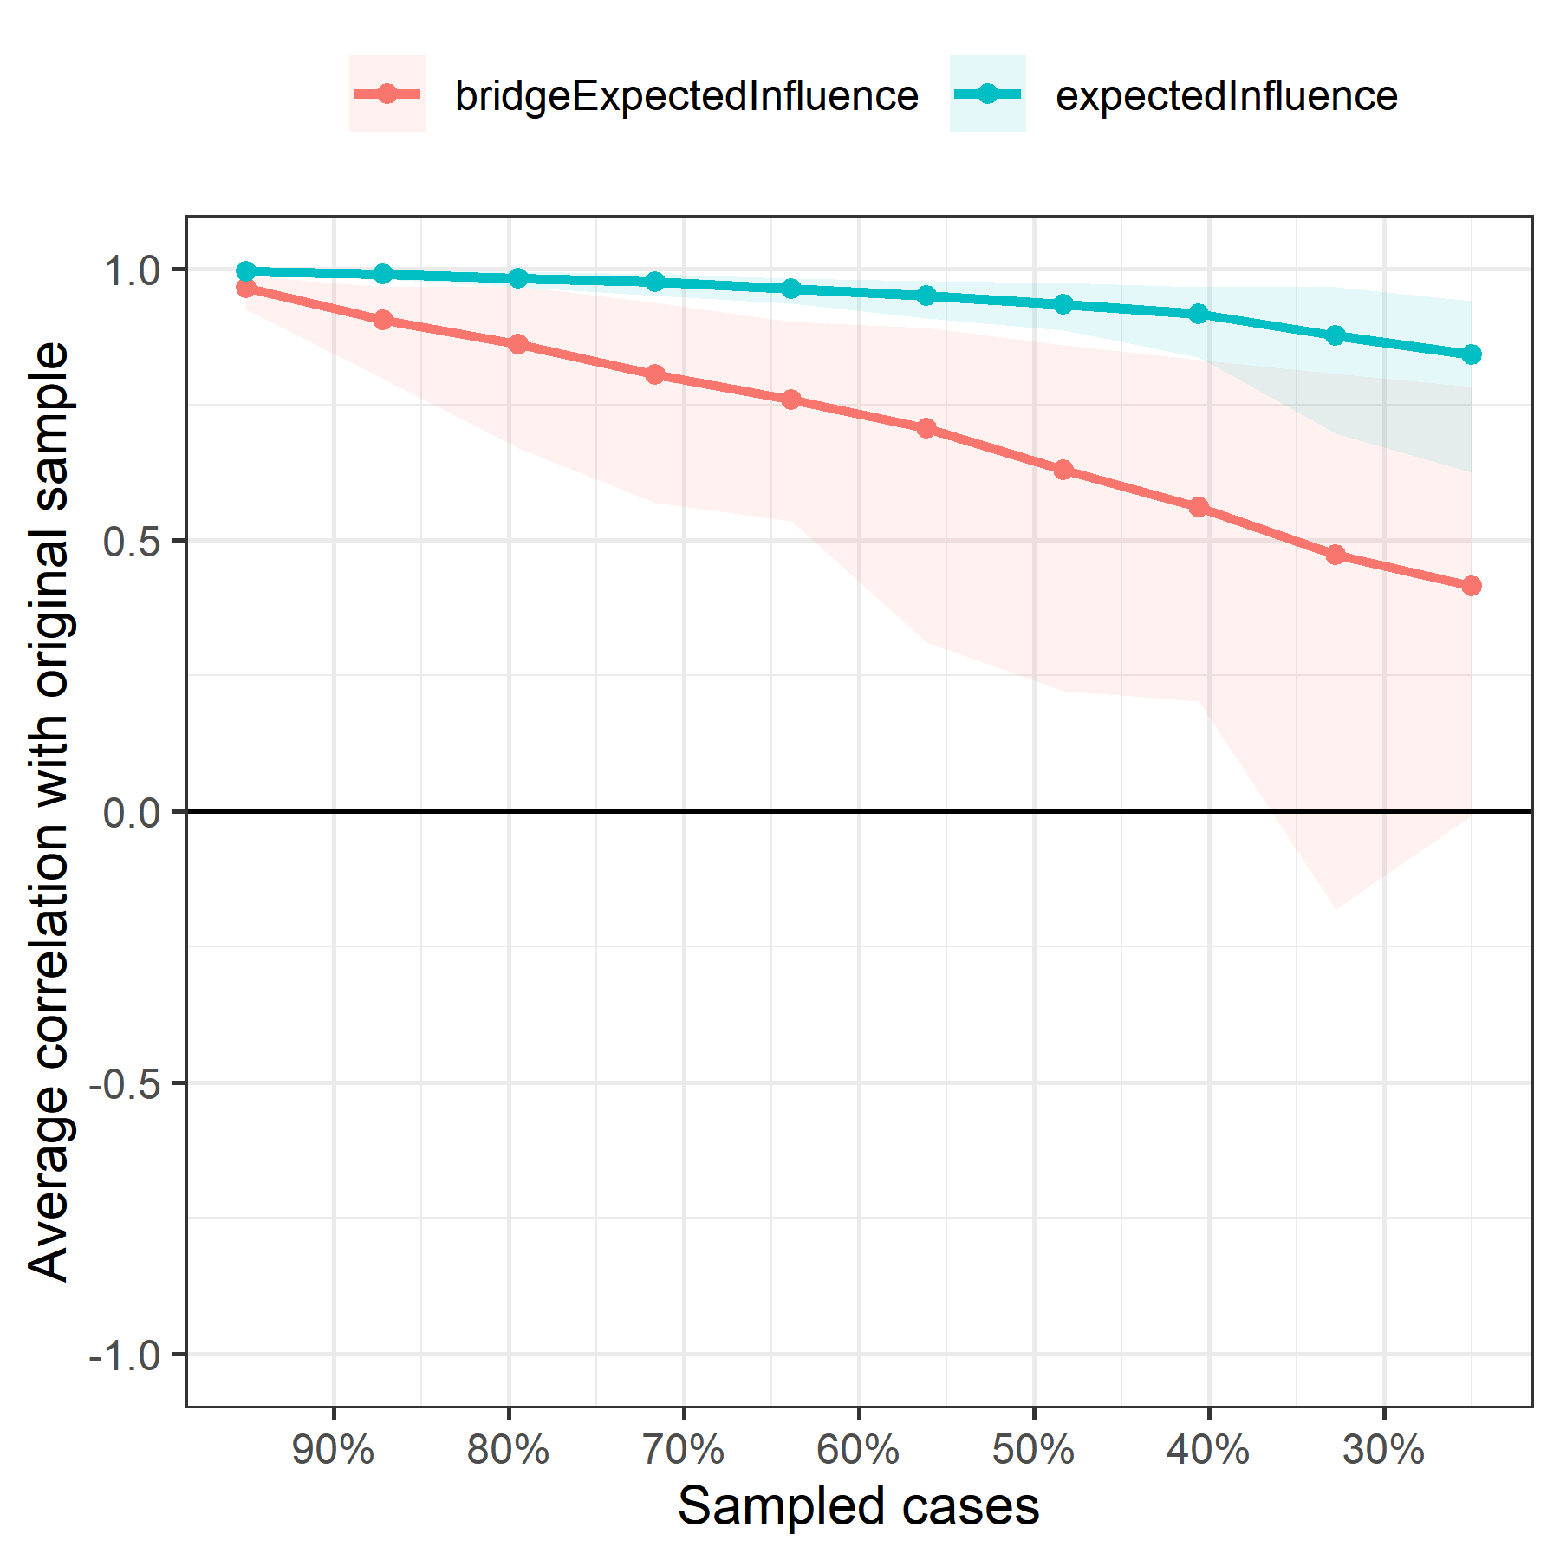
Note. The x-axis represents the percent of dropped case on the original sample. The y-axis represents the correlation between rest sample and original sample. Lines indicate the means and areas indicate the range from the 2.5th quantile to the 97.5th quantile.

Figure S5 Accuracy of the edge estimates of the cross-lagged panel network.
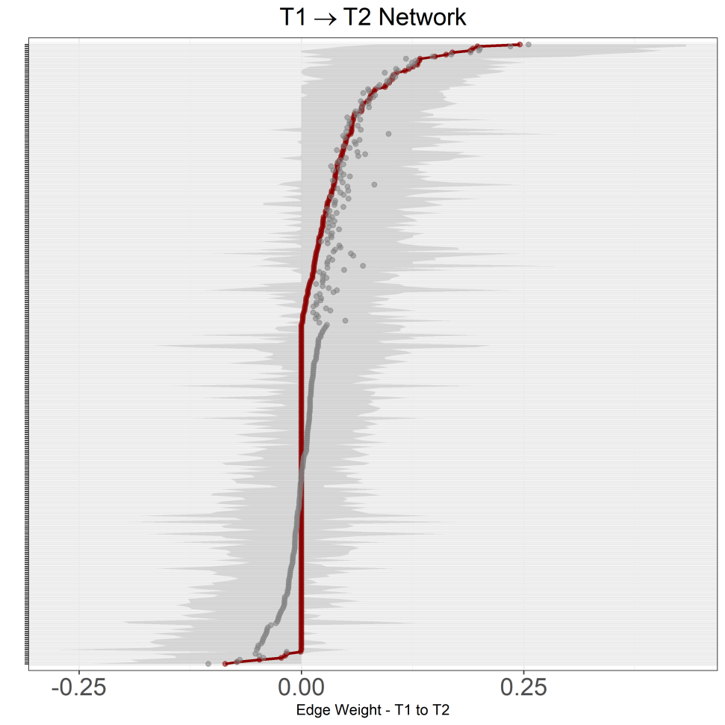
Note. Each horizontal line represents one edge of the network. The red point and gray point on each horizontal line represent the sample values of the edge and the bootstrap mean of the edge, respectively. The gray line on each horizontal line represents the bootstrapped CIs of the edge, and narrower gray line means better accuracy of the edge.

Figure S6 Stability of central indices of the cross-lagged panel network.
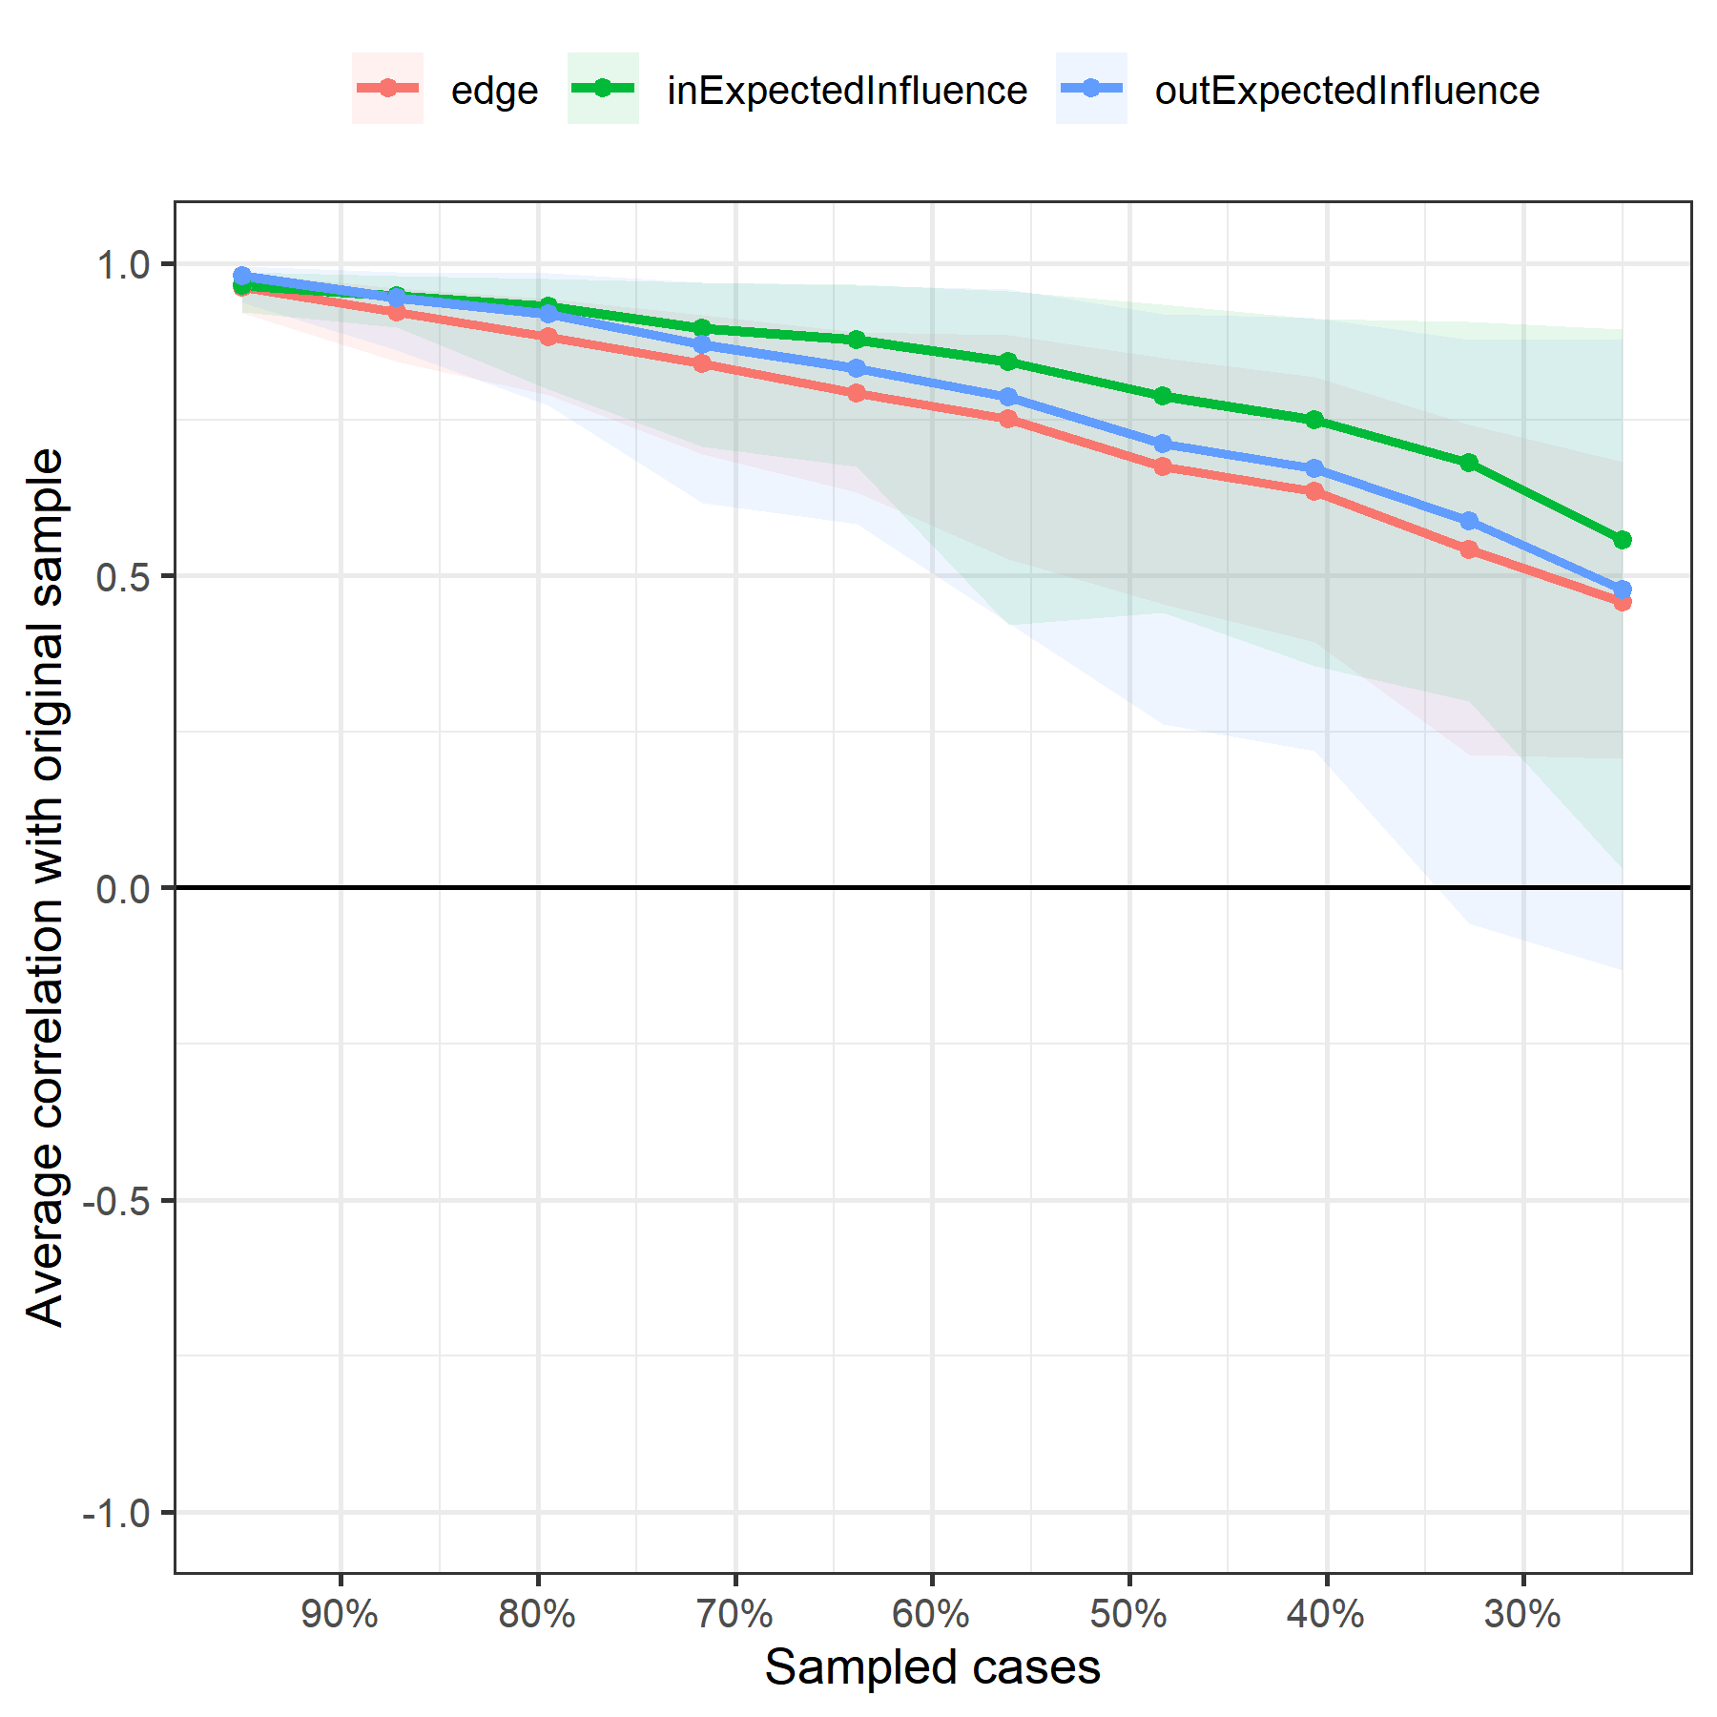
Note. The x-axis represents the percent of dropped case on the original sample. The y-axis represents the correlation between rest sample and original sample. Lines indicate the means and areas indicate the range from the 2.5th quantile to the 97.5th quantile.

