Supplementary file 2
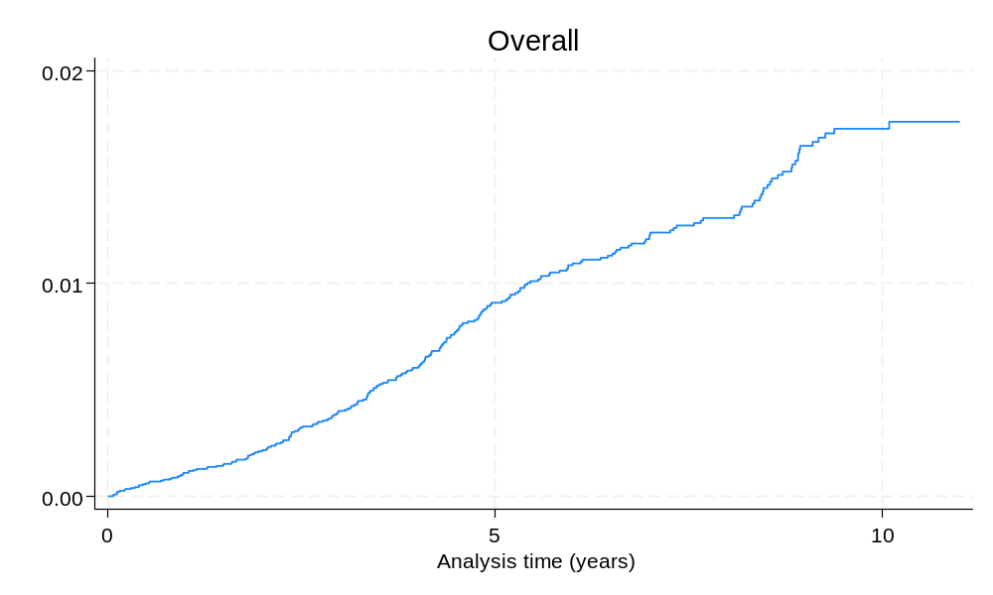
Fig 1a. Kaplan-Meier failure function, overall

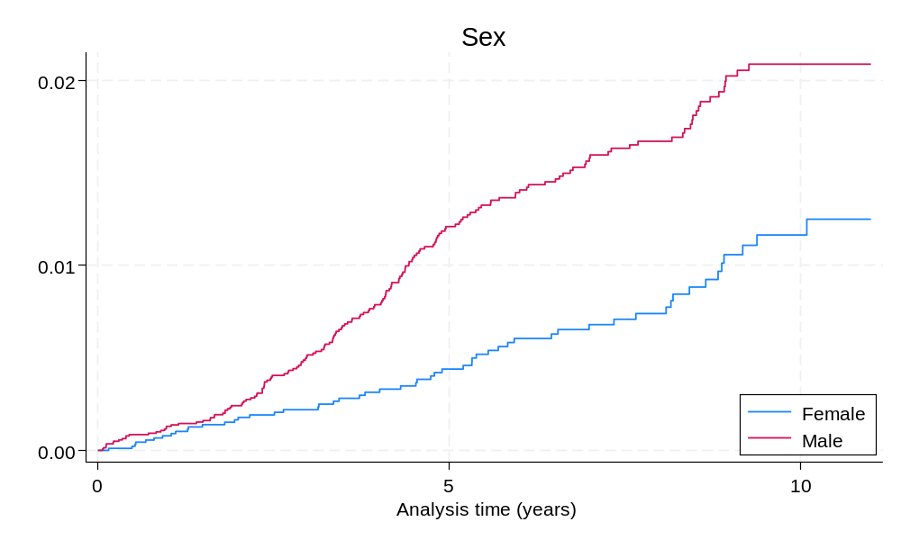
Fig 1b. Kaplan-Meier failure function, by sex (p<0.001, logrank test)

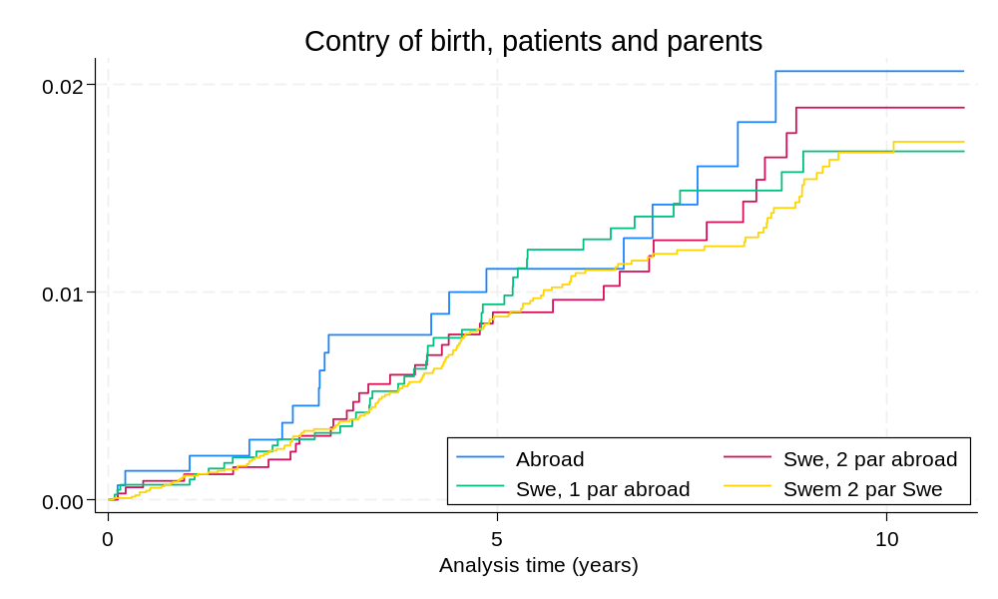
Fig 1c. Kaplan-Meier failure function, by patient’s and parents’ country of birth (p=0.786, logrank test)

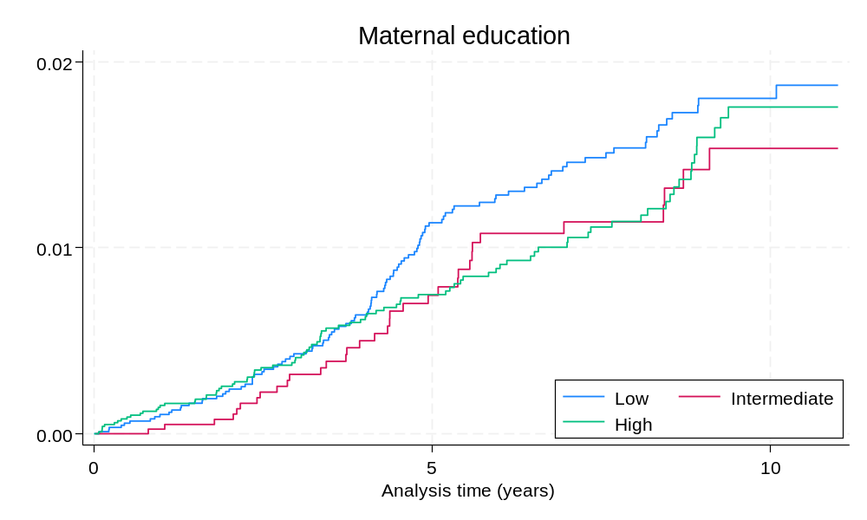
Fig 1d. Kaplan-Meier failure function, by maternal education (p=0.319, logrank test)

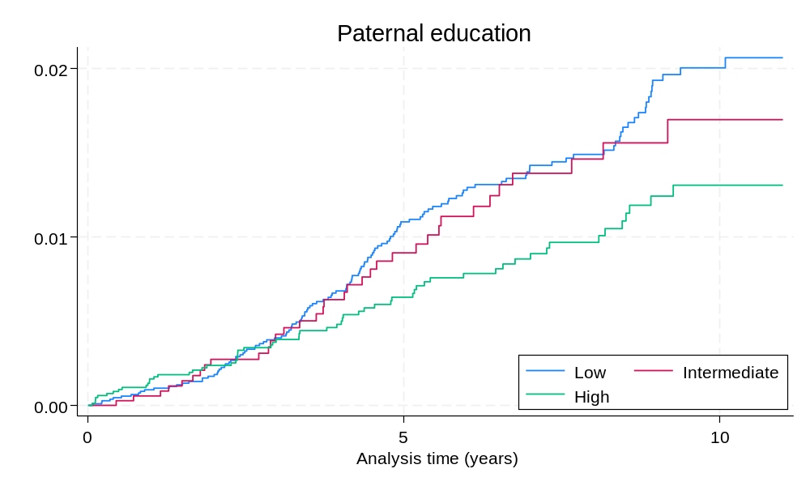
Fig 1e. Kaplan-Meier failure function, by paternal education (p=0.036, logrank test)

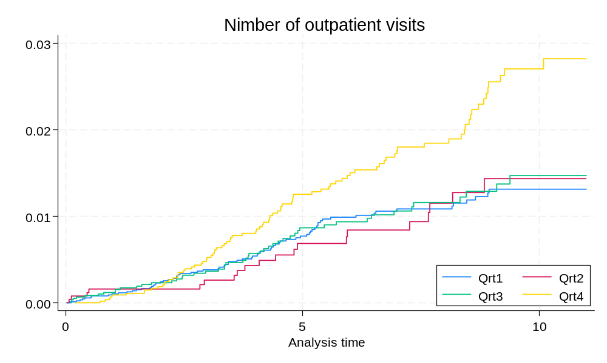
Fig 1f. Kaplan-Meier failure function, by number of outpatient visits (quartiles)(p<0.001, logrank test)

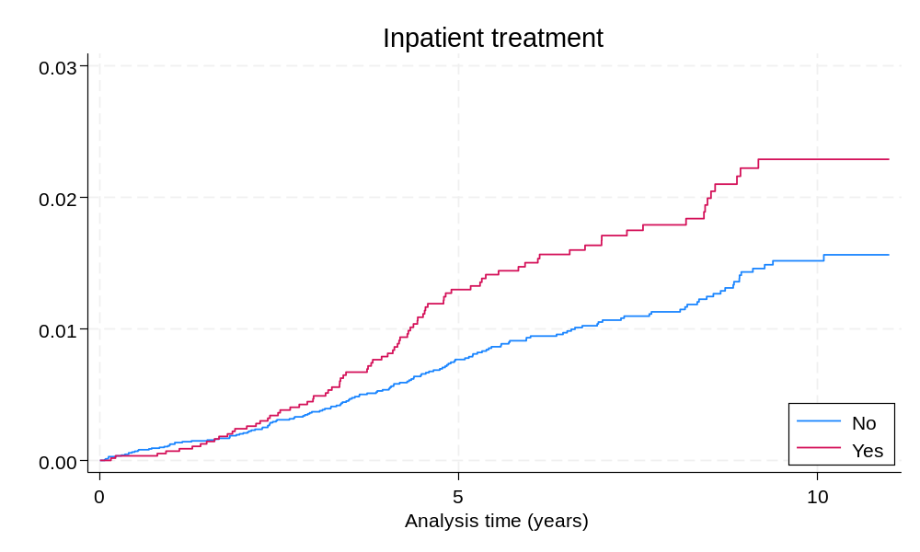

Fig 1g. Kaplan-Meier failure function, by inpatient treatment (p=0.002, logrank test)

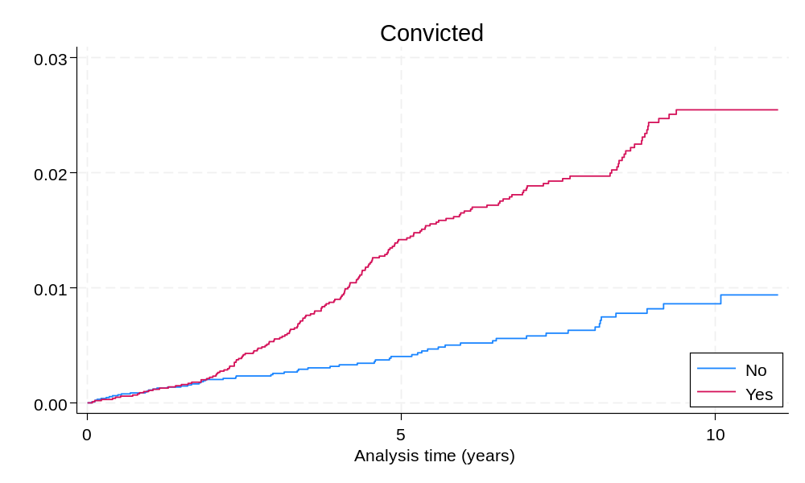
Fig 1h. Kaplan-Meier failure function, by conviction (p<0.001, logrank test)

