Childhood adversity moderates the association between serum cortisol and earlier-onset posttraumatic stress disorder

Jae-Min Kim^{a*1}, Hee-Ju Kang^{a1}, Ju-Wan Kimª, Ju-Yeon Leeª, Hyunseok Jang,^{b} Jung-Chul Kim,^{b} Sung-Wan Kimª, Il-Seon Shinª

Supplementary materials

1. Eligibility criteria
2. References
Figure S1. Participant flow and prevalence of posttraumatic stress disorder over 2 years following physical injury.
Table S1. Baseline characteristics according to post-traumatic stress disorder (PTSD) over 2-years.
Eligibility criteria

1-1. Inclusion criteria
- individuals aged 18 years or older at the index injury.
- patients hospitalised for more than 24 hours after sustaining a moderate to severe physical injury measured by the Injury Severity Score (ISS) ≥9 [1].
- individuals sufficiently proficient in the Korean language to comprehend the study protocol.

1-2. Exclusion criteria
- moderate or severe brain injury measured by the Glasgow Coma Scale (GCS) <10 [2].
- physical injuries resulting from suicide attempts.
- conditions hindering comprehensive psychiatric evaluation due to severe physical ailments.
- prior history of psychiatric disorders including psychotic disorder, bipolar disorder, or alcohol or substance use disorders other than depressive and anxiety disorders.
- significant cognitive impairments due to organic mental or neurocognitive disorders.
- pre-existing convulsive disorders or a history of anticonvulsant use.

References
1. Baker SP, O’Neil B, Haddon W, et al (1974) The injury severity score: a method for describing patients with multiple injuries and evaluating emergency care. J Trauma 14:187–196. https://doi.org/10.1097/00005373-197403000-00001
2. Teasdale G, Jennett B (1974) Assessment of coma and impaired consciousness. A practical scale. Lancet 2:81–84. https://doi.org/10.1016/S0140-6736(74)91639-0
Fig. S1. Participant flow and prevalence of posttraumatic stress disorder over 2 years following physical injury.
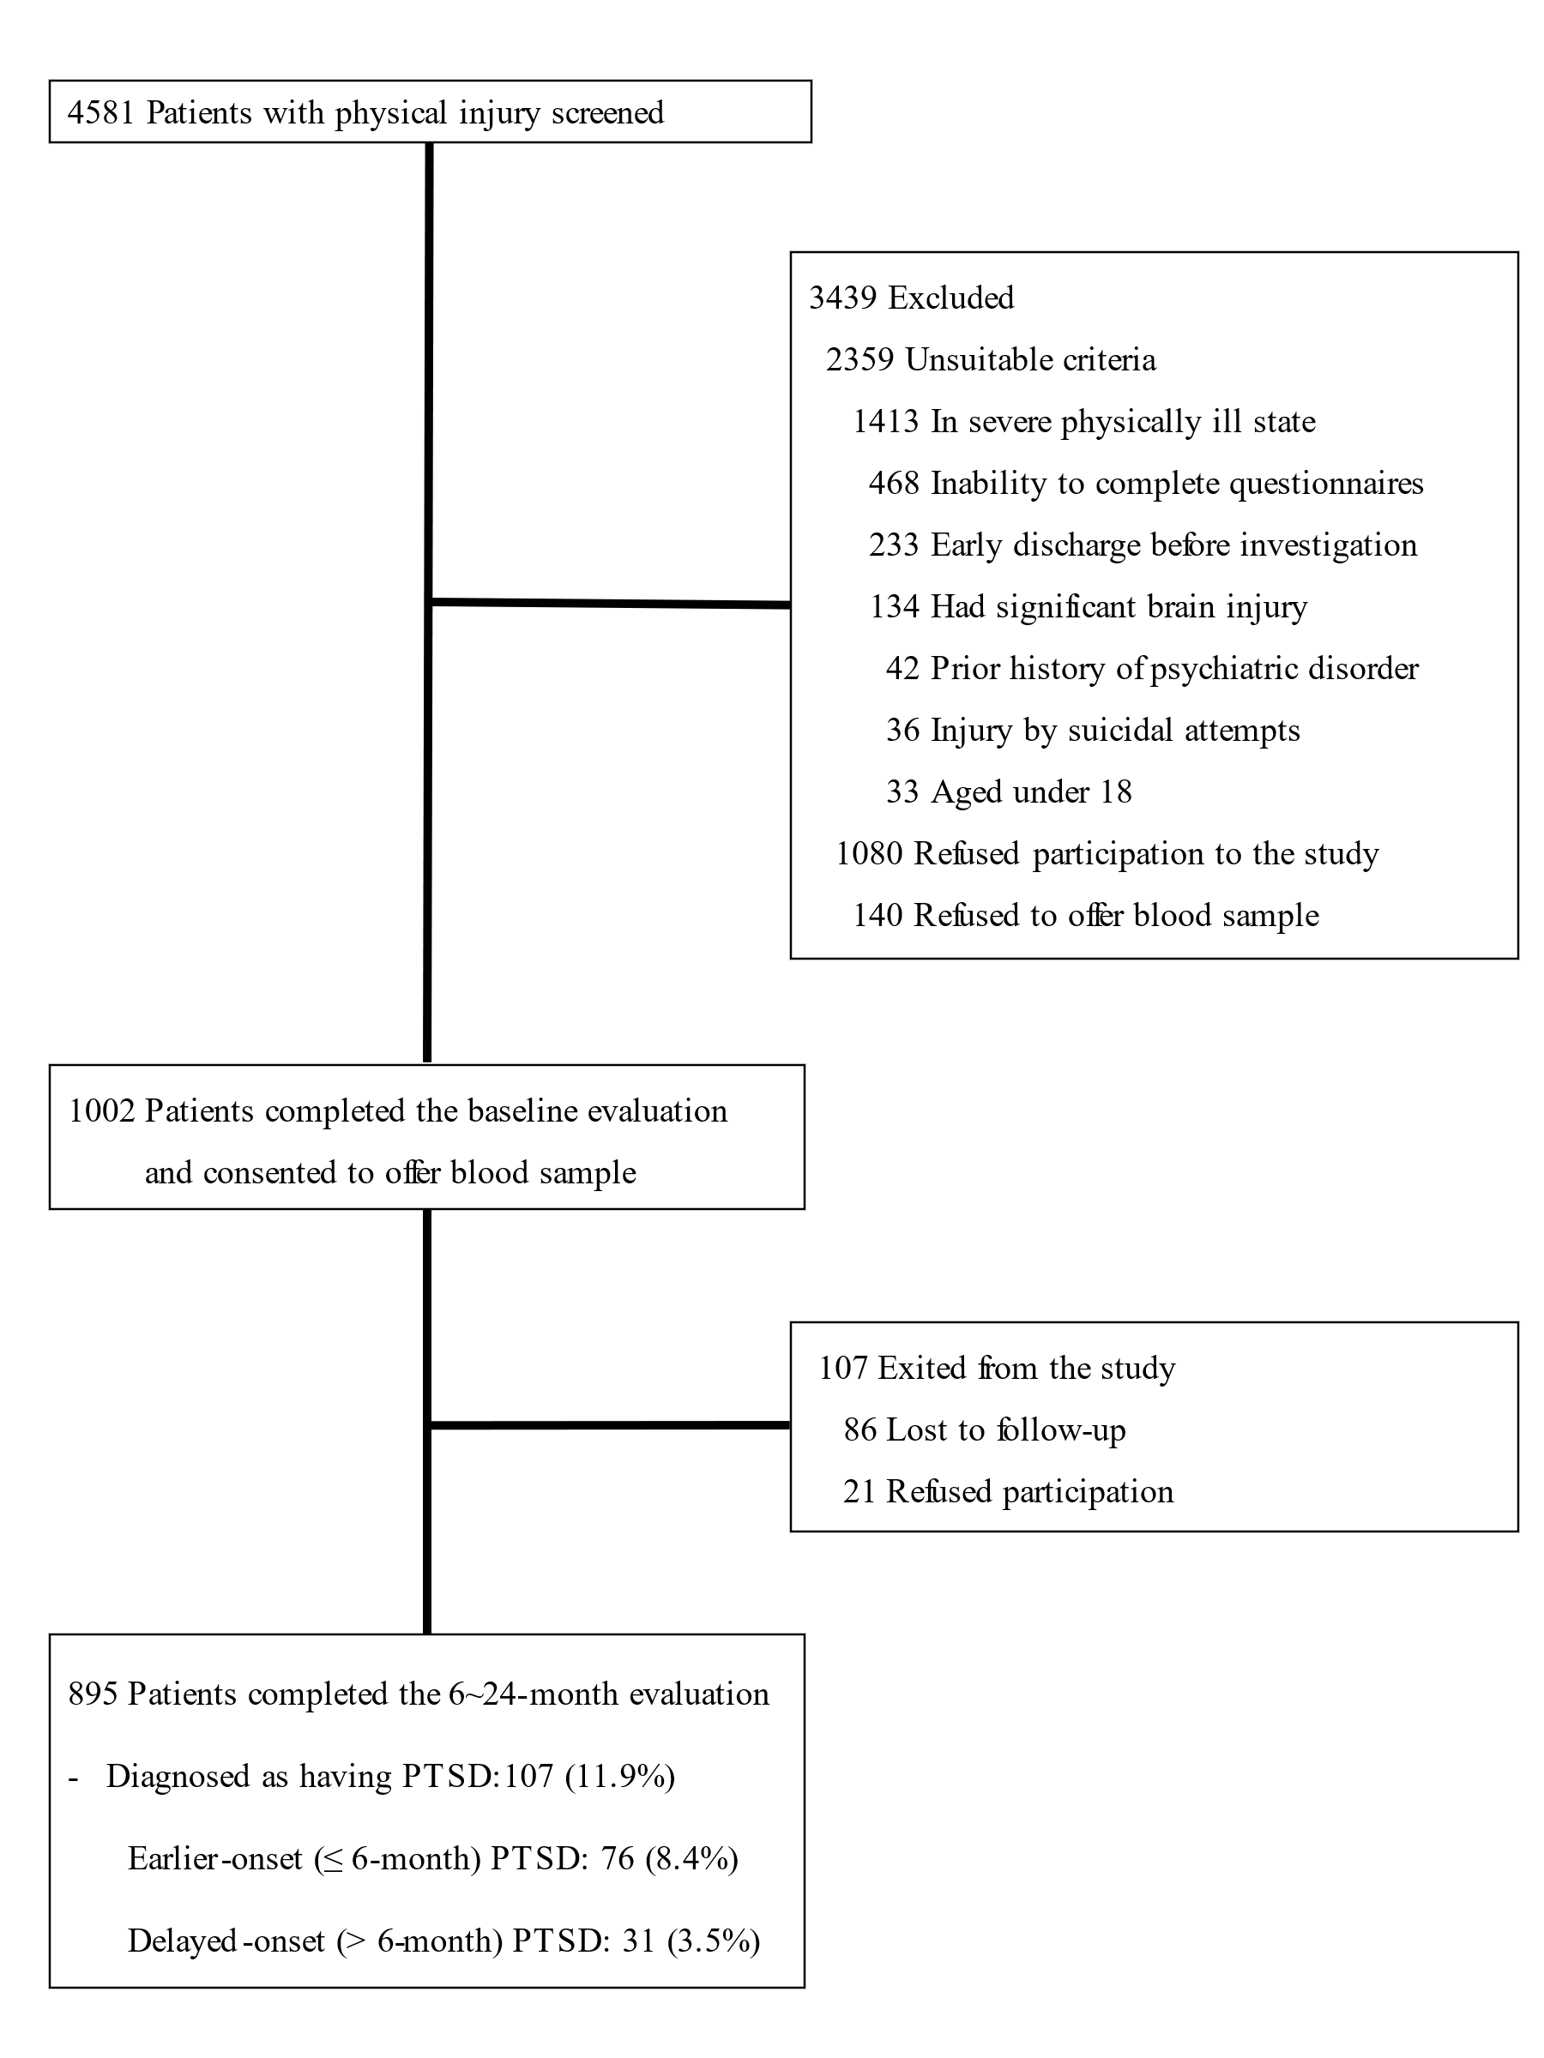
Table S1. Baseline characteristics according to post-traumatic stress disorder (PTSD) over 2-years.
 | Absent  PTSD (N=788) | Present PTSD  (N=107) | Statistical coefficients | P-valueª
Age, mean (SD) years | 56.7 (17.2) | 52.2 (14.7) | t=+2.949 | 0.004
Sex, N (%) female | 228 (28.9) | 44 (41.1) | χ²=6.615 | 0.010
Education, mean (SD) years | 10.6 (4.1) | 11.8 (3.5) | t=-3.166 | 0.002
Marital status, N (%) unmarried | 273 (34.6) | 30 (28.0) | χ²=1.837 | 0.175
Living alone, N (%) | 124 (15.7) | 10 (9.3) | χ²=3.022 | 0.082
Unemployed status, N (%) | 134 (17.0) | 17 (15.9) | χ²=0.084 | 0.772
Previous psychiatric disorders, N (%) | 44 (5.6) | 17 (15.9) | χ²=15.749 | <0.001
Previous traumatic events, N (%) | 25 (3.2) | 14 (13.1) | χ²=22.206 | <0.001
Physical disorders, mean (SD) numbers | 1.9 (2.0) | 1.6 (1.8) | t=+1.421 | 0.156
Current smoker, N (%) | 220 (27.9) | 37 (34.6) | χ²=2.042 | 0.153
Alcohol Use Disorders Identification Test, mean (SD) scores | 10.5 (10.0) | 10.0 (10.2) | t=+0.537 | 0.592
Body mass index, mean (SD) | 23.6 (3.5) | 23.7 (3.4) | t=-0.272 | 0.786
Connor-Davidson Resilience Scale, mean (SD) scores | 65.4 (15.4) | 65.3 (17.4) | t=+0.099 | 0.921
Multidimensional Scale of Perceived Social Support, mean (SD) scores | 34.8 (10.0) | 35.9 (10.8) | t=-1.052 | 0.293
Injury Severity Score, mean (SD) scores | 14.7 (5.8) | 15.2 (6.0) | t=-0.774 | 0.439
Glasgow Coma Scale, mean (SD) scores | 14.8 (0.7) | 14.9 (0.5) | t=-0.124 | 0.902
Injury type, N (%) intentional | 70 (8.9) | 11 (10.1) | χ²=0.164 | 0.686
Hospital Anxiety Depression scale-anxiety subscale, mean (SD) scores | 2.7 (3.2) | 5.9 (4.8) | t=-6.626 | <0.001
Hospital Anxiety Depression scale-depression subscale, mean (SD) scores | 5.2 (4.7) | 8.6 (5.2) | t=-6.436 | <0.001
Heart rate per minute, mean (SD) | 78.7 (11.3) | 79.0 (10.7) | t=-0.280 | 0.779
ª t-tests or χ² tests, as appropriate.
Bold style indicates statistical significance (P-value<0.05).

