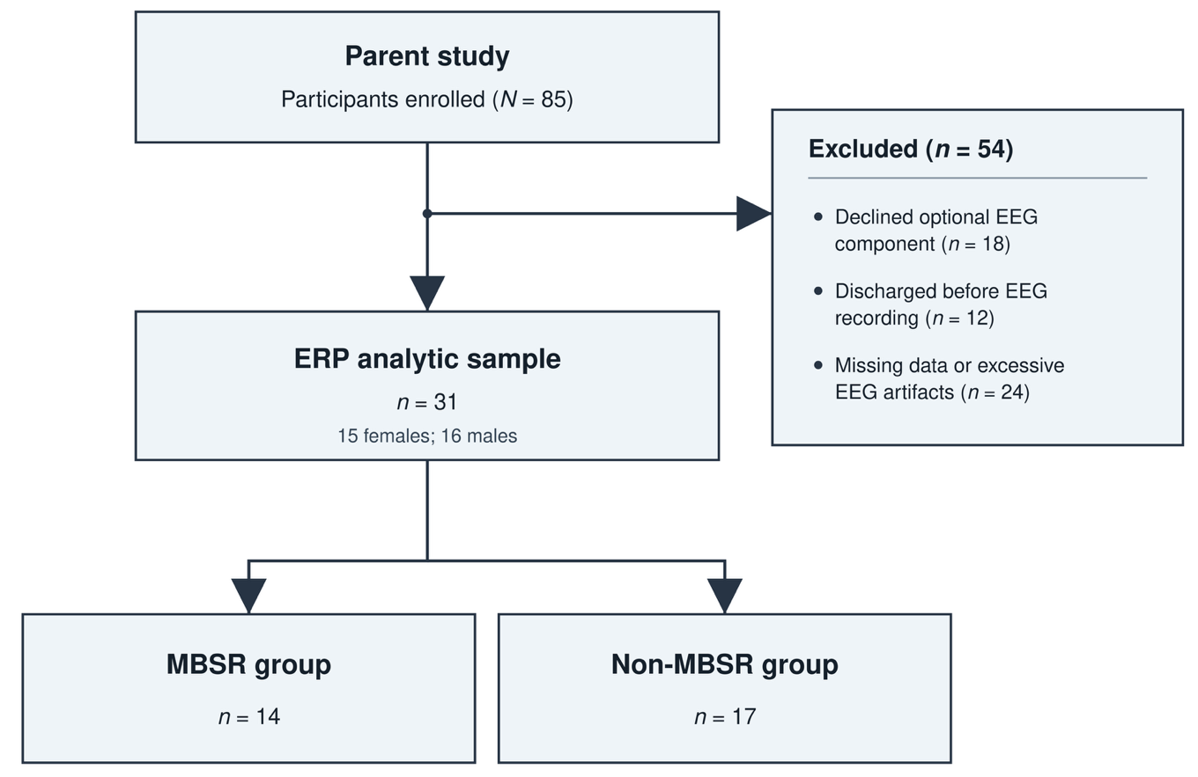
Supplementary Fig. 1 CONSORT-style participant flow diagram
Supplementary Table 1. Demographic and clinical characteristics of participants retained in and excluded from the current analysis.
Characteristic | Retained (n = 31) | Excluded (n = 54) | Test | p
Group allocation, n (%) |  |  | χ² (1) = 1.19 | .276
MBSR | 14 (45.2) | 31 (57.4) | χ² (1) = 1.19 | .276
Non-MBSR | 17 (54.8) | 23 (42.6) | χ² (1) = 1.19 | .276
Sex, n (%) |  |  | χ² (1) = 1.05 | .306
Female | 15 (48.4) | 20 (37.0) | χ² (1) = 1.05 | .306
Male | 16 (51.6) | 34 (63.0) | χ² (1) = 1.05 | .306
Baseline age, years |  |  | Welch’s t (71.57) = 6.88 | < .001
Mean (SD) | 14.84 (1.24) | 12.78 (1.47) | Welch’s t (71.57) = 6.88 | < .001
Diagnosis, n (%) |  |  | Fisher–Freeman–Halton exact test | .797
ADHD and AD | 10 (32.3) | 21(38.9) | Fisher–Freeman–Halton exact test | .797
ADHD without AD | 8 (25.8) | 16 (29.6) | Fisher–Freeman–Halton exact test | .797
AD without ADHD | 11 (35.5) | 14 (25.9) | Fisher–Freeman–Halton exact test | .797
Neither ADHD nor AD | 2 (6.5) | 3 (5.6) | Fisher–Freeman–Halton exact test | .797
Note. ADHD = attention-deficit/hyperactivity disorder; AD = affective disorder. AD included major depressive disorder, dysthymic disorder, generalized anxiety disorder, social phobia, possible mood disorder, and post-traumatic stress disorder. Values are n (%) unless otherwise indicated. All tests were two-sided. Pearson chi-square tests were used for group allocation and sex, Welch’s independent-samples t test was used for age, and the Fisher–Freeman–Halton exact test was used for diagnostic category.

