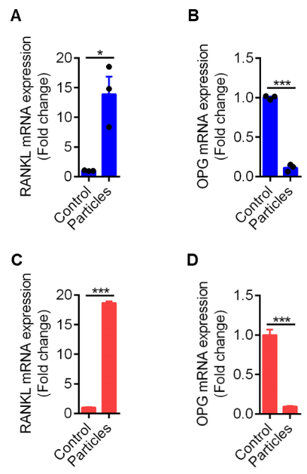
Fig.S1. Rankl and Opg expression induced by UHMWPE particles. (A&B) The relative mRNA expression of RANKL and OPG in calvarial bone induced by UHMWPE implantation (n=3). (C&D) The relative mRNA expression of RANKL and OPG in MLO-Y4 cells induced by 50 μg/ml UHMWPE particles for 24 hours. *P<0.05, ***P<0.001. P-values were analyzed by two-tailed t tests.

