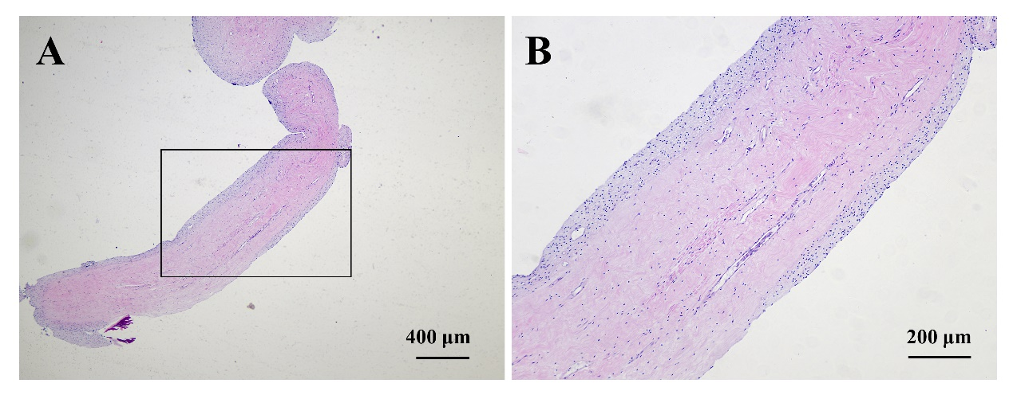
Supplement Figure S1. HE staining of dental pulp tissue extracted from the third molars. (A) Low-magnification HE staining image of the dental pulp tissue. Scale bar: 400 μm. (B) Magnified view of the boxed area in panel A. Scale bar: 200 μm.

Supplement Figure S2. FACS gating strategy for DPMSC. Potential cell doublets and rare dead cells were systematically excluded from the analysis through sequential gating.

Supplement Figure S3. Cell size distribution of microfluidic sorted subpopulations of DPMSC from different donors. All data are represented as mean ± standard deviation.

Supplement Figure S4. Cell cycle analysis of size-dependent DPMSC subpopulations. (A) Cell cycle profile of size-dependent subpopulations. (B) Quantification of cell cycle stages in size-dependent subpopulations. All error bars represent standard deviation. Symbols * and ^ indicate statistically significant difference compared to S1 and S2, respectively, determined by Students’ t-test (p < 0.05).

Supplement Figure S5. Colony-forming efficiency and differentiation potency of size-dependent DPMSC subpopulations from different donors. (A) Colony forming efficiency of size-dependent DPMSC subpopulations derived from 4 different donors. (B) Quantifications of Alizarin Red S stain concentrations in osteogenically differentiated size-dependent DPMSC subpopulations from 4 different donors. (C) Size of the cartilage pellets formed in vitro by size-dependent DPMSC subpopulations from 4 different donors. (D-E) Quantitative PCR analysis of relative mRNA levels of aggrecan (ACAN, D) and Collagen II (Col II, E) in cartilage pellets formed in vitro by size-dependent DPMSC subpopulations from 3 different donors. All error bars represent standard deviation. Symbols *, ^, #, and @ indicate statistically significant difference compared to unsorted DPMSC and subpopulations S1, S2, and S3, respectively, determined by Students’ t-test (p < 0.05).
Supplement Figure S6: Image-based quantification of DPMSC chondrogenesis. (A-B) Overall image-based quantification of Col II (A) and Alcian Blue (B, stains glycosaminoglycans, GAGs) staining in histological sections of cartilage pellets formed in vitro by size-dependent DPMSC subpopulations. (C) Image-based quantification of Col II content in the cartilage pellets formed in vitro by size-dependent DPMSC subpopulations derived from 3 different donors. (D) Image-based quantification of GAGs content in the cartilage pellets formed in vitro by size-dependent DPMSC subpopulations from 5 different donors. All error bars represent standard deviation. Symbols *, ^, #, and @ indicate statistically significant difference compared to unsorted DPMSC and subpopulations S1, S2, and S3, respectively, determined by Students’ t-test (p < 0.05).

Supplement Figure S7: T cell suppressive capacity of size-dependent DPMSC subpopulations from different donors. (A-C) FACS plots showing CFSE fluorescence intensity of activated CD3⁺ T cells cocultured with size-dependent DPMSC subpopulations derived from 3 different donors. (D-F) Proportions of CD3⁺ T cell subsets that have undergone different numbers of cell divisions following PHA activation, when co-cultured with size-dependent DPMSC subpopulations from 3 different donors, quantified based on the FACS plots. (G-I) T cell proliferation indices (TPI) of activated CD3⁺ T cells co-cultured with size-dependent DPMSC subpopulations from 3 different donors. All error bars represent standard deviation.
Supplement Figure S8. Inhibition of macrophage M1 polarization by size-dependent DPMSC subpopulations from different donors. (A) FACS analysis of classical macrophage (M0) marker expression in PMA-activated THP-1 cells. Blue: unstained DPMSCs; Red: DPMSCs stained for various surface markers. (B) Quantification of CD86⁺CD206⁻ population in THP-1 derived M1 macrophages following co-culture with size-dependent DPMSC subpopulations from 3 different donors. All error bars represent standard deviation. Symbols *, ^, and # indicate statistically significant difference compared to M0, M1+unsorted, and M1+S1 groups, respectively, determined by Students’ t-test (p < 0.05), respectively.

Supplement Figure 9: Transcriptome profiling of Size-dependent DPMSC subpopulations. (A) PCA of the unsorted and size-dependent subpopulations of DPMSCs. Round, triangular, and square marker shapes represent DPMSCs derived from three different donors. Grey, green, blue, and red colors represent unsorted DPMSC, large-sized, medium-sized, and small-sized DPMSC subpopulations, respectively. The variation in marker size indicates data derived from independent sorting experiments. (B) Heatmaps illustrating the DEGs of the size-dependent DPMSC subpopulations relative to the unsorted DPMSCs. (C) GO enrichment analysis of the top enriched GO terms in the size-dependent DPMSC subpopulations (among the top 10 enriched GO terms in each GO category).

Supplement Figure S10. Relative gene expression of osteogenic and chondrogenic regulators and pro-inflammatory cytokine receptors. All error bars represent standard deviation. Symbols * and ^ indicate statistically significant difference compared to unsorted DPMSC and subpopulations S, respectively, determined by Students’ t-test (p < 0.05).

Gene Name | Forward Primer Sequence | Reverse Primer Sequence
GAPDH | ATG GGG AAG GTG AAG GTC G | TAA AAG CAG CCC TGG TGA CC
Col II | GGC AAT AGC AGG TTC ACG TAC A | CGA TAA CAG TCT TGC CCC ACT T
ACAN | TCG AGG ACA GCG AGG CC | TCG AGG GTG TAG CGT GTA GAG A
Supplement Table S1. qPCR primers for human genes.

