- SiO₂
- Fe₃O₄-La
Element | W% | A%
C | 10.58 | 22.10
O | 36.34 | 56.97
Fe | 42.27 | 18.98
La | 10.81  100 | 1.95  100
Element | W% | A%
O | 66.05 | 77.20
Na | 2.12 | 1.72
Si | 30.42 | 20.25
S | 1.41  100 | 0.82  100

- Fe₃O₄-La@SiO₂
Element | W% | A%
C | 4.58 | 10.48
O | 37.02 | 63.61
Si | 0.18 | 0.17
Fe  La | 48.27  9.96 | 23.76  1.97
 | 100 | 100

Figure S1. Elemental quantitative data of (a) SiO₂, (b) Fe₃O₄-La, and (c) Fe₃O₄-La@SiO₂ nanoparticles.

Cell viability %  Fe3O4-La@SiO2 | Cell viability %  Fe3O4-La | Percent of nanoparticle Wt%
100 | 98 | 1
95 | 90 | 3
79 | 72 | 5
Table 1. Cell viability % for the Fe₃O₄-La using MTT assay.

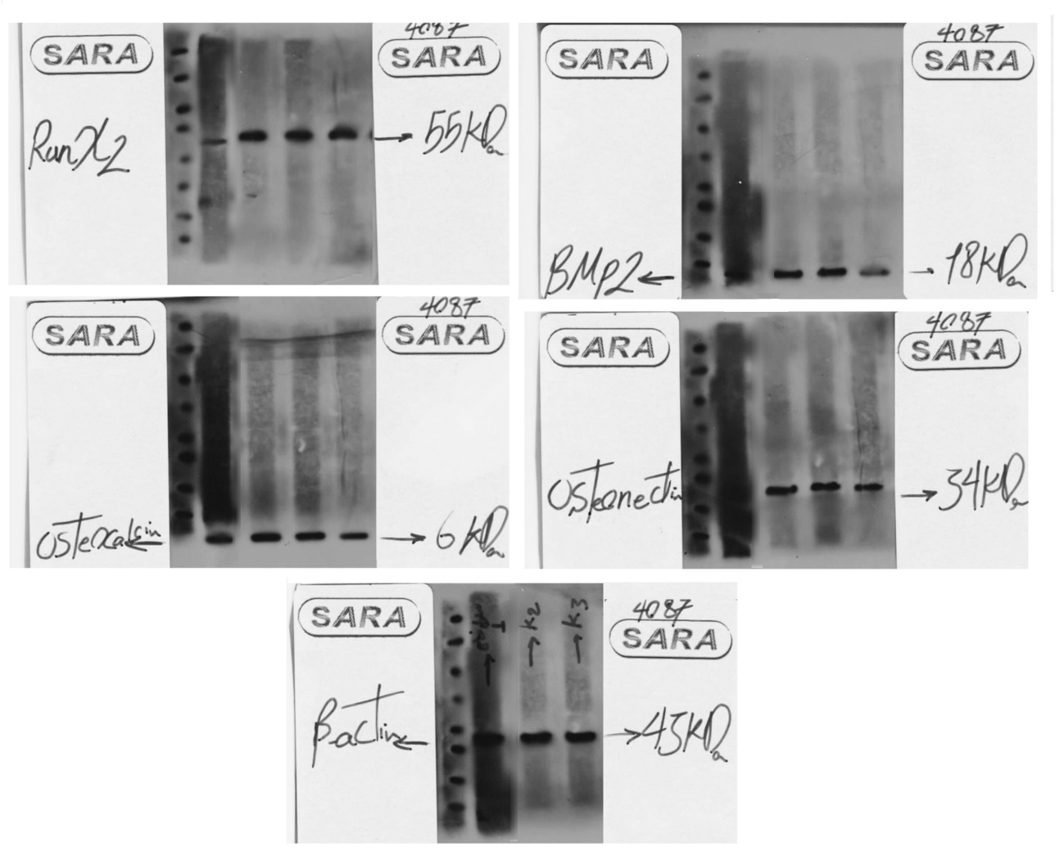
Figure S2. Full-length blots/gels of Runx2, BMP2, Osteocalcin, Osteonectin and β-actin proteins by Western blot analysis.

