Supplementary Fig. S1 In vitro antibacterial performance of the hydrogels against gram-negative bacteria (Escherichia coli, E. coli) (A) Sterile agar plates were inoculated with E. coli, and sterile paper disks soaked with different hydrogel samples extracts were placed on the agar surface. Representative images showing the inhibition zones formed by different hydrogel formulations against E. coli on agar plates. Scale bar =2 cm. (B) Quantification of the inhibition zones, demonstrating the relative antibacterial efficacy of each hydrogel formulation. (C) Colony-forming units (CFU) of E. coli after incubation with the hydrogels extracts. The control group represents untreated bacteria, while the other groups represent bacteria treated with different hydrogel formulations. (D) Survival ratio of E. coli, calculated based on OD600 measurements after treatment with the hydrogels extract, indicating the percentage of surviving bacteria relative to the control group. (E) Biofilm inhibition assay was applied to assess the biofilm inhibition capacity of both STA and STAG hydrogels against E. coli. Left: The representative photographs and respective microscopy images of crystal-violet-stained biofilms after different treatments. Right: quantification of the different eliminations of biofilms by recording the absorbance of crystal violet at 570 nm. Data are analyzed using one-way ANOVA followed Tukey HSD test and presented as the mean ± SD. n=3 (biological replicates). **p <0.01 vs. control; # p<0.05, ## p<0.01 vs. STA hydrogel.
Supplementary Fig. S2 Blood glucose levels of diabetic BALB/c mice (A and C) Blood glucose levels of diabetic BALB/c mice of Fig. 5 (A) and Fig. S4 (C) were measured by ELISA kits at 0, 1, 2, and 3 weeks after the initial STZ injection. (B and D) Blood glucose levels of diabetic wound model mice of Fig. 5 (B) and Fig. S4 (D) were measured by ELISA kits on days 0, 7, and 14 after S. aureus infection. n=6 (biological replicates). Data are presented as the mean ± SD.
Supplementary Fig. S3 Comparison of wound healing efficacy on STAG hydrogel and commercial hydrogel The diabetic wound model mice were separated into 3 groups: the PBS-treated control group, the STAG hydrogel-treated group, and the commercial scar therapy hydrogel (Strataderm scar therapy hydrogel)-treated group. (A) Schematic diagram of the in vivo experimental setup, illustrating the treatment of S. aureus-infected diabetic wounds in BALB/c mice with different hydrogel dressings. (B) Representative images of wounds at different time points (0, 3, 5, 7, and 14 days) post-treatment, showing wound closure progression. (C) Quantification of wound closure rates at different time points, indicating the effectiveness of the hydrogel formulations in promoting wound healing. Data are analyzed using one-way ANOVA followed Tukey HSD test and presented as the mean ± SD. n=6 (biological replicates). **p <0.01 vs. control; ## p<0.01 vs. commercial hydrogel.
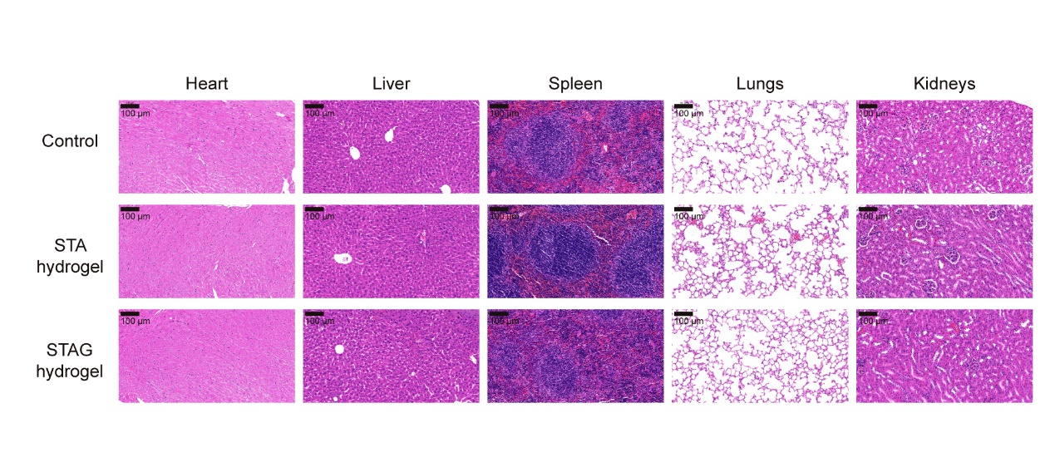
Supplementary Fig. S4 In vivo biosafety of STA and STAG hydrogels on mice The diabetic wound model mice were separated into 3 groups: the PBS-treated control group, the STA hydrogel-treated group, and the STAG hydrogel-treated group. The histopathological alterations in mice’ heart, liver, spleen, lung, and kidney were evaluated using H&E staining. Scale bar = 100 µm.

