Table S1. Primers used in this study.
primer | sequences (5'-3')
N20-ompT-F | atccggccatgagtcccaggGTTTTAGAGCTAGAAATAGCAAGTTAA
N20-ompT-R | cctgggactcatggccggatACTAGTATTATACCTAGGACTGAGCTAGC
N20-lon-F | tagaaccgatgtaagtacggGTTTTAGAGCTAGAAATAGCAAGTTAAA
N20-lon-R | ccgtacttacatcggttctaACTAGTATTATACCTAGGACTGAGCTAGC
N20-iclR-F | acgatgaggaacatgcgctgGTTTTAGAGCTAGAAATAGCAAGTTAAA
N20-iclR-R | cagcgcatgttcctcatcgtACTAGTATTATACCTAGGACTGAGCTAGC
N20-arcA-F | aggtacgtttaatcaccacgGTTTTAGAGCTAGAAATAGCAAGTTAAA
N20-arcA-R  tnaA-F-1  tnaA-R-1 | cgtggtgattaaacgtacctACTAGTATTATACCTAGGACTGAGCTAGC  cactcgcgcttatcgtgaagGTTTTAGAGCTAGAAATAGCAAGTTAAAAT  cttcacgataagcgcgagtgACTAGTATTATACCTAGGACTGAGCTA
H1-ompT-F | aagtggcaccgagtcggtgcAACTGCCCCTGATATTGAGTG
H1-ompT-R | cgattgaatggagaccttttCAACGTTAAATAGATTTTCTCCCC
H2-ompT-F | agaaaatctatttaacgttgAAAAGGTCTCCATTCAATCGTT
H2-ompT-R | ctctagagaattcaaaaaaaTTCGCCGGAAACATGTCG
H1-lon-F | aagtggcaccgagtcggtgcGGCGAAGACGTTGAAAACATCATT
H1-lon-R | gtgcattttgcgcgaggtcaAGAGCTCTCTCTTAGTTTAATTTCCG
H2-lon-F | ttaaactaagagagagctctTGACCTCGCGCAAAATG
H2-lon-R | ctctagagaattcaaaaaaaGTTTCAGCTCACGAGCGT
H1-iclR-F | aagtggcaccgagtcggtgcGCATTCCGCAATACGCG
H1-iclR-R | ataaatcagaggcgaaaaagGACAGTCTCCTTTTTCTGTATCGT
H2-iclR-F | tacagaaaaaggagactgtcCTTTTTCGCCTCTGATTTATACG
H2-iclR-R | ctctagagaattcaaaaaaaATTGTTTTTGGCTTTGCGC
H1-arcA-F | aagtggcaccgagtcggtgcTCGATCCCCTGCCCG
H1-arcA-R | tgttttccatgatctcttccCATTATTCCTTTAACACTTTTTCAAA
H2-arcA-F | aaagtgttaaaggaataatgGGAAGAGATCATGGAAAACAAAC
H2-arcA-R  H1-tnaA-F  H1-tnaA-R  H2-tnaA-F  H2-tnaA-R | ctctagagaattcaaaaaaaTAAGAAAATTACGGTTTTTCAGTGA  ccgagtcggtgctttttttgaattcCTTCGCTTCATTGTTAGCACTCC  gagccggaagcataaagtgtaaaTACATAATCCTTCATTTATTTTAATTACA  agtcggacttcgcgttcgcgtaaTTAAAACACTCAGAGTGGCTATAAGGA  ggagctgcacatgaactcgagGCTGGCAACGAAAATGGCA
pTargetF-ompT-F | ggcgacatgtttccggcgaatttttttgaattctctagagtcgaCC
pTargetF-ompT-R | actcaatatcaggggcagttGCACCGACTCGGTGCCA
pTargetF-lon-F | acgctcgtgagctgaaactttttttgaattctctagagtcga
pTargetF-lon-R | aatgatgttttcaacgtcttcgccGCACCGACTCGGTGCC
pTargetF-iclR-F | cgcgcaaagccaaaaacaattttttttgaattctctagagtcga
pTargetF-iclR-R | tgtcgcgtattgcggaatgcGCACCGACTCGGTGCC
pTargetF-arcA-F | gaaaaaccgtaattttcttatttttttgaattctctagagtcga
pTargetF-arcA-R | tttatcgggcaggggatcgagcaccgactcggtgccac
ompT-test-F | TTGCTGAACCGAGTTGATACAT
ompT-test-R | CAGCAAAACCGGTTTATATCAGTA
lon-test-F | TGACGCAACCACGCTGA
lon-test-R | CCTGCTCATCGCTGATACCC
iclR-test-F | CGACGGCGAGTTATTTATTGA
iclR-test-R | GCGTCGAGATCGTATTCACC
arcA-test-F | TCGTTTCCAGATTTCTTGGC
arcA-test-R  T7-pol-F  T7-pol-R  T7 RNAP-F  T7 RNAP-R  16sRNA-qp-F  16sRNA-qp-R  GFP-qp-F  GFP-qp-R | AGCGGTTTGTGAACTTCGC  taaaataaatgaaggattatgtaTTTACACTTTATGCTTCCGGCTC  cttatagccactctgagtgttttaaTTACGCGAACGCGAAGTCC  ATGAACACGATTAACATCGCTAAG  TTACGCGAACGCGAAGTC  Cgcaggcggtttgttaagtc  Cgagactcaagcttgccagt  AATCAAAGCTAACTTCAAAATTCG  CAGCAGTTACAAACTCAAGAAGGA

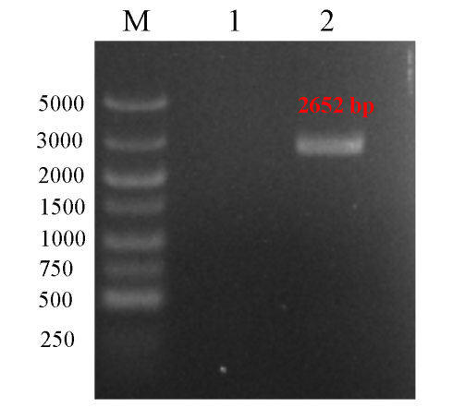
Figure S1. PCR gel electrophoresis of of T7 RNAP in EcN::T7 strain. Lane 1: EcN strain; Lane 2: EcN::T7 strain.
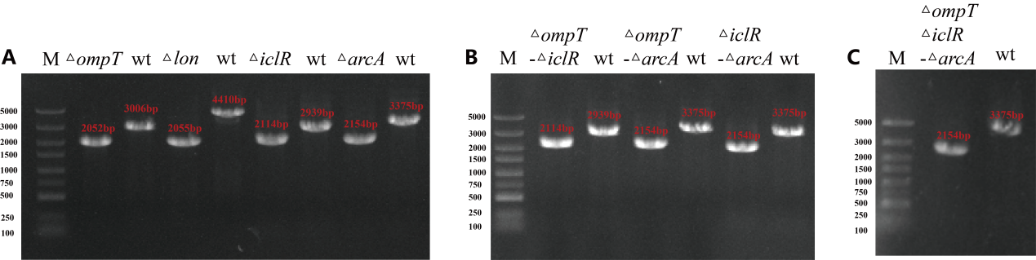
Figure S2. PCR gel electrophoresis of EcN engineering strain. (A) PCR of EcN::T7 single-knockout colonies. (B) PCR of EcN::T7 double-knockout colonies. (C) PCR of EcN::T7 triple-knockout colonies.

