Two-color spheroid model for determining the O₂-induced radiosensitivity of HNSCC
Danny Knobloch-Sperlich^{1*#}, Matthias Kappler^{2*}, Markus Glaß³, Antje Güttler¹, Marina Petrenko¹, Jonas Pyko⁴, Tony Gutschner⁴, Frank Tavasol², Dirk Vordermark¹ and Matthias Bache¹
¹ Department of Radiotherapy, Martin Luther University Halle-Wittenberg, Ernst-Grube-Straße 40, Halle (Saale), Germany
² Department of Oral and Maxillofacial Plastic Surgery, Martin Luther University Halle-Wittenberg, Ernst-Grube-Straße 40, Halle (Saale), Germany
³ Institute of Molecular Medicine, Section for Molecular Cell Biology, Faculty of Medicine, Martin Luther University Halle-Wittenberg, Halle (Saale), Germany
⁴ Institute of Molecular Medicine, Section for RNA Biology and Pathogenesis, Faculty of Medicine, Martin Luther University Halle-Wittenberg, Halle (Saale), Germany

* Both authors contributed equally to the manuscript.
# Correspondence: danny.knobloch-sperlich@uk-halle.de

Supplementary Figures
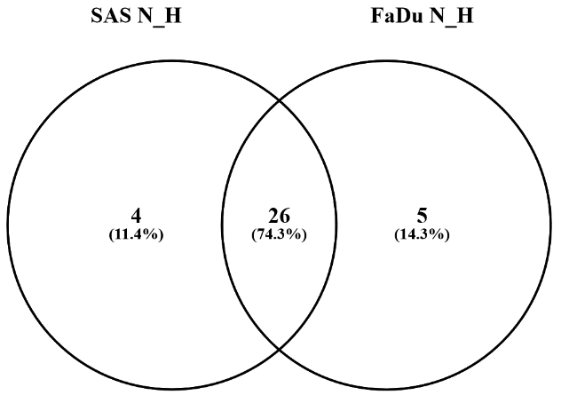
Supplemental Figure 1: VENN diagram of GSEA of mRNA-sequencing data considering all protein-coding genes. All HALLMARK Sets from SAS and FaDu cells were compared to each other [42].

A | B
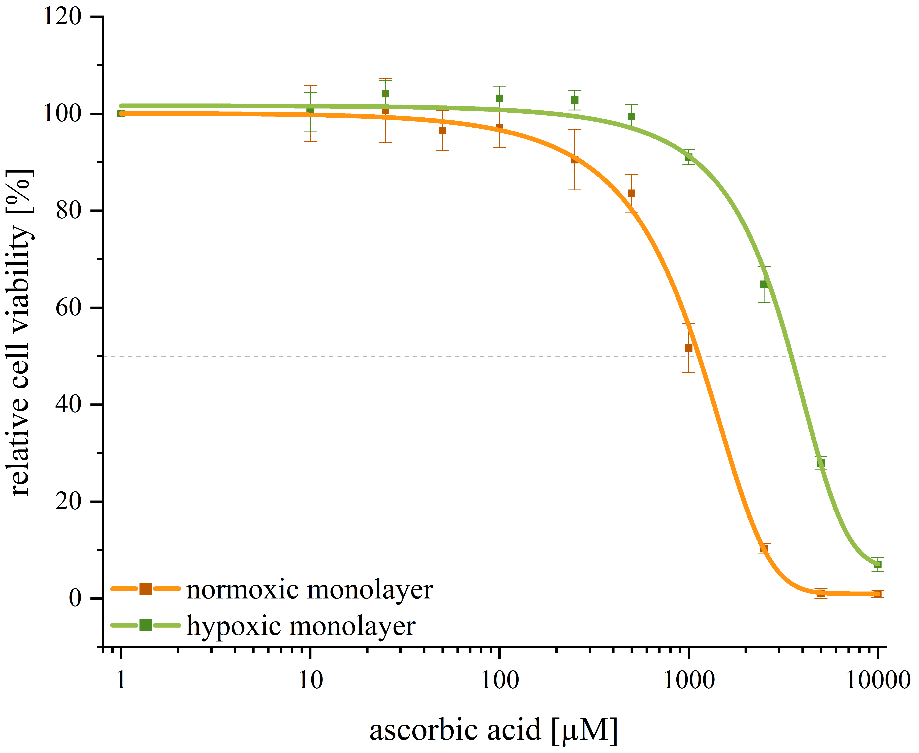 | 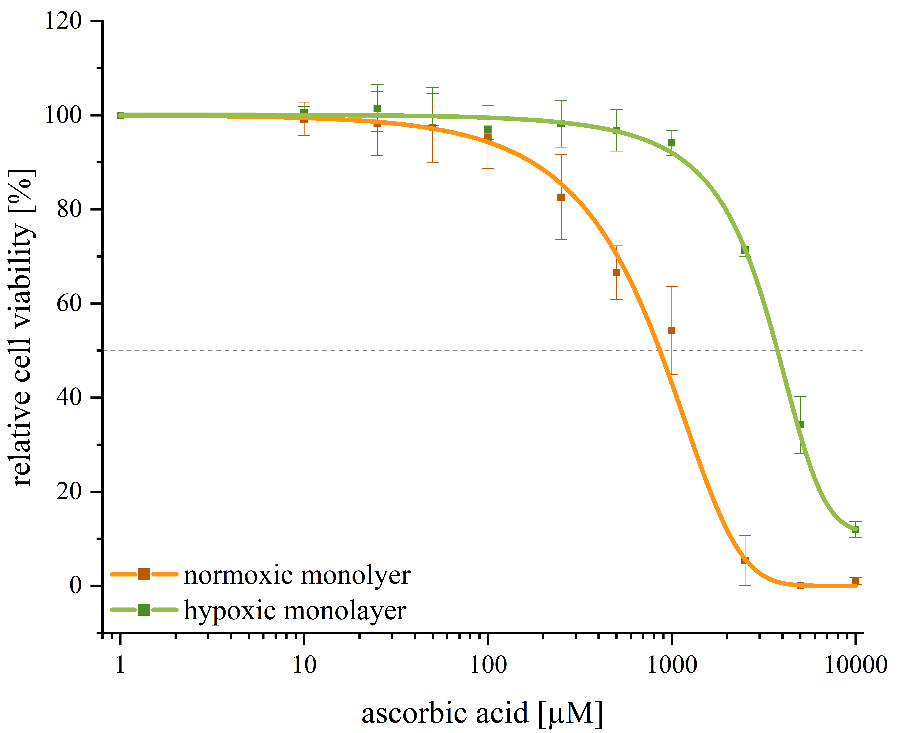
Supplemental Figure 2: 2D and 3D CellTiter-Glo Luminescent Viability Assay. Dose‒response curves of ascorbic acid treatment. The different HNSCC strains, SAS (A) and FaDu (B), were tested. The IC₅₀ values of three independent experiments were determined from the fitted dose‒response curves. The dotted lines indicate a relative cell survival rate of 50%.

A | 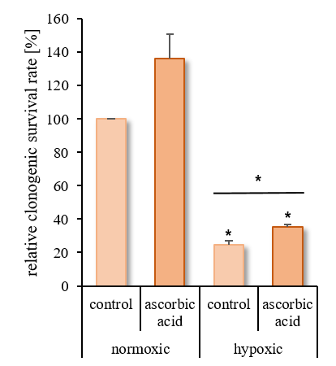 | B | 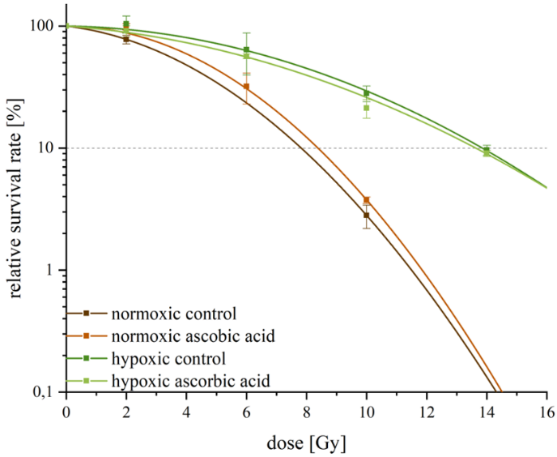
C | 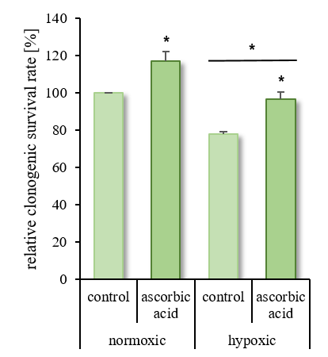 | D | 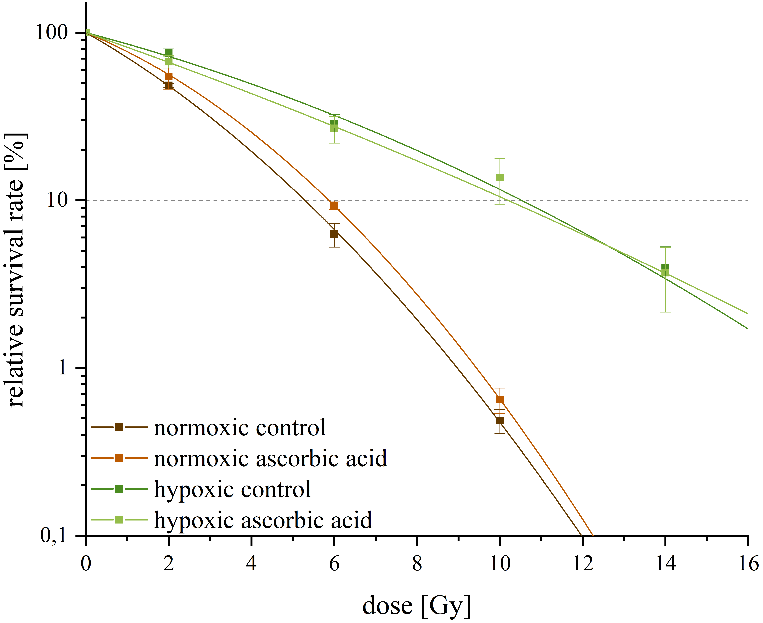
Supplemental Figure 3: Clonogenic survival and radiosensitivity of 2D HNSCC models with or without ascorbic acid under normoxic (21 % O₂) and hypoxic (0.1 % O₂) conditions. The diagrams show the clonogenic survival rate [%] without (A/C) or with (B/D) irradiation for each HNSCC line, SAS (A/B) and FaDu (C/D). The cells were irradiated with 2–14 Gy. The data represent the mean values (+/± SDs) of at least three independent experiments. The dotted lines indicate a relative cell survival rate of 10%. Significant p values are highlighted with asterisks (*p ≤ 0.05).
Supplemental Table 1: OER of monolayer cells and two-color spheroids relative to that of the normoxic or mCherry-labeled control. Significant p values are highlighted with asterisks (* p < 0.05; ** p < 0.01, *** p < 0.001).
2D | SAS |  | FaDu
 | normoxic | hypoxic | normoxic | hypoxic
control | 1.00 | 2.08 ± 0.15** | 1.00 | 2.09 ± 0.15**
ascorbic acid | 1.34 ± 0.04** | 2.04 ± 0.04* | 1.12 ± 0.03* | 2.05 ± 0.14**
3D | SAS |  | FaDu
 | mCherry | GFP | mCherry | GFP
control | 1.00 | 1.42 ± 0.08*** | 1.00 | 1.54 ± 0.04***
ascorbic acid | 1.21 ± 0.09** | 1.38 ± 0.08*** | 1.19± 0.10* | 1.58 ± 0.11***

