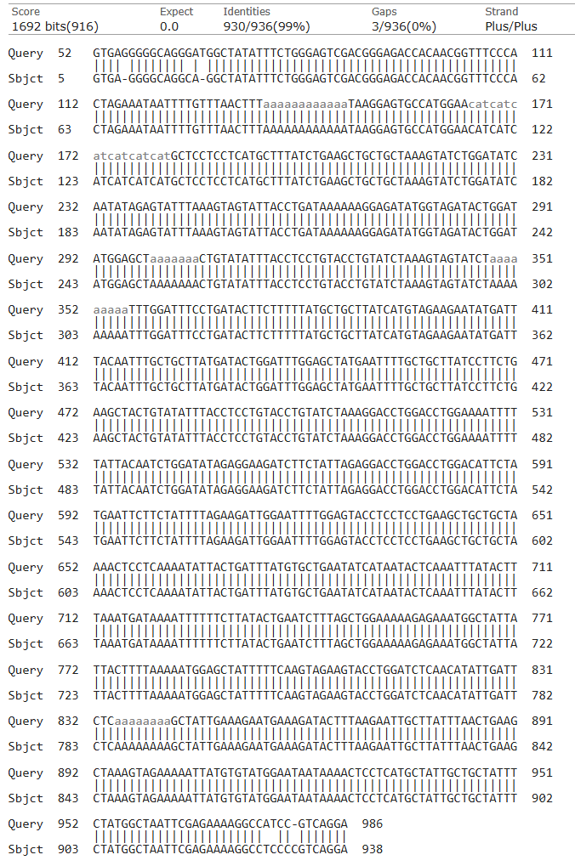
Figure S1. Alignment of the sequencing result (Query) of the integrated construct carrying the HPV_MEV sequence with the synthesized HPV_MEV sequence (Subject) using the BLASTn tool (NCBI).

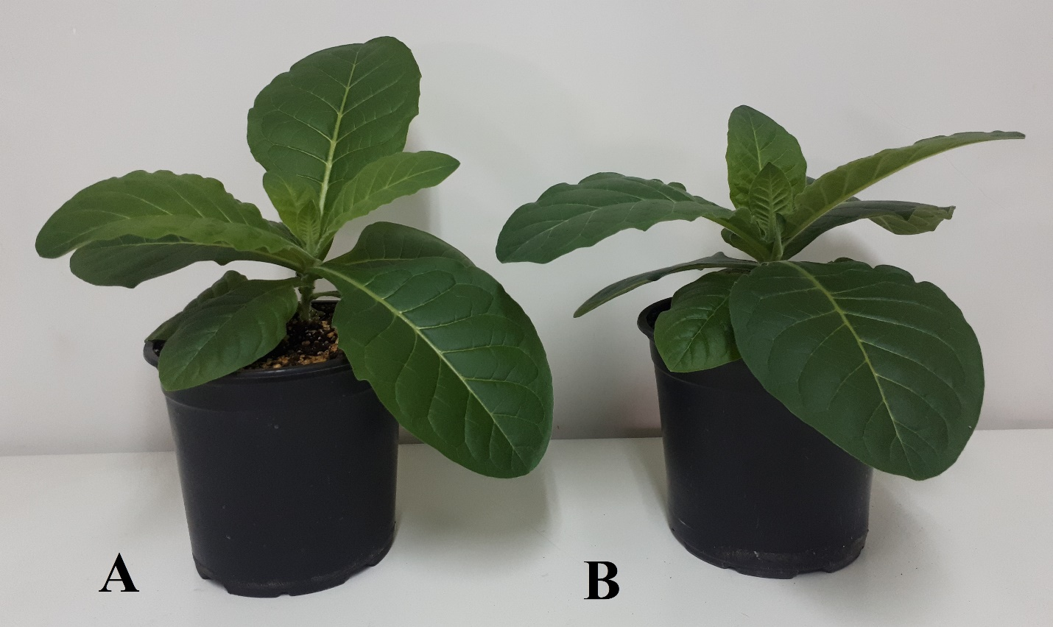
Figure S2. A) representative transplastomic plant expressing HPV_MEV, B) wild-type control plant. The transplastomic lines displayed normal growth and development with no discernible differences in compared with wild-type controls.

