CIRCLE-F/V: A Dual-Mode CRISPR/Cas13a Cascade Biosensor for Ultrasensitive and Visual Detection of Low-abundance EGFR Mutations
Tao ZHU¹, Zixuan WANG², Yingyu WU¹, Weiwei JIANG¹, Fei DENG³, Rong FANG^{2**}, Danting YANG^{1**}
(1 School of Public health, Health Science Center, Ningbo University, 818 Fenghua Road, Ningbo, Zhejiang Province, 315211, People’s Republic of China. 2 Ningbo Clinical Pathology Diagnosis Center, Ningbo, Zhejiang 315021, PR China. 3 ARC Centre of Excellence in Nanoscale Biophotonics, University of New South Wales, Sydney 2052.)
** The corresponding authors contributed equally. E-mail: rachelrainyr@163.com; yangdanting@nbu.edu.cn
Acknowledgements
This work was supported by the Natural Science Foundation of Zhejiang Provincial (grant number LY23H260002), Public Welfare Technology Application Research Project of Ningbo (grant number 2023S106), Ningbo Top Medical and Health Research Program (grant number 2023010211), and K.C.Wong Magna Fund in Ningbo University.

1. Selective elimination of wild-type alleles by MscI digestion
The restriction enzyme MscI was used as a front-end enrichment strategy to selectively elimiate wild-type (WT) EGFR alleles prior to downstream amplification. MscI recognizes the hexanucleotide motif 5’-TGGCCA-3’ and cleaves between the G and C nucleotides. The EGFR L858R mutation in NSCLC arises from a T→G substitution at nucleotide position 2573 (c.2573T>G), resulting in a sequence change from 5’-TGGCCA-3’ (WT) to 5’-GGGCCA-3’ (Mutant). While the WT allele retains the intact MscI recognition site and is therefore susceptible to cleavage, the single-nucleotide substitution disrupts the restriction motif in the mutant allele, rendering it resistant to digestion. Consequently, in heterogeneous DNA samples containing both WT and mutant alleles, MscI selectively cleaves WT templates while preserving L858R mutant sequences for downstream amplification [1-2]. This selective digestion step enhances mutation enrichment and improves the sensitivity of downstream CRISPR-Cas13a detection.
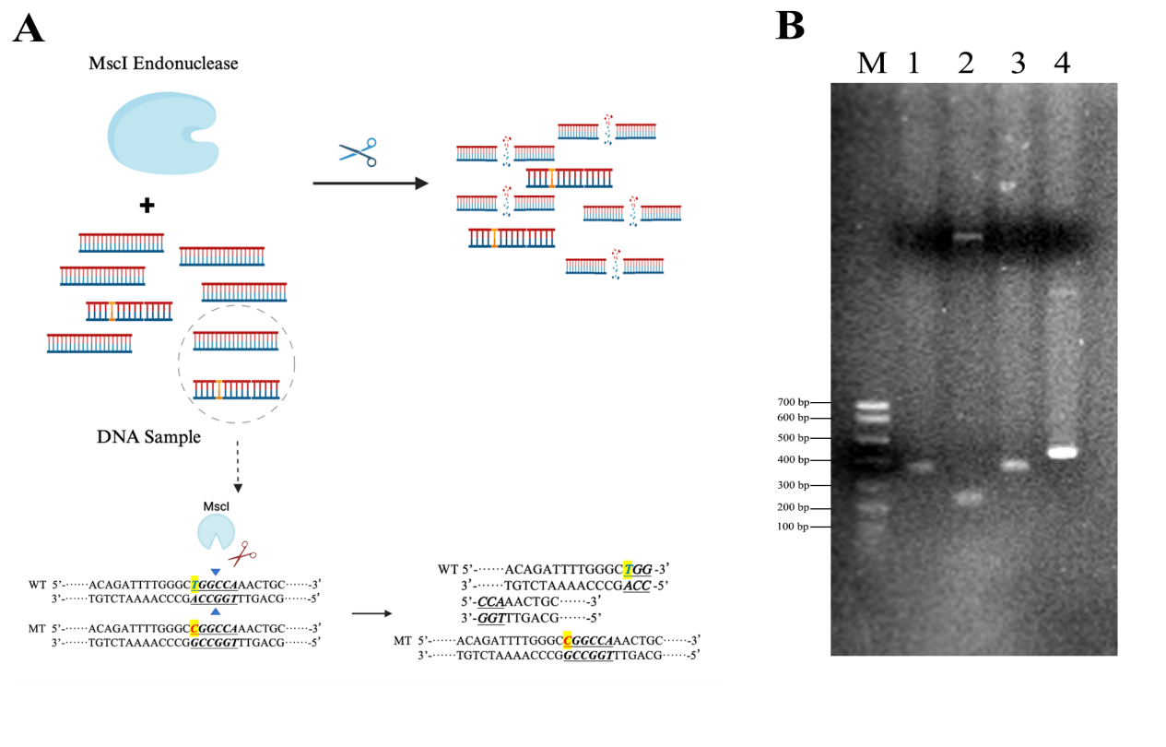
Figure S1. Schematic illustration of selective MscI digestion of the EGFR L858R wild-type allele and corresponding polyacrylamide gel electrophoresis (PAGE) analysis. (A) Diagram showing MscI-mediated digestion of the wild-type gene fragment. (B) PAGE analysis of L858R mutant and wild-type gene fragment following MscI digestion. M: DNA ladder; Lane 1: L858R Mutant DNA treated with MscI; Lane 2: Wild-type DNA treated with MscI; Lane 3: L858R Mutant DNA without MscI treatment; Lane 4: Wild-type DNA without MscI treatment.

Table S1 Nucleic acid sequence
Primers name | Sequences (5'-3')
L858R-PCR-F | TAATACGACTCACTATAGGGTGCAGAGCTTCTTCCCATGA
L858R-PCR-R | CTGACCTAAAGCCACCTCCT
G12C-PCR-F | TAATACGACTCACTATAGGGCTACGCCACAAGCTCCAACTACCACAAG
G12C-PCR-R | GTTGGAGCTTGTGGCGTAGGCAAGAGT
EGFR 746~750-PCR-F | TAATACGACTCACTATAGGGGCACCATCTCACAATTGCCA
EGFR 746~750-PCR-R | GACATGAGAAAAGGTGGGCC
KRAS G12-PCR-F | TAATACGACTCACTATAGGGGGCCTGCTGAAAATGACTGA
KRAS G12-PCR-R | TGTATCAAAGAATGGTCCTGCAC
ALKRAA-F3-PCR-F | TAATACGACTCACTATAGGGGAGGTGTATGAAGGCCAGGT
ALKRAA-R3-PCR-R | AGGGATTGCAGGCTCACC
crRNA1 | GAUUUAGACUACCCCAAAAACGAAGGGGACUAAAACCAGCAGUUUGGCCCGCCCAAAAUCUGUG
crRNA2 | GAUUUAGACUACCCCAAAAACGAAGGGGACUAAAACCAGUUUGGCCCGCCCAAAAUCUGUGAUC
crRNA3 | GAUUUAGACUACCCCAAAAACGAAGGGGACUAAAACUUUGGCCCGCCCAAAAUCUGUGAUCUUG
crRNA4 | GAUUUAGACUACCCCAAAAACGAAGGGGACUAAAACGGCCCGCCCAAAAUCUGUGAUCUUGACA
crRNA5 | GAUUUAGACUACCCCAAAAACGAAGGGGACUAAAACACCCAGCAGUUUGGCCCGCCCAAAAUCU
crRNA-C | GAUUUAGACUACCCCAAAAACGAAGGGGACUAAAACGGCUUCUGGACUACCUAUGC
Fluorescence probe | FAM-UUUUU-BHQ1
Dumbbell triggered cascade amplificationsingle-stranded probe | p-UUGCAUAGGUAGUCCAGAAGCCUUUCUGGACUACCUAUGC

Table S2 Comparison of T-line and C-line band intensities in different VAFs samples
Group | Test line gray value（T line） | Control line gray value（C line） | T/C
a | 142280 | 145127 | 0.980382699
b | 134983 | 120998 | 1.115580423
c | 139907 | 105281 | 1.328891253
d | 146489 | 107986 | 1.356555479
e | 146151 | 99099 | 1.474797929
f | 143015 | 94574 | 1.512202085
g | 63409 | 97287 | 0.65177259

2. Clinical Sample Collection and NGS Analysis
  - Methods
    - Clinical sample sources and ethical approval
This study included 11 formalin-fixed, paraffin-embedded (FFPE) tissues tumor tissue samples obtained from patients diagnosed with lung or colorectal cancer at the Ningbo Clinical Pathological Diagnosis Center. The study protocol was reviewed and approved by the Ethics Committee of the Ningbo Clinical Pathological Diagnosis Center (Approval No. NBPC-NBSZ202501). As the study involved retrospective analysis of archived specimens without additional patient intervention and posed minimal risk, all samples and associated data were anonymized. The Ethics Committee has approved the waiver of patient informed consent.
    - DNA Extraction and Sequencing Library Preparation
Genomic DNA was extracted from FFPE tissues using a commercial DNA extraction kit (Kaishuo Biotechnology Co., Ltd., RC1102) according to the manufacturer's instructions. DNA concentration and quality were assessed using a Qubit 4.0 fluorometer (Thermo Fisher Scientific, Q33226) and agarose gel electrophoresis. Sequencing libraries were constructed using a targeted capture kit covering the full coding sequence (CDS) of the EGFR gene.
    - Sequencing and Bioinformatic Analysis
Libraries were sequenced using paired-end 150 bp reads on the Illumina NextSeq 550DX platform. After adapter trimming and quality filtering, reads were aligned to the human reference genome (hg19/GRCh37). Variant analysis was performed using the Genesis automated analysis platform. The minimum average sequencing depth was set to 500×, and target region coverage was ≥99%. Variants were considered reportable if they met both of the following criteria: ≥20 mutant reads, and VAF ≥1%. The analytical LOD for the NGS assay was 1% VAF.
  - NGS Results of Clinical Tumor Tissue Samples
NGS analysis identified EGFR mutations in 7 of the 13 clinical tumor tissue samples. The detected VAFs ranging from 2.31% to 10.85%, with average sequencing depths between 2646× and 4694×. Target region coverage exceeded 99% for all samples. No EGFR mutations were detected in mutation-negative samples, and VAF values at all candidate sites were below the detection threshold (LOD = 1%). Detailed information for each sample, including sequencing platform, mutant reads, total reads, and calculated VAF, is provided in Table S3.”

Table S3. Summary of NGS Results for Clinical Tumor Tissue Samples Used in EGFR Genotyping Validation
Sample ID | Patient ID | Sample Type | Sequencing Platform | Target Region | Total Read Count | Mutant Read Count | Variant Type | VAF（%） | Interpretation
S01 | 8162 | FFPE Tumor Tissue | Illumina NextSeq 550DX | EGFR Exons 18–21 | 4398 | 477 | EGFR L858R | 10.85 | Positive
S02 | 7755 | FFPE Tumor Tissue | Illumina NextSeq 550DX | EGFR Exons 18–21 | 4760 | 503 | EGFR L858R | 10.57 | Positive
S03 | 7488 | FFPE Tumor Tissue | Illumina NextSeq 550DX | EGFR Exons 18–21 | 4076 | 384 | EGFR L858R | 9.42 | Positive
S04 | 6926 | FFPE Tumor Tissue | Illumina NextSeq 550DX | EGFR Exons 18–21 | 3330 | 330 | EGFR L858R | 9.91 | Positive
S05 | 7970 | FFPE Tumor Tissue | Illumina NextSeq 550DX | EGFR Exons 18–21 | 5166 | 253 | EGFR L858R | 4.9 | Positive
S06 | 7821 | FFPE Tumor Tissue | Illumina NextSeq 550DX | EGFR Exons 18–21 | 4694 | 281 | EGFR L858R | 5.99 | Positive
S07 | 7882 | FFPE Tumor Tissue | Illumina NextSeq 550DX | EGFR Exons 18–21 | 4330 | 100 | EGFR L858R | 2.31 | Positive
S08 | 6311 | FFPE Tumor Tissue | Illumina NextSeq 550DX | EGFR Exons 18–21 | 5831 | 2 | Same Genomic Position | - | Negative
S09 | 4051 | FFPE Tumor Tissue | Illumina NextSeq 550DX | EGFR Exons 18–21 | 2896 | 0 | Same Genomic Position | - | Negative
S10 | 6263 | FFPE Tumor Tissue | Illumina NextSeq 550DX | EGFR Exons 18–21 | 5935 | 0 | Same Genomic Position | - | Negative
S11 | 6290 | FFPE Tumor Tissue | Illumina NextSeq 550DX | EGFR Exons 18–21 | 5821 | 1 | Same Genomic Position | - | Negative

Table S4 Comparison of band intensity between T and C lines in clinical samples
Group | Test line gray value（T line） | Control line gray value（C line） | T/C
1 | 10128 | 13796 | 0.734125834
2 | 9661 | 13368 | 0.72269599
3 | 10009 | 13038 | 0.767679092
4 | 9783 | 13676 | 0.715340743
5 | 8789 | 13023 | 0.674882899
6 | 10216 | 12415 | 0.822875554
7 | 8879 | 12682 | 0.700126163
8 | 7664 | 11988 | 0.639305973
9 | 6633 | 11114 | 0.596814828
10 | 6897 | 10891 | 0.633275181
11 | 6758 | 11037 | 0.612304068
mut | 12212 | 6057 | 2.016179627
wt | 6235 | 10774 | 0.578708001

[1] Xu S, Wang X, Wu C, et al. MscI restriction enzyme cooperating recombinase-aided isothermal amplification for the ultrasensitive and rapid detection of low-abundance EGFR mutations on microfluidic chip. Biosens Bioelectron, 2024, 247, 115925. https://doi.org/10.1016/j.bios.2023.115925
[2] Zhang H, Gao H, Mu W, et al. Electrochemical-Fluorescent Bimodal Biosensor Based on Dual CRISPR-Cas12a Multiple Cascade Amplification for ctDNA Detection. Anal Chem, 2024, 14028-14035. https://doi.org/10.1021/acs.analchem.4c03012
Ethics and Consent to Participate declarations:
This study was approved by the Ethics Committee of Ningbo Clinical Pathology Diagnosis Center （approval number: NBPC-NBSZ202501）. As the study is an observational anonymous study, the signed informed consent was waived.
Acknowledgements
This work was supported by the Natural Science Foundation of Zhejiang Provincial (grant number LY23H260002), Public Welfare Technology Application Research Project of Ningbo (grant number 2023S106), Ningbo Top Medical and Health Research Program (grant number 2023010211), and K.C.Wong Magna Fund in Ningbo University.
CRediT authorship contribution statement
Tao ZHU: Data curation, Investigation, Methodology, Software, Writing - original draft. Zixuan WANG: Resources, Data curation. Yingyu WU: Software, Supervision. WeiWei JIANG: Supervision. Fei DENG: Methodology, Supervision. Rong FANG: Writing - Review and Editing, Resources, Funding acquisition. Danting YANG: Conceptualization, Methodology, Writing - Review and Editing, Supervision, Funding acquisition.
Author statement
The authors declare that they have seen and approved the final version of the manuscript being submitted, and warrant that the article is the authors' original work, hasn't received prior publication and isn't under consideration for publication elsewhere. Permission has been received to use any material in the manuscript such as figures etc. which isn't original content.
Declaration of Competing Interest
The authors declare that they have no known competing financial interests or personal relationships that could have appeared to influence the work reported in this paper.

