Supplementary information
Proof-of-concept engineering of Escherichia coli expressing a bee-derived cytochrome P450 monooxygenase for thiamethoxam detoxification

Table S1 List of CYP450s with evidence upon thiamethoxam exposure
Name | Source | Remark | Reference
CYP6DZ7 | Bemisia tabaci | Increased expression upon exposure | (1)
CYP6DZ4 | Bemisia tabaci | Increased expression upon exposure | (1)
CYP6CM1 | Bemisia tabaci | Increased expression upon exposure | (1,2)
CYP6ER1 | Nilaparvata lugens | Overexpressed gene in resistant strains | (3)
CYP4G68 | Bemisia tabaci | Increased expression upon exposure | (1,4)
CYP6CX1 | Bemisia tabaci | Increase expression upon exposure | (2)
CYP6DB3 | Bemisia tabaci | Increased expression upon exposure and increased sensitivity when KO | (5)
CYP6DV5 | Bemisia tabaci | Increased expression upon exposure and increased sensitivity when KO | (6)
CYP9Z140 | Leptinotarsa decemlineata | Increased expression upon exposure and increased sensitivity when KO | (7)
CYP9AY1 | Leptinotarsa decemlineata | Increased expression upon exposure and increased sensitivity when KO | (7)
CYP6CY14 | Aphis gossypii Glover | Increased expression upon exposure and increased sensitivity when KO | (8)
CYP9Q1 | Apis mellisfera | Significantly induced at 0.1 ng/bee thiamethoxam | (9)

Table S2 List of webtools used in this work
Tool | Website
Amino acid sequence | https://www.ncbi.nlm.nih.gov/
Protein modelling | https://colab.research.google.com/github/sokrypton/ColabFold/blob/  main/AlphaFold2.ipynb
Protein structure validation | https://www.ebi.ac.uk/thornton-srv/software/PROCHECK/
Chemical structure | https://pubchem.ncbi.nlm.nih.gov/
Transmembrane protein prediction | https://dtu.biolib.com/DeepTMHMM

Figure S1 Transmembrane protein prediction of a bee CYP450 using DeepTMHMM tool (A) The predicted topology (B) The sequence analysis
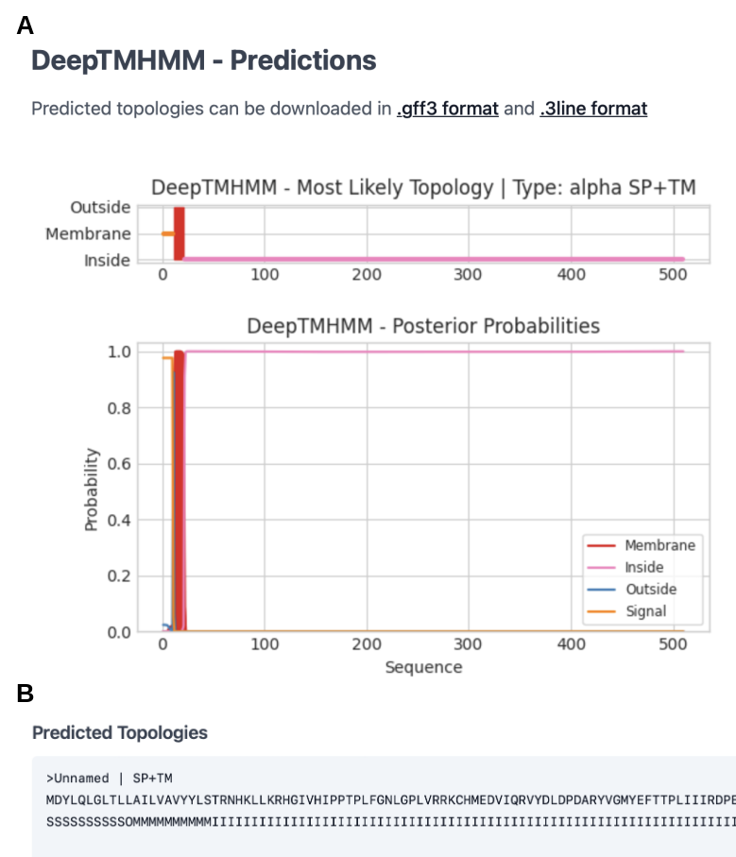

Figure S2 Full blotting images of Western Blot analysis of the CYP450 expression in E. coli (A) Replicate 1 (B) Replicate 2 (C) Replicate 3
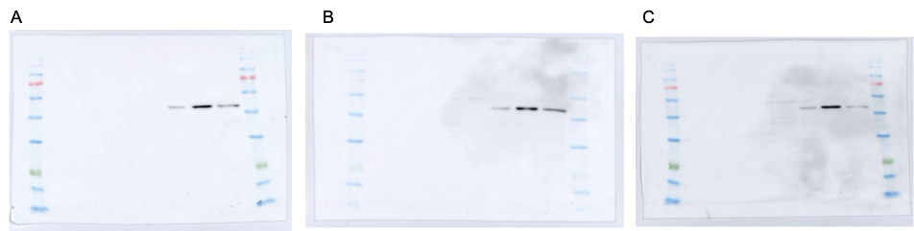

Figure S3 LC-MS analysis of cultivation supernatant from E. coli BL21(DE3) expressing CYP450 in the presence of thiamethoxam

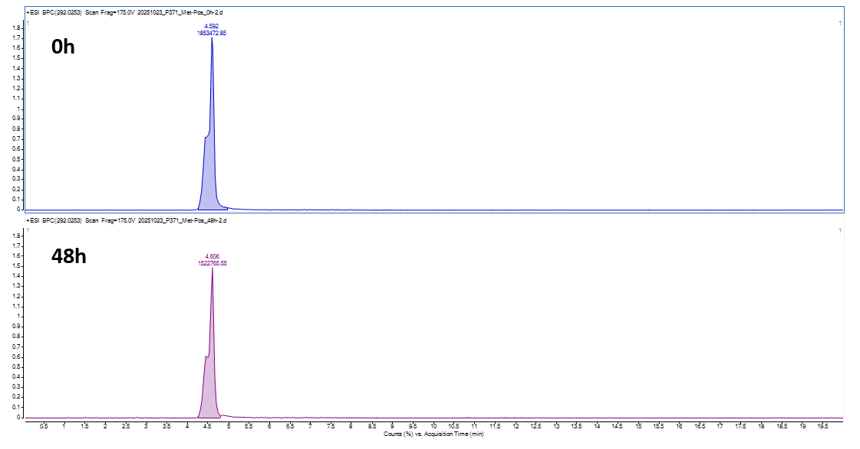

Reference
1. Wang Q, Wang MN, Jia ZZ, Ahmat T, Xie LJ, Jiang WH. Resistance to neonicotinoid insecticides and expression changes of eighteen cytochrome P450 genes in field populations of Bemisia tabaci from Xinjiang, China. Entomol Res. 2020;50(4):205–11.
2. Yang N, Xie W, Yang X, Wang S, Wu Q, Li R, et al. Transcriptomic and Proteomic Responses of Sweetpotato Whitefly, Bemisia tabaci, to Thiamethoxam. PLoS One. 2013;8(5).
3. Sun X, Gong Y, Ali S, Hou M. Mechanisms of resistance to thiamethoxam and dinotefuran compared to imidacloprid in the brown planthopper: Roles of cytochrome P450 monooxygenase and a P450 gene CYP6ER1. Pestic Biochem Physiol [Internet]. 2018;150(February):17–26. Available from: https://doi.org/10.1016/j.pestbp.2018.06.014
4. Liang J, Yang J, Hu J, Fu B, Gong P, Du T, et al. Cytpchrome P450 CYP4G68 Is Associated with Imidacloprid and Thiamethoxam Resistance in Field Whitefly, Bemisia tabaci (Hemiptera: Gennadius). Agric. 2022;12(4).
5. Wei X, Hu J, Yang J, Yin C, Du T, Huang M, et al. Cytochrome P450 CYP6DB3 was involved in thiamethoxam and imidacloprid resistance in Bemisia tabaci Q (Hemiptera: Aleyrodidae). Pestic Biochem Physiol. 2023;194(May).
6. Fengshan Y, Cheng YIN, Jing Y, Xuegao WEI, Tianhua DU, Xin Y, et al. Cloning and expression profiles of cytochrome P450 CYP6DV5 in Bemisia tabaci and its role in resistance of B. tabaci to thiamethoxam. Chinese J Pestic Sci http//www.nyxxb.cn. 2021;23(1):83–9.
7. Wang Y, Tian Y, Zhou D, Fang J, Cao J, Shi C, et al. Expression and Functional Analysis of Two Cytochrome P450 Monooxygenase Genes and a UDP-Glycosyltransferase Gene Linked with Thiamethoxam Resistance in Colorado Potato Beetle Cytochrome P450 Monooxygenase Genes and A UDP-Glycosyltransferase Gene Linked wi. 2024;
8. Wu Y, Xu H, Pan Y, Gao X, Xi J, Zhang J, et al. Expression profile changes of cytochrome P450 genes between thiamethoxam susceptible and resistant strains of Aphis gossypii Glover. Pestic Biochem Physiol [Internet]. 2018;149(February):1–7. Available from: https://doi.org/10.1016/j.pestbp.2018.05.007
9. Christen V, Grossar D, Charrière JD, Eyer M, Jeker L. Correlation Between Increased Homing Flight Duration and Altered Gene Expression in the Brain of Honey Bee Foragers After Acute Oral Exposure to Thiacloprid and Thiamethoxam. Front Insect Sci. 2021;1(December):1–15.

