Supplementary data
MelC tyrosinase dependent enzymatic synthesis of functional melanins from phenolic monomers
Nimya Krishnanª, Koijam Monica Deviª, Chan-Seo Yeoª , Kwon-Young Choi^{a,b,c*}
ªDepartment of Molecular Science and Technology, Ajou University, Suwon, Gyeonggi-do, Republic of Korea
^{b}College of Advanced Bio-Convergence Engineering, Ajou University, Suwon, Gyeonggi-do, Republic of Korea
^{c}Advanced Bio-Convergence Research Institute, Ajou University, Suwon, Gyeonggi-do, Republic of Korea
Correspondence
Kwon-Young Choi
ªDepartment of Molecular Science and Technology, Ajou University, Suwon, Gyeonggi-do,
Republic of Korea
^{b}College of Advanced Bio-Convergence Engineering, Ajou University, Suwon, Gyeonggi-do, Re
public of Korea
Tel.: +82-31-219-1825
E-mail: kychoi@ajou.ac.kr
Supplementary Figure legends
Figure S1. Melanin production using screened phenolic substrates
Figure S2. MALDI-TOF MS OF (A)Eumelanin, (B)PC-melanin, (C) 4HPA-melanin
Figure S3. EPR Analysis of (A) Eumelanin, (B) PC-melanin, (C) 4HPA-melanin

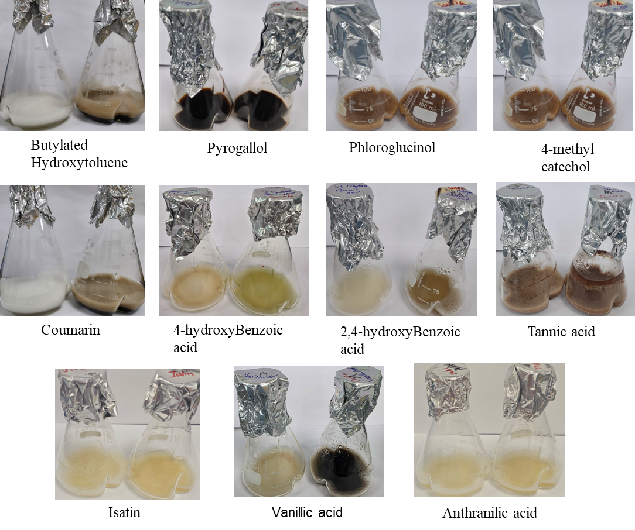
Figure S1. Melanin production using screened phenolic substrates
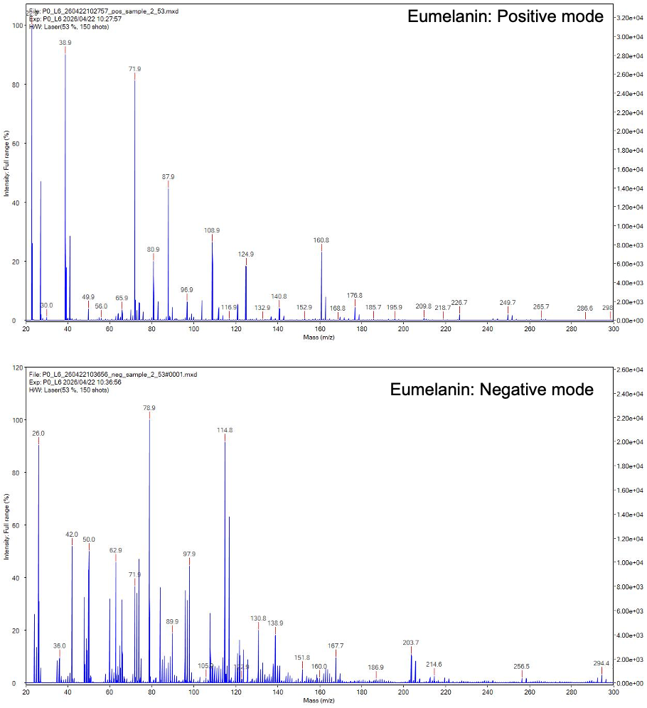
A)

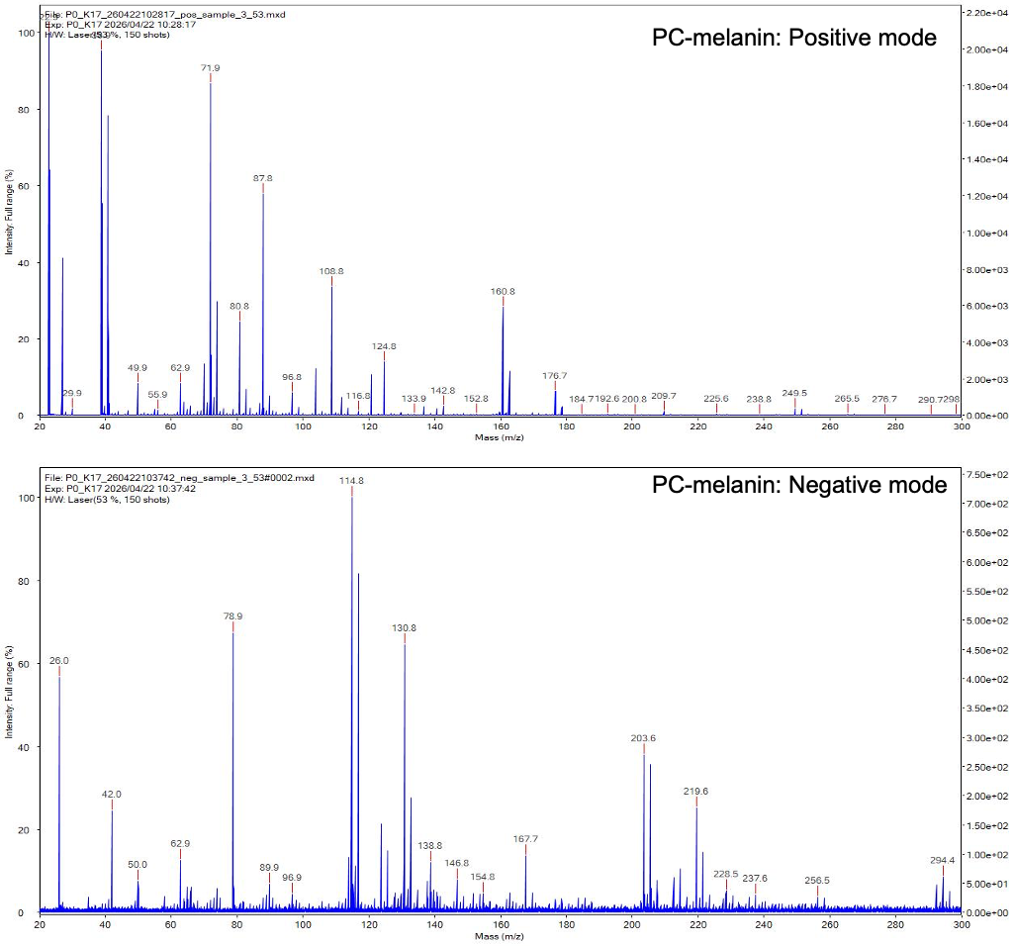
B)
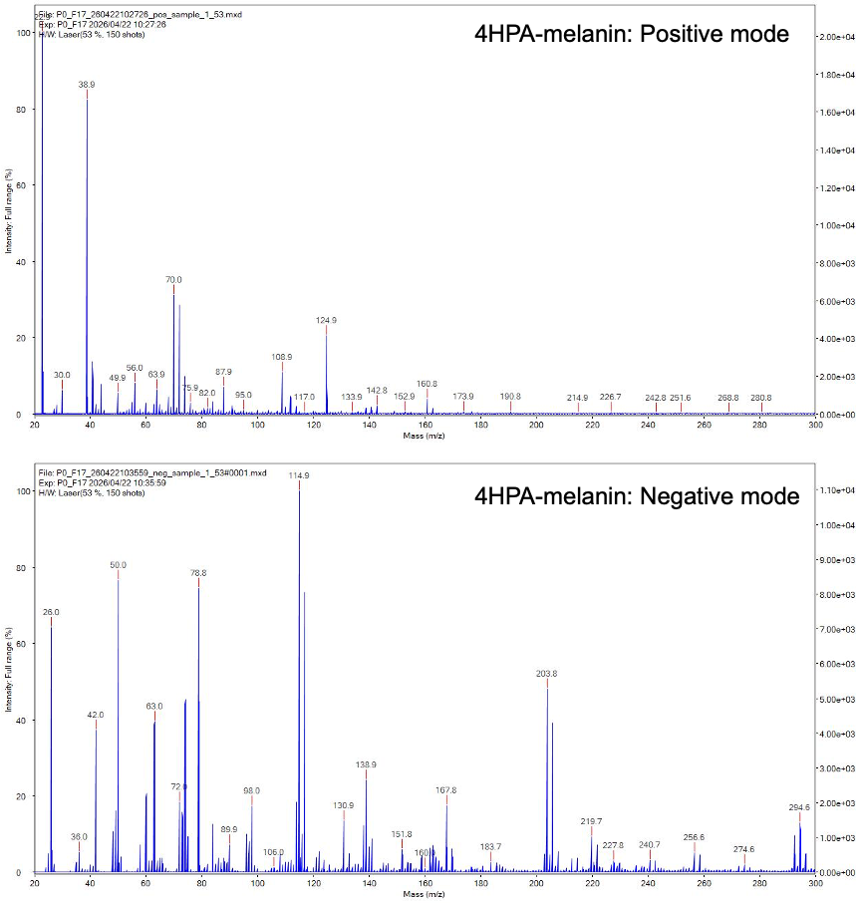
C)
Figure S2. MALDI-TOF MS OF (A)Eumelanin, (B)PC-melanin, (C) 4HPA-melanin

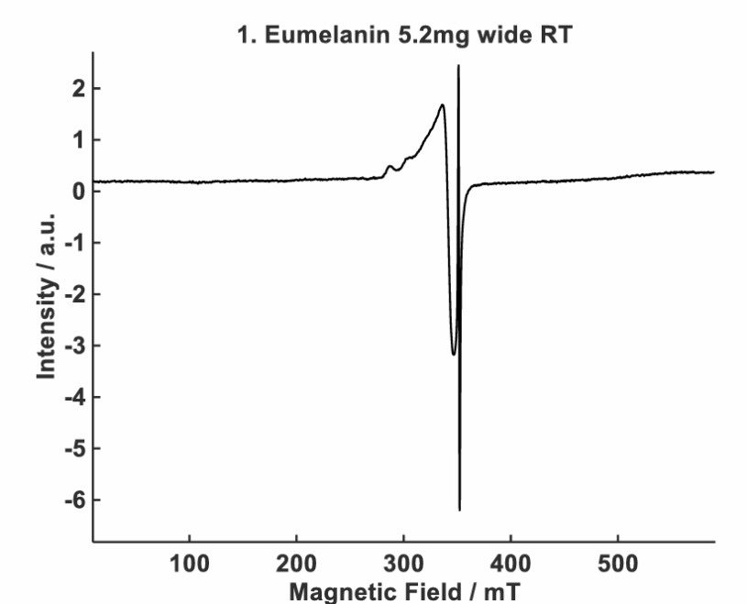
A)
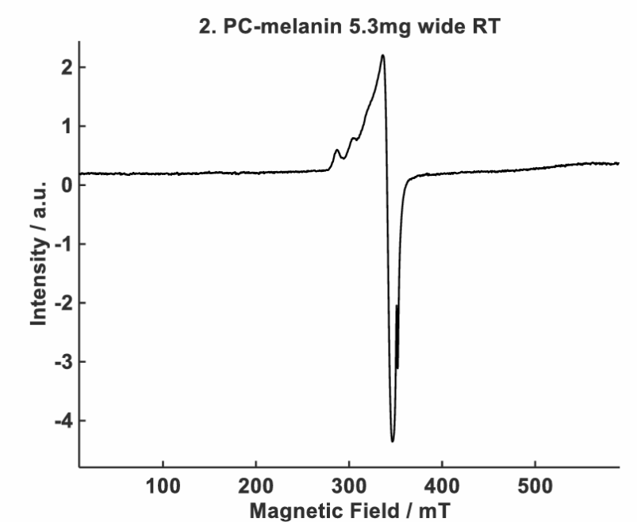
B)
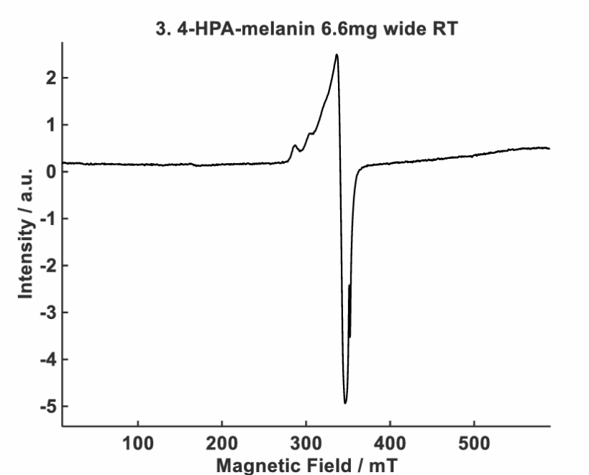
C)
Figure S3. EPR Analysis of (A) Eumelanin, (B) PC-melanin, (C) 4HPA-melanin

