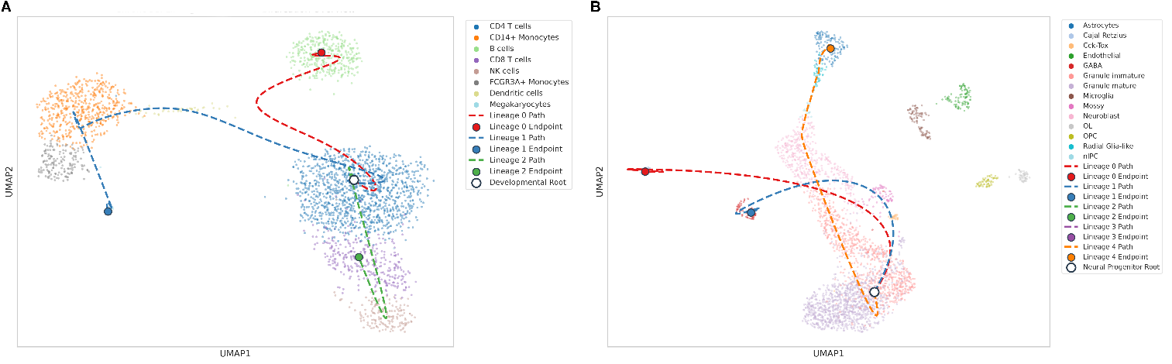
Supplementary Figure 2. Topographical Trajectory Tree and Lineage Alignment Overlays. Complete mathematical projection mapping calculated continuous branches of development directly onto the baseline single-cell embedding coordinates for both physiological validation validation models: (A) Human Peripheral Blood Mononuclear Cells (PBMCs) and (B) Mouse Dentate Gyrus Neurogenesis. Background single cells are colored by their discrete curated identity to preserve absolute population context and lineage composition layout. The prominent white highlighted circles identify the computed developmental origin vertices (Developmental Root nodes), serving as the foundational synchronization centers from which cell-fate vectors branch. Fine dashed tracks (color-coded by lineage; 3 paths for human, 5 paths for mouse) illustrate the continuous trajectories optimized via fate-weighted cubic B-spline interpolation, effectively plotting the precise chronological flow of differentiating cell states toward their terminal destinations (solid circular endpoints). This unified mapping explicitly highlights key developmental bifurcation points directly within their respective tissue-specific microenvironments.

