SUPPLEMENTAL INFORMATION

ADDITIONAL MODELING DETAILS
For full training details and code, refer to the Github repository: https://github.com/cavalab/ecg-survival-benchmark .

Model Training
Models train for up to 200 epochs, stopping early if their performance on the validation set does not improve for 20 consecutive epochs. As in past work (1), we use the AdamW optimizer, start with a 1e-3 learning rate, and scale the learning rate by 0.1x if validation performance does not improve for 10 consecutive epochs to a minimum of 1e-8 (2). We trained models with five random, where the seed also determines the training/validation data split. Models were trained on a cluster that unpredictably provided a A40, A100, L40 or Nvidia Quadro GPU. Data was loaded to RAM, requesting 100GB for Code-15, 150GB for BCH, and 300GB for MIMIC-IV. Training was done on batches of 512 shuffled data samples with 256 loaded onto a GPU concurrently. Per configuration, we evaluate the model with minimum validation loss.
Additionally, DeepSurv requires GPU batches to contain positive events for loss calculations; for these models, GPU-batches that contained no positive-event samples had their last sample replaced with a positive-event sample chosen randomly from the training set.
Code-15 models averaged 4.5 hours to train and achieved maximum validation performance by 30 epochs. MIMIC-IV models took 7.2 hours and achieved maximum validation performance by 12 epochs. Training times depend on GPU, with faster GPUs taking 600s/epoch and slower ones up to 2200s/epoch. GPU batch sizes were based on slower GPUs.
When Test and Train dataset lead orders did not match (Code15 differs from MIMICIV), the Test dataset was reordered to match the Train dataset’s format.

Survival Modeling
Concordance is measured with the Antolini concordance (3) implementation from PyCox with score contributions weighted by Kaplan-Meier estimates.
For Classifier-Cox models, the classifier’s output is a binary label predicting mortality by a time horizon. We treat this output as a generic biomarker and fit a Cox regression on validation data with the scikit-survival package (4). This fitting step includes the full[time-to-event, event] information, so these regressions still model mortality over the full dataset’s timespan.
The LH, MTLR, and DeepHit models fit survival functions at discrete time points. We used 100 uniformly distributed time points between ‘0’ and the maximum time-to-event in each validation dataset. DeepSurv models and Cox regressions can be queried at any time of interest.
Before measuring model performance, to maintain consistency, we sample the Cox and DeepSurv survival functions at the same 100 time points used to fit the LH, MTLR, and DeepHit models. This sampling greatly simplifies concordance calculations, which would otherwise need survival estimates for every ECG at every unique time-to-event.
When measuring model performance at the 1,2,5,10-year marks, we use the temporally closest sampled survival function value (e.g. MIMIC-IV data has a maximum follow-up time of almost 13 years; one-year AUROC is measured from the survival function at the 1.008-year mark).
See Therneau et al. (5) for a thorough guide to survival modeling.

Data labeling
When training classifiers, we label events as a ‘1’ when patients experience an event by horizon h, else 0, even if censored. This same labeling applied to AUROC/AUPRC measures. While there is no standard approach for integrating censored patients with time-dependent measures (6), past work tends to exclude patients that have not reached the horizon-of-interest (7,8), which inflates the event rate (consider a 1000-person study with an annual 90 percent drop-out rate and 1 percent event rate: after two years there are ~5 events and ~10 controls). We chose to mark censored patients as non-events for classifier labels and AUPRC to avoid inflating the event rate. This is reasonable for Code-15, where drop-out rates exceed event rates, and for MIMIC-IV and BCH, where censoring implies lower patient risk. While such choices cannot be avoided in measuring AUROC/AUPRC, Deep-Survival methods inherently avoid them.

REFERENCES

1. Hughes JW, Tooley J, Torres Soto J, Ostropolets A, Poterucha T, Christensen MK, et al. A deep learning-based electrocardiogram risk score for long term cardiovascular death and disease. Npj Digit Med. 2023 Sept;6(1):169.
2. Ribeiro AH, Ribeiro MH, Paixão GMM, Oliveira DM, Gomes PR, Canazart JA, et al. Automatic diagnosis of the 12-lead ECG using a deep neural network. Nat Commun. 2020 Apr;11(1):1760.
3. Antolini L, Boracchi P, Biganzoli E. A time-dependent discrimination index for survival data. Stat Med. 2005 Dec;24(24):3927–44.
4. Pölsterl S, Navab N, Katouzian A. Fast training of support vector machines for survival analysis. In: Appice A, Rodrigues PP, Santos Costa V, Gama J, Jorge A, Soares C, editors. Machine learning and knowledge discovery in databases. 2015. p. 243–59. (Lecture notes in computer science).
5. Therneau TM. A package for survival analysis in R [Internet]. 2024. Available from: https://CRAN.R-project.org/package=survival
6. Kamarudin AN, Cox T, Kolamunnage-Dona R. Time-dependent ROC curve analysis in medical research: current methods and applications. BMC Med Res Methodol. 2017 Apr;17:53.
7. Raghunath S, Ulloa Cerna AE, Jing L, vanMaanen DP, Stough J, Hartzel DN, et al. Prediction of mortality from 12-lead electrocardiogram voltage data using a deep neural network. Nat Med. 2020 June;26(6):886–91.
8. Sun W, Kalmady SV, Sepehrvand N, Salimi A, Nademi Y, Bainey K, et al. Towards artificial intelligence-based learning health system for population-level mortality prediction using electrocardiograms. Npj Digit Med. 2023 Feb;6(1):21.

SUPPLEMENTAL FIGURES
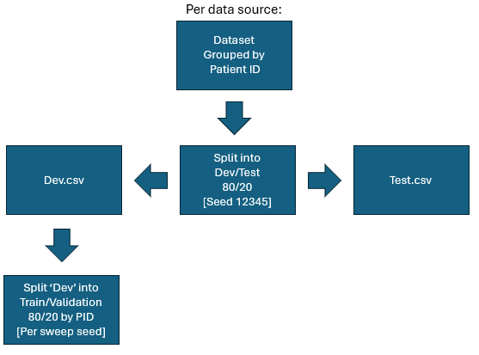

Figure S1. Data split flowchart. Per data source, data is grouped by PID. These are then split 80/20 into dev/test, with labels saved into separate .csv files. When a model is built with a random seed, that seed determines the dev set split into training/validation subsets. Prior to model runs, train/test/validation PIDs are checked for intersection. Patient ID Non-intersection was also confirmed manually for each dataset (BCH, Code15, MIMICIV, All) and swept model seed.

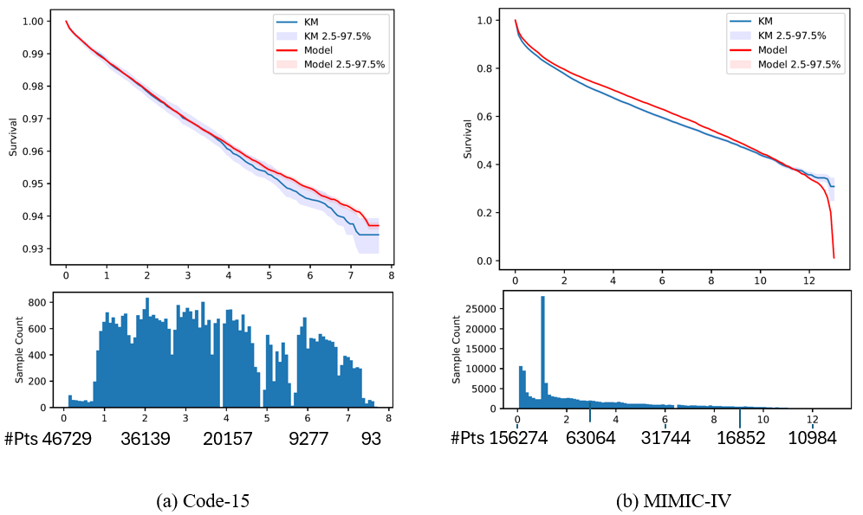
Figure S2. Kaplan-Meier and population-averaged survival functions for the highest-concordance-index non-demographic Code-15 (left) and MIMIC-IV (right) models. Bottom subplots show sample count at each time point. Plots show median and 95% confidence intervals per time point (100) over 100 bootstraps. Red values indicate the number of patients under observation. Note differences in scale.

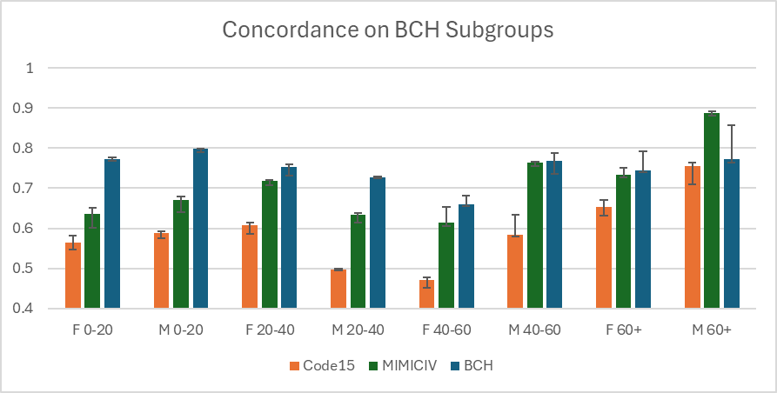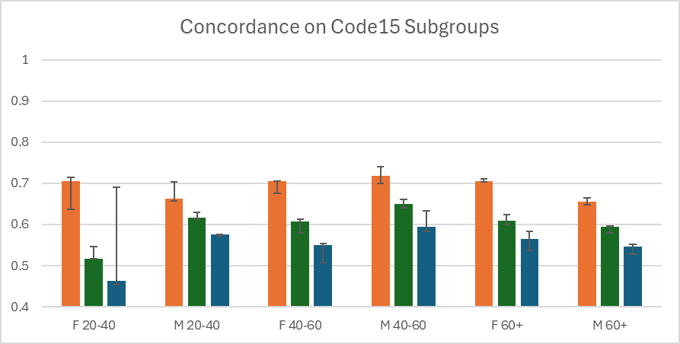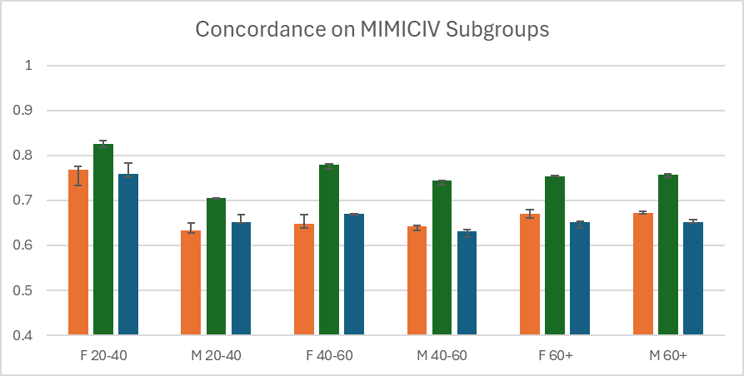

Figure S3. Median (IQR) model concordance per patient subgroup, evaluating best model with demographics. Bar color indicates the training site used. Code-15 and MIMIC-IV Age 0-20 are not shown due to low event count; for reference, see Table S2. Models perform best on their own test set, except possibly MIMIC-IV on BCH M60+.

SUPPLEMENTAL TABLES

Table S1: Median concordance (Inter-quartile range) for locally trained models, grouped by dataset, survival approach, model inputs, neural network architecture. Values in bold denote the best performing models per dataset.
 |  |  | Survival Approach
Dataset | Model Inputs | Model Architecture | Cla-01 | Cla-02 | Cla-05 | Cla-10 | DeepHit | DeepSurv | LH | MTLR
BCH | y ~ Age + Sex | Feedforward Net | 0.60 (0.60-0.61) | 0.61 (0.61-0.61) | 0.62 (0.62-0.63) | 0.64 (0.64-0.64) | 0.65 (0.65-0.66) | 0.65 (0.65-0.65) | 0.63 (0.63-0.64) | 0.64 (0.63-0.64)
BCH | y ~ Age + Sex | XGB | 0.56 (0.56-0.57) | 0.59 (0.58-0.59) | 0.62 (0.61-0.62) | 0.63 (0.63-0.63) | - | - | - | -
BCH | y ~ ECG | ECGTransForm | 0.68 (0.67-0.68) | 0.67 (0.67-0.67) | 0.64 (0.59-0.67) | 0.66 (0.60-0.68) | 0.30 (0.11-0.46) | 0.76 (0.67-0.77) | 0.09 (0.01-0.11) | 0.00 (0.00-0.00)
BCH | y ~ ECG | InceptionTime | 0.77 (0.76-0.77) | 0.77 (0.77-0.77) | 0.78 (0.77-0.78) | 0.78 (0.78-0.79) | 0.78 (0.77-0.78) | 0.79 (0.78-0.79) | 0.78 (0.76-0.78) | 0.78 (0.78-0.79)
BCH | y ~ ECG | ResNet | 0.78 (0.77-0.78) | 0.76 (0.76-0.77) | 0.78 (0.78-0.79) | 0.78 (0.78-0.78) | 0.77 (0.77-0.79) | 0.79 (0.77-0.79) | 0.78 (0.78-0.79) | 0.79 (0.79-0.80)
BCH | y ~ ECG + Age + Sex | ECGTransForm | 0.59 (0.59-0.60) | 0.62 (0.61-0.62) | 0.63 (0.63-0.63) | 0.65 (0.64-0.74) | 0.66 (0.64-0.66) | 0.65 (0.65-0.65) | 0.64 (0.64-0.65) | 0.62 (0.61-0.63)
BCH | y ~ ECG + Age + Sex | InceptionTime | 0.78 (0.77-0.78) | 0.78 (0.78-0.79) | 0.79 (0.79-0.79) | 0.79 (0.79-0.79) | 0.79 (0.79-0.80) | 0.79 (0.79-0.80) | 0.79 (0.79-0.79) | 0.79 (0.79-0.79)
BCH | y ~ ECG + Age + Sex | ResNet | 0.78 (0.77-0.78) | 0.77 (0.76-0.78) | 0.78 (0.76-0.78) | 0.78 (0.77-0.80) | 0.79 (0.79-0.80) | 0.79 (0.79-0.80) | 0.78 (0.77-0.78) | 0.79 (0.79-0.79)
Code-15 | y ~ Age + Sex | Feedforward Net | 0.79 (0.79-0.79) | 0.79 (0.79-0.79) | 0.79 (0.79-0.79) | 0.79 (0.79-0.79) | 0.79 (0.79-0.79) | 0.79 (0.79-0.79) | 0.79 (0.79-0.79) | 0.79 (0.79-0.79)
Code-15 | y ~ Age + Sex | XGB | 0.78 (0.78-0.78) | 0.79 (0.79-0.79) | 0.79 (0.79-0.79) | 0.79 (0.79-0.79) | - | - | - | -
Code-15 | y ~ ECG | ECGTransForm | 0.25 (0.13-0.38) | 0.54 (0.54-0.54) | 0.50 (0.50-0.50) | - | 0.00 (0.00-0.01) | 0.37 (0.24-0.68) | 0.05 (0.01-0.19) | 0.00 (0.00-0.00)
Code-15 | y ~ ECG | InceptionTime | 0.75 (0.75-0.75) | 0.77 (0.77-0.78) | 0.78 (0.78-0.78) | 0.78 (0.78-0.78) | 0.79 (0.78-0.79) | 0.79 (0.78-0.79) | 0.78 (0.78-0.79) | 0.79 (0.79-0.79)
Code-15 | y ~ ECG | ResNet | 0.77 (0.76-0.77) | 0.77 (0.77-0.78) | 0.76 (0.75-0.79) | 0.77 (0.77-0.78) | 0.80 (0.80-0.80) | 0.80 (0.80-0.80) | 0.80 (0.79-0.80) | 0.80 (0.79-0.80)
Code-15 | y ~ ECG + Age + Sex | ECGTransForm | 0.79 (0.79-0.79) | 0.79 (0.79-0.79) | 0.79 (0.79-0.79) | 0.79 (0.79-0.79) | 0.79 (0.79-0.79) | 0.79 (0.79-0.79) | 0.79 (0.79-0.79) | 0.79 (0.79-0.79)
Code-15 | y ~ ECG + Age + Sex | InceptionTime | 0.81 (0.81-0.81) | 0.81 (0.81-0.82) | 0.82 (0.82-0.82) | 0.82 (0.82-0.82) | 0.82 (0.82-0.82) | 0.82 (0.82-0.82) | 0.82 (0.82-0.82) | 0.82 (0.82-0.82)
Code-15 | y ~ ECG + Age + Sex | ResNet | 0.80 (0.80-0.81) | 0.81 (0.81-0.82) | 0.81 (0.81-0.82) | 0.82 (0.81-0.82) | 0.82 (0.81-0.82) | 0.82 (0.81-0.83) | 0.81 (0.81-0.82) | 0.83 (0.82-0.83)
MIMIC-IV | y ~ Age + Sex | Feedforward Net | 0.66 (0.66-0.66) | 0.66 (0.66-0.66) | 0.66 (0.66-0.66) | 0.66 (0.66-0.66) | 0.65 (0.65-0.65) | 0.65 (0.65-0.65) | 0.65 (0.65-0.65) | 0.65 (0.65-0.65)
MIMIC-IV | y ~ Age + Sex | XGB | 0.65 (0.65-0.66) | 0.66 (0.65-0.66) | 0.66 (0.66-0.66) | 0.66 (0.66-0.66) | - | - | - | -
MIMIC-IV | y ~ ECG | ECGTransForm | 0.00 (0.00-0.32) | 0.23 (0.01-0.47) | 0.00 (0.00-0.00) | 0.00 (0.00-0.27) | 0.00 (0.00-0.00) | - | 0.73 (0.00-0.73) | 0.00 (0.00-0.00)
MIMIC-IV | y ~ ECG | InceptionTime | 0.76 (0.76-0.76) | 0.76 (0.76-0.76) | 0.76 (0.76-0.76) | 0.75 (0.75-0.75) | 0.77 (0.76-0.77) | 0.76 (0.76-0.76) | 0.76 (0.76-0.76) | 0.76 (0.76-0.76)
MIMIC-IV | y ~ ECG | ResNet | 0.77 (0.76-0.77) | 0.76 (0.76-0.76) | 0.76 (0.76-0.76) | 0.75 (0.75-0.76) | 0.77 (0.77-0.77) | 0.75 (0.75-0.76) | 0.77 (0.76-0.77) | 0.77 (0.76-0.77)
MIMIC-IV | y ~ ECG + Age + Sex | ECGTransForm | 0.66 (0.66-0.66) | 0.66 (0.66-0.67) | 0.66 (0.66-0.66) | 0.66 (0.66-0.66) | 0.65 (0.65-0.65) | - | 0.65 (0.65-0.65) | 0.65 (0.65-0.65)
MIMIC-IV | y ~ ECG + Age + Sex | Feedforward Net | 0.71 (0.68-0.71) | 0.72 (0.69-0.72) | 0.69 (0.69-0.69) | 0.69 (0.68-0.70) | 0.68 (0.65-0.72) | - | 0.71 (0.69-0.72) | 0.64 (0.64-0.64)
MIMIC-IV | y ~ ECG + Age + Sex | InceptionTime | 0.77 (0.77-0.78) | 0.77 (0.77-0.77) | 0.77 (0.77-0.77) | 0.76 (0.76-0.76) | 0.78 (0.78-0.78) | 0.77 (0.77-0.77) | 0.78 (0.78-0.78) | 0.77 (0.77-0.78)
MIMIC-IV | y ~ ECG + Age + Sex | ResNet | 0.78 (0.77-0.78) | 0.77 (0.77-0.77) | 0.77 (0.77-0.77) | 0.76 (0.76-0.76) | 0.78 (0.77-0.78) | 0.77 (0.76-0.77) | 0.78 (0.77-0.78) | 0.78 (0.77-0.78)
MIMIC-IV | y ~ ECG + Age + Sex | XGB | 0.73 (0.73-0.73) | 0.73 (0.73-0.73) | 0.73 (0.73-0.73) | 0.72 (0.72-0.72) | - | - | - | -
MIMIC-IV | y ~ ECG + Age + Sex + Machine Measures | ECGTransForm | 0.72 (0.72-0.72) | 0.72 (0.69-0.72) | 0.69 (0.69-0.71) | 0.69 (0.69-0.69) | 0.72 (0.72-0.72) | - | 0.72 (0.72-0.72) | 0.68 (0.67-0.69)
MIMIC-IV | y ~ ECG + Age + Sex + Machine Measures | InceptionTime | 0.77 (0.77-0.77) | 0.77 (0.77-0.77) | 0.76 (0.76-0.76) | 0.75 (0.75-0.76) | 0.77 (0.77-0.77) | - | 0.77 (0.77-0.77) | 0.77 (0.77-0.77)
MIMIC-IV | y ~ ECG + Age + Sex + Machine Measures | ResNet | 0.77 (0.77-0.77) | 0.77 (0.77-0.77) | 0.76 (0.76-0.77) | 0.76 (0.76-0.76) | 0.77 (0.77-0.77) | - | 0.77 (0.77-0.77) | 0.77 (0.76-0.77)

Table S2: (Top) Mortality events and rates by age and sex in each test cohort. (Bottom) Mortality events and rates associated with a mortality by year h.

 |  | Mortality Events (%) by Age and Sex, Test Set
Age | Sex | BCH | MIMIC-IV | Code-15
[0,20) | F | 727 (4.2) | 5 (1.4) | 2 (0.2)
[0,20) | M | 994 (4.9) | 2 (0.7) | 3 (0.3)
[20,40) | F | 307 (10.2) | 441 (5.3) | 29 (0.3)
[20,40) | M | 463 (16.1) | 542 (8.4) | 37 (0.7)
[40,60) | F | 110 (15.5) | 2699 (13.7) | 96 (1.1)
[40,60) | M | 127 (19.2) | 4290 (19.8) | 130 (2.5)
<60 | F | 1144 (5.4) | 3145 (11.1) | 127 (0.7)
<60 | M | 1584 (6.6) | 4834 (17) | 170 (1.5)
60+ | F | 59 (28.8) | 16773 (34.2) | 651 (6.6)
60+ | M | 20 (17.2) | 18705 (37.1) | 740 (9.8)
All | F | 1203 (5.6) | 19918 (25.7) | 778 (2.8)
All | M | 1604 (6.7) | 23539 (29.8) | 910 (4.8)
All | Both | 2807 (6.2) | 43457 (27.8) | 1688 (3.6)
 |  | Mortality Events (%) by year
Year |  | BCH | MIMIC-IV | Code-15
1 |  | 1638 (0.9) | 116185 (14.8) | 2804 (1.2)
2 |  | 2730 (1.5) | 144446 (18.4) | 4907 (2.1)
5 |  | 5641 (3.1) | 192334 (24.5) | 7944 (3.4)
10 |  | 8735 (4.8) | 295173 (37.6) | 8411 (3.6)
Max |  | 12556 (6.9) | 218240 (27.8) | 8411 (3.6)

Table S3. Deep-Survival outperform Classifier-Cox Models. Unpaired Mann-Whitney U Test; per row: 4 survival models, 2 CNNS, 5 random seeds. Grey rows indicate matching Test, Train datasets.

 |  |  | ECG Only |  | ECG + Age/Sex
 |  |  | Concordance |  | Concordance
Train | Test | Type | Median (IQR) | P | Median (IQR) | P
Code-15 | Code15 | CC | 0.774 (0.756, 0.780) | 4.65E-10 | 0.815 (0.808, 0.818) | 2.33E-04
Code-15 | Code15 | DS | 0.791 (0.785, 0.799) | 4.65E-10 | 0.819 (0.817, 0.821) | 2.33E-04
Code-15 | BCH | CC | 0.710 (0.702, 0.723) | 4.68E-01 | 0.734 (0.725, 0.742) | 3.81E-02
Code-15 | BCH | DS | 0.709 (0.654, 0.731) | 4.68E-01 | 0.724 (0.638, 0.743) | 3.81E-02
Code-15 | MIMICIV | CC | 0.662 (0.650, 0.678) | 4.09E-02 | 0.689 (0.682, 0.701) | 6.13E-01
Code-15 | MIMICIV | DS | 0.673 (0.659, 0.689) | 4.09E-02 | 0.691 (0.684, 0.700) | 6.13E-01
MIMIC-IV | Code15 | CC | 0.642 (0.632, 0.654) | 4.33E-01 | 0.684 (0.676, 0.697) | 1.25E-02
MIMIC-IV | Code15 | DS | 0.645 (0.632, 0.660) | 4.33E-01 | 0.698 (0.683, 0.723) | 1.25E-02
MIMIC-IV | BCH | CC | 0.699 (0.674, 0.713) | 6.13E-05 | 0.738 (0.711, 0.757) | 1.95E-06
MIMIC-IV | BCH | DS | 0.666 (0.656, 0.684) | 6.13E-05 | 0.690 (0.653, 0.718) | 1.95E-06
MIMIC-IV | MIMICIV | CC | 0.761 (0.756, 0.763) | 6.56E-03 | 0.771 (0.763, 0.775) | 1.98E-03
MIMIC-IV | MIMICIV | DS | 0.764 (0.761, 0.766) | 6.56E-03 | 0.775 (0.770, 0.777) | 1.98E-03
BCH | Code15 | CC | 0.576 (0.556, 0.586) | 1.42E-01 | 0.616 (0.603, 0.635) | 3.31E-02
BCH | Code15 | DS | 0.564 (0.548, 0.581) | 1.42E-01 | 0.653 (0.599, 0.678) | 3.31E-02
BCH | BCH | CC | 0.775 (0.769, 0.782) | 2.07E-02 | 0.782 (0.774, 0.789) | 2.56E-05
BCH | BCH | DS | 0.783 (0.773, 0.789) | 2.07E-02 | 0.792 (0.788, 0.795) | 2.56E-05
BCH | MIMICIV | CC | 0.602 (0.568, 0.627) | 7.84E-01 | 0.661 (0.634, 0.673) | 2.48E-03
BCH | MIMICIV | DS | 0.595 (0.568, 0.620) | 7.84E-01 | 0.677 (0.663, 0.683) | 2.48E-03

Table S4: Statistical Comparison of ResNet vs InceptionTime models across datasets and choice of covariates. ResNet models generally outperform InceptionTime models. IT – InceptionTime. RN – ResNet. Wilcoxon Paired Test; per row: 8 survival models, 2 CNNs, 5 random seeds. Grey rows indicate matching Test, Train datasets.

 |  |  | Covariates
 |  |  | y ~ ECG |  | y ~ ECG + Age + Sex
Train | Test | Architecture | Median Concordance (IQR) | P | Median Concordance (IQR) | P
Code15 | Code15 | IT | 0.782 (0.777 - 0.786) | 1.25E-02 | 0.817 (0.815 - 0.820) | 4.52E-01
Code15 | Code15 | RN | 0.787 (0.773 - 0.800) | 1.25E-02 | 0.817 (0.810 - 0.821) | 4.52E-01
Code15 | BCH | IT | 0.702 (0.692 - 0.709) | 2.29E-09 | 0.732 (0.720 - 0.736) | 5.10E-01
Code15 | BCH | RN | 0.725 (0.711 - 0.736) | 2.29E-09 | 0.732 (0.694 - 0.747) | 5.10E-01
Code15 | MIMIC-IV | IT | 0.656 (0.646 - 0.662) | 1.81E-08 | 0.686 (0.682 - 0.690) | 9.60E-06
Code15 | MIMIC-IV | RN | 0.687 (0.676 - 0.693) | 1.81E-08 | 0.701 (0.690 - 0.711) | 9.60E-06
MIMIC-IV | Code15 | IT | 0.641 (0.632 - 0.651) | 1.32E-01 | 0.695 (0.680 - 0.710) | 2.32E-01
MIMIC-IV | Code15 | RN | 0.646 (0.632 - 0.661) | 1.32E-01 | 0.686 (0.673 - 0.701) | 2.32E-01
MIMIC-IV | BCH | IT | 0.667 (0.658 - 0.682) | 1.20E-08 | 0.702 (0.672 - 0.727) | 2.51E-03
MIMIC-IV | BCH | RN | 0.700 (0.678 - 0.714) | 1.20E-08 | 0.732 (0.696 - 0.755) | 2.51E-03
MIMIC-IV | MIMIC-IV | IT | 0.761 (0.758 - 0.764) | 2.00E-02 | 0.773 (0.768 - 0.777) | 9.00E-01
MIMIC-IV | MIMIC-IV | RN | 0.763 (0.760 - 0.766) | 2.00E-02 | 0.772 (0.764 - 0.777) | 9.00E-01
BCH | Code15 | IT | 0.564 (0.551 - 0.578) | 3.07E-01 | 0.635 (0.613 - 0.662) | 4.87E-03
BCH | Code15 | RN | 0.577 (0.551 - 0.589) | 3.07E-01 | 0.614 (0.588 - 0.635) | 4.87E-03
BCH | BCH | IT | 0.778 (0.770 - 0.784) | 8.17E-02 | 0.790 (0.784 - 0.794) | 1.17E-03
BCH | BCH | RN | 0.781 (0.773 - 0.790) | 8.17E-02 | 0.783 (0.773 - 0.792) | 1.17E-03
BCH | MIMIC-IV | IT | 0.571 (0.559 - 0.588) | 1.58E-08 | 0.660 (0.635 - 0.668) | 5.85E-05
BCH | MIMIC-IV | RN | 0.624 (0.612 - 0.637) | 1.58E-08 | 0.679 (0.664 - 0.688) | 5.85E-05

Table S5: Including demographics improves concordance. Wilcoxon Paired Test; per row: 8 survival models, 2 CNNs, 5 Random seeds. Grey rows indicate matching Test, Train datasets.
 |  |  |  | ECG Only |  | ECG + Age + Sex
 |  |  |  | Concordance |  | Concordance
Train |  | Test |  | Median (IQR) |  | Median (IQR) |  | P
Code-15 |  | Code15 |  | 0.783 (0.773 - 0.793) |  | 0.817 (0.813 - 0.820) |  | 7.85E-15
Code-15 |  | BCH |  | 0.709 (0.697 - 0.726) |  | 0.732 (0.712 - 0.743) |  | 4.75E-07
Code-15 |  | MIMICIV |  | 0.669 (0.654 - 0.687) |  | 0.690 (0.683 - 0.700) |  | 3.96E-13
MIMIC-IV |  | Code15 |  | 0.644 (0.632 - 0.656) |  | 0.690 (0.677 - 0.704) |  | 1.17E-13
MIMIC-IV |  | BCH |  | 0.680 (0.664 - 0.705) |  | 0.715 (0.685 - 0.744) |  | 2.00E-08
MIMIC-IV |  | MIMICIV |  | 0.762 (0.758 - 0.765) |  | 0.772 (0.767 - 0.777) |  | 1.43E-14
BCH |  | Code15 |  | 0.569 (0.551 - 0.585) |  | 0.625 (0.602 - 0.657) |  | 7.58E-14
BCH |  | BCH |  | 0.779 (0.771 - 0.787) |  | 0.789 (0.780 - 0.794) |  | 2.05E-04
BCH |  | MIMICIV |  | 0.598 (0.568 - 0.626) |  | 0.668 (0.656 - 0.683) |  | 9.13E-15

Table S6: Median concordance (Inter-quartile range) for local versus globally trained models, grouped by test dataset and survival approach. Results are shown for ResNet architecture, trained with demographic inputs.

 |  | Test Data
Survival Approach | Train Data | Code-15 | MIMIC-IV | BCH
Cla-01 | Global | 0.81 (0.81-0.82) | 0.78 (0.78-0.79) | 0.80 (0.78-0.80)
Cla-01 | Local | 0.68 (0.63-0.80) | 0.70 (0.68-0.77) | 0.75 (0.74-0.76)
Cla-02 | Global | 0.81 (0.81-0.81) | 0.78 (0.78-0.79) | 0.80 (0.79-0.80)
Cla-02 | Local | 0.68 (0.64-0.81) | 0.70 (0.68-0.77) | 0.76 (0.74-0.76)
Cla-05 | Global | 0.82 (0.82-0.82) | 0.78 (0.78-0.78) | 0.80 (0.80-0.80)
Cla-05 | Local | 0.68 (0.62-0.80) | 0.70 (0.68-0.77) | 0.76 (0.72-0.77)
Cla-10 | Global | 0.82 (0.81-0.82) | 0.77 (0.77-0.77) | 0.81 (0.81-0.81)
Cla-10 | Local | 0.67 (0.60-0.80) | 0.70 (0.68-0.76) | 0.75 (0.72-0.78)
DeepHit | Global | 0.83 (0.83-0.83) | 0.78 (0.78-0.78) | 0.80 (0.80-0.81)
DeepHit | Local | 0.73 (0.67-0.81) | 0.70 (0.69-0.77) | 0.69 (0.59-0.79)
DeepSurv | Global | 0.81 (0.81-0.81) | 0.77 (0.77-0.78) | 0.80 (0.80-0.80)
DeepSurv | Local | 0.70 (0.68-0.81) | 0.70 (0.69-0.76) | 0.76 (0.73-0.79)
LH | Global | 0.83 (0.82-0.83) | 0.78 (0.78-0.78) | 0.79 (0.78-0.80)
LH | Local | 0.70 (0.58-0.81) | 0.70 (0.68-0.77) | 0.74 (0.73-0.77)
MTLR | Global | 0.82 (0.82-0.82) | 0.78 (0.78-0.78) | 0.80 (0.80-0.80)
MTLR | Local | 0.69 (0.63-0.82) | 0.71 (0.67-0.77) | 0.70 (0.67-0.78)

