Supplement Material

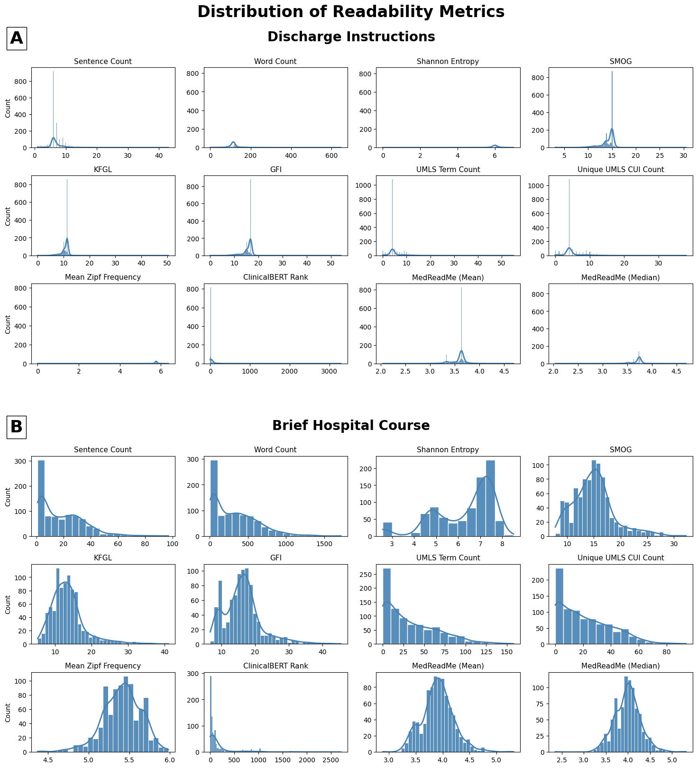
Supplement Figure 1. Distribution of all readability metrics for (a) Discharge Instructions; (b) Brief Hospital Course

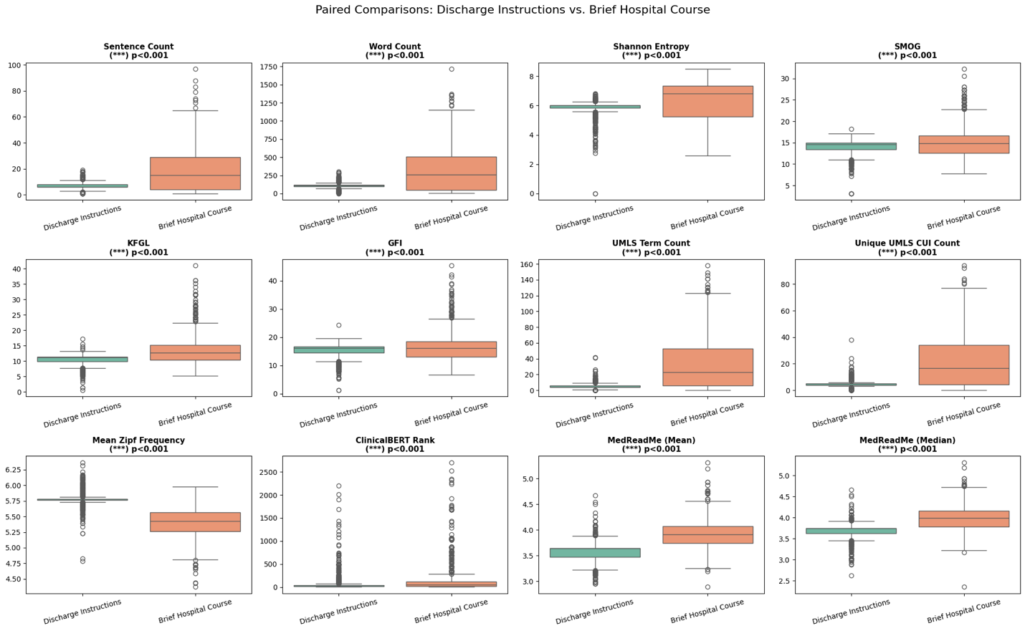Supplement Figure 2. Box plot comparing Discharge Instructions vs. Brief Hospital Course across all metrics

Supplement Results

1 ANOVA Statistics for Comparison across different diagnosis groups

Supplement Table S1. ANOVA test statistics across four diagnosis groups for the Discharge Instruction Section.
Metric | F-Stat | P-Value | Significance
Number of sentences | 8.03 | 0.000 | ***
Number of words | 0.424 | 0.736 | ns
Shannon Entropy | 6.057 | 0.000 | ***
SMOG | 81.168 | 0.000 | ***
KFGL | 51.252 | 0.000 | ***
GFI | 92.146 | 0.000 | ***
UMLS term count | 2.532 | 0.055 | ns
Unique UMLS term count | 4.198 | 0.006 | **
Zipf frequency | 13.768 | 0.000 | ***
MedReadMe mean score | 17.943 | 0.000 | ***
MedReadMe median score | 5.313 | 0.001 | **
UMLS term count | 10.906 | 0.000 | ***

Supplement Table S2. ANOVA test statistics across four diagnosis groups for the Brief Hospital Course Section.
Metric | F-Stat | P-Value | Significance
Number of sentences | 1.581 | 0.192 | ns
Number of words | 2.086 | 0.101 | ns
Shannon Entropy | 0.615 | 0.606 | ns
SMOG | 5.554 | 0.001 | ***
KFGL | 5.639 | 0.001 | ***
GFI | 7.166 | 0.000 | ***
UMLS term count | 1.332 | 0.263 | ns
Unique UMLS term count | 3.695 | 0.012 | *
Zipf frequency | 15.831 | 0.000 | ***
ClinicalBERT average rank | 2.487 | 0.059 | ns
MedReadMe mean score | 21.166 | 0.000 | ***
MedReadMe median score | 18.732 | 0.000 | ***

Supplementary Table S3: Diagnosis with the Highest Documentation Complexity for the Discharge Instruction and the Brief Hospital Course Section
Metric | Discharge Instructions | Brief Hospital Course
Number of sentences | Eating Disorder | Bipolar Disorder
Number of words | Major Depression | Bipolar Disorder
Shannon Entropy | Major Depression | Schizophrenia
SMOG | Major Depression | Eating Disorder
KFGL | Major Depression | Eating Disorder
GFI | Major Depression | Eating Disorder
UMLS term count | Major Depression | Bipolar Disorder
Unique UMLS term count | Major Depression | Bipolar Disorder
Zipf frequency | Bipolar Disorder | Eating Disorder
ClinicalBERT average rank | Eating Disorder | chizophrenia
MedReadMe mean score | Major Depression | Eating Disorder
MedReadMe median score | Major Depression | Eating Disorder

2 Significant Pairwise t-test Statistics after Bonferroni Correction for Comparison across different diagnosis groups

Supplementary Table S4: Significant Pairwise Comparisons for Discharge Instructions
Metric | Comparison Pair | Less Readable Group | p-value | Effect Size*
Number of sentences | Eating Disorder > Bipolar Disorder | Eating Disorder | 0.009 | 0.49
 | Eating Disorder > Bipolar | Eating Disorder | 0.019 | 0.44
Shannon Entropy | Major Depression > Eating Disorder | Major Depression | 0.002 | 0.42
 | Bipolar > Eating Disorder | Bipolar Disorder | 0.005 | 0.41
 | Schizophrenia > Eating Disorder | Schizophrenia | 0.007 | 0.43
SMOG | Major Depression > Eating Disorder | Major Depression | <0.001 | 1.61
 | Bipolar > Eating Disorder | Bipolar Disorder | <0.001 | 1.57
 | Schizophrenia > Eating Disorder | Schizophrenia | <0.001 | 1.30
KFGL | Major Depression > Eating Disorder | Major Depression | <0.001 | 1.15
 | Bipolar > Eating Disorder | Bipolar Disorder | <0.001 | 1.34
 | Schizophrenia > Eating Disorder | Schizophrenia | <0.001 | 1.21
GFI | Major Depression > Schizophrenia | Major Depression | 0.032 | 0.21
 | Major Depression > Eating Disorder | Major Depression | <0.001 | 1.65
 | Bipolar > Eating Disorder | Bipolar Disorder | <0.001 | 1.72
 | Schizophrenia > Eating Disorder | Schizophrenia | <0.001 | 1.46
Mean Zipf Freq. † | Major Depression < Eating Disorder | Major Depression | <0.001 | 1.04
 | Bipolar < Eating Disorder | Bipolar Disorder | <0.001 | 0.49
 | Schizophrenia < Eating Disorder | Schizophrenia | <0.001 | 0.66
Unique UMLS term count | Major Depression > Bipolar Disorder | Major Depression | 0.015 | 0.16
ClinicalBERT Rank | Major Depression < Eating Disorder | Eating Disorder | 0.008 | 0.72
 | Bipolar < Eating Disorder | Eating Disorder | 0.019 | 0.57
MedReadMe Median | Major Depression > Eating Disorder | Major Depression | 0.004 | 0.61
 | Bipolar > Eating Disorder | Bipolar Disorder | 0.014 | 0.47
 | Schizophrenia > Eating Disorder | Schizophrenia | 0.030 | 0.39
* Effect size is measured using Cohen’s d value.
† For Mean Zipf Frequency, a lower score indicates less readable text.

Supplementary Table S5: Significant Pairwise Comparisons for Brief Hospital Course
Metric | Comparison Pair | Less Readable Group | p-value | Effect Size*
SMOG | Major Depression < Schizophrenia | Schizophrenia | 0.025 | 0.32
KFGL | Major Depression < Schizophrenia | Schizophrenia | 0.023 | 0.34
GFI | Major Depression < Schizophrenia | Schizophrenia | 0.017 | 0.34
 | Major Depression < Eating Disorder | Eating Disorder | 0.016 | 0.50
Mean Zipf Freq.† | Major Depression > Eating Disorder | Eating Disorder | <0.001 | 0.90
 | Bipolar > Eating Disorder | Eating Disorder | <0.001 | 0.78
 | Schizophrenia > Eating Disorder | Eating Disorder | 0.001 | 0.59
Unique UMLS term count | Eating Disorder < Bipolar | Bipolar Disorder | 0.005 | 0.39
ClinicalBERT Rank | Major Depression > Eating Disorder | Major Depression | 0.001 | 0.37
 | Bipolar > Eating Disorder | Bipolar | 0.020 | 0.32
 | Schizophrenia > Eating Disorder | Schizophrenia | 0.049 | 0.32
MedReadMe Mean | Major Depression < Schizophrenia | Schizophrenia | 0.004 | 0.37
 | Major Depression < Eating Disorder | Eating Disorder | <0.001 | 0.98
 | Bipolar < Eating Disorder | Eating Disorder | <0.001 | 0.93
 | Schizophrenia > Eating Disorder | Eating Disorder | 0.005 | 0.53
MedReadMe Median | Major Depression < Schizophrenia | Schizophrenia | 0.003 | 0.40
 | Major Depression < Eating Disorder | Eating Disorder | <0.001 | 0.92
 | Bipolar < Eating Disorder | Eating Disorder | <0.001 | 0.85
 | Schizophrenia < Eating Disorder | Eating Disorder | 0.035 | 0.42
* Effect size is measured using Cohen’s d value.
† For Mean Zipf Frequency, a lower score indicates less readable text.

3 Descriptive Statistics of each metric Stratified by Diagnosis group
Supplementary Table S6: Descriptive Statistics of Readability Metrics Stratified by Diagnosis for the Discharge Summary Section.
Metric | Diagnosis Group | Mean (SD) | 95% CI [Lower, Upper]
Number of sentences | Major Depression | 6.79 (2.37) | [6.63, 6.95]
 | Bipolar Disorder | 6.68 (2.24) | [6.50, 6.87]
 | Schizophrenia | 6.96 (2.35) | [6.65, 7.27]
 | Eating Disorder | 7.92 (3.78) | [7.19, 8.65]
Number of words | Major Depression | 114.74 (34.14) | [112.44, 117.03]
 | Bipolar Disorder | 113.01 (31.87) | [110.37, 115.64]
 | Schizophrenia | 113.18 (31.88) | [108.98, 117.38]
 | Eating Disorder | 111.92 (56.98) | [100.90, 122.95]
Shannon entropy | Major Depression | 5.93 (0.49) | [5.90, 5.96]
 | Bipolar Disorder | 5.92 (0.48) | [5.88, 5.96]
 | Schizophrenia | 5.92 (0.42) | [5.87, 5.98]
 | Eating Disorder | 5.72 (0.56) | [5.61, 5.82]
SMOG | Major Depression | 14.36 (1.48) | [14.26, 14.46]
 | Bipolar Disorder | 14.32 (1.50) | [14.20, 14.45]
 | Schizophrenia | 14.04 (1.62) | [13.83, 14.26]
 | Eating Disorder | 11.98 (1.51) | [11.68, 12.27]
KFGL | Major Depression | 10.83 (2.00) | [10.69, 10.96]
 | Bipolar Disorder | 10.78 (1.62) | [10.64, 10.91]
 | Schizophrenia | 10.53 (1.50) | [10.33, 10.72]
 | Eating Disorder | 8.54 (1.90) | [8.17, 8.91]
GFI | Major Depression | 15.79 (2.35) | [15.63, 15.94]
 | Bipolar Disorder | 15.74 (2.20) | [15.56, 15.92]
 | Schizophrenia | 15.30 (2.32) | [14.99, 15.60]
 | Eating Disorder | 11.93 (2.29) | [11.48, 12.37]
UMLS term count | Major Depression | 5.34 (3.67) | [5.09, 5.59]
 | Bipolar Disorder | 4.87 (3.49) | [4.58, 5.16]
 | Schizophrenia | 4.79 (3.05) | [4.39, 5.20]
 | Eating Disorder | 5.29 (5.65) | [4.19, 6.38]
Unique UMLS term count | Major Depression | 5.17 (3.03) | [4.96, 5.37]
 | Bipolar Disorder | 4.70 (2.76) | [4.47, 4.92]
 | Schizophrenia | 4.68 (2.93) | [4.30, 5.07]
 | Eating Disorder | 4.46 (4.29) | [3.63, 5.29]
Mean Zipf frequncy | Major Depression | 5.77 (0.10) | [5.76, 5.77]
 | Bipolar Disorder | 5.76 (0.27) | [5.73, 5.78]
 | Schizophrenia | 5.77 (0.17) | [5.75, 5.80]
 | Eating Disorder | 5.88 (0.15) | [5.85, 5.91]
Clinicalbert rank | Major Depression | 49.92 (139.05) | [40.56, 59.27]
 | Bipolar Disorder | 60.42 (163.34) | [46.93, 73.92]
 | Schizophrenia | 78.61 (207.17) | [51.34, 105.89]
 | Eating Disorder | 189.20 (430.92) | [105.81, 272.59]
Medreadme mean | Major Depression | 3.60 (0.15) | [3.59, 3.61]
 | Bipolar Disorder | 3.59 (0.17) | [3.58, 3.61]
 | Schizophrenia | 3.59 (0.17) | [3.57, 3.62]
 | Eating Disorder | 3.53 (0.27) | [3.48, 3.58]
Medreadme median | Major Depression | 3.71 (0.13) | [3.70, 3.72]
 | Bipolar Disorder | 3.70 (0.16) | [3.69, 3.71]
 | Schizophrenia | 3.70 (0.17) | [3.68, 3.72]
 | Eating Disorder | 3.62 (0.27) | [3.57, 3.67]

Supplementary Table S7: Descriptive Statistics of Readability Metrics Stratified by Diagnosis for the Brief Hospical Course Section.
Metric | Diagnosis Group | Mean (SD) | 95% CI [Lower, Upper]
Number of sentences | Major Depression | 17.26 (14.07) | [15.90, 18.63]
 | Bipolar Disorder | 19.87 (17.66) | [17.78, 21.97]
 | Schizophrenia | 17.98 (15.52) | [15.30, 20.65]
 | Eating Disorder | 19.29 (18.98) | [14.59, 24.00]
Number of words | Major Depression | 302.59 (260.28) | [277.25, 327.92]
 | Bipolar Disorder | 354.60 (329.31) | [315.51, 393.69]
 | Schizophrenia | 317.83 (281.04) | [269.44, 366.22]
 | Eating Disorder | 288.37 (278.54) | [219.35, 357.39]
Shannon entropy | Major Depression | 6.23 (1.38) | [6.09, 6.36]
 | Bipolar Disorder | 6.33 (1.41) | [6.16, 6.50]
 | Schizophrenia | 6.39 (1.18) | [6.18, 6.59]
 | Eating Disorder | 6.24 (1.23) | [5.94, 6.54]
SMOG | Major Depression | 14.49 (3.66) | [14.13, 14.84]
 | Bipolar Disorder | 14.95 (3.46) | [14.54, 15.36]
 | Schizophrenia | 15.71 (4.37) | [14.96, 16.46]
 | Eating Disorder | 16.03 (4.46) | [14.92, 17.13]
KFGL | Major Depression | 12.95 (4.27) | [12.53, 13.37]
 | Bipolar Disorder | 13.38 (4.19) | [12.88, 13.87]
 | Schizophrenia | 14.52 (5.64) | [13.55, 15.49]
 | Eating Disorder | 14.76 (6.27) | [13.20, 16.31]
GFI | Major Depression | 15.63 (5.27) | [15.11, 16.14]
 | Bipolar Disorder | 16.24 (5.10) | [15.64, 16.85]
 | Schizophrenia | 17.50 (6.46) | [16.39, 18.62]
 | Eating Disorder | 18.39 (6.87) | [16.69, 20.09]
UMLS term count | Major Depression | 31.89 (33.51) | [28.63, 35.15]
 | Bipolar Disorder | 36.01 (33.88) | [31.99, 40.03]
 | Schizophrenia | 31.80 (28.16) | [26.95, 36.65]
 | Eating Disorder | 29.02 (26.99) | [22.33, 35.70]
Unique UMLS term count | Major Depression | 19.76 (19.67) | [17.85, 21.68]
 | Bipolar Disorder | 23.57 (19.39) | [21.27, 25.87]
 | Schizophrenia | 21.79 (16.89) | [18.88, 24.70]
 | Eating Disorder | 16.35 (14.00) | [12.88, 19.82]
Mean Zipf frequncy | Major Depression | 5.44 (0.23) | [5.42, 5.46]
 | Bipolar Disorder | 5.41 (0.23) | [5.39, 5.44]
 | Schizophrenia | 5.38 (0.24) | [5.34, 5.42]
 | Eating Disorder | 5.23 (0.26) | [5.17, 5.30]
Clinicalbert rank | Major Depression | 183.10 (334.16) | [150.57, 215.62]
 | Bipolar Disorder | 160.21 (314.27) | [122.90, 197.52]
 | Schizophrenia | 188.54 (442.26) | [112.39, 264.69]
 | Eating Disorder | 64.67 (208.45) | [13.01, 116.32]
Medreadme mean | Major Depression | 3.86 (0.28) | [3.83, 3.89]
 | Bipolar Disorder | 3.89 (0.25) | [3.86, 3.92]
 | Schizophrenia | 3.97 (0.33) | [3.91, 4.03]
 | Eating Disorder | 4.15 (0.35) | [4.06, 4.23]
Medreadme median | Major Depression | 3.94 (0.28) | [3.91, 3.97]
 | Bipolar Disorder | 3.98 (0.25) | [3.95, 4.01]
 | Schizophrenia | 4.06 (0.36) | [4.00, 4.12]
 | Eating Disorder | 4.20 (0.33) | [4.12, 4.29]

