Supplemental Materials for “Disease- and gene-specific deep learning for pathogenicity prediction of rare missense variants in cancer predisposition genes”

Da-Bin Lee, Hyun-Uk Kang and Kyu-Baek Hwang*

Department of Computer Science and Engineering, Graduate School, Soongsil University, Seoul 06978, Korea

* Correspondence and requests for materials should be addressed to K.-B.H. (e-mail: kbhwang@ssu.ac.kr)

Supplementary Methods
This section describes the hyperparameters and optimization procedures used for model training. We detail the hyperparameters that were optimized specifically for our proposed method, as well as the procedure used for their optimization. Hyperparameter optimization was conducted for both our method and the baseline models, including extreme gradient boosting (XGBoost) [1] and random forest (RF) [2]. Previous studies comparing multiple machine-learning algorithms under both the disease-specific (DS) and gene-specific (GS) settings for BRCA1 and BRCA2 consistently reported that XGBoost and RF achieved superior performance [3]. Based on these findings, we adopted XGBoost and RF as the baseline models for comparison. As described in Section 2.3, the pathogenicity prediction task was evaluated under two experimental settings: one assuming access to variants across hereditary cancer–related genes (DS), and the other assuming that only variants from a single gene are available (GS). Accordingly, we applied separate optimization procedures depending on the data setting. The overall process of hyperparameter optimization is shown in Supplementary Fig. 12.
For the DS setup, hyperparameter optimization was performed using variants from the target gene as the validation set. For example, when evaluating BRCA1, the model was trained on variants from all other disease-related genes and validated on BRCA1 variants not included in the test set. Model performance was evaluated using the average of the area under the precision–recall curve (AUPRC), the area under the receiver operating characteristic curve (AUROC), and accuracy on the validation data. The configuration with the highest average score was selected; when multiple configurations yielded identical performance, the final selection was determined based on the corresponding training results. This strategy reflects a realistic scenario in which gene-agnostic information is used to guide predictions for a specific target gene.
For the GS setup, hyperparameter optimization was conducted using 3-fold cross-validation. To ensure valid evaluation, each fold was required to contain at least one pathogenic and one benign variant. For each hyperparameter configuration, three independent runs were performed, and performance was evaluated on the validation fold using AUPRC, AUROC, and accuracy. The configuration with the highest average performance across these three metrics was selected as optimal. When multiple configurations yielded identical average performance, the final selection was based on the highest mean performance on the corresponding training folds.
The main hyperparameters tuned for the proposed method were the dropout rate, the number of fine-tuning epochs, and the batch size. All other hyperparameters were fixed to their default values, and parameters specified in the main manuscript were held constant. The search space comprised the following combinations: dropout rate ∈ {0.4, 0.6, 0.8}, epochs ∈ {10, 20}, and batch size ∈ {10, 20}, resulting in 12 candidate configurations. Using the optimization procedure described above, the configuration with the best validation performance was selected. The final model was then trained on the full training set under the selected configuration and evaluated on the test data.
For the baseline models, hyperparameter optimization was performed as follows. XGBoost was optimized using $η$ ∈ {0.05, 0.1, 0.15, 0.2}, nrounds ∈ {50, 60, …, 250}, $γ$ ∈ {0, 0.05}, max_depth ∈ {3, 4, 5}, and min_child_weight ∈ {1, 2}. RF was tuned with nTree ∈ {100, 500, 1,000, 3,000} and mtry ∈ {10, 20, 40, 80, 120}. All baseline models were trained and validated using the same procedures as the proposed method to ensure fair and consistent comparison.
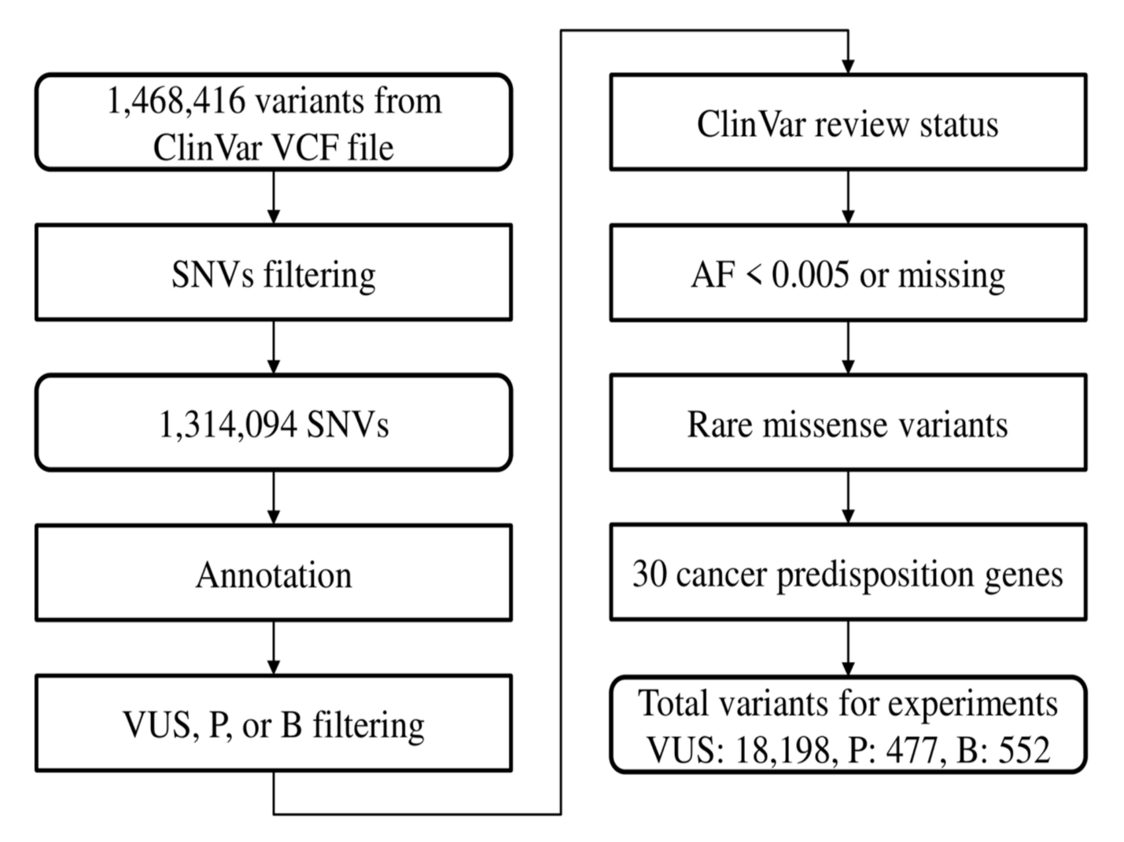
Supplementary Fig. 1. Schematic overview of ClinVar data filtering, preprocessing, and dataset construction for imbalanced pathogenicity prediction.
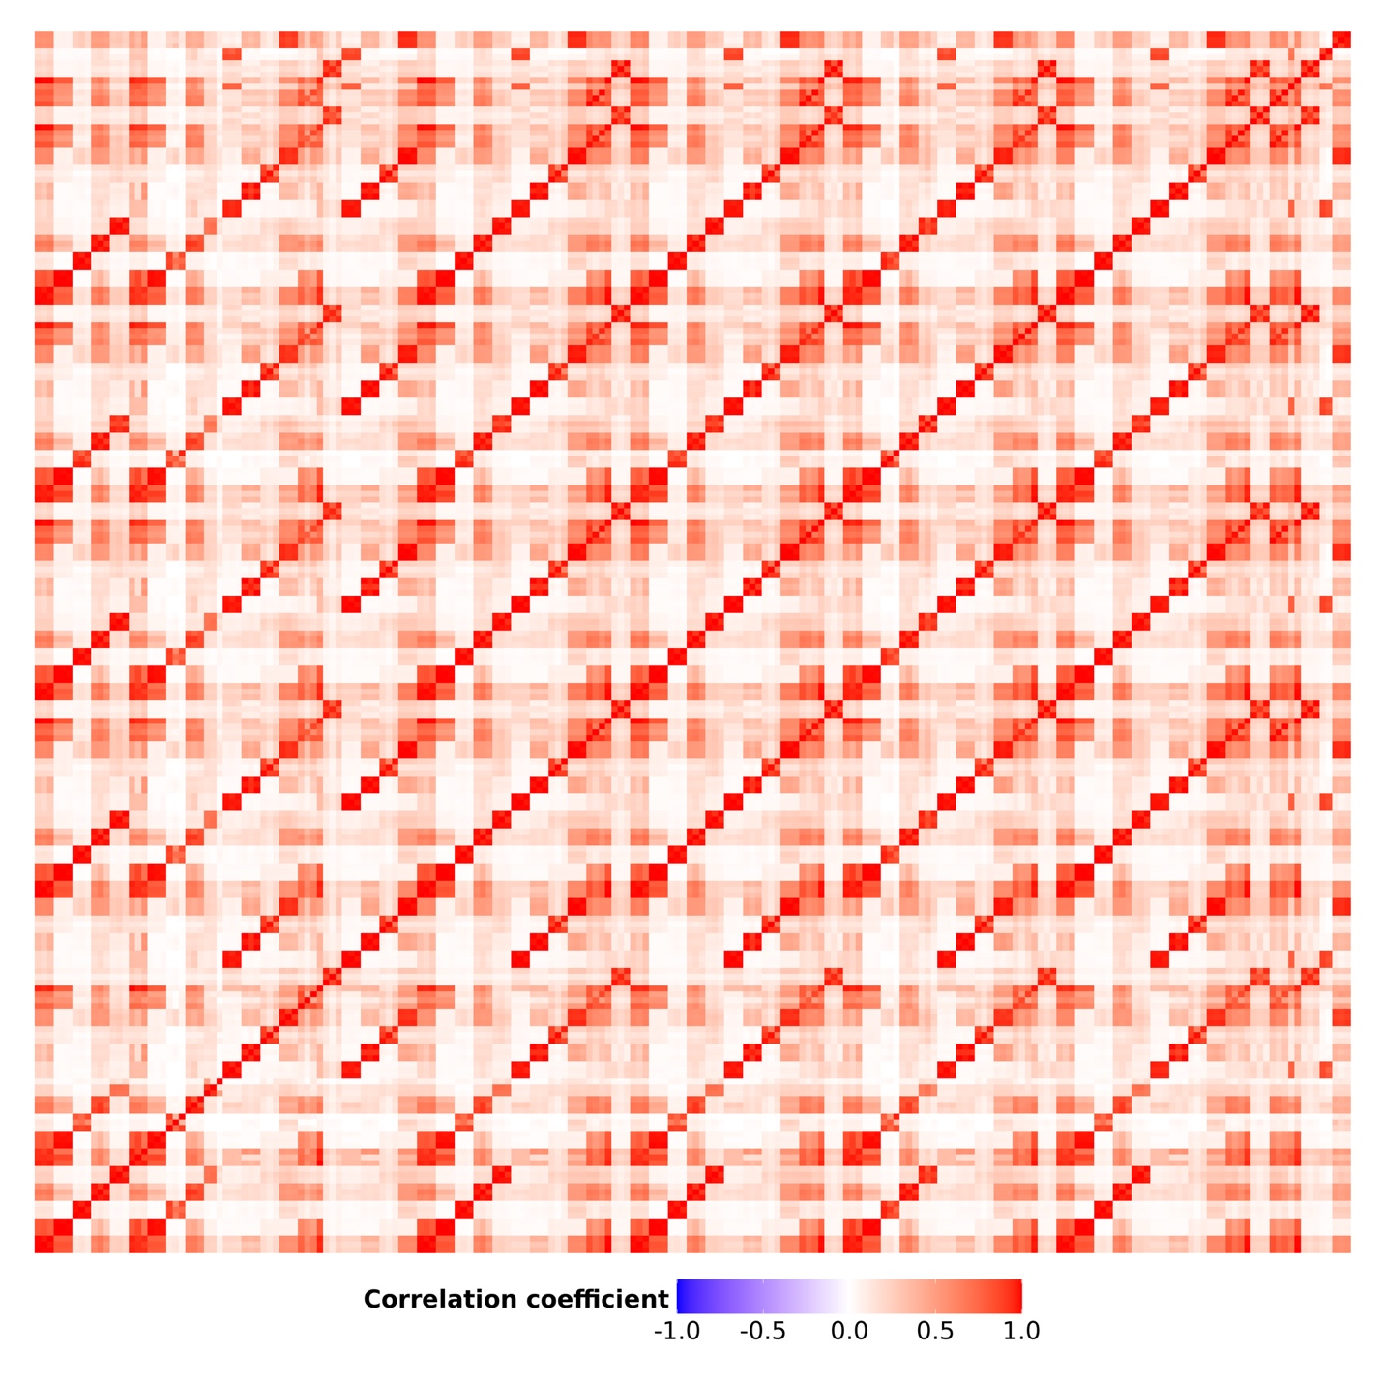
Supplementary Fig. 2. Heatmap of pairwise Pearson’s correlation coefficients among allele frequency-related features.
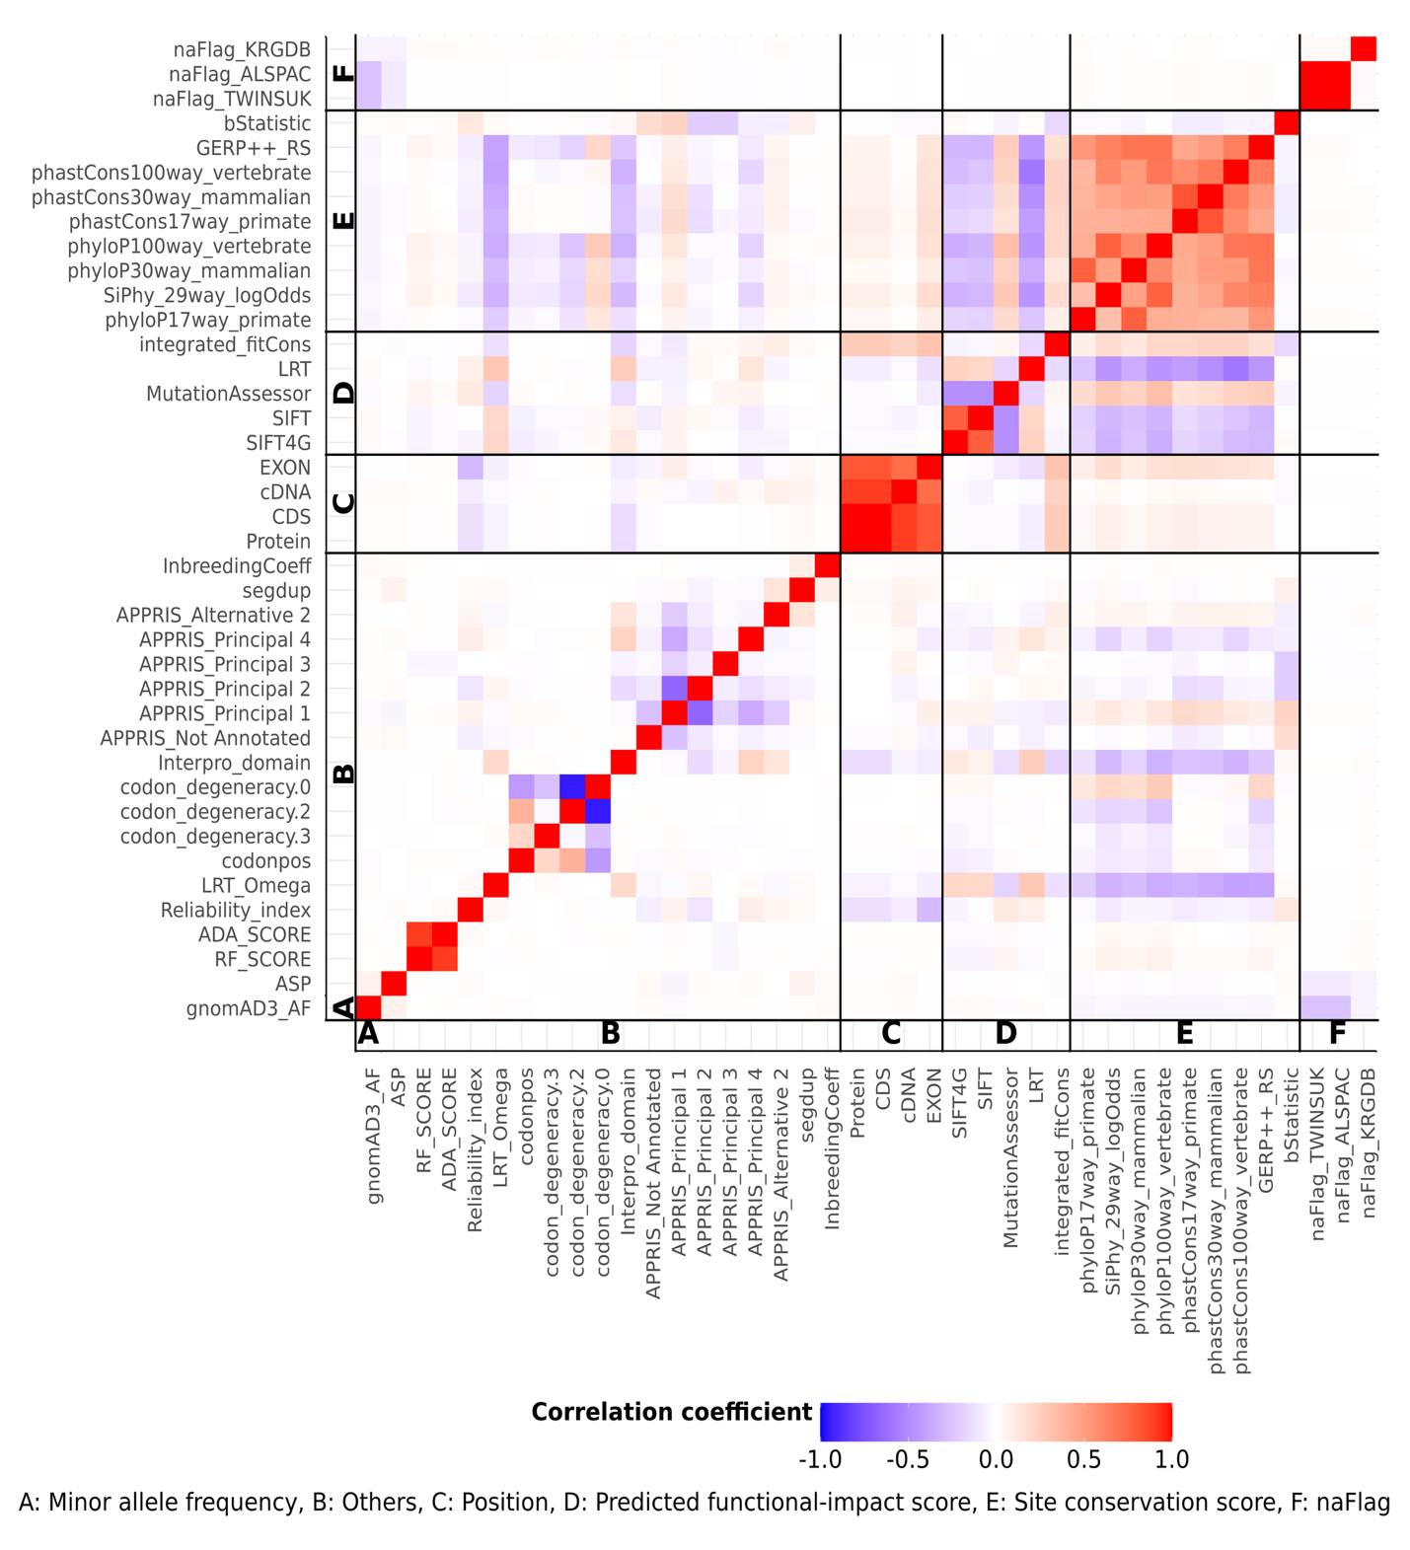
Supplementary Fig. 3. Heatmap of pairwise Pearson’s correlation coefficients across all features, using gnomAD3_AF as representative allele-frequency feature.
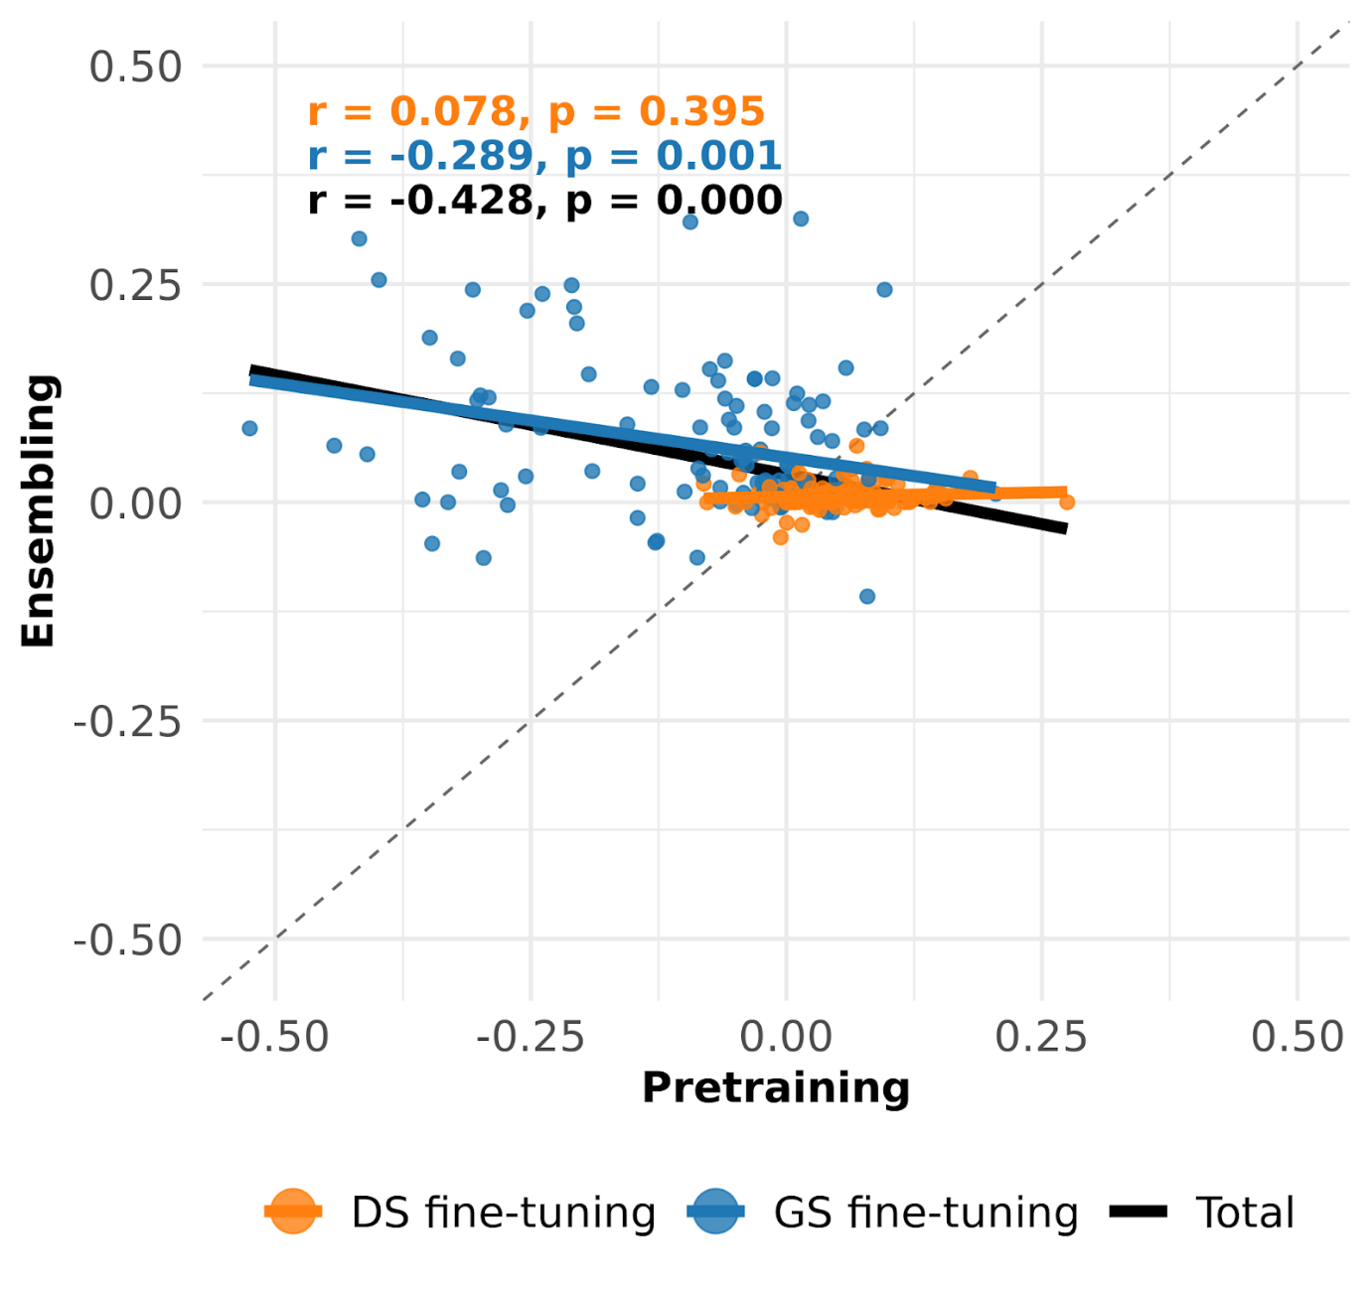
Supplementary Fig. 4. Scatter plots of performance gains from pretraining and ensembling; r indicates Pearson’s correlation coefficient.
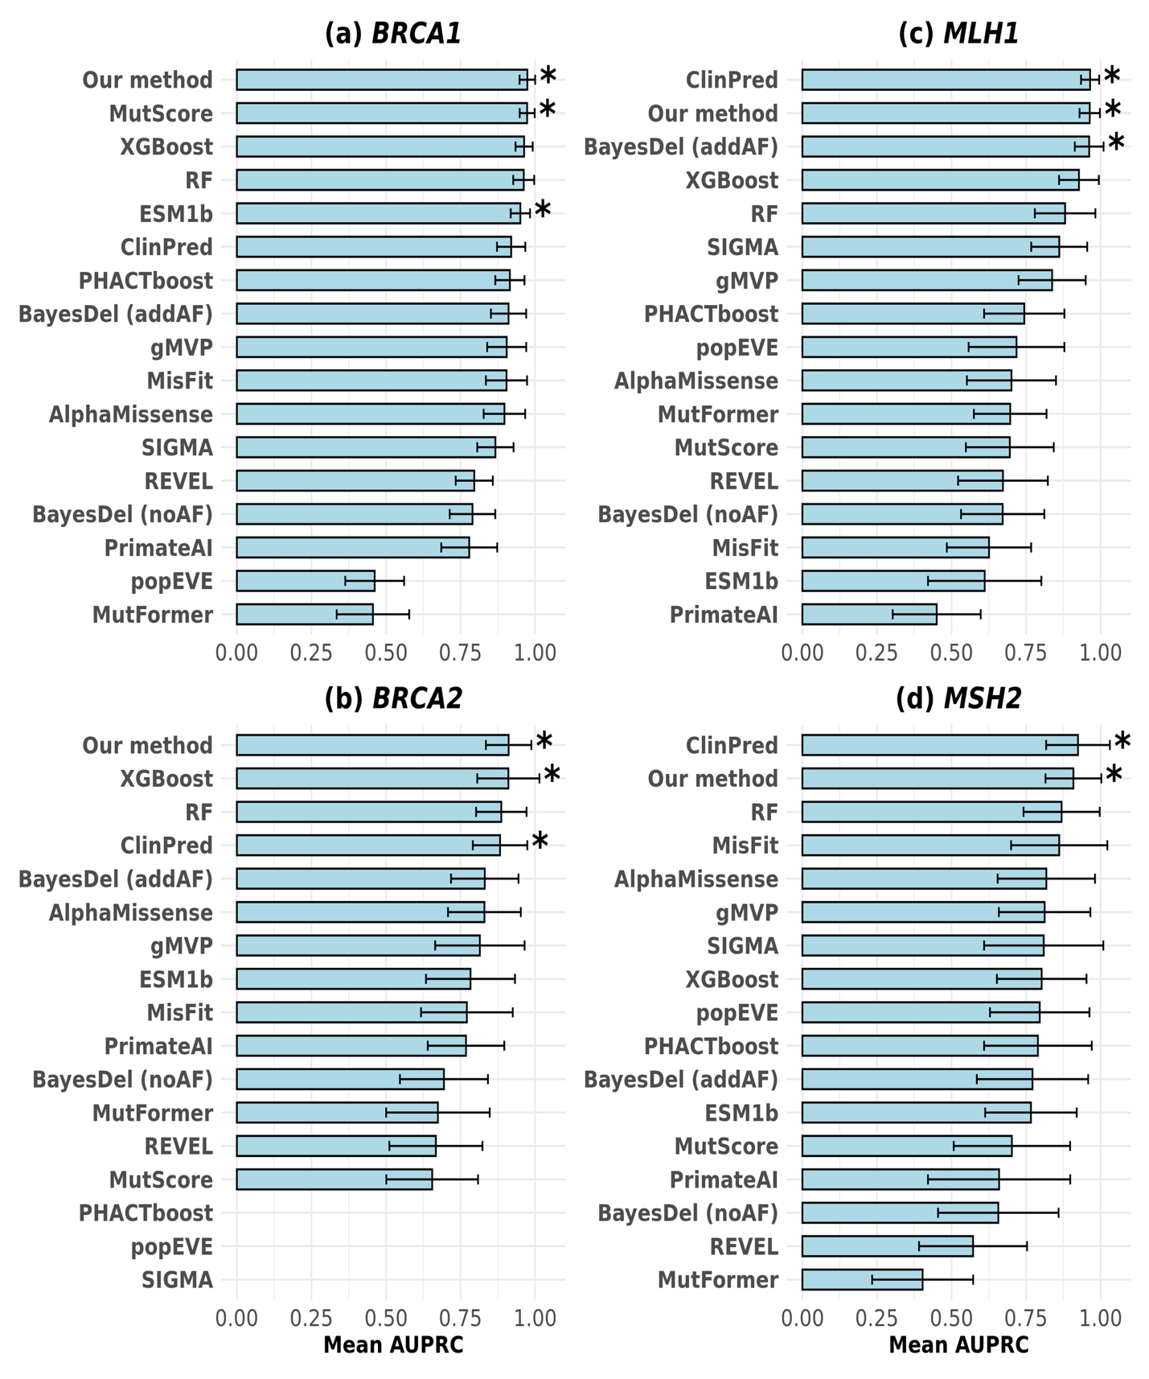Supplementary Fig. 5. Performance comparison with existing methods for each gene.
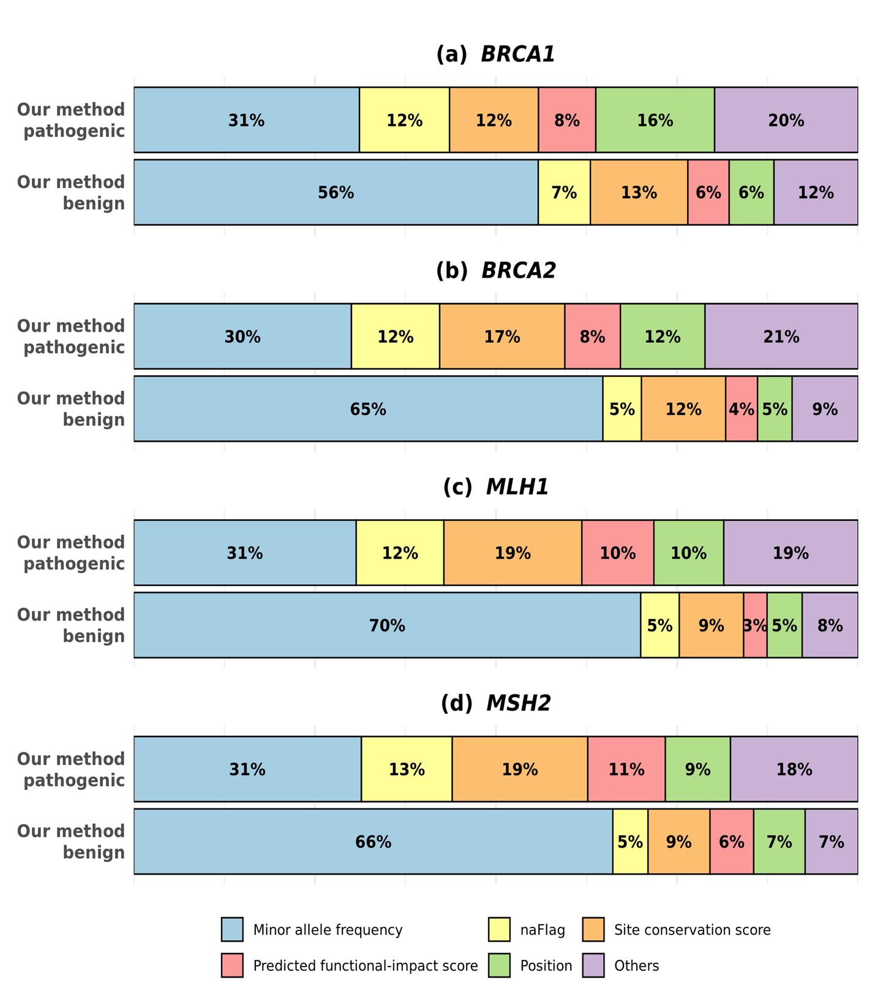
Supplementary Fig. 6. LRP-derived contributions specific to pathogenic and benign variants of six feature categories of our method.

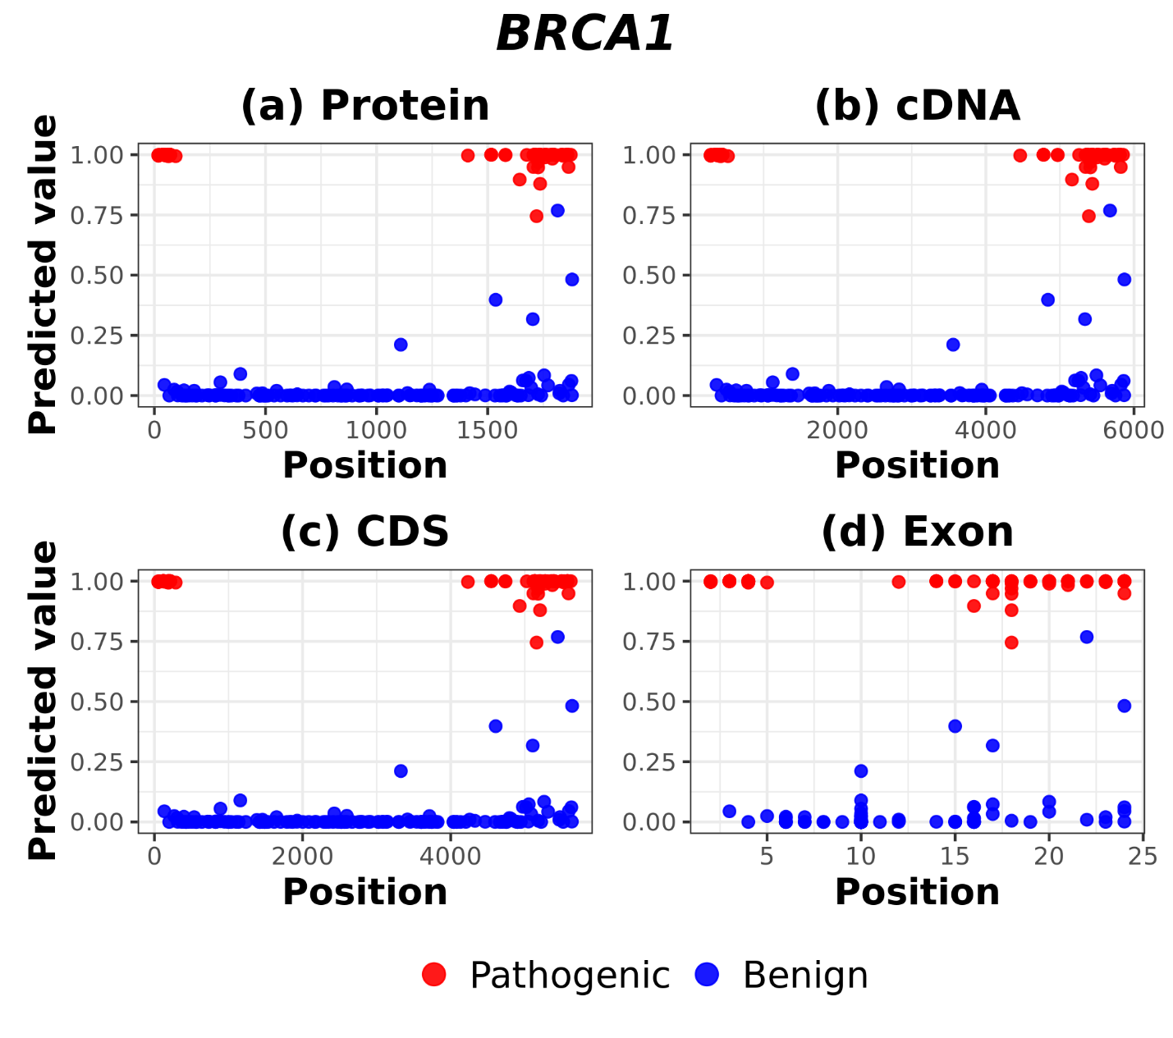
Supplementary Fig. 7. Visualization of positions and predicted pathogenicity scores of variants for BRCA1.
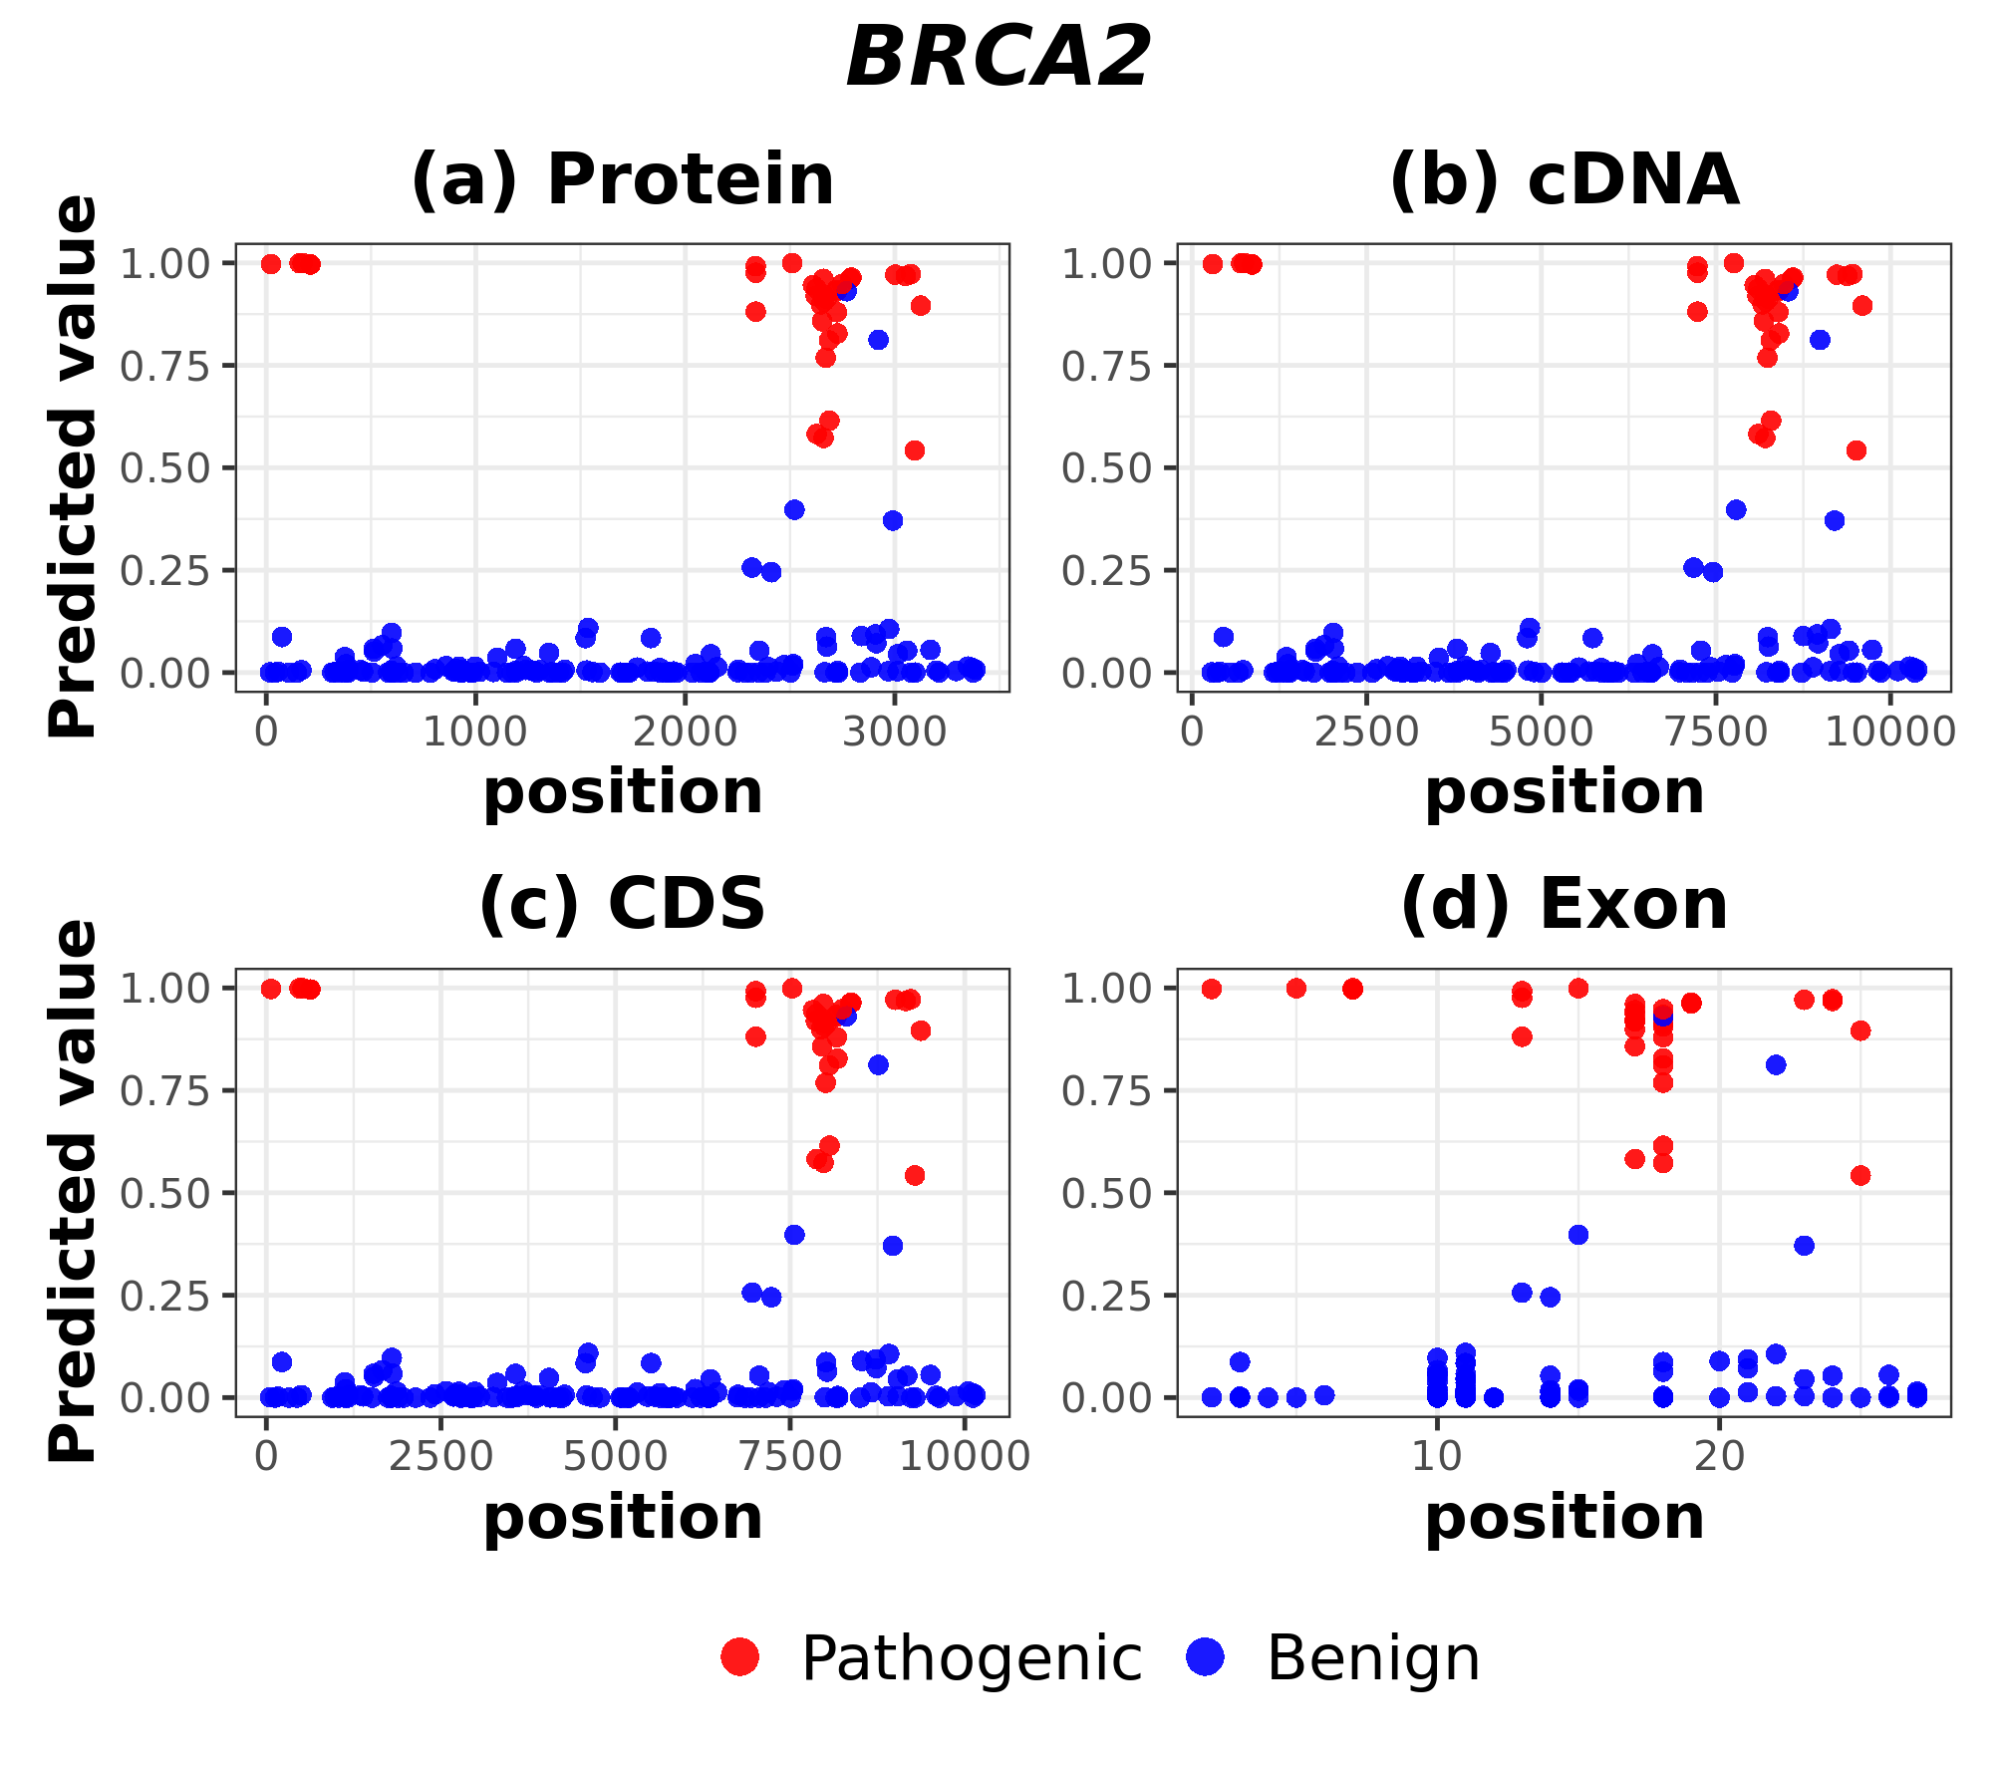
Supplementary Fig. 8. Visualization of positions and predicted pathogenicity scores of variants for BRCA2.
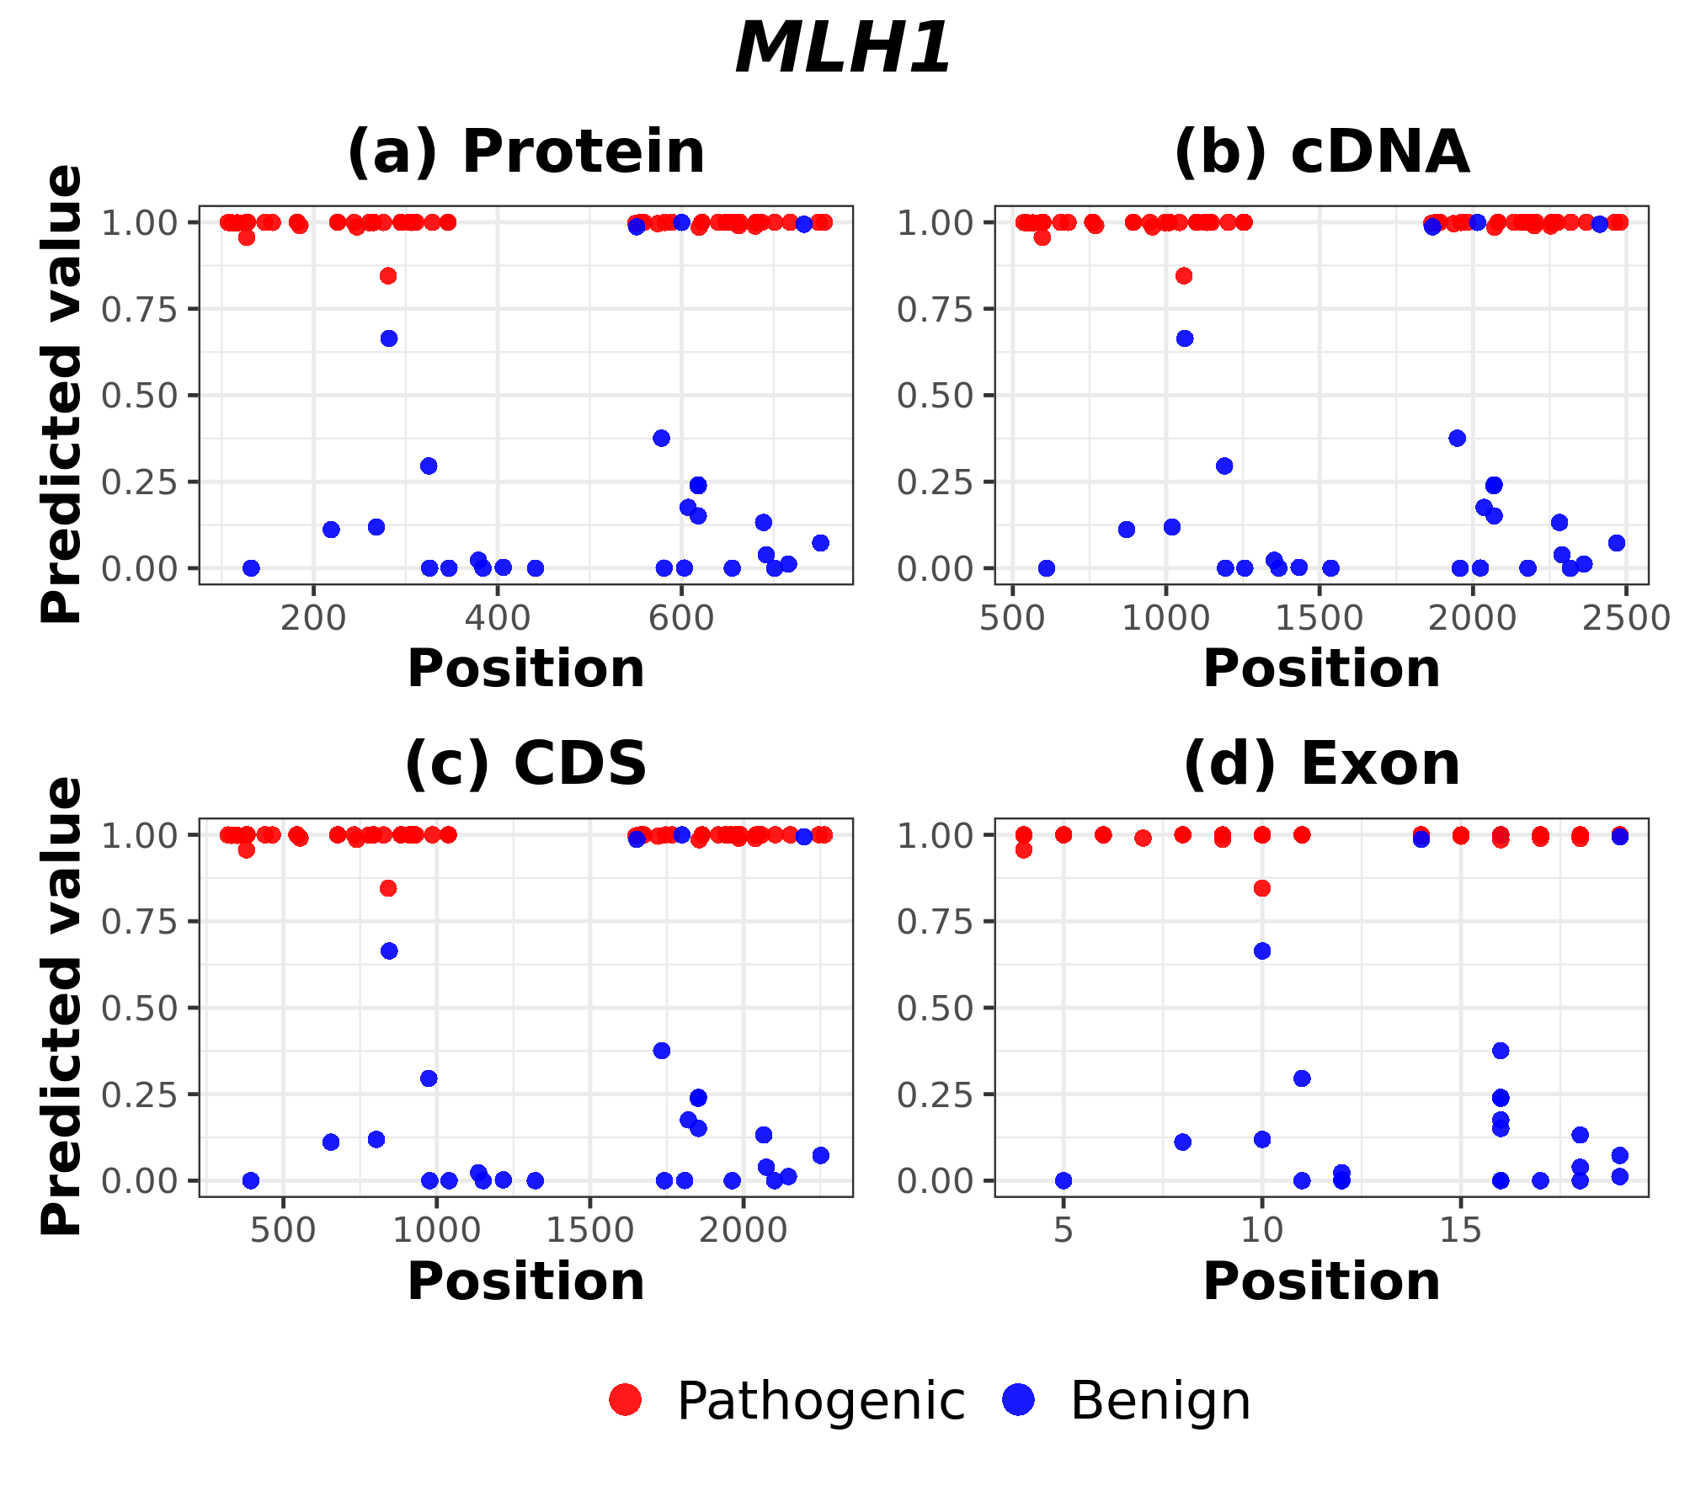
Supplementary Fig. 9. Visualization of positions and predicted pathogenicity scores of variants for MLH1.
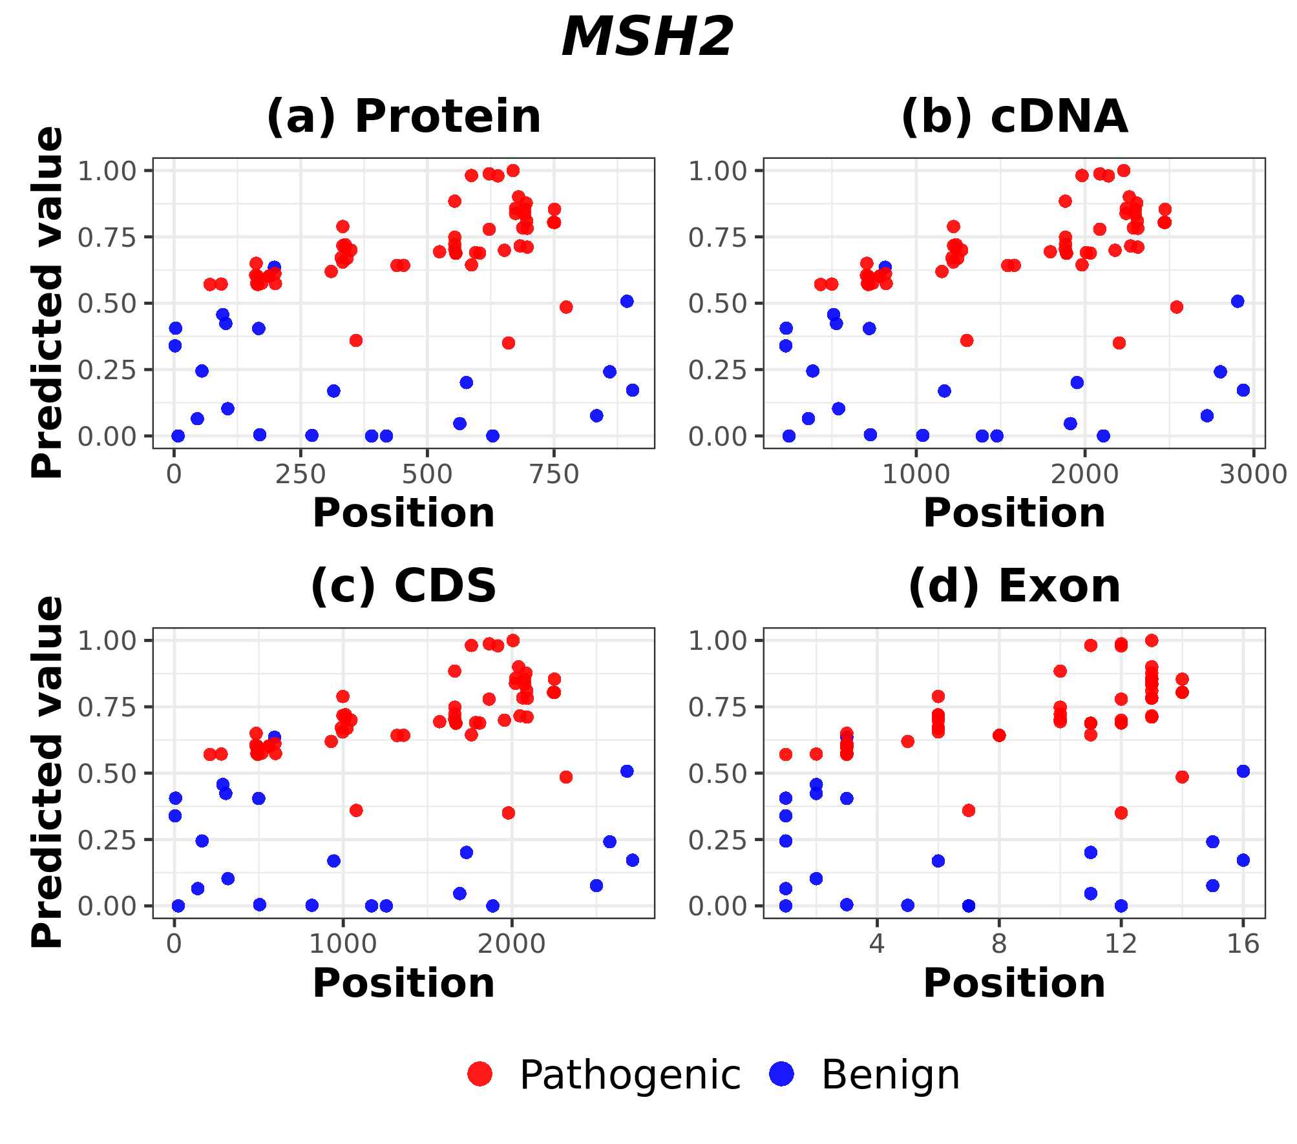
Supplementary Fig. 10. Visualization of positions and predicted pathogenicity scores of variants for MSH2.
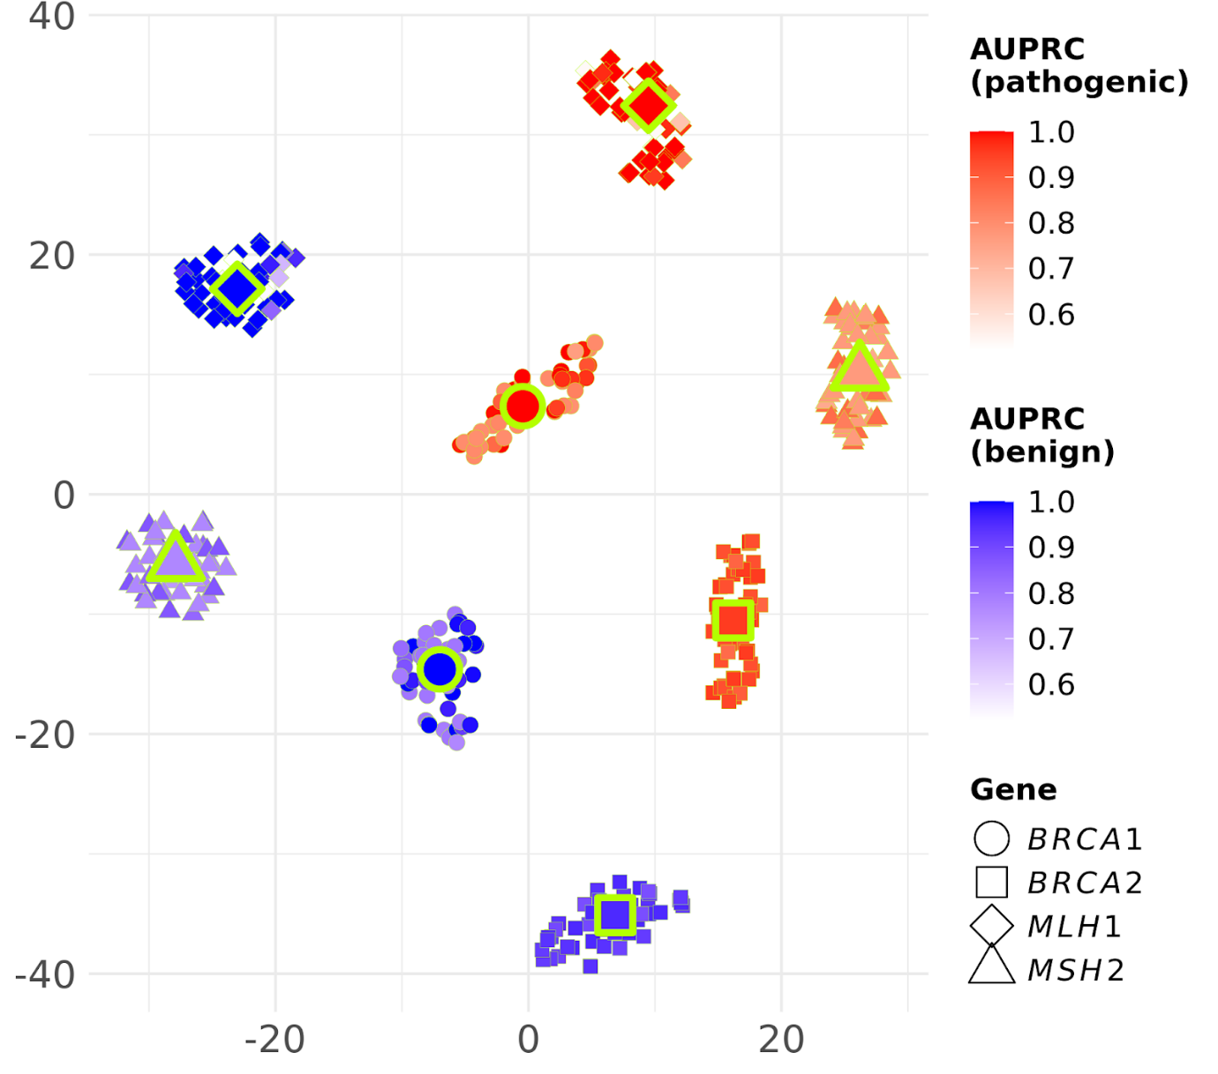
Supplementary Fig. 11. t-SNE visualization of LRP scores from the single DNN and 50-DNN across genes and labels.

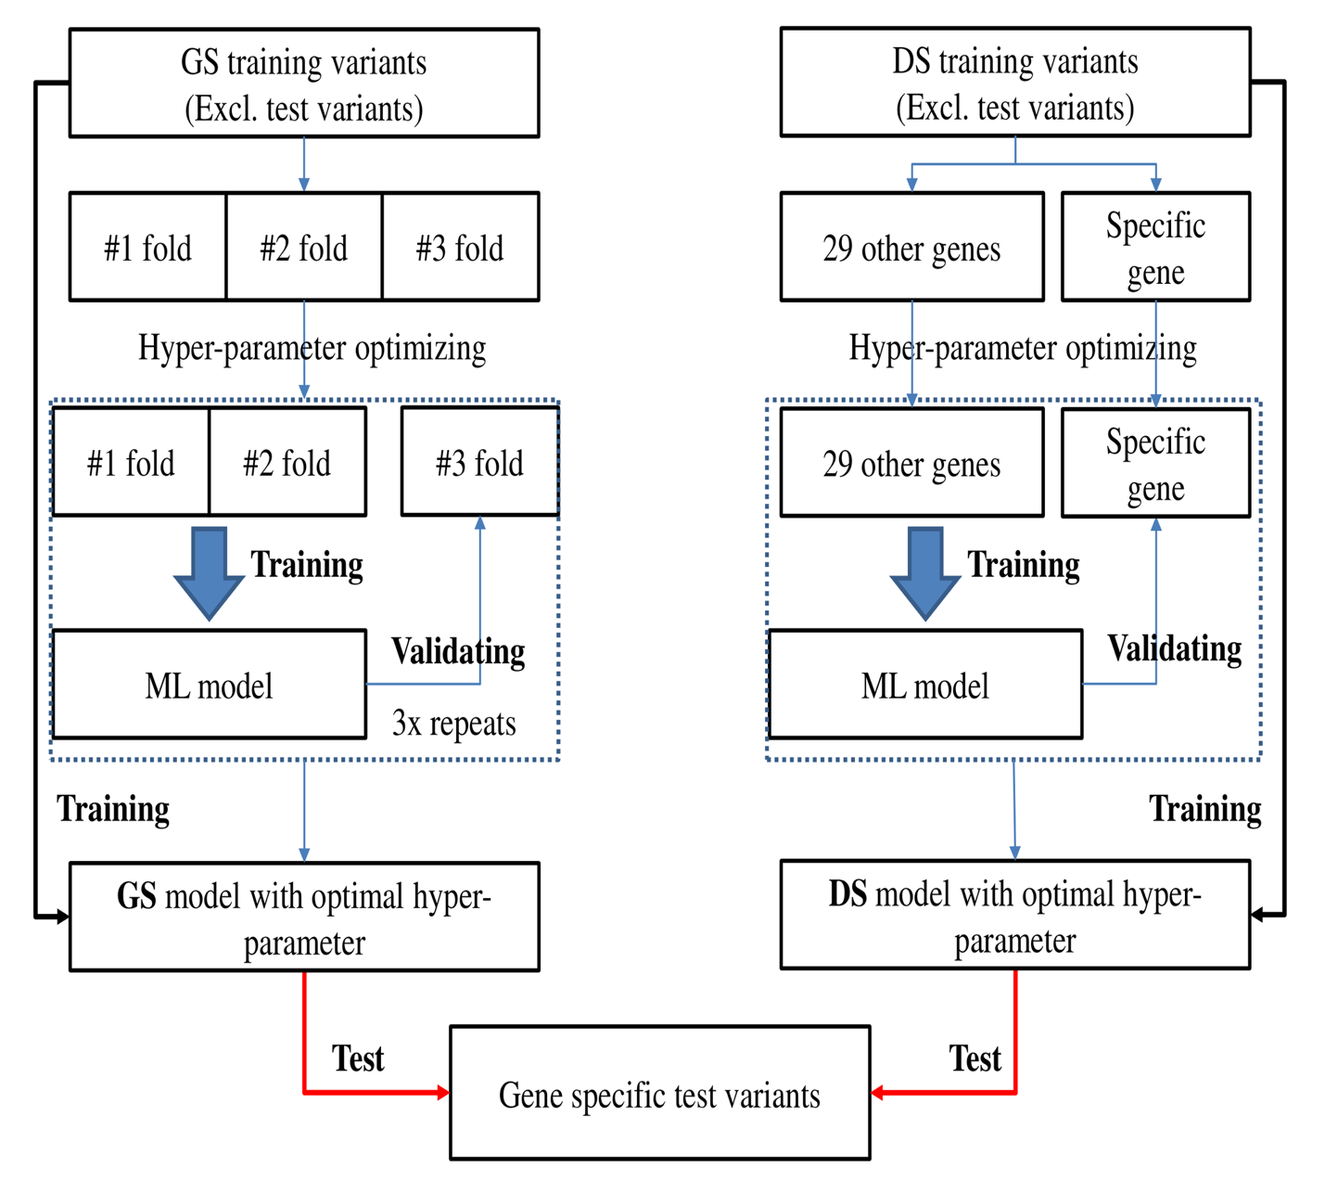
Supplementary Fig. 12. Overview of the hyperparameter optimization process.

Supplementary Table 1. Ensembl transcript IDs (GRCh38, version 94) for cancer predisposition genes.
Gene | Transcript ID | Gene | Transcript ID
APC | ENST00000257430.8 | MLH1 | ENST00000231790.6
ATM | ENST00000278616.8 | MSH2 | ENST00000233146.6
BAP1 | ENST00000460680.5 | MSH6 | ENST00000234420.9
BARD1 | ENST00000260947.8 | MUTYH | ENST00000372098.7
BMPR1A | ENST00000372037.7 | NBN | ENST00000265433.7
BRCA1 | ENST00000471181.7 | PALB2 | ENST00000261584.8
BRCA2 | ENST00000544455.5 | PMS2 | ENST00000265849.11
BRIP1 | ENST00000259008.6 | POLD1 | ENST00000595904.6
CDH1 | ENST00000261769.9 | POLE | ENST00000320574.9
CDK4 | ENST00000257904.10 | PTEN | ENST00000371953.7
CDKN2A | ENST00000498124.1 | RAD51C | ENST00000337432.8
CHEK2 | ENST00000382580.6 | RAD51D | ENST00000590016.5
EPCAM | ENST00000263735.8 | SMAD4 | ENST00000342988.7
GREM1 | ENST00000622074.1 | STK11 | ENST00000326873.11
MITF | ENST00000352241.8 | TP53 | ENST00000269305.8

Supplementary Table 2. Final number of variants retained for each gene after preprocessing and filtering.
Gene | VUS | Pathogenic | Benign | Gene | VUS | Pathogenic | Benign
APC | 1877 | 6 | 16 | MLH1 | 479 | 61 | 27
ATM | 2216 | 28 | 9 | MSH2 | 910 | 57 | 22
BAP1 | 257 | 0 | 3 | MSH6 | 1293 | 22 | 20
BARD1 | 667 | 1 | 4 | MUTYH | 376 | 18 | 1
BMPR1A | 138 | 2 | 0 | NBN | 526 | 0 | 4
BRCA1 | 1153 | 85 | 141 | PALB2 | 835 | 0 | 5
BRCA2 | 2357 | 36 | 143 | PMS2 | 669 | 7 | 4
BRIP1 | 781 | 1 | 5 | POLD1 | 374 | 2 | 10
CDH1 | 616 | 6 | 41 | POLE | 609 | 1 | 12
CDK4 | 90 | 2 | 0 | PTEN | 102 | 12 | 0
CDKN2A | 148 | 21 | 2 | RAD51C | 296 | 4 | 1
CHEK2 | 541 | 2 | 1 | RAD51D | 215 | 0 | 7
EPCAM | 6 | 0 | 7 | SMAD4 | 134 | 8 | 2
GREM1 | 0 | 0 | 1 | STK11 | 286 | 7 | 1
MITF | 10 | 1 | 4 | TP53 | 237 | 87 | 59

Supplementary Table 3. Overview of the dataset composition for experiments.
Gene | VUS for pretraining | DS labeled |  | GS labeled |  | Test
Gene | VUS for pretraining | Pathogenic | Benign | Pathogenic | Benign | Pathogenic | Benign
BRCA1 | 18198 | 463 | 480 | 71 | 69 | 14 | 72
BRCA2 | 18198 | 471 | 479 | 30 | 70 | 6 | 73
MLH1 | 18198 | 535 | 471 | 55 | 10 | 6 | 17
MSH2 | 18198 | 538 | 473 | 53 | 8 | 4 | 14

Supplementary Table 4. Comparison of the effects of pretraining and deep ensembling for BRCA1.
BRCA1 |  | Disease-specific fine-tuning |  | Gene-specific fine-tuning
Ensembling | Pretraining | AUPRC | P | AUPRC | P
Single DNN | Pretraining | 0.897 ± 0.073 | 7.9E-07 | 0.908 ± 0.059 | 2.6E-07
Single DNN | No pretraining | 0.853 ± 0.061 | 4.0E-12 | 0.890 ± 0.060 | 1.6E-08
50-DNN | Pretraining | 0.906 ± 0.068 | 1.7E-06 | 0.974 ± 0.026
50-DNN | No pretraining | 0.851 ± 0.063 | 4.8E-12 | 0.949 ± 0.057 | 0.006
Bold values indicate the best-performing method, and P denotes the p-value obtained from a paired t-test.

Supplementary Table 5. Comparison of the effects of pretraining and deep ensembling for BRCA2.
BRCA2 |  | Disease-specific fine-tuning |  | Gene-specific fine-tuning
Ensembling | Pretraining | AUPRC | P | AUPRC | P
Single DNN | Pretraining | 0.901 ± 0.079 | 3.2E-05 | 0.783 ± 0.135 | 2.6E-07
Single DNN | No pretraining | 0.860 ± 0.106 | 2.2E-05 | 0.794 ± 0.123 | 1.6E-08
50-DNN | Pretraining | 0.911 ± 0.076 |  | 0.833 ± 0.132 | 1.1E-05
50-DNN | No pretraining | 0.893 ± 0.107 | 0.033 | 0.837 ± 0.103 | 6.6E-07
Bold values indicate the best-performing method, and P denotes the p-value obtained from a paired t-test.

Supplementary Table 6. Comparison of the effects of pretraining and deep ensembling for MLH1.
MLH1 |  | Disease-specific fine-tuning |  | Gene-specific fine-tuning
Ensembling | Pretraining | AUPRC | P | AUPRC | P
Single DNN | Pretraining | 0.955 ± 0.035 | 0.008 | 0.802 ± 0.159 | 2.9E-06
Single DNN | No pretraining | 0.892 ± 0.058 | 7.0E-09 | 0.938 ± 0.057 | 0.003
50-DNN | Pretraining | 0.964 ± 0.034 |  | 0.865 ± 0.134 | 2.6E-04
50-DNN | No pretraining | *0.957 ± 0.041 | 0.087 | 0.950 ± 0.050 | 0.047
Bold values indicate the best-performing method, and P denotes the p-value obtained from a paired t-test. * indicates methods not significantly different from the best-performing method (P ≥ 0.05).

Supplementary Table 7. Comparison of the effects of pretraining and deep ensembling for MSH2.
MSH2 |  | Disease-specific fine-tuning |  | Gene-specific fine-tuning
Ensembling | Pretraining | AUPRC | P | AUPRC | P
Single DNN | Pretraining | 0.909 ± 0.094 |  | 0.659 ± 0.206 | 5.0E-09
Single DNN | No pretraining | 0.876 ± 0.121 | 0.005 | 0.855 ± 0.112 | 2.3E-04
50-DNN | Pretraining | *0.909 ± 0.094 | 0.418 | 0.740 ± 0.209 | 7.4E-06
50-DNN | No pretraining | 0.879 ± 0.122 | 0.010 | 0.872 ± 0.110 | 0.004
Bold values indicate the best-performing method, and P denotes the p-value obtained from a paired t-test. * indicates methods not significantly different from the best-performing method (P ≥ 0.05).

Supplementary Table 8. Comparison of gene-specific AUPRCs across different hidden node counts in a single DNN.
Gene | Node counts | AUPRC | P
BRCA1 | 1000 | 0.845 ± 0.088 | 0.002
BRCA1 | 5000 | 0.878 ± 0.055 | 0.009
BRCA1 | 9000 | 0.908 ± 0.059
BRCA2 | 1000 | 0.771 ± 0.147 | 0.026
BRCA2 | 5000 | 0.806 ± 0.130
BRCA2 | 9000 | 0.783 ± 0.135 | 0.027
MLH1 | 1000 | 0.820 ± 0.155 | 0.025
MLH1 | 5000 | 0.862 ± 0.159
MLH1 | 9000 | 0.802 ± 0.159 | 3.5E-04
MSH2 | 1000 | 0.815 ± 0.129
MSH2 | 5000 | 0.726 ± 0.187 | 2.9E-04
MSH2 | 9000 | 0.659 ± 0.206 | 6.1E-05
Bold values indicate the best-performing method, and P denotes the p-value obtained from a paired t-test.

Supplementary Table 9. Effect of pretraining across training sample sizes in the gene-specific setup for BRCA1.
GS training sample size | AUPRC w/ pretraining | AUPRC w/o pretraining | P
140  (p = 71, B = 69) | 0.974 | 0.949 | 0.006
105  (p = 53, B = 52) | 0.906 | 0.905 | 0.484
70  (p = 35, B = 35) | 0.907 | 0.882 | 0.096
35  (p = 17, B = 18) | 0.811 | 0.828 | 0.268
Bold values indicate the best-performing method, and P denotes the p-value obtained from a paired t-test.
Supplementary Table 10. Comparison of VUS-inclusive and VUS-exclusive pretraining for disease-specific fine-tuning using a single DNN model.
Gene | Pretraining | AUPRC | P
BRCA1 | With VUS | 0.897 ± 0.073 | 1.5E-11
BRCA1 | Without VUS | 0.835 ± 0.077 | 1.5E-11
BRCA2 | With VUS | 0.901 ± 0.079 | 2.7E-04
BRCA2 | Without VUS | 0.863 ± 0.107 | 2.7E-04
MLH1 | With VUS | 0.955 ± 0.035 | 1.6E-07
MLH1 | Without VUS | 0.911 ± 0.059 | 1.6E-07
MSH2 | With VUS | 0.909 ± 0.094 | 0.001
MSH2 | Without VUS | 0.867 ± 0.116 | 0.001
Bold values indicate the best-performing method, and P denotes the p-value obtained from a paired t-test.

Supplementary Table 11. Comparison of VUS-inclusive and VUS-exclusive pretraining for gene-specific fine-tuning using a single DNN model.
Gene | Pretraining | AUPRC | P
BRCA1 | With VUS | 0.908 ± 0.059 | 0.257
BRCA1 | Without VUS | *0.902 ± 0.062 | 0.257
BRCA2 | With VUS | 0.783 ± 0.135 | 0.080
BRCA2 | Without VUS | *0.759 ± 0.160 | 0.080
MLH1 | With VUS | 0.802 ± 0.159 | 8.0E-06
MLH1 | Without VUS | 0.933 ± 0.077 | 8.0E-06
MSH2 | With VUS | 0.659 ± 0.206 | 3.7E-07
MSH2 | Without VUS | 0.837 ± 0.162 | 3.7E-07
Bold values indicate the best-performing method, and P denotes the p-value obtained from a paired t-test. * indicates methods not significantly different from the best-performing method (P ≥ 0.05).

Supplementary Table 12. Performance comparison with existing methods.
Model | AUPRC | P
Our method | 0.940 ± 0.070
ClinPred | 0.923 ± 0.080 | 0.014
XGBoost | 0.901 ± 0.114 | 7.8E-06
RF | 0.900 ± 0.099 | 2.6E-07
BayesDel (addAF) | 0.869 ± 0.136 | 1.2E-10
gMVP | 0.842 ± 0.129 | 4.1E-13
SIGMA | 0.839 ± 0.150 | 9.3E-08
PHACTboost | 0.817 ± 0.150 | 2.9E-15
AlphaMissense | 0.812 ± 0.148 | 1.9E-15
MisFit | 0.791 ± 0.172 | 2.2E-16
ESM1b | 0.754 ± 0.179 | 9.8E-14
MutScore | 0.721 ± 0.183 | 2.2E-16
BayesDel (noAF) | 0.703 ± 0.155 | 2.2E-16
PrimateAI | 0.665 ± 0.207 | 2.2E-16
popEVE | 0.659 ± 0.203 | 2.2E-16
REVEL | 0.652 ± 0.167 | 2.2E-16
MutFormer | 0.574 ± 0.201 | 2.2E-16
Bold values indicate the best-performing method, and P denotes the p-value obtained from a paired t-test.

Supplementary Table 13. Performance comparison with existing methods for BRCA1.
Model | AUPRC | P
Our method | 0.974 ± 0.026
MutScore | *0.974 ± 0.025 | 0.107
XGBoost | 0.963 ± 0.029 | 0.008
RF | 0.962 ± 0.035 | 0.015
ESM1b | *0.951 ± 0.032 | 0.201
ClinPred | 0.920 ± 0.048 | 1.9E-07
PHACTboost | 0.916 ± 0.049 | 1.6E-07
BayesDel (addAF) | 0.911 ± 0.059 | 3.7E-06
gMVP | 0.905 ± 0.065 | 2.2E-06
MisFit | 0.904 ± 0.069 | 3.4E-06
AlphaMissense | 0.897 ± 0.070 | 5.3E-07
SIGMA | 0.867 ± 0.061 | 0.002
REVEL | 0.796 ± 0.062 | 1.8E-06
BayesDel (noAF) | 0.790 ± 0.076 | 4.4E-14
PrimateAI | 0.779 ± 0.094 | 7.0E-13
popEVE | 0.462 ± 0.099 | 2.2E-16
MutFormer | 0.456 ± 0.122 | 1.2E-09
Bold values indicate the best-performing method, and P denotes the p-value obtained from a paired t-test. * indicates methods not significantly different from the best-performing method (P ≥ 0.05). Some pathogenicity scores used for comparison were unavailable or provided conflicting values for certain variants; in such cases, the corresponding folds were excluded. Consequently, the paired comparison with ESM1b was restricted to 9 of the 30 folds, substantially reducing statistical power. This reduction in statistical power likely explains the lack of statistical significance for ESM1b, despite its fifth-ranked mean AUPRC.

Supplementary Table 14. Performance comparison with existing methods for BRCA2.
Model | AUPRC | P
Our method | 0.911 ± 0.076
XGBoost | *0.910 ± 0.104 | 0.483
RF | 0.887 ± 0.085 | 0.033
ClinPred | *0.883 ± 0.091 | 0.114
BayesDel (addAF) | 0.831 ± 0.113 | 0.002
AlphaMissense | 0.830 ± 0.122 | 0.002
gMVP | 0.815 ± 0.150 | 0.003
ESM1b | 0.784 ± 0.149 | 2.5E-04
MisFit | 0.771 ± 0.154 | 6.8E-05
PrimateAI | 0.768 ± 0.128 | 2.9E-06
BayesDel (noAF) | 0.694 ± 0.148 | 7.5E-08
MutFormer | 0.674 ± 0.174 | 1.8E-07
REVEL | 0.667 ± 0.156 | 2.9E-08
MutScore | 0.655 ± 0.154 | 1.6E-09
PHACTboost | NA | NA
popEVE | NA | NA
SIGMA | NA | NA
Bold values indicate the best-performing method, and P denotes the p-value obtained from a paired t-test. * indicates methods not significantly different from the best-performing method (P ≥ 0.05). Some pathogenicity scores used for comparison were unavailable or provided conflicting values for certain variants; in such cases, the corresponding folds were excluded. For PHACTboost, popEVE, and SIGMA, no matched folds were available, and thus statistical testing was not performed.

Supplementary Table 15. Performance comparison with existing methods for MLH1.
Model | AUPRC | P
ClinPred | 0.965 ± 0.030
Our method | *0.964 ± 0.034 | 0.444
BayesDel (addAF) | *0.962 ± 0.048 | 0.380
XGBoost | 0.928 ± 0.067 | 0.003
RF | 0.881 ± 0.102 | 5.6E-05
SIGMA | 0.861 ± 0.094 | 1.1E-06
gMVP | 0.838 ± 0.113 | 3.0E-07
PHACTboost | 0.744 ± 0.135 | 2.8E-10
popEVE | 0.718 ± 0.161 | 1.9E-09
AlphaMissense | 0.701 ± 0.149 | 8.3E-11
MutFormer | 0.697 ± 0.122 | 4.6E-14
MutScore | 0.696 ± 0.147 | 3.1E-11
REVEL | 0.673 ± 0.151 | 3.4E-12
BayesDel (noAF) | 0.672 ± 0.140 | 1.4E-12
MisFit | 0.626 ± 0.141 | 2.4E-14
ESM1b | 0.611 ± 0.190 | 1.0E-08
PrimateAI | 0.451 ± 0.148 | 2.2E-16
Bold values indicate the best-performing method, and P denotes the p-value obtained from a paired t-test. * indicates methods not significantly different from the best-performing method (P ≥ 0.05).

Supplementary Table 16. Performance comparison with existing methods for MSH2.
Model | AUPRC | P
ClinPred | 0.924 ± 0.107
Our method | *0.909 ± 0.094 | 0.097
RF | 0.869 ± 0.128 | 0.005
MisFit | 0.861 ± 0.161 | 2.0E-04
AlphaMissense | 0.818 ± 0.163 | 1.8E-05
gMVP | 0.812 ± 0.153 | 5.3E-06
SIGMA | 0.809 ± 0.200 | 1.2E-04
XGBoost | 0.803 ± 0.150 | 1.3E-06
popEVE | 0.796 ± 0.167 | 1.1E-08
PHACTboost | 0.790 ± 0.181 | 2.5E-06
BayesDel (addAF) | 0.772 ± 0.187 | 1.3E-07
ESM1b | 0.767 ± 0.154 | 7.2E-08
MutScore | 0.703 ± 0.195 | 2.7E-09
PrimateAI | 0.660 ± 0.239 | 3.8E-08
BayesDel (noAF) | 0.657 ± 0.202 | 1.6E-10
REVEL | 0.572 ± 0.181 | 1.9E-13
MutFormer | 0.403 ± 0.169 | 2.2E-16
Bold values indicate the best-performing method, and P denotes the p-value obtained from a paired t-test. * indicates methods not significantly different from the best-performing method (P ≥ 0.05).

Supplementary Table 17. Overlapping variant counts between ClinPred training data and our test sets across 30 folds per gene.
Gene | Mean | Standard deviation
BRCA1 | 81 (94%) | 1.819
BRCA2 | 75 (95%) | 1.612
MLH1 | 21 (91%) | 1.185
MSH2 | 15 (83%) | 0.971
The “Mean” element indicates the average count (percentage).

Additional file 1. Detailed descriptions of the 243 features used for model training. (Provided as a separate MS Excel file.)
Additional file 2. Pairwise Pearson’s correlation coefficients among allele frequency variables. (Provided as a separate MS Excel file.)

References
1. Chen T: XGBoost: A Scalable Tree Boosting System. Cornell University 2016.
2. Breiman L: Random Forests. Machine Learning 2001, 45(1):5-32.
3. Kang M, Kim S, Lee DB, Hong C, Hwang KB: Gene-specific machine learning for pathogenicity prediction of rare BRCA1 and BRCA2 missense variants. Sci Rep 2023, 13(1):10478.

