- Effiicient-B0 | 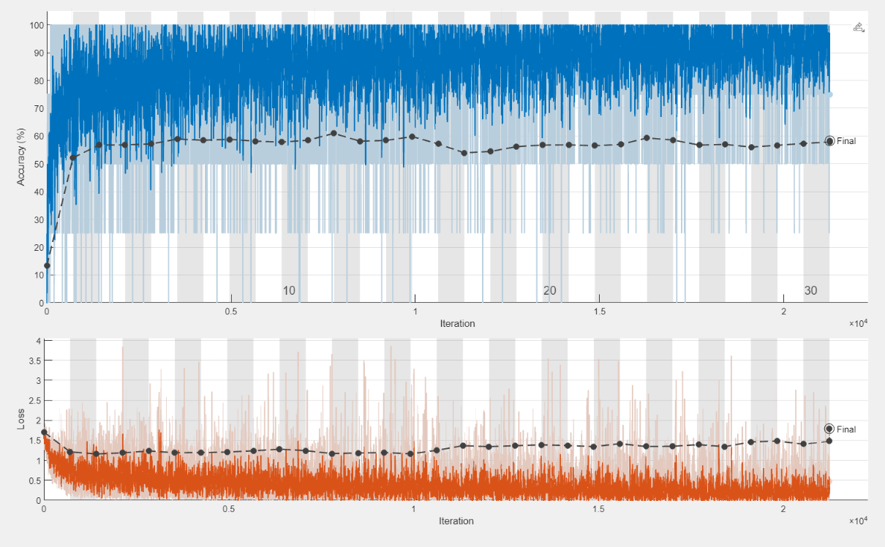
- MobileNet | 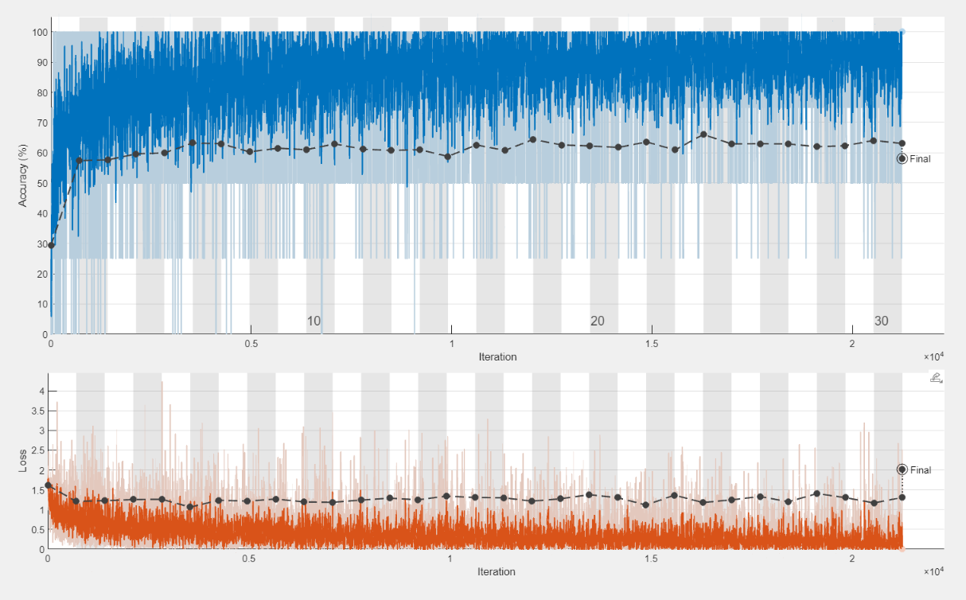
- ResNEt-18 | 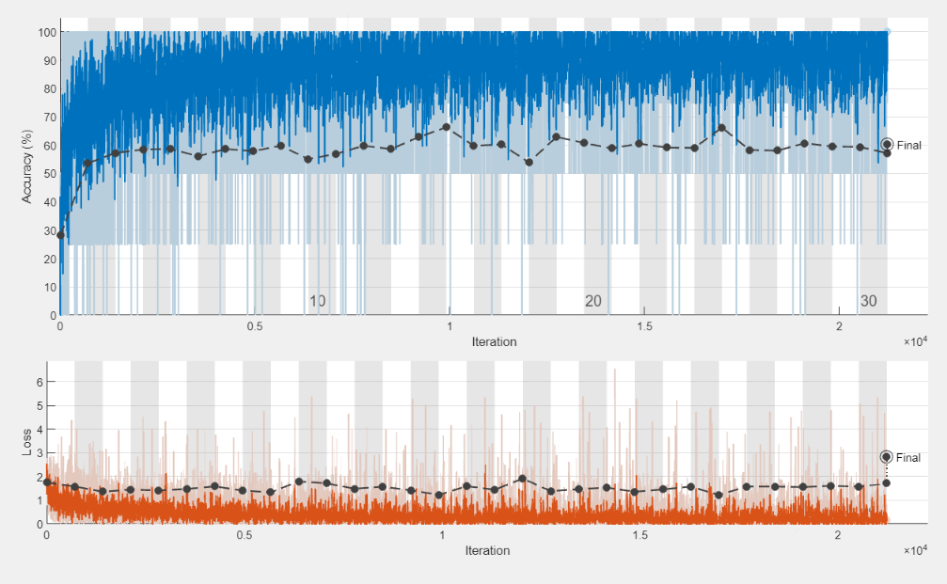

Figure S.1 Training Validation Curves for (a) Efficient-B0, (b) MobileNet, (c) ResNet-18 trained on the SIPaKMeD dataset

