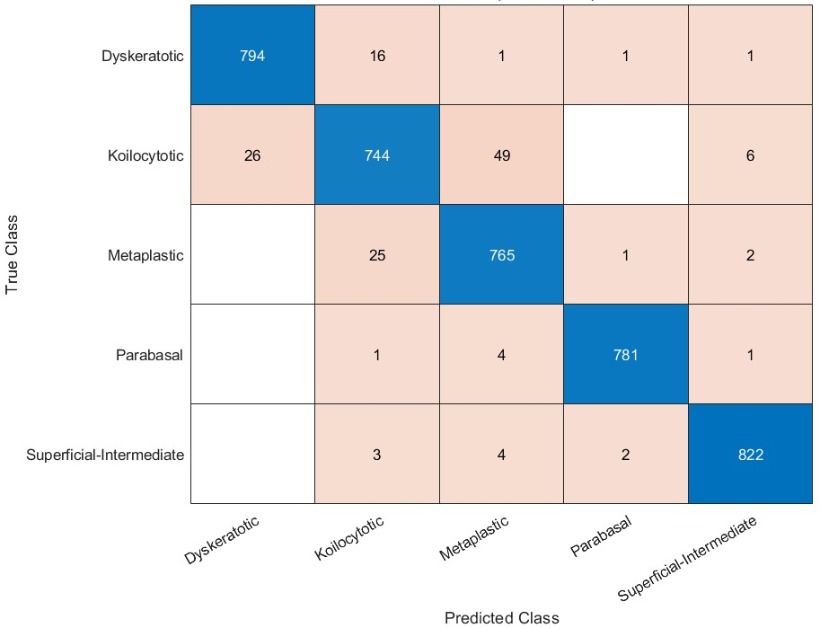 | 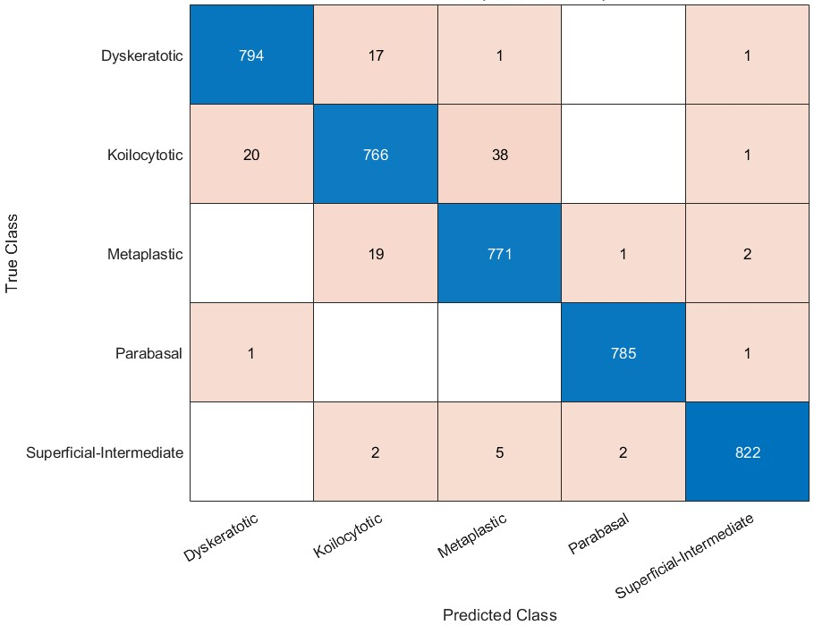
LSVM | QSVM
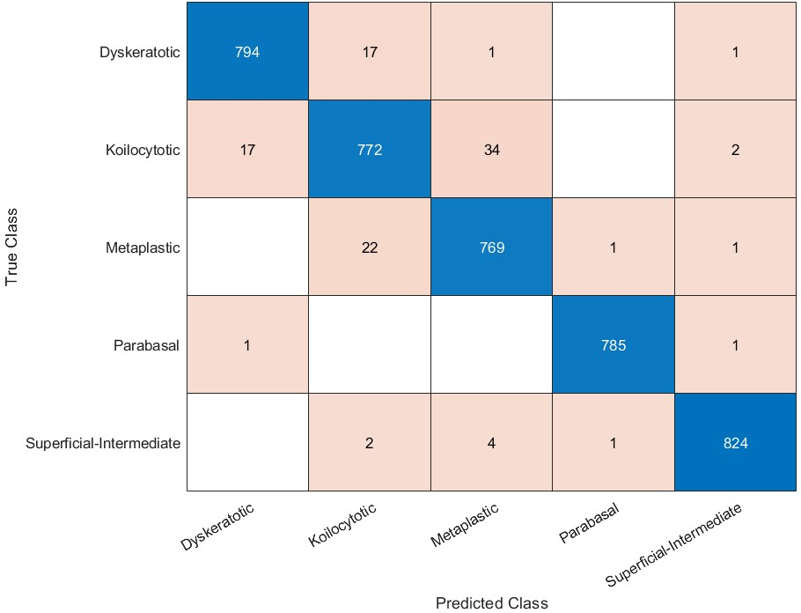 | 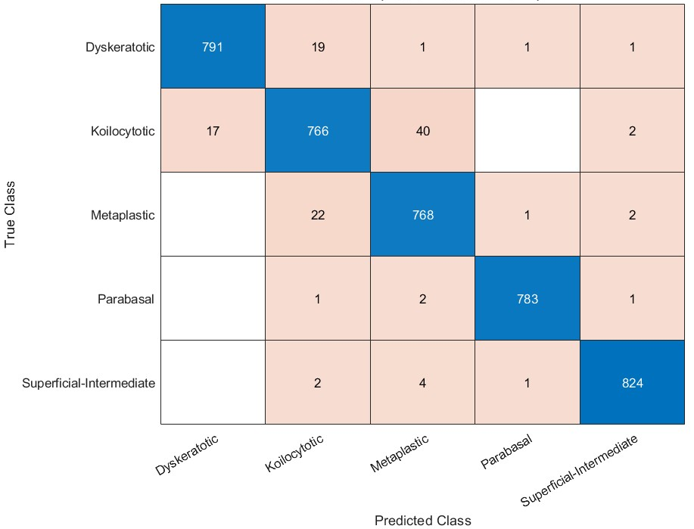
CSVM | GSVM
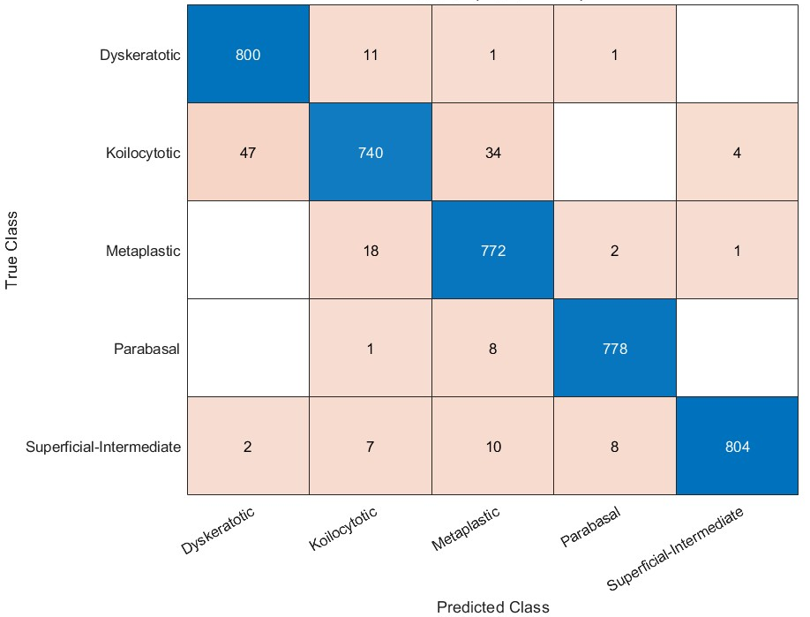 | 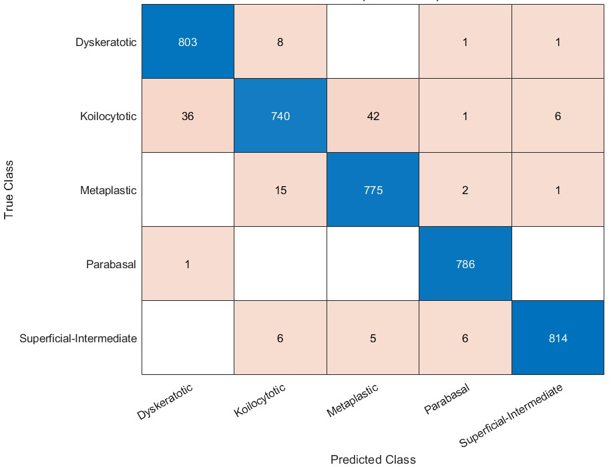
MKNN | CKNN
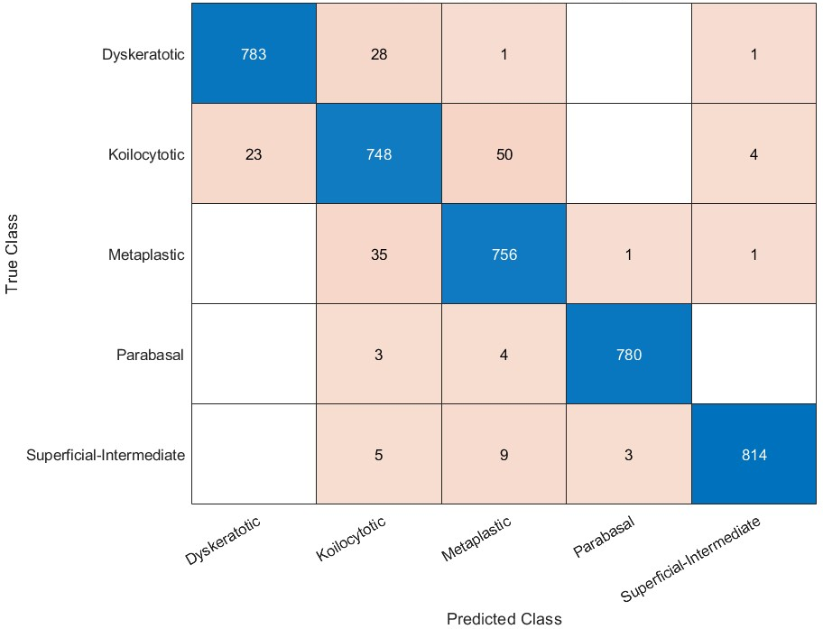
LDA
Figure S3 Confusion metrics (TP and TN vs. FP and FN) for the seven classification models learnt with the picked attributes of ANOVA feature selection from the SIPaKMeD dataset.

