Supplementary Materials A
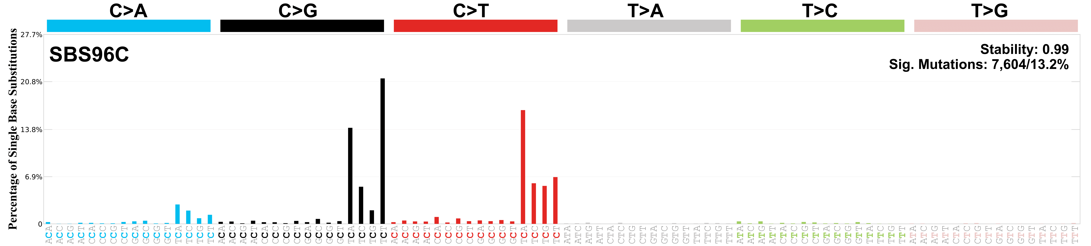
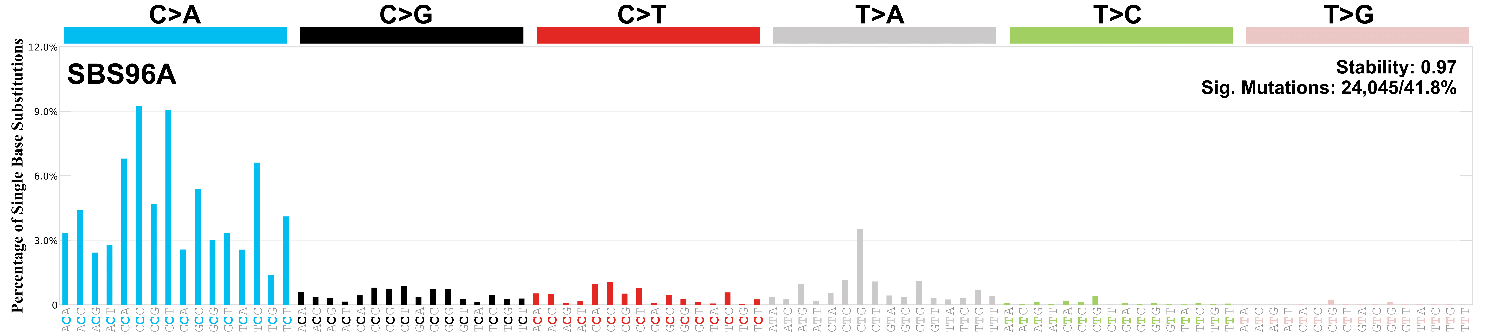
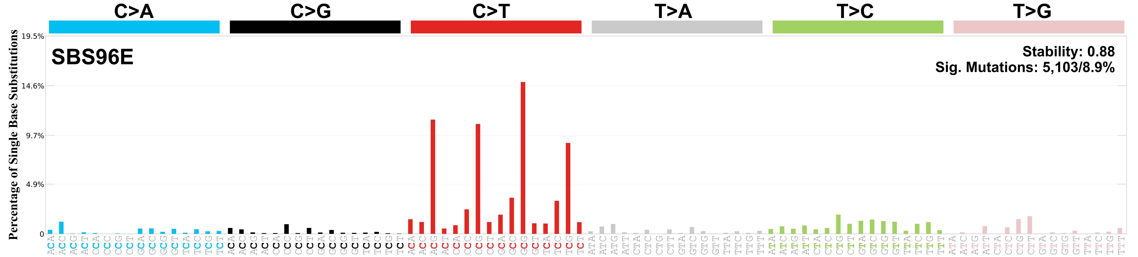

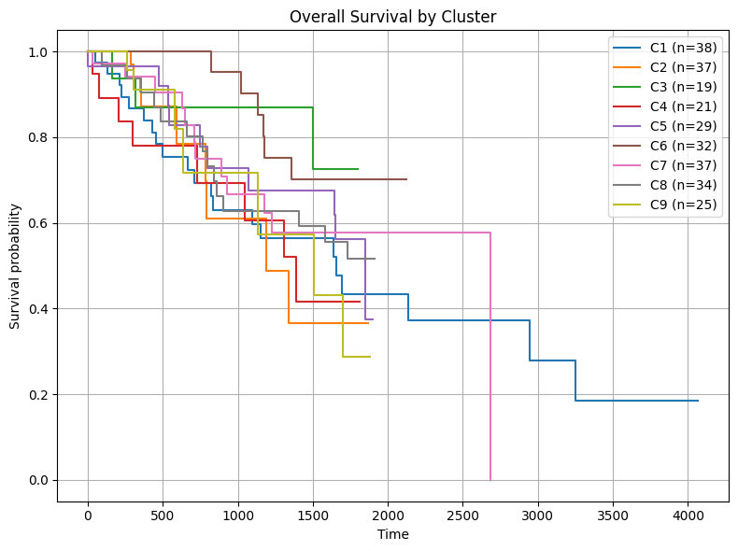

Figure S1: Survival rates for each cluster using Kaplan-Meier Survival Analysis.

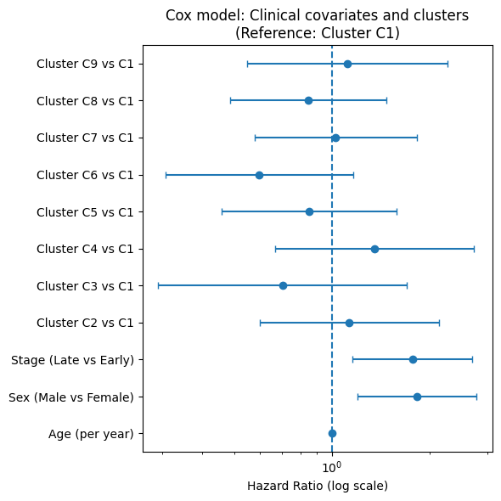
Figure S2: Adjusted Cox proportional hazard model showing that hazard ratios did not differ significantly after adjustment.

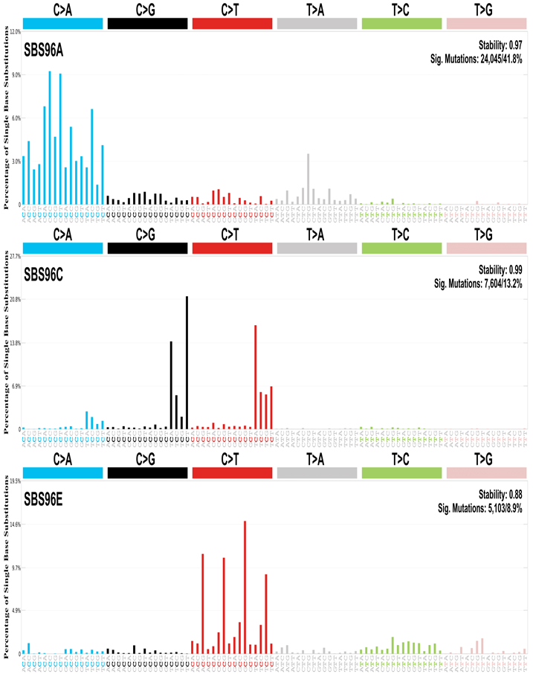

Figure S3: Mutation Analysis SBS signature, top 3 based on stability/similarity, all greater than >0.85.

Histology subtype | Count | Percent
Adenocarcinoma, NOS | 180 | 60.2
Squamous cell carcinoma, NOS | 111 | 37.1
Not Reported | 4 | 1.3
Adenocarcinoma with mixed subtypes | 2 | 0.7
Squamous cell carcinoma, keratinizing, NOS | 1 | 0.3
Missing | 1 | 0.3

Table S1: Breakdown of histological subtypes in the finalized cohort.

Clinical variable | N included | P-value
Stage | 293 | 0.00267
Gender | 298 | 0.00000261
Histology | 298 | 1.33E-37
Smoking status | 293 | 3.54E-09

Table S2: Chi-squared tests p-value results on associated clinical variables and cluster identity.

