Supplementary File

Large-Scale Transcriptomic Data Mining Using Explainable XGBoost and SHAP Reveals Shared Biomarkers and Molecular Mechanisms between Type-2 Diabetes and Triple-Negative Breast Cancer for Drug Repurposing
Md. Feroj Ahmed¹, Ovi Sharma^{1,2}, Tasfia Noor^{1,3}, Md. Abdul Latif ¹, Md. Foysal Ahmed¹, Moumita Bashak¹, Dewan Mumdood Ahmed¹, Md. Sanoar Hossain^{1,4}, Md. Nurul Haque Mollah¹*
¹Bioinformatics Lab (Dry), Department of Statistics, University of Rajshahi, Rajshahi-6205, Bangladesh.
²MBBS, TMSS Medical College, Bogura, Bangladesh.
³Department of Computer Science & Engineering, Rajshahi University of Engineering & Technology, Rajshahi-6204, Bangladesh.
⁴Institute of Bangladesh Studies (IBS), University of Rajshahi, Rajshahi-6205, Bangladesh.

*Corresponding author: Md. Nurul Haque Mollah (Email: mollah.stat.bio@ru.ac.bd )

Supporting Items | Pages
Supplementary Methods
Method S1: Linear Model for Microarray (LIMMA) | 3
Method S2: XGBoost machine learning implementation | 3-4
Method S3: ADMET criteria | 4-5
Supplementary Figures
Fig. S1. A) Integrated T2D samples before batch-effect correction using pyComBat. (B) Integrated TNBC samples before batch-effect correction using pyComBat. (C) Integrated T2D samples after batch-effect correction using pyComBat. (D) Integrated TNBC samples after batch-effect correction using pyComBat | 6
Fig. S2. Visualization of principal component analysis A) TNBC dataset before batch correction (B) TNBC dataset after batch correction. (C) T2D dataset before batch correction. (D T2D dataset after batch correction. | 7
Fig. S3. (A) SHAP values and effect directions of the top 20 sDEGs in the T2D machine-learning model. (B) SHAP values and effect directions of the top 20 sDEGs in the TNBC machine-learning model. Positive SHAP values indicate a higher likelihood of disease status, whereas negative SHAP values indicate a tendency toward the normal (control) state. | 8
Supplementary Tables
Table S1. Collection of type-2 diabetes (T2D) related candidate drug agents from published articles and other sources | 9-10
Table S2. Collection of drug agents for T2D and TNBC from DrugBank database | 11-12
Table S3. Collection of sKGs drug agents from DGIdb 4.0 database | 13
Table S4. List of sDEGs for T2D and TNBC | 13
Table S5. Binding Pocket Identification and Druggability Assessment of the target protein. | 14
Table S6. Binding affinity scores of 50 drugs molecule from 146 molecule with sKGs and TFs | 14-15

Supporting methods
Method S1: Linear Model for Microarray (LIMMA)
The statistical linear models for microarray (LIMMA) data analysis is a popular approach for identification of differentially expressed genes (DEGs) between case and control samples
The LIMMA model is written as,

$$z_{g}={Xα}_{g}+ ∈_{g} … 1$$
where $z_{g}={\left(z_{g1},z_{g2},z_{g3}, …, z_{gn}\right)}^{'}$ is the responses (expressions) m-vector of gth gene with $n= n_{1}+n_{2}$samples (g = 1, 2,…, G), X is an n×2 design matrix, $α_{g}={\left(α_{g1}, α_{g2}\right)}^{'}$ is a 2-vector (2<n) of effects for ccRCC and control groups of n samples and the error vector $∈_{g} \sim N(0, { W}_{g}σ_{g}^{2})$. The gth gene is said to be equally expressed gene (EEG) if the null hypothesis ($H_{0})$: $α_{g1}= α_{g2}= > γ_{g}=\left( α_{g1}- α_{g2}\right)=0$ is true. Otherwise, it is said to be a differentially expressed gene (DEG). To test the significance of $H_{0}$, the test statistic for LIMMA approach is defined as
$${\tilde{t}}_{g}= \frac{{\hat{γ}}_{g}+γ_{g}}{{\tilde{S}}_{g} \sqrt{δ_{g}}} …2$$

which follows t-distribution under $H_{0}$. Adjusted P-values based on the moderated t-statistic and the average of log2 fold-change (Log₂FC) values of treatment group with respect to the control group were used to select DEGs.

Method S2: XGBoost machine learning implementation
XGBoost classifier is a gradient boosting method that combines the regression tree [1]. The goal function of the XGBoost algorithm model is $obj(θ) = L(θ) + Ω(θ)$, where L(θ) is the training loss function, and $Ω(θ)$ is the complexity function of the tree. $L\left(θ\right)= \sum_{i=1}^{n}{l(y_{i},ŷ_{i})}, l(y_{i},ŷ_{i})$ corresponds to the training loss function for each sample, where $y_{i}$ represents the true value of the ith sample, and $ŷ_{i}$ represents the estimated value of the ith sample. $ŷ_{i}= \sum_{k=1}^{K}{f_{k}(x_{i})}$, $f_{k}∈F,$ where K represents the number of trees, F represents all possible DT, and f denotes a specific CART tree. $Ω\left(f\right)= γT+\frac{1}{2} λ\sum_{i =1}^{T}{w_{i}^{2},}$ where $w_{i}^{ }$ is the score on the ith leaf node, and T is the number of leaf nodes in the tree. By adjusting parameters, the objective function was continuously optimized, and optimal results were obtained. The grid search algorithm was used to optimize the hyper-parameters, including max_depth, min_child_weight, gamma, subsample, colsample_bytree and learning_rate in each iteration[2]. SHapley Additive exPlanations (SHAP) -value-based selection is mostly used for important feature selection. SHAP leverages game theory concepts to compute feature importance in two steps: training a classification model using all features in the initial interaction and then computing SHAP values for each feature, subsequently ranking them to identify the most significant features for modeling the target problem[3].
We applied the XGBoost machine learning model separately to each disease dataset to prioritize genes based on their ability to distinguish disease samples from controls. This approach allowed us to capture potential non-linear relationships within gene expression patterns. To interpret the model and identify the most influential features, SHAP was used, which highlighted the top contributing genes driving the classification. All available data was used during model training to capture the full range of gene expression variability and improve model robustness. Prior to model fitting, 5-fold cross-validation was performed to optimize hyperparameters and minimize the risk of overfitting, ensuring reliable and generalizable results.

Method S3: ADMET criteria
The ADME/T properties of the selected compounds were evaluated using established in-silico pkCSM prediction platforms (DeepPK and pkCSM). These tools estimate pharmacokinetic and toxicity parameters based on molecular structure and graph-based signatures. Drug suitability was determined using widely accepted qualitative and quantitative thresholds for ADMET parameters, as outlined below:
1. Absorption
- Caco-2 permeability (logPapp): > -6.0 means acceptable permeability.
- Human Intestinal Absorption (HIA): Positive means absorbed otherwise not.
- P-glycoprotein (P-gp): Inhibitor/non-inhibitor noted (no strict exclusion, but flagged for transport effects).
2. Distribution
- Blood–Brain Barrier (BBB): Penetrable or non-penetrable depending on therapeutic target (no strict cutoff).
- CNS permeability (logPS): between -3.0 and -1.0 means moderate CNS accessibility.
3. Metabolism
- CYP3A4 inhibition: Preferably Non-inhibitor is good.
- CYP2D6 inhibition: Preferably Non-inhibitor is good.

4. Excretion
- Total Clearance (log ml/min/kg): Moderate range (no strict cutoff; values approximately 5 to 9 considered acceptable).
- Half-life < 3 hours means acceptable for early-stage candidates (indicates no excessive accumulation).
5. Toxicity
- AMES Mutagenicity: Non-mutagenic means safe
- Fathead Minnow Toxicity has no strict predicted range
- Rat Acute Toxicity (LD50): Within safe predicted limits means no high acute toxicity.

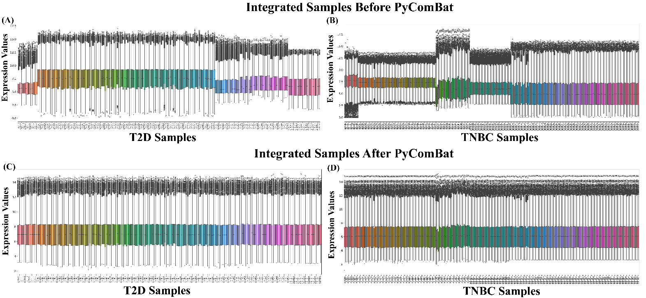
Supporting Figures

Fig. S1. A) Integrated T2D samples before batch-effect correction using pyComBat. (B) Integrated TNBC samples before batch-effect correction using pyComBat. (C) Integrated T2D samples after batch-effect correction using pyComBat. (D) Integrated TNBC samples after batch-effect correction using pyComBat.

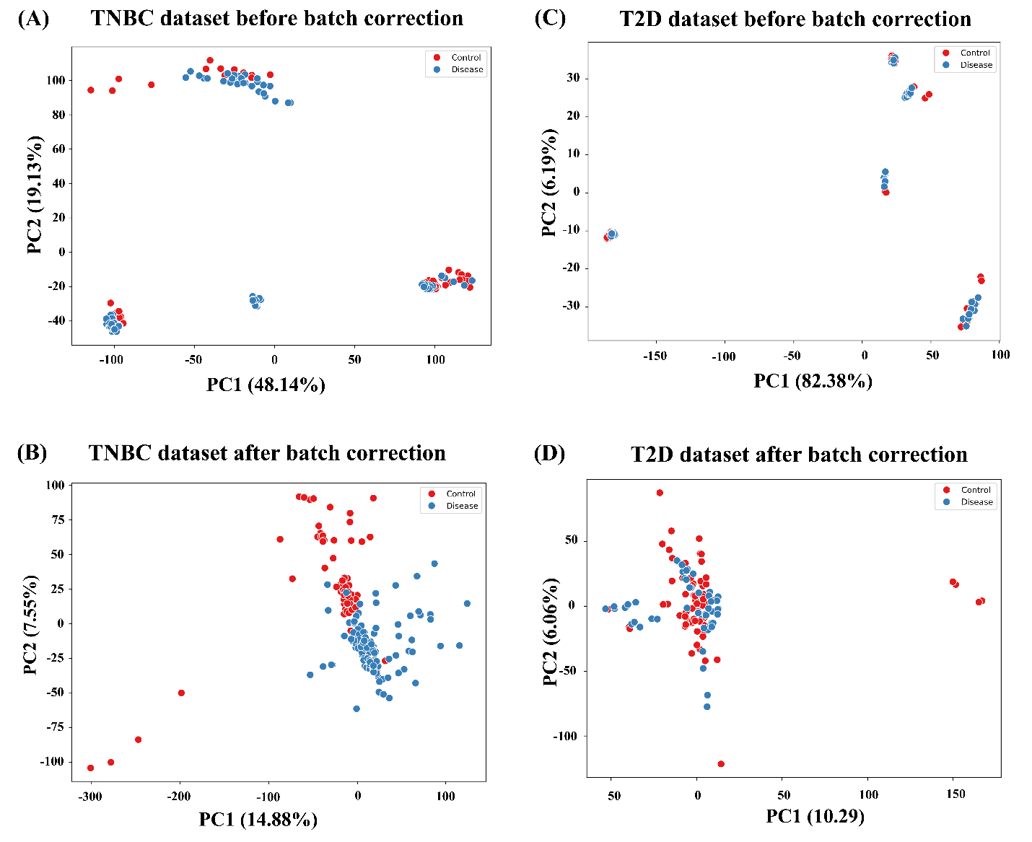
Fig. S2. Visualization of principal component analysis A) TNBC dataset before batch correction (B) TNBC dataset after batch correction. (C) T2D dataset before batch correction. (D T2D dataset after batch correction.
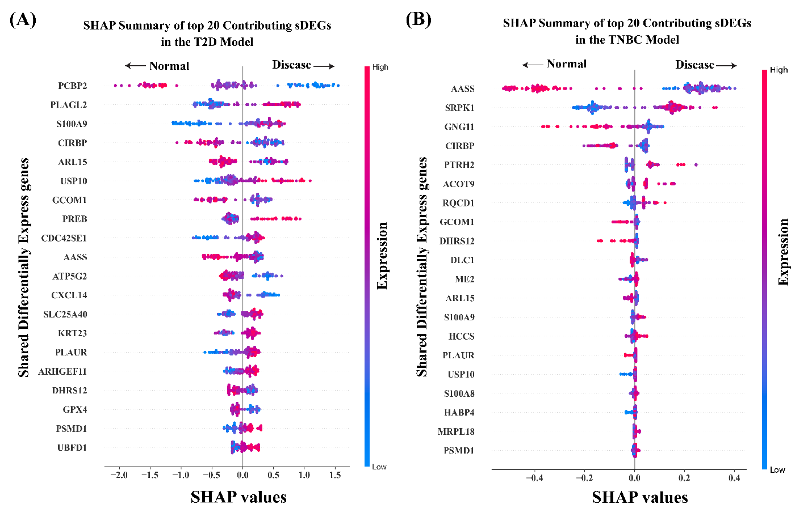

Fig. S3. (A) SHAP values and effect directions of the top 20 contributing sDEGs in the T2D machine-learning model. (B) SHAP values and effect directions of the top 20 contributing sDEGs in the TNBC machine-learning model. Positive SHAP values indicate a higher likelihood of disease status, whereas negative SHAP values indicate a tendency toward the normal (control) state.

Supporting Tables
Table S1. Collection of type-2 diabetes (T2D) related candidate drug agents from published articles and other sources
Articles | Drug agents
[4] | Alogliptin, Saxagliptin, Sitagliptin, Lixisenatide, Empaglifl ozin, Liraglutide, Canaglifl ozin, Exenatide, Linagliptin, Dapaglifl ozin, Dulaglutide, Acarbose
[5] | Sulfonylureas, Meglitinides, Metformin, Thiazolidinediones, α-Glucosidase, nhibitors, Insulin
[6] | Basal, Biphasic, Prandial, Basal bolus, GLP-1 agonists, Exenatide LAR, DPP-4 inhibitors, AGI, Thiazolidinediones, Sulphonylureas, Glinides, Metformin
[5] | Insulin, Sulphonylureas, Metformin, Acarbose, Pioglitazone, rosiglitazone
[7] | Acetohexamide, olbutamide, Chlorpropamide, Tolazamide, Glipizide, Glipizide, Glyburide, Glyburide micronised, Glimepiride, Gliquidone, Gliclazide
[8] | Statins, Fibrates, ACE inhibitors and ARBs, Aspirin, Metformin, Glitazones
[9] | Ciglitazone, Troglitazone, Pioglitazone, Englitazone, Darglitazone, Rosiglitazone, Isaglitazone
[10] | Biguanides, Sulfonylureas, Thiazolidinediones, peptide-1 receptor, Dipeptidyl peptidase-4, Sodium glucose
[11] | Sulfonylureas, Biguanides, Inhibitors of α-glucosidase, Thiazolidinediones, Meglitinides, Dipeptidyl peptidase 4 inhibitors
[12] | Insulin, Sulphonylurea, Biguanides, Acarbose, Thiazolidinediones, PPAR/ dual agonists, GLP-1 analogs
[13] | Colesevelam, Exenatide, Linagliptin, Liraglutide, Saxagliptin, Sitagliptin, Taspoglutide, Empagliflozin, Exenatide, Alogliptin, Albiglutide, Omarigliptin, Dulaglutide, Lixisenatide, Sotagliflozin, Ertugliflozin
[14] | Insulin and its derivatives, Sulphonylurea, Biguanide, Acarbose, Voglibose, Pioglitazone, Exercise, Curcumin, Resveratol, α-thioctic acids,
[15] | Metformin, Albiglutide, Dulaglutide, Exenatide, Exenatide XR, Liraglutide, Lixisenatide, Canagliflozin, Dapagliflozin, Empagliflozin, Alogliptin, Linagliptin, Sitagliptin, Saxagliptin, Glimepiride, Glipizide, Glyburide, Pioglitazone, Rosiglitazone
[16] | Thiazolidinediones, Biguanide, Sulfonylureas, Meglitinides, Insulin
[17] | Biguanides, Sulfonylureas, Meglitinides, Thiazolidinediones, Alpha-Glucosidase Inhibitors, Incretin, Bromocriptine, Insulin
[18] | Berberine, Resveratrol, Emodin, Ellagic acid, Epigallocatechin gallate, Curcumin, Baicalein, Naringenin, Hesperetin, Chrysin, Genistein, Kaempferol, Eriodictyol, Apigenin, Quercetin
[19] | Steroids, Triterpenoids, Saponins, Glycosides, Carbohydrates, Alkaloids, Flavonoids, Tannins & Phenolic, Proteins, Amino acid
[20] | Tannin, Saponin, Alkaloid, Flavonoid, Phenol, Terpenoid, Carbohydrate
[21] | Singrin, Boeravinone E, Boeravinone D, Wedelolactone, Squamosamide , Taxifolin
[22] | Polyphenols, Amino Acid, Saponins, Terpenoids, Abscisic Acid, Lycopene and b-Carotene, Oxyphytosterol, Phytosterols/Stanols
[23] | Epigallocatechin gallate, Cyandin and cyanidin 3-glucoside, Soy isoflavones mixture, Genistein, Naringin, Quercetin, Berberine, Resveratrol
[24] | 6-Methoxykaempferol, α-Bisabolol, Anthecotulide, Apigenin, Apigenin-7-glucoside, Axillarin, Azulene, β-Sitosterol, Caffeic acid, Catechin, Chlorogenic acid, Chrysoeriol, Chrysosplenetin, Eupatoletin, Isoferulic acid, Isorhamnetin, Jaceidin, Kaempferol, Linoleic acid, Luteolin, Matricarin, Oleic acid, Patuletin, Quercetagetin-3,6,7,3',4'-, pentamethylether, Quercetin, Sinapic acid, Spinacetin, Stigmasterol, Thiamine, Umbeliferone.
[25] | saponins, alkaloids, terpenes, phenylpropanoids, isoprenoids, steroids, coumarins, flavonoids, phenolic acids, lignans, contain chemicals such as flavonoids, terpenoids, lignans, sulfides, polyphenolics, carotenoids, coumarins
[26] | (9Z,12Z)-octadeca-9,12-dienoic acid, 4-[Bis(2-hydroxyethyl)amino]phenyl]-1,1,2-ethylenetricarbonitrile, 1-(2-(methylthio)pyrimidin-4-yl)ethanone, 1-(2-chloropyridin-4-yl)ethanone, 1-(furan-2-yl)ethanone, 1,19-Eicosadiene, 2-methoxyphenol, 2-Pentadecanone, 2-Phenyloxazole-4-carboxylic acid, 2-Propenoic acid-3-(4-hydroxy-3-methethoxyphenly ferullic acid, 2,3-Dihydrobenzofuran-5-boronic acid, 2,6-Dimethoxyphenol, 7-decen-4-olide, 14-Methylpentadecanoic acid, Citronellyl isobutyrate, E stilbene, Inositol 1,4,5-trisphosphate, Methyl stearate, n-Hexadecanoic acid, Phenol, 2,6-bis(bromomethyl)-4-chloro-3,5-dimethyl, Phytol
[27] | Flavanoid, Tannin, Terpenoids, Alkaloids, Saponins
[28] | 4,5-dimethyl-3-hydroxy-2(5H)-furanone, apigenin, bromelain, caffeic acid, cholecalciferol, dihydrokaempferol 7-o-glucopyranoside, galactomannan, genkwanin, isoimperatorin, luteolin, luteolin 7-o-glucoside, neohesperidin, oleanoic acid, pelargonidin-3-rutinoside, quercetin, quinic acid
[29] | 2,3-Butanediol, Glycerin, 4H-Pyran-4-one,2,3- dihydro-3,5-dihydroxy6-methyl, 5- Hydroxymethylfurfural, D-Glucose,6-O-à-Dgalactopyranosyl, Sucrose, Cyclooctasiloxane, hexadecamethyl -, n -Hexadecanoic acid, 4H -Pyran - 4 -one,5 - hydroxy - 2 – (hydroxymethyl)
[30] | Flavonoids, Alkaloids, Glycosides, Polysaccharides, Terpenoids and steroids, Saponins Isothiocyanate,
[31] | Methionine, Cystine, Selenium, Folate, Choline, Tocopherols + tocotrienols, Carotenoids, Polyphenols, Phenolic acids, Phenolic acid, Ferulic acid, Flavanoids, Alkylresorcinols, Avenanthramides, Betaine, Phytosterols
[32] | Coumarin, p-Coumaric acid, o-Coumaric acid, Vanillic acid, Caffeic acid, Ferulic acid, Syringic acid, Sinapinic acid, Genistein, Apigenin, Naringenin, Kaempferol, Luteolin, Epicatechin, Epigallocatechin, Quercetin, 2-Phenylethyl-β-D-glucoside, Phenyl-6I-O-maloyl-β-D-glucoside

Table S2. Collection of drug agents for T2D and TNBC from DrugBank database
sources | T2D
[33] | Thyroid, porcine, Thyrotropin alfa, Iodide I-131, Levothyroxine, Liothyronine, Iodide I-123, Technetium Tc-99m pertechnetate, Liotrix, Sorafenib, Bacillus calmette-guerin substrain connaught live antigen, Teprotumumab, Bacillus calmette-guerin substrain russian BCG-I live antigen, Cabozantinib, Resmetirom, Propylthiouracil, Nadofaragene, firadenovec, Cyproterone acetate, Nogapendekin alfa, Tivozanib, Potassium perchlorate, Vismodegib, Lenvatinib, Thyroglobulin, Potassium Iodide, Temsirolimus, Diosmin, Regorafenib, Methimazole, Hexaminolevulinate, Vandetanib, Doxorubicin, Aminoglutethimide, Avelumab, Carbimazole, Imiquimod, Rutin, Dextrothyroxine, Carboplatin, Mitotane, Afamitresgene autoleucel, Tiratricol, Sodium iodide, Retifanlimab, Sonidegib, Temoporfin, Vinflunine, Zileuton, Estradiol valerate, Cemiplimab, Carbazochrome, Encorafenib, Protirelin, Somatostatin, Axitinib, Dabrafenib, Esculin, Tyrosine, Hydroxyethyl Starch, Melphalan, Histamine, Sunitinib, Medroxyprogesterone acetate, Ritlecitinib, Penpulimab, Balsam of Peru, Tucatinib, Gefitinib, Streptozocin, Calcipotriol, Selenic acid, Aldesleukin, Toripalimab, Pentosan polysulfate, Calcium glubionate anhydrous, Erdafitinib, Chlorotrianisenem, Quinestrol, Isoetharine, Iopodic acid, Trametinib, Mechlorethamine, Tremelimumab, Minoxidilk, Ethiodized oil, Mometasone, Cholecystokinin, Bleomycin, Dioxybenzone, Estramustine, Fluocinolone acetonide, Flutamide, Loteprednol etabonate, Glasdegib, Tetryzoline, Estrone, Estrone sulfate, Pilocarpine, Panitumumab, Ferric sulfate, Goserelin, Estradiol dienanthate, Diethylstilbestrol, Estradiol benzoate, Technetium Tc-99m tilmanocept, Bicalutamide, Strontium chloride Sr-89, Pheniramine, Ixabepilone, Clomifene, Nivolumab, Abiraterone, Atezolizumab
TNBC
[33] | Octocrylene, Polyethylene glycol 400, Fulvestrant, Neomycin, Hexylresorcinol, Calcitriol, Histamine, Povidone-iodine, Estriol, Octinoxate, Ergotamine, Letrozole, Estradiol, Calcifediol, Prednisone, Estrone sulfate, Pertuzumab, Elacestrant, Sacituzumab govitecan, Prednisone acetate, Adenosine, Miconazole, Benzocaine, Gadobutrol, Phenobarbital, Racementhol, Abemaciclib, Formestane, Tamoxifen, Migalastat, Sodium fluoride, Talbutal, Fluoroestradiol F-18, Butalbital, Ribociclib, Exemestane, Gadoteridol, Anastrozole, Toremifene, Sucrose, Alfacalcidol, Dapagliflozin, Prednisolone, Trastuzumab, Lapatinib, Palbociclib, Capivasertib, Albuterol, Methylprednisolone, Betamethasone, Iodine, Gallium Ga-68 gozetotide, Trabectedin, Hydrocortisone, Polyestradiol phosphate, Datopotamab deruxtecan, Salicylic acid, Cabazitaxel, Testolactone, Sodium fluorophosphate, Alpelisib, Patent Blue, Tucatinib, Raloxifene, Sipuleucel-T, Olaparib, Mirvetuximab soravtansine, Pentobarbital, Talazoparib, Nitroglycerin, Margetuximab, Ixazomib, Carfilzomib, Bortezomib D-mannitol, Ixazomib Citrate, Bortezomib, Vemurafenib, Paclitaxel, Erlotinib, Hexachlorophene, Sertraline Hydrochloride, Thimerosal, Abiraterone Acetate, Enzalutamide, Venetoclax, Epirubicin, Sulconazole Nitrate, Azacitidine, Cinnarizine, Paroxetine Hydrochloride, Hemihydrate, Ibrutinib, Cabozantinib S-malate, Docetaxel Anhydrous, Masoprocol, Indoprofen, Cisplatin, Pyrithione Zinc, Astemizole, Dopamine, Sunitinib, Decitabine, Triflupromazine, Methimazole, Brigatinib, Irinotecan Hydrochloride, Apomorphine, Idelalisib, Trametinib Dimethyl Sulfoxide, Bendamustine, Clioquinol, Ipilimumab, Clemastine, Selumetinib, Rituximab, Cytarabine, Osimertinib, Raloxifene Hydrochloride, Pimozide, Amoxapine, Vitamin K3, Vorinostat, Clotrimazole, Perphenazine, Genistein, Ethopropazine Hydrochloride, Crizotinib, Fenofibrate Micronized, Iodoquinol, Pembrolizumab, Levonorgestrel, Zanubrutinib, Oxaliplatin, Econazole Nitrate, Inositol, Alectinib, Pazopanib, Thiotepa, Thioridazine, Benzalkonium Chloride, Dabrafenib, Melphalan, Cyclophosphamide Anhydrous, Tamoxifen Citrate, Nortriptyline, Lorlatinib, Ruxolitinib, Alemtuzumab, Selinexor, Sapanisertib, Propylthiouracil, Chlorambucil, Trifluridine, Mitomycin, Obinutuzumab, Loperamide, Methotrexate, Mercaptopurine, Zinc Chloride, Azathioprine, Triamterene, Niclosamide, Salmeterol Xinafoate, Enalapril Maleate, Sirolimus, Ifosfamide, Temozolomide, Mitoxantrone, Diethylstilbestrol, Mitoxantrone Hydrochloride, Bevacizumab, Pirtobrutinib, Nivolumab, Fluphenazine Hydrochloride, Chlorpromazine, Cetuximab, Nitazoxanide, Interferon Alfa-2b, Cladribine, Clomipramine, Ursodiol, Glutaral, Duvelisib, Mechlorethamine Hydrochloride, Fluorouracil, Camptothecin, Acalabrutinib, Chloroxine, Doxorubicin Liposome, Ribavirin, Furazolidone, Clofibrate, Topotecan Hydrochloride, Encorafenib, Hydralazine, Lenalidomide, Benzethonium Chloride, Fenretinide, Panitumumab, Gemcitabine, Axitinib, Pramlintide, Trifluoperazine, Anisindione, Capecitabine, Resveratrol, Warfarin, Sorafenib, Doxorubicin Hydrochloride, Etoposide, Ceritinib, Prochlorperazine, Maprotiline, Haloperidol Decanoate, Carboplatin, Bithionol, Daunorubicin Hydrochloride, Granisetron, Papain, Ambroxol, Eribulin, Megestrol acetate, Gefitinib, Trastuzumab Emtansine, Gallium Nitrate, Danazol, Trastuzumab Deruxtecan, Buserelin, Aminoglutethimide, Tirbanibulin, Pafolacianine, Doxorubicin, Docetaxel, Pegulicianine, Avutometinib, Vinorelbine, Darolutamide, Rucaparib, Bexarotene, Piflufolastat F 18, Zenocutuzumab, Goserelin, Durvalumab, Catumaxomab, Tepotinib, Pralatrexate, Samarium (153sm) Lexidronam, Denosumab, Telisotuzumab Vedotin, Lenvatinib, Capmatinib, Apalutamide, Degarelix,P apain, Letrozole, Pertuzumab, Fulvestrant, Formestane, Tamoxifen, Fluoroestradiol F-18, Exemestane, Elacestrant, Anastrozole, Toremifene, Sucrose, Racementhol, Trastuzumab, Lapatinib, Albuterol, Iodine, Gallium Ga-68 gozetotide, Trabectedin, Sacituzumab govitecan, Testolactone, Ribociclib, Tucatinib, Raloxifene, Sipuleucel-T, Abemaciclib, Olaparib, Bevacizumab, Ixabepilone, Margetuximab, Methyltestosterone, Neratinib, Ambroxol, Benzocaine, Eribulin, Alpelisib, Talazoparib, Megestrol acetate, Patent Blue, Gefitinib, Trastuzumab emtansine, Paclitaxel, Gallium nitrate, Capecitabine, Danazol, Trastuzumab deruxtecan, Palbociclib, Capivasertib, Buserelin, Cetuximab, Aminoglutethimide, Tirbanibulin, Pafolacianine, Datopotamab deruxtecan, Doxorubicin, Docetaxel, Pegulicianine, Avutometinib, Vinorelbine, Darolutamide, Rucaparib, Estrone sulfate, Bexarotene, Gemcitabine, Piflufolastat F 18, Zenocutuzumab, Goserelin, Durvalumab, Sodium fluorophosphate, Catumaxomab, Methotrexate, Tepotinib, Mirvetuximab soravtansine, Pralatrexate, Samarium (153Sm) lexidronam, Denosumab, Dabrafenib, Telisotuzumab vedotin, Lenvatinib, Capmatinib, Apalutamide, Degarelix

Table S3. Collection of sKGs drug agents from DGIdb 4.0 database
[34] | Ixazomib, Carfilzomib, Bortezomib D-mannitol, Ixazomib Citrate, Bortezomib, Vemurafenib, Paclitaxel, Erlotinib, Hexachlorophene, Sertraline Hydrochloride, Thimerosal, Abiraterone Acetate, Enzalutamide, Venetoclax, Epirubicin, Sulconazole Nitrate, Azacitidine, Cinnarizine, Paroxetine Hydrochloride, Hemihydrate, Ibrutinib, Cabozantinib S-malate, Capivasertib, Tamoxifen, Docetaxel Anhydrous, Masoprocol, Indoprofen, Cisplatin, Pyrithione Zinc, Astemizole, Dopamine, Sunitinib, Decitabine, Triflupromazine, Methimazole, Brigatinib, Irinotecan Hydrochloride, Apomorphine, Idelalisib, Trametinib Dimethyl Sulfoxide, Bendamustine, Clioquinol, Ipilimumab, Olaparib, Clemastine, Selumetinib, Rituximab, Cytarabine, Osimertinib, Raloxifene Hydrochloride, Pimozide, Amoxapine, Vitamin K3, Vorinostat, Clotrimazole, Perphenazine, Fulvestrant, Palbociclib, Genistein, Ethopropazine Hydrochloride, Crizotinib, Fenofibrate Micronized, Iodoquinol, Pembrolizumab, Levonorgestrel, Zanubrutinib, Oxaliplatin, Econazole Nitrate, Inositol, Alectinib, Pazopanib, Thiotepa, Thioridazine, Benzalkonium Chloride, Dabrafenib, Melphalan, Cyclophosphamide Anhydrous, Tamoxifen Citrate, Nortriptyline, Lorlatinib, Ruxolitinib, Alemtuzumab, Selinexor, Sapanisertib, Propylthiouracil, Chlorambucil, Trifluridine, Mitomycin, Obinutuzumab, Loperamide, Methotrexate, Mercaptopurine, Zinc Chloride, Azathioprine, Triamterene, Niclosamide, Salmeterol Xinafoate, Enalapril Maleate, Sirolimus, Alpelisib, Ifosfamide, Temozolomide, Mitoxantrone, Diethylstilbestrol, Mitoxantrone Hydrochloride, Bevacizumab, Pirtobrutinib, Nivolumab, Fluphenazine Hydrochloride, Chlorpromazine, Cetuximab, Nitazoxanide, Interferon Alfa-2b, Cladribine, Clomipramine, Ursodiol, Glutaral, Abemaciclib, Trabectedin, Duvelisib, Mechlorethamine Hydrochloride, Fluorouracil, Camptothecin, Acalabrutinib, Chloroxine, Doxorubicin Liposome, Ribavirin, Furazolidone, Clofibrate, Topotecan Hydrochloride, Encorafenib, Hydralazine, Lenalidomide, Benzethonium Chloride, Fenretinide, Panitumumab, Gemcitabine, Axitinib, Pramlintide, Trifluoperazine, Anisindione, Capecitabine, Resveratrol, Warfarin, Sorafenib, Doxorubicin Hydrochloride, Etoposide, Ceritinib, Prochlorperazine, Maprotiline, Haloperidol Decanoate, Carboplatin, Bithionol, Daunorubicin Hydrochloride, Granisetron, Methylprednisolone

Table S4. List of sDEGs for T2D and TNBC
Up sDEGs
USP10, HCCS, CDC42SE1, HIST1H2BD, PTRH2, ARHGEF11, PLAGL2, PREB, SLC25A40, PLAUR, ASCC3, PSMD1, ME2, ALDH1B1, KRT23, MRPL18, RQCD1, MYD88, S100A9, SRPK1, S100A8, ACOT9, HSPH1, UBFD1
Down sDEGs
PCBP2, CIRBP, CXCL14, ATP5G2, AASS, DHRS12, DLC1, GCOM1, GNG11, ARL15, GPX4, HABP4

Table S5: Binding Pocket Identification and Druggability Assessment of the target protein
Gene | Chain | Volume (Å³) | Surface (Å²) | Depth(Å) | Hydrophobicity  ratio | Druggability  Score
S100A9 | A | 1772.03 | 2556.53 | 24.44 | 0.46 | 0.81
CIRBP | A | 591.42 | 1148.6 | 15.25 | 0.41 | 0.74
USP10 | A | 564.32 | 670.40 | 12.81 | 0.30 | 0.65
PSMD1 | A | 539.46 | 1067.88 | 17.49 | 0.33 | 0.77
TP53 | A | 939.26 | 1131.39 | 19.57 | 0.41 | 0.81
EGR1 | A | 606.14 | 1363.08 | 17.77 | 0.46 | 0.76
USF1 | A | 446.91 | 893.8 | 18.02 | 0.40 | 0.75

Table S6. Binding affinity scores of 50 drugs molecule from 146 molecule with sKGs and TFs
Drugs | CIRBP | USP10 | EGR1 | S100A9 | TP53 | USF1 | PSMD1
Tucatinib | -10 | -8.2 | -9.4 | -9.2 | -9.3 | -8.7 | -7.7
Ursodiol | -9.3 | -8.1 | -9.7 | -8.9 | -9.3 | -8.6 | -7.6
Pimozide | -9.5 | -9.5 | -9.1 | -9.6 | -7.5 | -8.8 | -7
Zanubrutinib | -9.5 | -8.1 | -9.1 | -9.6 | -8.6 | -8.1 | -7
Tepotinib | -9 | -8.9 | -9.1 | -8.7 | -8.6 | -8.2 | -7.4
Bexarotene | -9.4 | -9.6 | -7.9 | -8.7 | -8.8 | -8.1 | -7.4
Olaparib | -9.5 | -9 | -9 | -8.8 | -8.5 | -7.8 | -7
Olaparib | -9.2 | -9 | -9 | -8.3 | -8.3 | -8.1 | -7.5
Astemizole | -8.7 | -9 | -8.4 | -9.3 | -8.2 | -8.3 | -7.5
Selinexor | -8.8 | -9.4 | -8.4 | -9.1 | -8.4 | -7.8 | -7
Cinnarizine | -10 | -8.8 | -8.6 | -8.6 | -7.6 | -8.1 | -7.2
Acalabrutinib | -9 | -8.2 | -8.9 | -9.2 | -8.7 | -7.8 | -7
Alectinib | -8.4 | -8.4 | -9 | -8.9 | -7.9 | -8.2 | -7.8
Ibrutinib | -8.9 | -8.5 | -9 | -8.6 | -8.1 | -8.3 | -7
Abiraterone Acetate | -8.7 | -8.8 | -8 | -8.8 | -8 | -8.4 | -7.6
Paclitaxel | -8.8 | -9 | -9 | -8.8 | -8 | -7.6 | -7
Pazopanib | -9 | -8.1 | -8.7 | -8.4 | -8.2 | -8.1 | -7.5
Sorafenib | -8.5 | -8.6 | -9.1 | -8.4 | -7.8 | -8.6 | -6.9
Avutometinib | -9.7 | -8.1 | -8.8 | -8.4 | -7.5 | -8 | -7.2
Ribociclib | -8.7 | -9.2 | -8.6 | -8.5 | -7.9 | -7.4 | -7.1
Lenvatinib | -9.3 | -8.8 | -8.1 | -7.8 | -8.3 | -7.8 | -7
Camptothecin | -8.5 | -7.7 | -9 | -7.9 | -8.6 | -7.7 | -7.2
Abemaciclib | -8.3 | -8.1 | -8.8 | -8.7 | -8.2 | -7.9 | -6.6
Lapatinib | -9.4 | -8.1 | -8.3 | -8 | -8.1 | -7.6 | -7
Fenretinide | -8.8 | -8.7 | -8 | -8 | -7.9 | -8 | -7
Dabrafenib | -8.4 | -8.5 | -8.5 | -8.3 | -8 | -7.8 | -6.8
Adenosine | -8.4 | -8 | -8.8 | -8.6 | -7.9 | -7.8 | -6.5
Tirbanibulin | -8.7 | -8.4 | -8.2 | -8.2 | -7.8 | -7.3 | -7.4
Palbociclib | -8.5 | -7.7 | -9.1 | -8.3 | -7.9 | -7.2 | -7.2
Abemaciclib | -8.5 | -8 | -8.5 | -8.4 | -8.1 | -7.9 | -6.5
Axitinib | -8.3 | -8.5 | -8.6 | -7.6 | -8.1 | -7.8 | -7
Fenofibrate Micronized | -8.7 | -8.8 | -7.9 | -7.9 | -8 | -7.3 | -7.3
Papain | -8.5 | -7.7 | -9 | -8.3 | -7.9 | -7.3 | -7.2
Ceritinib | -8.7 | -8.6 | -7.9 | -8.1 | -8.1 | -7.1 | -7.3
Pirtobrutinib | -8.5 | -8.3 | -8.1 | -8 | -8.6 | -7.7 | -6.5
Dabrafenib | -8.4 | -8.5 | -8.3 | -8.3 | -8 | -7.5 | -6.7
Talbutal | -9 | -8.7 | -8.2 | -8.2 | -7.5 | -7.6 | -6.5
Testolactone | -8.7 | -8.4 | -7.8 | -8.2 | -7.8 | -7.3 | -7.4
Talazoparib | -9 | -8.7 | -8 | -8.3 | -7.5 | -7.5 | -6.5
Etoposide | -7.8 | -8.8 | -8.3 | -8 | -7.4 | -7.4 | -7.2
Lorlatinib | -8.7 | -8.5 | -7.8 | -8.6 | -7.5 | -7 | -6.7
Formestane | -9 | -8.8 | -7.8 | -7.3 | -7.7 | -7.4 | -6.7
Loperamide | -8.8 | -8.3 | -8.5 | -7.2 | -7.6 | -7.9 | -6.4
Palbociclib | -8.4 | -7.7 | -7.9 | -8.3 | -8 | -7.1 | -7.2
Vemurafenib | -8.7 | -8.2 | -8 | -7.5 | -8.1 | -7.6 | -6.5
Ambroxol | -8.4 | -7.6 | -8.4 | -8.3 | -7.5 | -7.4 | -6.9
Alpelisib | -8 | -7.6 | -8.4 | -8.7 | -7.5 | -7.4 | -6.9
Danazol | -8.2 | -8.1 | -7.9 | -7.8 | -8.4 | -7.3 | -6.7
Fluoroestradiol F-18 | -8.9 | -8.8 | -7.7 | -7.4 | -7.7 | -7.2 | -6.7
Fulvestrant | -8.4 | -7.6 | -8.3 | -7.6 | -7.7 | -7.7 | -7.1

References
[1] T. Chen and C. Guestrin, “XGBoost: A scalable tree boosting system,” Proc. ACM SIGKDD Int. Conf. Knowl. Discov. Data Min., vol. 13-17-August-2016, pp. 785–794, 2016, doi: 10.1145/2939672.2939785.
[2] Q. Li, H. Yang, P. Wang, X. Liu, K. Lv, and M. Ye, “XGBoost-based and tumor-immune characterized gene signature for the prediction of metastatic status in breast cancer,” J. Transl. Med., vol. 20, no. 1, 2022, doi: 10.1186/s12967-022-03369-9.
[3] H. Wang, Q. Liang, J. T. Hancock, and T. M. Khoshgoftaar, “Feature selection strategies: a comparative analysis of SHAP-value and importance-based methods,” J. Big Data, vol. 11, no. 1, 2024, doi: 10.1186/s40537-024-00905-w.
[4] C. J. Bailey, A. A. Tahrani, and A. H. Barnett, “Future glucose-lowering drugs for type 2 diabetes,” Lancet Diabetes Endocrinol., vol. 4, no. 4, pp. 350–359, 2016, doi: 10.1016/S2213-8587(15)00462-3.
[5] A. J. Krentz, M. B. Patel, and C. J. Bailey, “New Drugs for Type 2 Diabetes Mellitus,” Drugs, vol. 68, no. 15, pp. 2131–2162, 2008, doi: 10.2165/00003495-200868150-00005.
[6] K. Esposito, P. Chiodini, G. Bellastella, M. I. Maiorino, and D. Giugliano, “Proportion of patients at HbA1c target <7% with eight classes of antidiabetic drugs in type 2 diabetes: Systematic review of 218 randomized controlled trials with 78 945 patients,” Diabetes, Obes. Metab., vol. 14, no. 3, pp. 228–233, 2012, doi: 10.1111/j.1463-1326.2011.01512.x.
[7] C. J.M. and M. A.D., “A rational approach to drug therapy of type 2 diabetes mellitus,” Drugs, vol. 60, no. 1, pp. 95–113, 2000.
[8] K. A. Deans and N. Sattar, “‘Anti-inflammatory’ drugs and their effects on type 2 Diabetes,” Diabetes Technol. Ther., vol. 8, no. 1, pp. 18–27, 2006, doi: 10.1089/dia.2006.8.18.
[9] M. Avery, C. Mizuno, A. Chittiboyina, T. Kurtz, and H. Pershadsingh, “Type 2 Diabetes and Oral Antihyperglycemic Drugs,” Curr. Med. Chem., vol. 15, no. 1, pp. 61–74, 2008, doi: 10.2174/092986708783330656.
[10] F. Paneni and T. F. Lüscher, “Cardiovascular Protection in the Treatment of Type 2 Diabetes: A Review of Clinical Trial Results Across Drug Classes,” Am. J. Cardiol., vol. 120, no. 1, pp. S17–S27, 2017, doi: 10.1016/j.amjcard.2017.05.015.
[11] E. A. Adeghate, H. Kalász, S. Al Jaberi, J. Adeghate, and K. Tekes, “Tackling type 2 diabetes-associated cardiovascular and renal comorbidities: a key challenge for drug development,” Expert Opin. Investig. Drugs, vol. 30, no. 2, pp. 85–93, 2021, doi: 10.1080/13543784.2021.1865914.
[12] R. Gupta, S. Walunj, R. Tokala, K. Parsa, S. Singh, and M. Pal, “Emerging Drug Candidates of Dipeptidyl Peptidase IV (DPP IV) Inhibitor Class for the Treatment of Type 2 Diabetes,” Curr. Drug Targets, vol. 10, no. 1, pp. 71–87, 2009, doi: 10.2174/138945009787122860.
[13] W. V. Tamborlane et al., “Expanding Treatment Options for Youth With Type 2 Diabetes: Current Problems and Proposed Solutions,” Diabetes Care, vol. 39, no. 3, pp. 323–329, 2016, doi: 10.2337/dc15-1649.
[14] D.-Y. Lu et al., “Type 2 Diabetes Treatment and Drug Development Study,” Open Diabetes J., vol. 8, no. 1, pp. 22–33, 2018, doi: 10.2174/1876524601808010022.
[15] J. Thrasher, “Pharmacologic Management of Type 2 Diabetes Mellitus: Available Therapies,” Am. J. Cardiol., vol. 120, no. 1, pp. S4–S16, 2017, doi: 10.1016/j.amjcard.2017.05.009.
[16] Kalsi A, Singh S, Taneja N, Kukal S, and Mani S, “Current treatments for type 2 diabetes, their side effects and possible complementary treatments,” Int. J. Pharm. Pharm. Sci., vol. 7, no. 3, pp. 13–18, 2015.
[17] A. B. Olokoba, O. A. Obateru, and L. B. Olokoba, “Type 2 diabetes mellitus: A review of current trends,” Oman Med. J., vol. 27, no. 4, pp. 269–273, 2012, doi: 10.5001/omj.2012.68.
[18] M. Kong et al., “Anti-inflammatory phytochemicals for the treatment of diabetes and its complications: Lessons learned and future promise,” Biomed. Pharmacother., vol. 133, 2021, doi: 10.1016/j.biopha.2020.110975.
[19] A. K. Tripathi and S. Kohli, “Anti-Diabetic Activity and Phytochemical Screening of Crude Extracts of PuerariaTuberosa DC. (FABACEAE) Grown in India on STZ -Induced Diabetic Rats,” Asian J. Med. Pharm. Res, vol. 3, no. 3, pp. 66–73, 2013.
[20] M. M. Hassan, S. Uddin, A. Bhowmik, A. Ashraf, M. M. Islam, and B. Rokeya, “Phytochemical screening and antidiabetic effects of fruit rind of Momordica dioica roxb. on streptozocin induced type 2 diabetic rats,” Heliyon, vol. 8, no. 1, 2022, doi: 10.1016/j.heliyon.2022.e08771.
[21] A. Yasmin et al., “Screening of novel phytochemicals as secreted frizzled-related protein 4 inhibitors: An early stage biomarker of Type 2 diabetes,” Artic. Pakistan J. Pharm. Sci., vol. 33, no. 3, pp. 1245–1250, 2020.
[22] R. Singh, I. Kazmi, M. Afzal, F. Imam, and K. S. Alharbi, “Dietary Phytochemicals and Their Potential Effects on Diabetes Mellitus 2,” Plant Hum. Heal. Vol. 3 Pharmacol. Ther. Uses, vol. 3, pp. 65–86, 2019, doi: 10.1007/978-3-030-04408-4_4.
[23] M. González-Castejón and A. Rodriguez-Casado, “Dietary phytochemicals and their potential effects on obesity: A review,” Pharmacol. Res., vol. 64, no. 5, pp. 438–455, 2011, doi: 10.1016/j.phrs.2011.07.004.
[24] A. S. Hariftyani, L. A. Kurniawati, S. Khaerunnisa, A. S. Veterini, Y. Setiawati, and R. Awaluddin, “In silico analysis of potential antidiabetic phytochemicals from Matricaria chamomilla l. Against ptp1b and aldose reductase for type 2 diabetes mellitus and its complications,” Nat. Prod. Sci., vol. 27, no. 2, pp. 99–114, 2021, doi: 10.20307/nps.2021.27.2.99.
[25] A. Adefegha, “Phytochemistry and mode of action of some tropical spices in the management of type-2 diabetes and hypertension,” African J. Pharm. Pharmacol., vol. 7, no. 7, pp. 332–346, 2013, doi: 10.5897/ajppx12.014.
[26] T. G. Atere, O. A. Akinloye, R. N. Ugbaja, D. Ajiboye Ojo, D. Samuel Metibemu, and I. olaposi Omotuyi, “Molecular Interactions and Docking Studies of the Phytochemical Constituents of Costus Afer against Therapeutic Targets of Type 2 Diabetes.,” J. Appl. Bioinforma. Comput. Biol., vol. 06, no. 03, 2017, doi: 10.4172/2329-9533.1000139.
[27] S. Rampogu, S. Parameswaran, M. R. Lemuel, and K. W. Lee, “Exploring the Therapeutic Ability of Fenugreek against Type 2 Diabetes and Breast Cancer Employing Molecular Docking and Molecular Dynamics Simulations,” Evidence-based Complement. Altern. Med., vol. 2018, 2018, doi: 10.1155/2018/1943203.
[28] M. A. Kausar et al., “Identifying the alpha-glucosidase inhibitory potential of dietary phytochemicals against diabetes mellitus type 2 via molecular interactions and dynamics simulation,” Cell. Mol. Biol., vol. 67, no. 5, pp. 16–26, 2021, doi: 10.14715/CMB/2021.67.5.3.
[29] Y. Sari, D. Indarto, and B. Wasita, “Identification of Epicatechin Gallate and Other Phytochemicals in Methanol Extract of Fresh and Dried Star-Fruits (Averrhoa carambola Linn.) for Treatment of Type 2 Diabetes Mellitus,” 2021, doi: 10.4108/eai.17-7-2021.2312400.
[30] A. Y. Onaolapo and O. J. Onaolapo, “Nutraceuticals and Diet-based Phytochemicals in Type 2 Diabetes Mellitus: From Whole Food to Components with Defined Roles and Mechanisms,” Curr. Diabetes Rev., vol. 16, no. 1, pp. 12–25, 2018, doi: 10.2174/1573399814666181031103930.
[31] D. P. Belobrajdic and A. R. Bird, “The potential role of phytochemicals in wholegrain cereals for the prevention of type-2 diabetes,” Nutr. J., vol. 12, no. 1, 2013, doi: 10.1186/1475-2891-12-62.
[32] G. Oboh, A. A. Olabiyi, A. J. Akinyemi, and A. O. Ademiluyi, “Inhibition of key enzymes linked to type 2 diabetes and sodium nitroprusside-induced lipid peroxidation in rat pancreas by water-extractable phytochemicals from unripe pawpaw fruit (carica papaya),” J. Basic Clin. Physiol. Pharmacol., vol. 25, no. 1, pp. 21–34, 2014, doi: 10.1515/jbcpp-2013-0002.
[33] C. Knox et al., “DrugBank 6.0: the DrugBank Knowledgebase for 2024,” Nucleic Acids Res., vol. 52, no. D1, pp. D1265–D1275, 2024, doi: 10.1093/nar/gkad976.
[34] S. L. Freshour et al., “Integration of the Drug-Gene Interaction Database (DGIdb 4.0) with open crowdsource efforts,” Nucleic Acids Res., vol. 49, no. D1, pp. D1144–D1151, 2021, doi: 10.1093/nar/gkaa1084.

