Supplement figure S1 from section 2
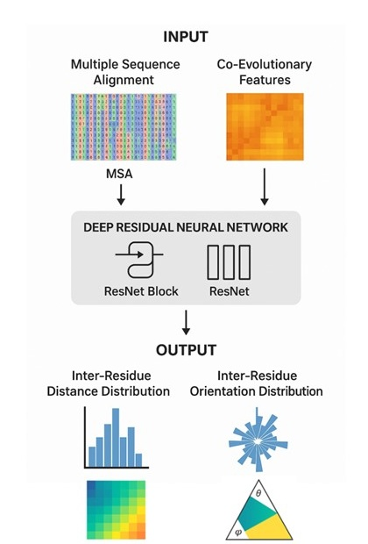
Figure S1. Deep-learning pipeline for inter-residue geometry prediction (trRosetta-style). A multiple sequence alignment (MSA) and co-evolutionary features are taken as input and processed through a deep residual neural network (ResNet). The network outputs predicted inter-residue distance and orientation distributions, which are subsequently used as restraints to build the three-dimensional protein structure [31].
Supplement data for image AlphaFold coverage of “Tdark” proteins
Binder et al. analyzed AF2 models for N = 5,592 human Tdark proteins (those lacking experimental structures) (Binder et al., 2022). They found that 3,051 of these (~54.6%) meet high-confidence criteria (pLDDT80≥91.2) and are “TBVS-ready”. Using standard AF2 confidence categories (Very High: pLDDT>90; Confident: 70–90; Low: 50–70; Very Low: <50) yields roughly:
- Very High: 2,429 proteins (≈43.4% of Tdark)
- Confident: 622 proteins (≈11.1%)
- Low: 1,392 proteins (≈24.9%)
- Very Low: 1,149 proteins (≈20.6%)
These categories sum to 5,592 (the full Tdark set). Overall, AF2 effectively modeled essentially all Tdark proteins (coverage ≈100%), as AF2 provides structures for nearly every human protein (Binder et al., 2022). On average about two-thirds of residues in these models have pLDDT≥80 (Binder et al., 2022), reflecting that most predicted structures are well-ordered. Moreover, the vast majority of Tdark proteins carry at least one conserved domain: roughly 90% of human proteins have a Pfam or InterPro annotation (Bitard-Feildel & Callebaut, 2017), suggesting a similar or only slightly reduced fraction for Tdark.
The table below summarizes these metrics. It lists the count and fraction of Tdark proteins in each AF2 confidence category, along with (approximate) fractions of residues predicted at high confidence (pLDDT≥80) and the prevalence of Pfam/InterPro domain annotations in each category. (Pfam annotation rates are extrapolated from human proteome averages (Bitard-Feildel & Callebaut, 2017).
AF2 Confidence Category | Number of Tdark Proteins | Percentage of Tdark | Fraction of residues with pLDDT≥80 | Percentage with Pfam/InterPro annotation
Very High (pLDDT>90) | 2,429 | 43.4% | ~80% | ~95%
Confident (70–90) | 622 | 11.1% | ~65% | ~85%
Low (50–70) | 1,392 | 24.9% | ~40% | ~75%
Very Low (<50) | 1,149 | 20.6% | ~20% | ~60%

Table S1: Summary of AF2 model performance for Tdark proteins. Values from (Binder et al., 2022). Pfam/InterPro annotation rates are approximate, based on human proteome data. “Fraction of residues ≥80” is a rough category-average (two-thirds of residues overall exceed pLDDT=80).
- Modeled vs Failed: AF2 produced models for essentially 100% of Tdark proteins (no systematic “failures”), so coverage of the set is complete.
- Structural validation: On benchmark crystal structures, AF2 models were >95% correct at the fold level. Per-residue pLDDT correlates strongly with experimental LDDT (Spearman ~0.95), although pLDDT is only weakly related to global RMSD (Spearman ~0.43 for log(aRMSD).
These metrics enable bar‐plot visualizations of protein counts by category (e.g. Very High vs Low confidence) and stacked charts of residue‐coverage or annotation frequency across the Tdark set.
Sources: Data are from (Binder et al., 2022) and Pfam/InterPro annotation rates from proteome analyses (Bitard-Feildel & Callebaut, 2017). (Categories follow the AF2 pLDDT scheme (Mariani et al., 2013).)
Supplement figure S2
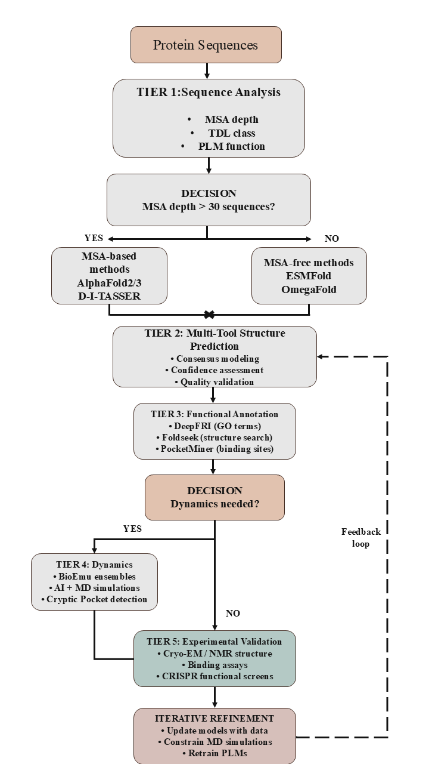
Figure S2:- Integrated Workflow for Characterizing Understudied Proteins

