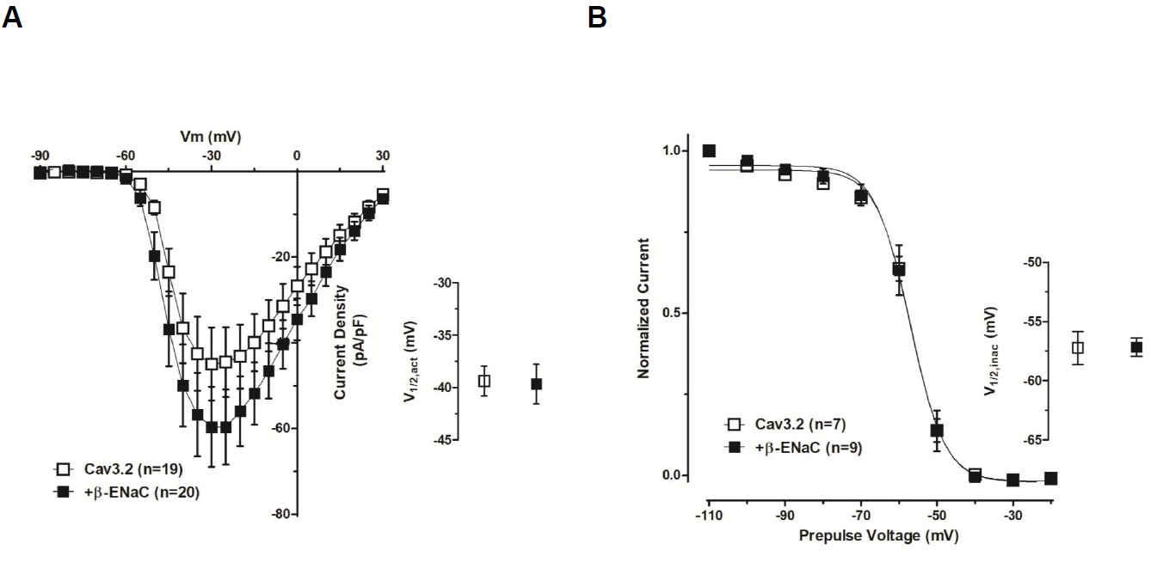

Figure S1 β-ENaC does not modify Cav3.2 currents or biophysical parameters. (A) Average current densities (pA/pF) as a function of voltage in tsA-201 cells transfected with Cav3.2 channels in the absence (open squares) and presence of β-ENaC (filled squares). Inset voltage for half activation. (B) Steady-state inactivation curves for Cav3.2 channels in the absence (open squares) and presence of β-ENaC (close squares). Inset: voltage for half inactivation.

