Supplementary information for
Role of Calcr expressing neurons in the medial amygdala in social contact among females

Kansai Fukumitsu*, Arthur J. Huang, Thomas J. McHugh, and Kumi O. Kuroda

*Corresponding author: Kansai Fukumitsu
Laboratory for Affiliative Social Behavior, RIKEN Center for Brain Science
Hirosawa 2-1, Wakoshi, Saitama 351-0198, Japan
E-mail: kansai.fukumitsu@riken.jp, Tel: +81-48-467-7556, Fax: +81-48-467-6853

This PDF file includes:

Fig. S1 and Statistical analysis

Supplementary Figure
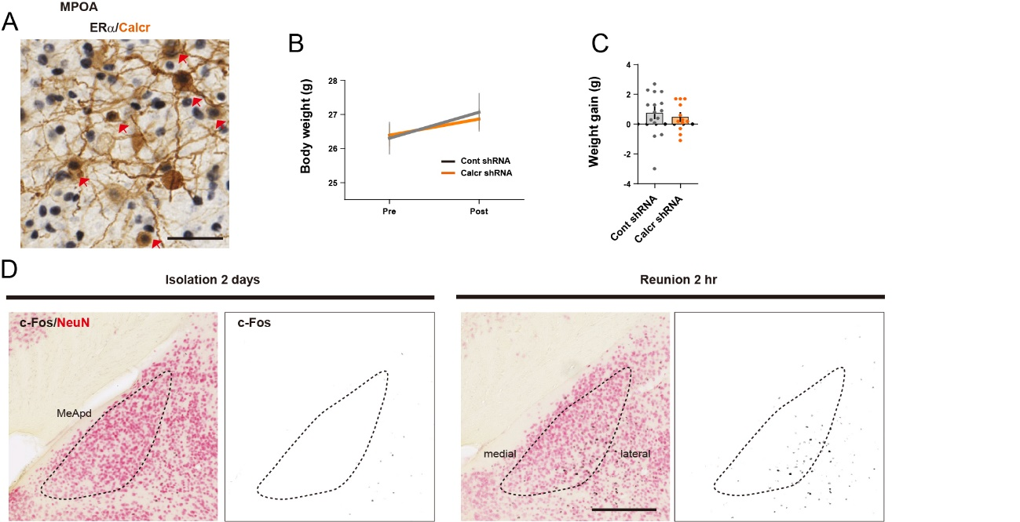
Supplementary Figure 1 Supportive experiments for this article
(A) Sections including MPOA were stained with anti-ERα (black) in combination with anti-Calcr (brown) antibody by IHC. Arrowheads indicate double-labeled cells in the MPOA. Scale bars, 50 μm.
(B, C) Targeted knockdown of Calcr in the MeApd does not affect weight gain. Body weight (b) and weight gain (c) recorded on the day of AAV injections (pre) and 1 day after the reunion test (post) (Cont shRNA: n = 15 mice and Calcr shRNA: n = 12 mice). No significant differences between groups [2-way repeated measure ANOVA with Sidak multiple comparison tests for (b). Welch’s unpaired t-test for (c)]. Graphs represent mean ± SEM. See Supplementary data for detailed statics.
(D) Distribution of c-Fos-ir cells in the MeApd in the control (2 days of somatic isolation) and 2 hr of reunion. Coronal sections stained for c-Fos (Black) in combination with NeuN (red) in the amygdala. Scale bars, 250 μm.

Statistical analysis
Figure | Part | test | t-value with degree of freedom for t-tests, exact P-value with degree of freedom for ANOVAs
1 | B | Two-tailed unpaired t-test | p=0.391, t=1, df=3 (MeAad), p=0.015, t=4.086, df=4 (MeApd),p=1, t=0, df=6 (MeApv),n.a. (CeM, CeL, CeC, AA, LA, BLA, BMA), Welch's unpaired t-test
2 | C | Two-tailed unpaired t-test | p=2.70E-05, t=5.27, df=22 , Welch's unpaired t-test
2 | D | Repeated measure Two-way ANOVA with Sidak's multiple comparison test | F7,175=0.4168, df=7, p=0.891 (interaction term), F1,25=1.875, df=1, p=0.1831 (Treatment), F7,175=1.434, df=7, p=0.1944, Sidak's multiple comparison, p=0.9994 (15 min: Cont shRNA vs Calcr shRNA), p=0.9844 (30 min: Cont shRNA vs Calcr shRNA), p=0.5396 (45 min: Cont shRNA vs Calcr shRNA), p=0.8404 (60 min: Cont shRNA vs Calcr shRNA), p=0.7651 (75 min: Cont shRNA vs Calcr shRNA), p=0.8242 (90 min: Cont shRNA vs Calcr shRNA), p=0.9984 (105 min: Cont shRNA vs Calcr shRNA), p=0.8430 (120 min: Cont shRNA vs Calcr shRNA)
2 | E | Two-tailed unpaired t-test | p=0.244, t=1.193, df=24, Welch's unpaired t-test
2 | F | Two-tailed unpaired t-test | p=0.214, t=1.274, df=25 (sniffing:partition), p=0.863, t=-0.173, df=24 (rearing), p=0.837, t=-0.207, df=19 (digging), p=0.422, t=0.815, df=25 (biting:partition), p=0.210, t=-1.291, df=21 (self-grooming), p=0.750, t=0.321, df=25 (eating), n.a. (panic), p=0.480, t=-0.717, df=23 (still), p=0.261, t=1.153, df=22 (movement), Welch's unpaired t-test
3 | A | Two-tailed unpaired t-test | p=0.00612, t=3.018, df=23 (sniffing:partition), p=0.156, t=1.477, df=18 (rearing), p=0.836, t=0.209, df=25 (digging), p=0.334, t=1, df=14 (biting:partition), p=0.512, t=0.664, df=25 (self-grooming), p=0.877, t=-0.156, df=22 (eating), n.a. (panic), p=0.122, t=-1.601, df=23 (still), p=0.293, t=1.079, df=20 (movement), p=0.385, t=0.882, df=25 (crawling under), p=0.416, t=0.827, df=22 (allo-grooming), p=0.719, t=0.363, df=22 (sniffing:peer), n.a. (mounting), n.a. (biting:peer), n.a. (chasing), Welch's unpaired t-test
3 | B | Repeated measure Two-way ANOVA with Sidak's multiple comparison test | F3,75=2.563, df=3, p=0.061 (interaction term), F1,25=9.836, df=1, p=0.0043 (Treatment), F3,75=63.53, df=3, p<0.0001, Sidak's multiple comparison, p=0.0311 (15 min: Cont shRNA vs Calcr shRNA), p=0.0058 (30 min: Cont shRNA vs Calcr shRNA), p=0.9125 (45 min: Cont shRNA vs Calcr shRNA), p>0.9999 (60 min: Cont shRNA vs Calcr shRNA)
3 | C | Two-tailed unpaired t-test | p=0.0057, t=-3.019, df=25 , Welch's unpaired t-test
S1 | B | Repeated measure Two-way ANOVA with Sidak's multiple comparison test | F1,25=0.332, df=1, p=0.569 (interaction term), Sidak's multiple comparison, p=0.989 (Pre: Cont shRNA vs Calcr shRNA), p=0.940 (Post: Cont shRNA vs Calcr shRNA)
S1 | C | Two-tailed unpaired t-test | p=0.551, t=0.604 df=24 , Welch's unpaired t-test

