Supplemental Figure 1
A
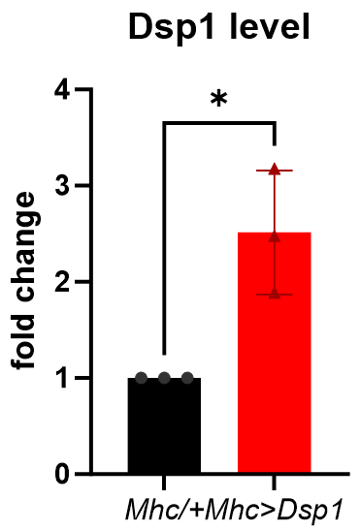

A) Overexpression of Dsp1 in muscle cells increases Dsp1 gene expression in Drosophila. RT-PCR for DSP1 gene expression in control and Dsp1-overexpressed flies. RP49 was used for normalization. Dsp1-overexpressed flies are significantly increased Dsp1 mRNA levels. Data are presented as the mean ± . *p<0.05 (Student’s t-test). Genotype: control is Mhc-GAL4/+(w1118) and Dsp1 is Mhc-GAL4/UAS-Dsp1

B
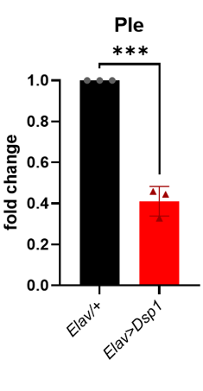
Overexpression of Dsp1 in neuronal cells reduces Ple gene expression in Drosophila. RT-PCR analysis was performed to measure Ple gene expression in the brains of control and DSP1-overexpressing flies, with RP49 used for normalization. The results showed that Ple mRNA levels were significantly reduced in DSP1-overexpressing flies. Data are presented as the mean ± SD. ***p<0.001 (Student’s t-test). Genotype: control is Elav-GAL4/+(w1118), Dsp1 is Elav-Gal4/UAS-DSP1

C
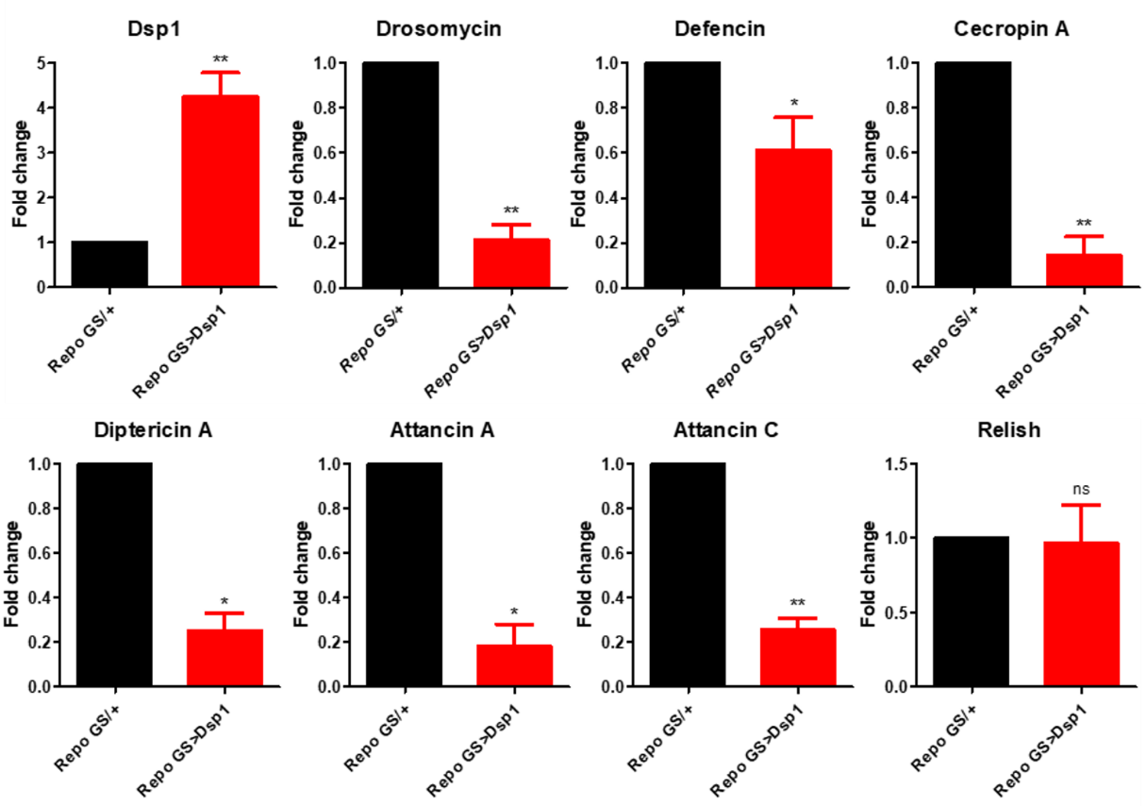
Overexpression of Dsp1 in glial cells reduces AMP-related gene expression in Drosophila. RT-PCR analysis was performed to measure AMP gene expression in the brains of control and DSP1-overexpressing flies, with RP49 used for normalization. The results showed that AMP mRNA levels were significantly reduced in DSP1-overexpressing flies. Data are presented as the mean ± SD. *p<0.05, **p<0.01, n.s, not significant (Student’s t-test). Genotypes: control is RepoGS-GAL4/+(w1118), Dsp1 is RepoGS-GAL4/DSP1

D
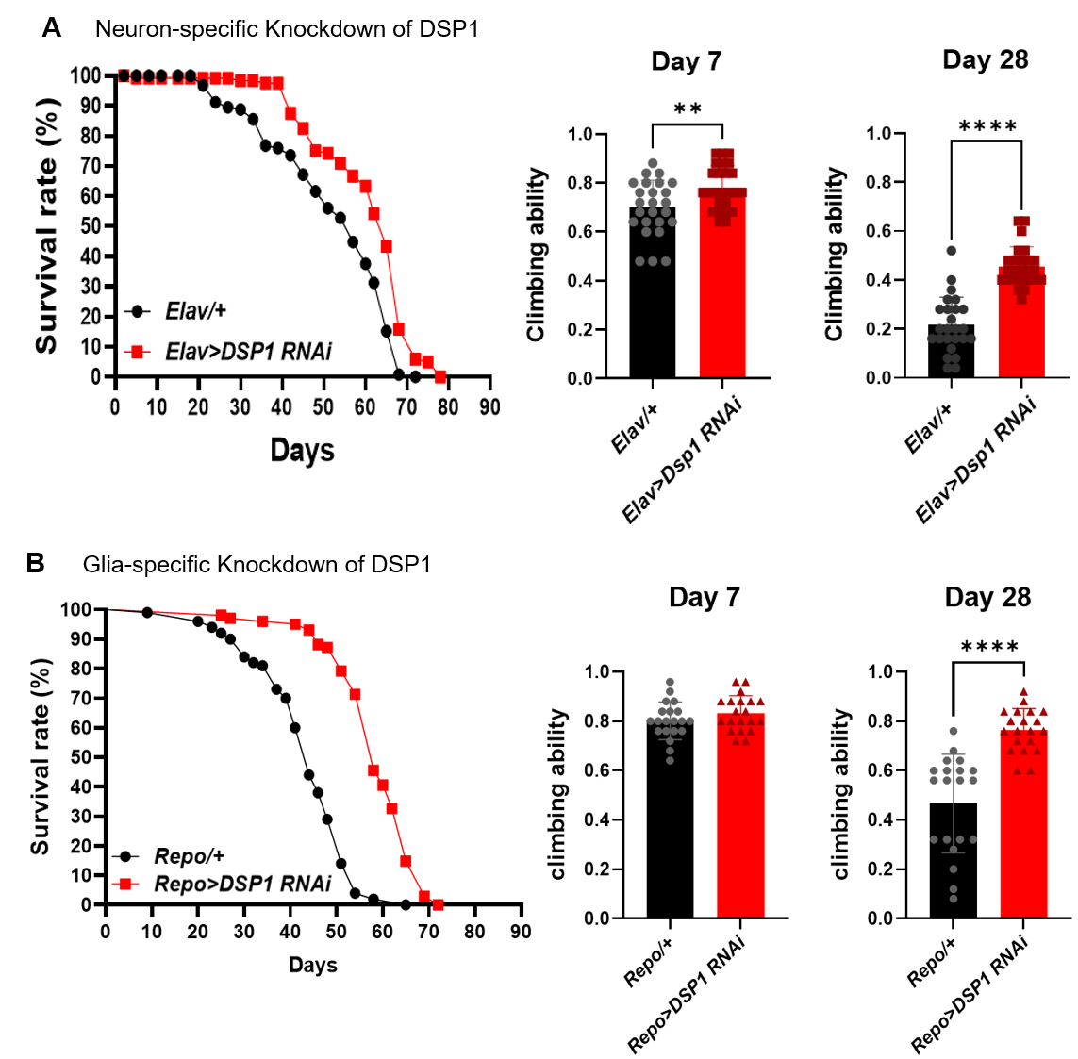
Knockdown of Dsp1 in neuron and glia induces neuroprotective effect in Drosophila. Lifespan analysis and climbing ability of Control and Dsp1 knockdown flies in neuron (A) and glia (B). Knockdown of Dsp1 was significantly extended lifespan and improved climbing ability compare with control. Data are presented as the mean ± SD. **p<0.01, ****p<0.0001 (Student’s t-test).

