Supplementary Figures

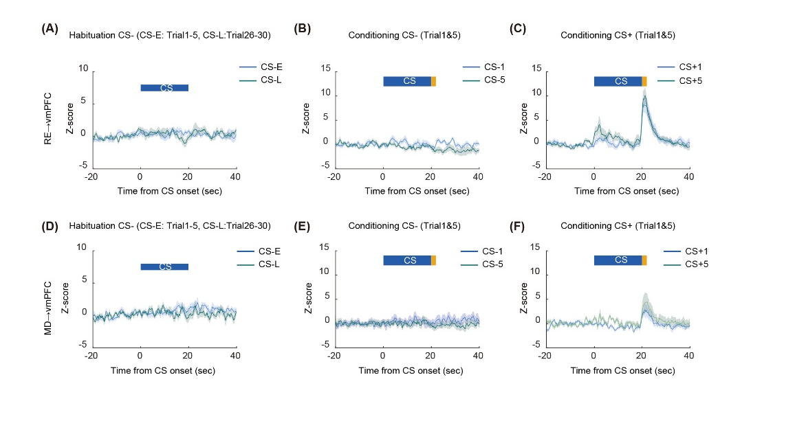
Supplementary Figure 1. Mean Z-scored calcium activity of vmPFC-projecting RE or MD neurons during habituation and aversive conditioning.
(A, D) Mean Z-scored calcium activity of vmPFC-projecting (A) RE or (D) MD neurons from a population of mice in response to CS- during early and late trials of habituation. (B, E) Mean Z-scored calcium activity of vmPFC-projecting (B) RE or (E) MD neurons from a population of mice in response to CS- at trial 1 and 5 during aversive conditioning. (C, F) Mean Z-scored calcium activity of vmPFC-projecting (B) RE or (E) MD neurons from a population of mice in response to CS+ at trial 1 and 5 during aversive conditioning. Shaded region denotes standard mean errors (n = 7). At the top of each plot, blue and orange lines denote CS and US period, respectively.

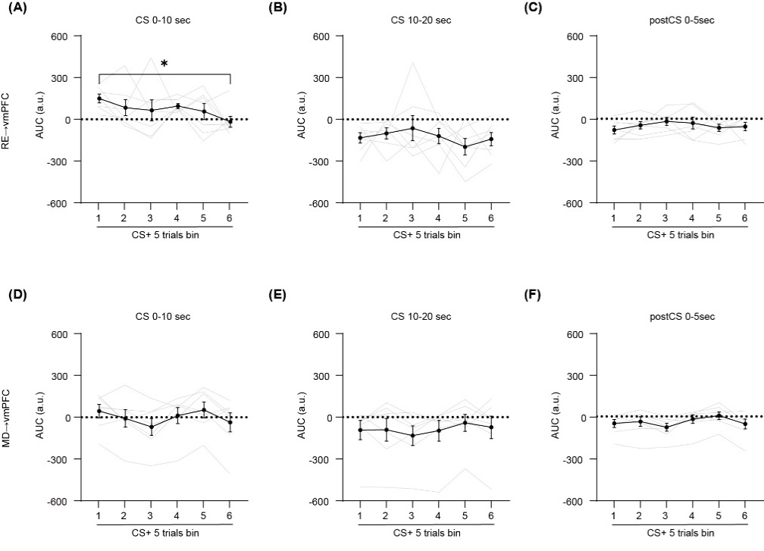
Supplementary Figure 2. Mean AUC of vmPFC-projecting RE or MD neurons during extinction.
(A, D) Mean Z-score AUC at every 5 trials bin during the 10sec after CS onset in (A) RE and (D) MD. (B, E) Mean Z-score of the AUC at every 5 trials bin during the 10sec before CS offset in (B) RE and (E) MD. (C, F) Mean Z-score of the AUC for each trial during the 5sec after CS offset in the (C) RE and (F) MD. All error bars indicate SEM across subjects (n = 7). One-way repeated measures ANOVA followed by Dunnett’s test.

