Supplementary Materials
Supplementary Figure 1:

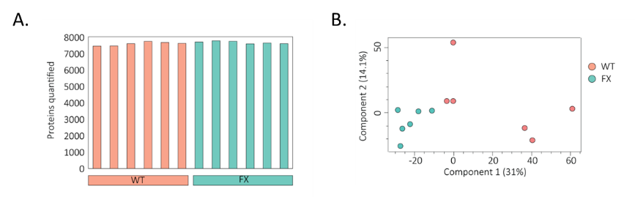

Supplementary figure 2: whole frame images
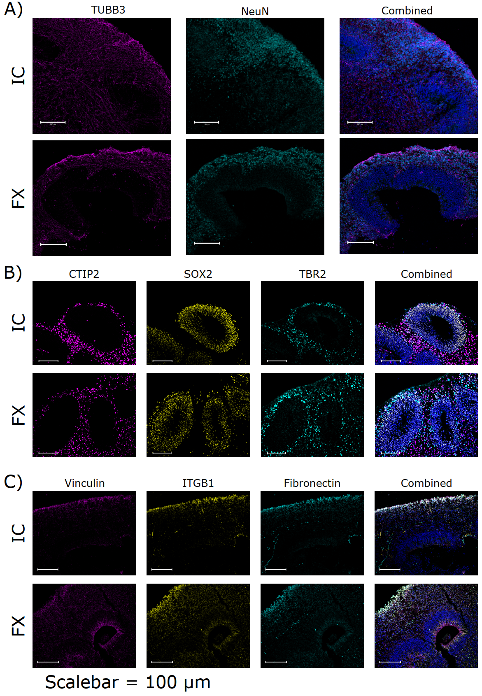

Supplementary figure 3: threshold analysis pipeline for ECM proteins:
