Supplementary
Table 1:
Table 1a: Pubmed Database search results as of 31st Dec 2025:
PUBMED

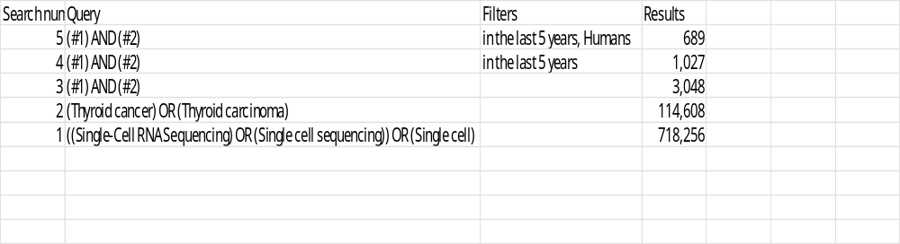

Table 1b: Ovid Medline Database search results as of 02-01-2026

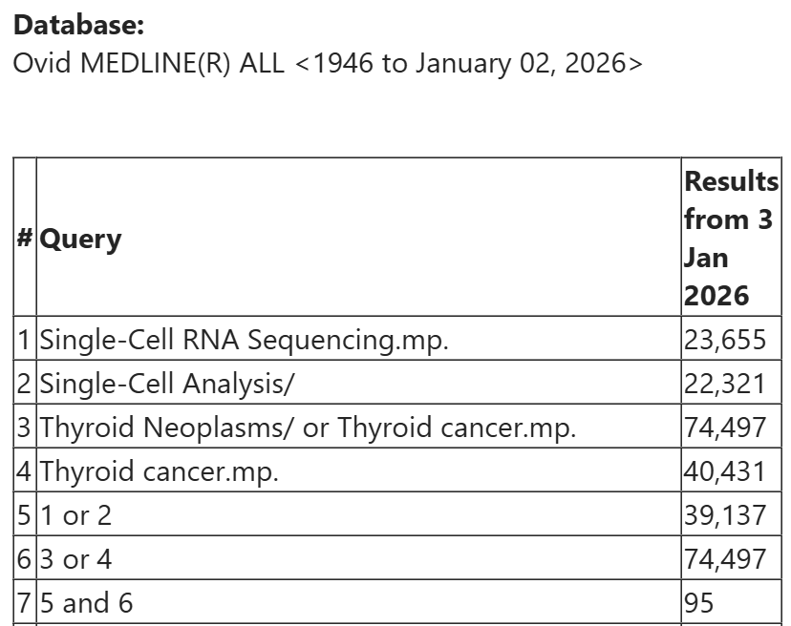

Supplementary Table 2: Reviewer Assessment of 22 studies
We identified 22 original studies that conducted scRNA-seq on primary thyroid tumour specimens (Table 1). For each study we evaluated reporting using a structured rubric covering four key items of single-cell isolation:
A. Tissue type and handling (fresh/ frozen, time to processing, size-specific modifications)
B. Mechanical and enzymatic dissociation (enzyme identity, temperatures, filtering)
C. RBC removal, neutralization and centrifugation (method, settings, durations)
D. Viability and pre-loading QC steps (viability thresholds, sorting)

For each item 0 = not reported, 1-2 = partially reported (some details but incomplete), and 3 = fully reported (specific parameters and rationale). Item scores were summed to yield a total reporting completeness score (range 0–12).
Total scores were mapped to reporting categories: Nil (0), Brief (1–4), Concise (5–8), and Detailed (9–12). Discrepancies were resolved by discussion.
Agreement = 59.1%; Cohen’s kappa = −0.088, indicating poor agreement. This likely reflects limitations from small sample size, prevalence imbalance (concise/detailed categories more common) and possibly bias between reviewers.
Table 2a: Methodological Reporting Results — Rubric-Based Scores from Two Reviewers
 | Study | Reviewer 1(SP)  -rubric points | Reviewer1 (SP)  -total scoring +category | Reviewer 2 (AS)  -rubric points | Reviewer 2 (AS)  -total scoring +category | Discrepancies:  N=final score=A  Y-final  Score=B | Final
1. | Chen,DQ, Zhou EQ, Chen HF,et al. Deciphering pathological behavior of pediatric medullary thyroid cancer from single-cell perspective (5) | A. 2  B. 3  C.2  D.1 | 8 = Concise | A. 1  B. 3  C.2  D.1 | 7=Concise | N=Concise | Concise
2. | Chen W, Yu X, Li H et al Single-cell RNA-seq reveals MIF-(CD74 + CXCR4) dependent inhibition of macrophages in metastatic papillary thyroid carcinoma (6) | A.0  B.0  C.0  D.0 | 0 = Nil | A.1  B.0  C.0  D.0 | 1=Brief | Y=Nil | Nil
3. | Guo K, Yang L, Huang Z, et al Single-Cell RNA Sequencing Reveals the Heterogeneity in Differentiation Trajectory and Tumor Microenvironment  Leading to More Aggressive Phenotypes of Papillary Thyroid Cancer in Children  and Young Adult Patients (7) | A.2  B.3  C.2  D.1 | 9 =Detailed | A.3  B.3  C.2  D.1 | 9=Detailed | N=Detailed | Detailed
4.  -study from Han uses method from Bassez | Han PZ, Ye WD, Yu PC et al. A distinct tumor microenvironment makes  anaplastic thyroid cancer more lethal but immunotherapy sensitive than papillary thyroid cancer(8); extension of Bassez A, et al. A single-cell map of intratumoral changes during anti-PD1 treatment of patients with breast cancer (9) | A.1  B.1  C.2  D.0 | 4=Brief | A.3  B.2  C.2  D.1 | 8=Concise | Y=Concise | Concise
5. | Hou Y, Lin B, Xu T, Jiang Jet al. The neurotransmitter calcitonin gene-related peptide shapes an immunosuppressive  microenvironment in medullary thyroid cancer.(11) | A.2  B.3  C.2  D.1 | 8=Concise | A.3  B.3  C.3  D.1 | 10=Detailed | Y=Detailed | Detailed
6. | Jandu D, Latar N, Bajrami A, Single Cell RNA Sequencing of Papillary Cancer  Mesenchymal Stem/Stromal Cells Reveals a Transcriptional Profile That Supports a  Role for These Cells in Cancer Progression(12) | A.1  B.3  C.1  D.0 | 5=Concise | A.3  B.3  C.2  D.0 | 8=Concise | N=Concise | Concise
7. | Lee, S. E.; Park, S.; Yi, S.et al; Unraveling the role of the mitochondrial one-carbon pathway in undifferentiated thyroid cancer by multi-omics analyses (13) | A.1  B.3  C.3  D.2 | 9=Detailed | A.0  B.3  C.3  D.0 | 6=Concise | Y=Concise | Concise
8 | Liao,T; Zeng,Y;Xu W et al; A spatially resolved transcriptome landscape during thyroid cancer progression(14) | A.2  B.3  C.0  D.0 | 5=Concise | A.2  B.3  C.0  D.1 | 8=Concise | N=Concise | Concise
9. | Li C, Wang P, Dong Z et al; Single-cell transcriptomics analysis reveals that the tumor-infiltrating B cells determine the indolent fate of papillary thyroid carcinoma.(15) | A.2  B.2  C.0  D.0 | 4=Brief | A.2  B.3  C.0  D.0 | 5=Concise | Y=Concise | Concise
10. | Lu L, Wang JR, Henderson YC et al. Anaplastic transformation  in thyroid cancer revealed by single-cell transcriptomics.(16) | A.2  B.3  C.3  D.0 | 8=Concise | A.2  B.2  C.3  D.0 | 7=Concise | N=Concise | Concise
11. | Pu, W.; Shi, X.; Yu, P; et al. Single-cell transcriptomic analysis of the tumor ecosystems underlying initiation and progression of papillary thyroid carcinoma (17) | A.2  B.2  C.0  D.2 | 6=Concise | A.2  B.3  C.0  D.2 | 7=Concise | N=Concise | Concise
12. | Wang, T.; Shi, J.; Li, L et al. Single-Cell Transcriptome Analysis Reveals Inter-Tumor Heterogeneity in Bilateral Papillary Thyroid Carcinoma (18) | A.2  B.2  C.0  D.1 | 5=Concise | A.3  B.3  C.1  D.1 | 8=Concise | N=Concise | Concise
13. | Wang, Z; Ji X; Zhang, Y; Interactions between LAMP3+ dendritic cells and T-cell subpopulations promote  immune evasion in papillary thyroid carcinoma.(19) | A.2  B.3  C.3  D.2 | 10=Detailed | A.3  B.3  C.3  D.2 | 11=Detailed | N=Detailed | Detailed
14. | Xiao, G.; Xie, R.; Gu, J.et al; Single-cell RNA-sequencing and spatial transcriptomic analysis reveal a distinct population of APOE(-) cells yielding pathological lymph node metastasis in papillary thyroid cancer(20) | A.1  B.3  C.0  D.0 | 4=Brief | A.1  B.3  C.0  D.0 | 4=Brief | N=Brief | Brief
15. | Xu L, Dai B, Zhang L et al, UBE2C mediates follicular thyroid carcinoma invasion and  metastasis via K29-Specific vimentin ubiquitination.(21) | A.0  B.0  C.0  D.0 | 0=Nil | A.1  B.0  C.0  D.0 | 1=Brief | Y=Brief | Brief
16. | Yan, T.; Qiu, W.; Song, J et al; ARHGAP36 regulates proliferation and migration in papillary thyroid carcinoma cells (22) | A.2  B.2  C.2  D.1 | 7=Concise | A.3  B.3  C.3  D.1 | 10=Detailed | Y=Detailed | Detailed
17. | Yan, T.; Qiu, W.; Weng, H et al;Single-Cell Transcriptomic Analysis of Ecosystems in Papillary Thyroid Carcinoma Progression(23) | A.2  B.2  C.2  D.1 | 7=Concise | A.3  B.3  C.3  D.1 | 10=Detailed | Y=Detailed | Detailed
18. | Yu Y, Ouyang W, Huang Y, Artificial intelligence-based multi-modal multi-tasks analysis reveals tumor molecular heterogeneity, predicts preoperative lymph node metastasis and prognosis in papillary thyroid carcinoma: a retrospective study. (24). | A.1  B.0  C.0  D.0 | 1=Brief | A.3  B.3  C.3  D.2 | 11=Detailed | Y=Detailed  (including supplement) | Detailed
19. | Zhang W, Wang J, Huang D et al. Single-cell sequencing  reveals SATB2/NOTCH1 signaling promotes the progression of malignancy of  epithelial cells from papillary thyroid cancer.(26) | A.1  B.3  C.0  D.1 | 5=Concise | A.3  B.2  C.0  D.1 | 6=Concise | N | Concise
20. | Zhang W, Zhang Y, Liu Z, PROS1-MERTK Axis Drives Tumor Microenvironment Crosstalk and  Progression in Papillary Thyroid Microcarcinoma.(27) | A.3  B.0  C.0  D.1 | 4=Brief | A.2  B.1  C.0  D.1 | 4=Brief | N | Brief
21. | Zhan, Z. J.; Li, N.; Sun, Y et al. Single-Cell Transcriptomics Reveals ITGA2-Mediated Metabolic Reprogramming and Immune Crosstalk in Paediatric Thyroid Carcinogenesis(28) | A.2  B.3  C.0  D.2 | 7=Concise | A.2  B.3  C.0  D.2 | 7=Concise | N | Concise
22. | Zheng G, Chen S, Ma W, Spatial and Single-Cell Transcriptomics Unraveled Spatial Evolution of Papillary  Thyroid Cancer. Adv Sci (Weinh). 2025 Jan;12(2):e2404491. doi:  10.1002/advs.202404491(29). | A.3  B.1  C.0  D.0 | 4=Brief | A.3  B.0  C.0  D.0 | 3=Brief | N | Brief

Supplementary Table 2b: Final Evaluation by Reviewers
Reporting Categories | Final evaluation by 2 reviewers
Nil | 1(4.5%)
Brief | 4 (18.2%)
Concise | 11 (50.0%)
Detailed | 6 (27.3%)
Discrepancies
Yes | 9 (40.9%)
No | 13(59.1%)

Supplementary Table 2c: Assessing agreement between reviewers
R1/R2 | R1=Y  (Studies) | R1=N  (Studies) | R1=Y  (Total) | R1=N  (Total)
R2=Y | 1,3, 6,8,10, 11, 12, 13, 14,19,20,21,22 | 4, 5,7,9, 15, 16,17, 18 | 13 | 8
R2=N | 2 |  | 1 | 0

Agreement=59.1%
Cohen’s kappa= -0.088

Supplementary Table 3: Pilot Outcomes from an Optimized Thyroid Dissociation Protocol -raw counts and percentages

Sample Number | Debris | FCAS Sorting-Y/N | Cell count for 10X capture | Viability % | Captured-Y/N
1 | low | Yes | 9500 | 85% | Yes
2 | moderate | Yes | NAD | <50% | No
3 | high | Yes | 2000 | 10% | No
4 | low | Yes | 20000 | 87% | Yes
5 | moderate | No | NAD | NAD | NAD
6 | low | Yes | 1800 | 60% | No
7 | low | Yes | 10600 | 63% | Yes
Immunomagnetic RBC depletion
8 | low | Yes | 16666 | 88% | Yes
9 | low | No | NAD | NAD | NAD
10 | low | Yes | 10540 | 87% | Yes
11 | low-interm | Yes | 20000 | 60% | Yes
12 | interm | Yes | NAD | 30% | No
13 | interm | Yes | 7020 | 100% | Yes
14 | interm | Yes | 55720 | 76% | Yes
15 | low-interm | Yes | 20000 | 81% | Yes
16 | low | No | 20000 | 91% | Yes
17 | low | Yes | 20000 | 87% | Yes
18 | low-interm | Yes | 20000 | 72% | Yes

Supplementary: Figure 1a and 1b:
Pilot Outcomes from an Optimized Thyroid Dissociation Protocol

Figure 1a: Cell count for 10x Chromium chip : RBC Lysis compared to Immunomagnetic RBC deletion

Figure 1b: Percentage viability: RBC Lysis compared to RBC Magnetic deletion
