ADDITIONAL FILES
Next-generation sequencing and FISH studies reveal the appearance of gene mutations and chromosomal abnormalities in hematopoietic progenitors in chronic lymphocytic leukemia

Quijada-Álamo M, Hernández-Sánchez M et al.

The additional files consist on the following sections:
Additional Tables 1-6
Additional Figures 1-2

ADDITIONAL TABLES
Additional Table 1. Clinico-biological characteristics from CLL patients.

Characteristic | Category
Age (years) |  | 61 [25-91]
Gender | Male | 55.4%
Binet Clinical Stage | A | 70.3%
 | B | 27%
 | C | 2.7%
Lymphadenopathies | Yes | 51.4%
Splenomegaly | Yes | 15.8%
Hepatomegaly | Yes | 7.9%
Leukocyte count (x10⁹/L) |  | 16.7 [5.1-369]
Lymphocyte count (x10⁹/L) |  | 10.3 [1.5-355]
Platelet count (x10⁹/L) |  | 173 [83-337]
Hemoglobin (g/dL) |  | 14.1 [7.2-16.6]
Serum LDH | High | 3%
Serum β₂microglobulin | High | 29.2%
IGHV mutational status | Unmutated | 53.6%
CD38 expression | Positive | 10.6%
FISH | Normal | 30.4%
 | 11q- | 11.3%
 | +12 | 17%
 | 13q- | 46.3%
 | IGH alterations | 9.3%
 | 17p- | 1.9%
First Therapy* | Yes | 84.2%
Median TFT** (months) |  | 35
Died during follow-up | Yes | 11.4%
Median OS*** (months) |  | 76
*13 BM samples were collected after treatment.
**TFT: Time to first therapy; ***OS: Overall Survival.

Additional Table 2. Illumina Primer Design.
Gene | Exon | Forward Primer (5’-3’) | Reverse Primer (5’-3’) | Amplicon Product Length (bp)
FBXW7 | 9 | GTGTTTTTCCAGTGTCTGAGAACAT | AGAAGTCCCAACCATGACAAGA | 227
MYD88 | 4 | TCCCAGGGGATATGCTGAAC | ATTCTCTTGCCAGAGCAGGG | 183
NOTCH1 | 34 | TGACCGCAGCCCAGTTC | ACTTGAAGGCCTCCGGAATG | 240
SF3B1 | 14 | TACCAACTCATGACTGTCCTTTC | CAGTGTGTCTCGCTTGCCA | 224
XPO1 | 15 | AGTAGGTCAATACCCACGTTTT | TCACAAGCCATATCCTGGACTC | 243

Additional Table 3. Validation of mutations detected at low frequency by ultra-deep NGS in flow-sorted cell fractions using 454 sequencing.
Patient ID | Mutated Gene | %mut CD34+CD19- | %mut CD3+ | %mut CD14+
13 | MYD88 | 7.1 | 1.3 | 3.7
31 | NOTCH1 | 2.7 | 0 | -
37 | XPO1 | - | 2.3 | -
42 | NOTCH1 | 5.1 | 0 | -
50 | SF3B1 | 1.6 | - | -
57 | FBXW7 | 4.4 | 0.9 | -

Additional Table 4. Patients characteristics regarding the presence of mutations in CD34+ progenitors
Characteristic | Category | Patients with mutated CD34+ cells (n=15) (%) | Patients with unmutated CD34+ cells (n=41) (%) | P
Age (years) |  | 61 [50-83] | 61 [25-91] | 0.749
Leukocytes, range /µL |  | 26200 [5090-369000] | 15900 [7200-279000] | 0.226
Lymphocytes, range /µL |  | 20300 [1520-355000] | 9100 [3400-270000] | 0.226
Plateletcount, range /µL |  | 137000 [83000-213000] | 176000 [95000-337000] | 0.416
Hemoglobin, range g/dL |  | 12.8 [7.2-16.2] | 14.5 [8.0-16.6] | 0.08
IGHV | Unmutated | 86.7 | 42.5 | 0.003
CD38 | Positive | 7.1 | 12.1 | 0.613
FISH | 11q- | 14.3 | 10.3 | 0.683
 | +12 | 7.1 | 20.5 | 0.253
 | 13q- | 53.3 | 43.6 | 0.520
 | IGH alt | 7.1 | 10.0 | 0.751
 | 17p- | 0 | 2.6 | 0.545
Sex | Male | 40.0 | 61.0 | 0.162
Β₂microglobulin | High | 62.5 | 12.5 | 0.011
Binet Stage | B and C | 44.4 | 25.0 | 0.267
Lymphadenopathy | Yes | 50.0 | 52.0 | 0.915
Hepatomegaly | Yes | 20.0 | 3.6 | 0.098
Splenomegaly | Yes | 30.0 | 10.7 | 0.151
Died during follow-up | Yes | 23.1 | 0 | 0.007
Therapy during follow-up | Yes | 90.9 | 80.8 | 0.444

Additional Table 5. Patients characteristics regarding the mutational burden maintenance or decrease in CD34+ progenitors.
Characteristic | Category | Mutations maintained on CD34+ progenitors (n=12)  (%) | Mutations decreased on CD34+ progenitors (n=8)  (%) | P
Age (years) |  | 60 [50-83] | 67 [60-82] | 0.302
Leukocytes, range /µL |  | 18000 [5090-369000] | 26400 [11900-87300] | 1.0
Lymphocytes, range /µL |  | 13900 [1520-355000] | 21100 [7200-74900] | 1.0
Platelet count, range /µL |  | 150000 [100000-226000] | 116000 [83000-262000] | 1.0
Hemoglobin, range g/dL |  | 12.6 [7.2-16.2] | 14.6 [8.0-15.3] | 1.0
IGHV | Unmutated | 92.3 | 57.1 | 0.061
CD38 | Positive | 0 | 14.3 | 0.179
FISH | 11q- | 15.4 | 0 | 0.310
 | +12 | 0 | 33.3 | 0.028
 | 13q- | 46.2 | 42.9 | 0.888
 | IGH alt | 15.4 | 0 | 0.310
 | 17p- | 0 | 0 | -
Sex | Male | 30.8 | 71.4 | 0.081
Β₂microglobulin | High | 50.0 | 100 | 0.197
Binet Stage | B and C | 33.3 | 50.0 | 0.569
Lymphadenopathy | Yes | 44.4 | 25.0 | 0.506
Hepatomegaly | Yes | 22.2 | 0 | 0.255
Splenomegaly | Yes | 22.2 | 20.0 | 0.923
Died during follow-up | Yes | 27.3 | 33.3 | 0.793
Therapy during follow-up | Yes | 90.0 | 100.0 | 0.464

Additional Table 6. Treatments prior bone marrow extraction of 4 CLL patients who relapsed and correlation with the CD19+ and CD34+ mutational status.
Patient ID | Last treatment before BM extraction | Time between last dose and BM extraction (months) | Mutated Gene | %CD19 |  | %CD34
8 | Lenalidomide + Rituximab | 18 | NOTCH1 |  | 97.5 |  | 79.5
33 | Fludarabine + Rituximab | 36 | NOTCH1 |  | 41.0 |  | 40.5
34 | Bendamustine | 27 | NOTCH1 |  | 50.0 |  | 51.5
34 | Bendamustine | 27 | XPO1 |  | 24.5 |  | 24.5
43 | Chlorambucil + Obinutuzumab | 31 | SF3B1 |  | 47.5 |  | 45.0

ADDITIONAL FIGURES
Additional Figure 1. Representation of the purity analysis of FACS sorted cell populations. CD34+CD19-hematopoietic stem cells; CD19+ B lymphocytes; CD3+ T lymphocytes; CD14+ monocytes.

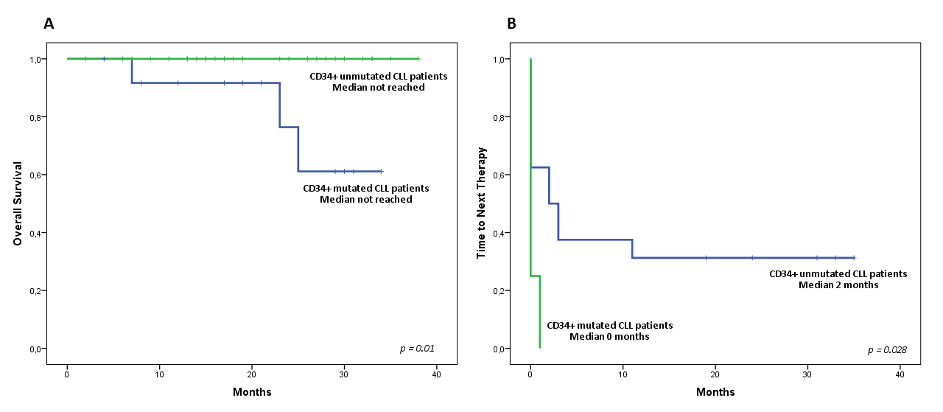
Additional Figure 2. Kaplan-Meier analysis of overall survival (A) and time to first therapy (B) in patients with mutations in their CD34+ progenitors.

