Additional file 2: Figure S1 Acute and chronic GVHD according to stem cell source.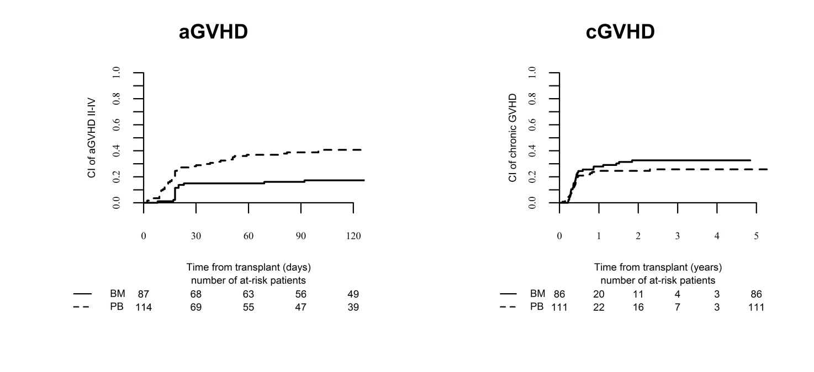
p=0.32
p<0.01

