Additional file 2 Prediction of transmembrane domain in amino acid sequences of SAE2.

ProScale analysis of SAE2 to predict the probable presence of transmembrane domain (TMD) (https://web.expasy.org/protscale/)

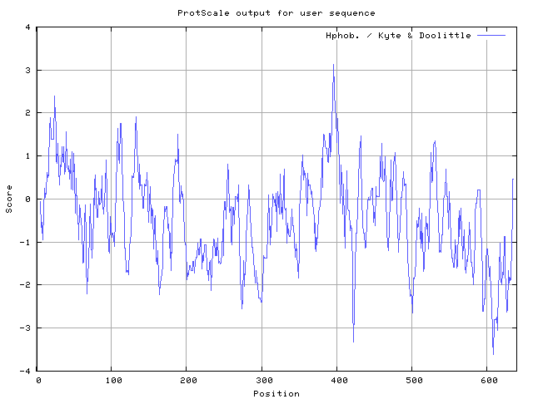

B. Analysis of SAE2 by TMHMM to predict the perspective TDM (http://www.cbs.dtu.dk/services/TMHMM-2.0/).
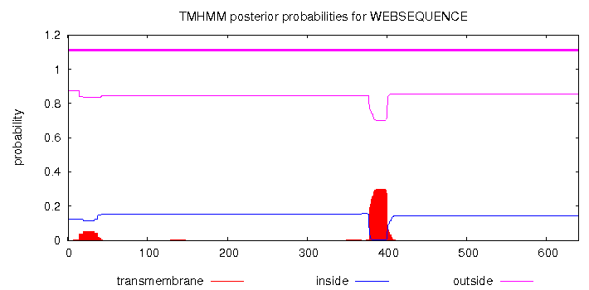
C. Prediction of transmembrane domain in SAE2 by PSORT II (http://psort.hgc.jp/form2.html)
ALOM: Klein et al's method for TM region allocation
Init position for calculation: 1
Tentative number of TMS(s) for the threshold 0.5: 2
Number of TMS(s) for threshold 0.5: 1
INTEGRAL Likelihood = -4.30 Transmembrane 383 - 399
PERIPHERAL Likelihood = 3.98 (at 36)
ALOM score: -4.30 (number of TMSs: 1)

MTOP: Prediction of membrane topology (Hartmann et al.)
Center position for calculation: 390
Charge difference: -1.5 C( 1.0) - N( 2.5)
N >= C: N-terminal side will be inside

>>> membrane topology: type 2 (cytoplasmic tail 1 to 378; TMD, 379-400)
370 380 390 400 410 420
LRMHIFSMNM KSRFDIKSMA GNIIPAIATT NAVIAGLIVL EGLKILSGKI DQCRTIFLNK
transmembrane domain (SAE2, homo sapiens)

850 860 870 880 890 900
PADKHKTKGI AGKIIPALVT TTAVVAGFVC IELIKVIQNK ALEKYKSTFM NLGIPFFGFV
transmembrane domain (UBA1, Dictyostelium discoideum)

Additional file 2 Prediction of transmembrane domain in amino acid sequences of SAE2.

A: Using ProScale (http://web.expasy.org/protscale/) to predict the transmembrane domain (hydrophobicity of a stretch of amino acids is greater than 3) in amino acid sequences of SAE2. B: Using a web program (Prediction of transmembrane helices in proteins,
http://www.cbs.dtu.dk/services/TMHMM-2.0/) to predict the transmembrane domain in amino acid sequences of SAE2.
C: Using PSORT II (http://psort.hgc.jp/form2.html) to predict the transmembrane domain in amino acid sequences of SAE2.

