Additional file 4 The intracellular location of cirRNA CCDC66 in A549 LADC cells as determined by fluorescence immunocytochemical staining

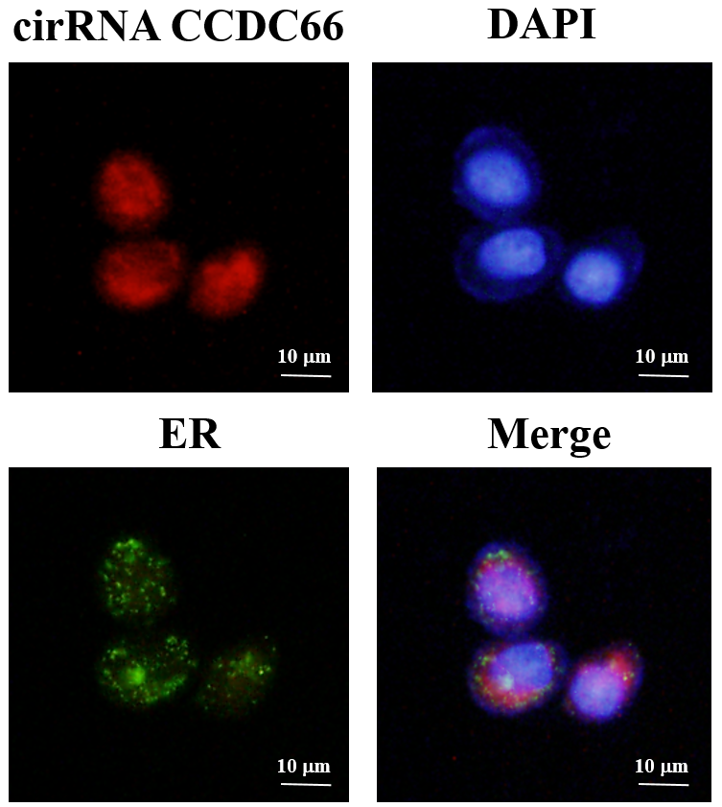

Additional file 4 Fluorescence immunocytochemical staining of A549 LADC cells. CCDC66 cirRNA was detected by specific probes to cirRNA (biotin-labeled), and then reacting to strptoavidin before visualized by the antibodies to strptoavidin conjugated with Texas red. The endoplasmic reticulum (ER) was labelled by transfecting A549 cells using plasmids encoding ER-targeted Discosoma green fluorescent protein (ER-GFP). Nuclei were stained with fluorescent dye 4', 6-diamidino-2-phenylindole (DAPI, blue fluorescence). A merged image of the above-mentioned markers is shown in the lower right corner. The white bar represents 10 μm. Like SAE2, CCDC66 cirRNA was distributed on the ER and in the cytoplasm.

