Single-cell RNA sequencing reveals compartmental remodeling of tumor-infiltrating immune cells induced by anti-CD47 targeting in pancreatic cancer

Yu Pan^{1#}, Fengchun Lu^{1#}, Qinglin Fei¹, Xingxing Yu¹, Ping Xiong², Xunbin Yu³, Yuan Dang⁴, Zelin Hou¹, Wenji Lin⁵, Xianchao Lin¹, Zheyang Zhang⁶, Minggui Pan⁷, Heguang Huang^{1*}

Supplementary Materials
(Table S1 – S3 and Figure S1 – S3)

Table S1 Clinical and pathologic features of PDAC patients
 | n = 106 | Expression of CD47 |  | P-Value | CD68+ M |  | P-Value | CD163+ M2 |  | P-Value
 | n = 106 | High | Low | P-Value | High | Low | P-Value | High | Low | P-Value
Gender
Male | 62 (58.5%) | 37 | 25 | 0.68 | 31 | 31 | 0.644 | 29 | 33 | 0.285
Female | 44 (41.5%) | 28 | 16 |  | 20 | 24 |  | 16 | 28
Age (years)
>=65 | 42 (39.6%) | 26 | 16 | 0.92 | 19 | 23 | 0.631 | 20 | 22 | 0.383
<65 | 64 (60.4%) | 39 | 25 |  | 32 | 32 |  | 25 | 39
Tumor site
Head | 65 (61.3%) | 42 | 23 | 0.381 | 31 | 34 | 0.913 | 30 | 35 | 0.332
Other | 41 (38.7%) | 23 | 18 |  | 20 | 21 |  | 15 | 26
Diameter (cm)
<4 | 49 (46.2%) | 30 | 19 | 0.985 | 21 | 28 | 0.315 | 16 | 33 | 0.058
>=4 | 57 (53.8%) | 35 | 22 |  | 30 | 27 |  | 29 | 28
CA 19-9 (U/ml)
<37 | 27 (25.5%) | 18 | 9 | 0.509 | 15 | 12 | 0.37 | 12 | 15 | 0.808
>=37 | 79 (74.5%) | 47 | 32 |  | 36 | 43 |  | 33 | 46
Procedure
PD | 58 (56.3%) | 38 | 20 | 0.329 | 26 | 32 | 0.457 | 25 | 33 | 0.266
DP | 38 (33.3%) | 21 | 17 |  | 20 | 18 |  | 26 | 24
TP | 10 (10.4%) | 6 | 4 |  | 5 | 5 |  | 6 | 4
pT-staging
pT1 | 3 (2.3%) | 3 | 0 | 0.545 | 2 | 1 | 0.089 | 2 | 1 | 0.015
pT2 | 37 (41.4%) | 23 | 14 |  | 13 | 24 |  | 9 | 28
pT3 | 46 (42.5%) | 28 | 18 |  | 24 | 22 |  | 24 | 22
pT4 | 20 (13.8%) | 11 | 9 |  | 12 | 8 |  | 10 | 10
pN-staging
pN0 | 40 (37.7%) | 21 | 19 | 0.147 | 17 | 23 | 0.368 | 14 | 26 | 0.227
pN+ | 66 (62.3%) | 44 | 22 |  | 34 | 32 |  | 31 | 35
pM-staging
pM0 | 101 | 62 | 39 | 0.951 | 48 | 53 |  | 43 | 58 | 0.909
pM1 | 5 | 3 | 2 |  | 3 | 2 |  | 2 | 3
Grading
G1 | 5 (4.7%) | 3 | 2 | 0.27 | 2 | 3 | 0.247 | 1 | 4 | 0.421
G2 | 79 (74.5%) | 46 | 33 |  | 36 | 43 |  | 33 | 46
G3 | 21 (19.8%) | 15 | 6 |  | 12 | 9 |  | 10 | 11
G4 | 1 (1.0%) | 1 | 0 |  | 1 | 0 |  | 1 | 0
Vascular invasion
Yes | 31 (29.2%) | 15 | 16 | 0.079 | 15 | 16 | 0.971 | 15 | 16 | 0.427
No | 75 (70.8%) | 50 | 25 |  | 36 | 39 |  | 30 | 45
Chemotherapy
Yes | 54 (50.9%) | 31 | 23 | 0.399 | 25 | 29 | 0.703 | 21 | 33 | 0.878
No | 52 (49.1%) | 34 | 18 |  | 26 | 26 |  | 24 | 28
CD68+ M
High | 51 (48.1%) | 38 | 13 | 0.007 | — | — | — | — | — | —
Low | 55 (51.9%) | 27 | 28 |  | — | — |  | — | —
CD163+ M2
High | 45 (42.5%) | 29 | 16 | 0.571 | 38 | 7 | < 0.001 | — | — | —
Low | 61 (57.5%) | 36 | 25 |  | 13 | 48 |  | — | —
Abbreviations: M, macrophages; M2, M2 macrophages; PD, pancreaticoduodenectomy;
DP, distal pancreatectomy; TP, total pancreatectomy

Table S2. Univariate and multivariate Cox proportional analysis for overall survival
Variable | n | Univariate analysis |  |  |  | Multivariate analysis
Variable | n | HR | 95% CI | P-value |  | HR | 95% CI | P-value
Gender
Male | 62 | 1
Female | 44 | 0.863 | 0.535-1.392 | 0.545
Age (years)
>=65 | 42 | 1
<65 | 64 | 0.998 | 0.976-1.025 | 0.996
Tumor site
Head | 65 | 1
Other | 41 | 0.631 | 0.388-0.992 | 0.056
Diameter (cm)
<4 | 49 | 1 |  |  |  | 1
>=4 | 57 | 1.643 | 1.027-2.626 | 0.038 |  | 1.626 | 1.006-2.626 | 0.047
CA 19-9 (U/ml)
<37 | 27 | 1
>=37 | 79 | 0.993 | 0.591-1.669 | 0.98
pT-staging
pT1+pT2 | 40 | 1
pT3+pT4 | 66 | 1.268 | 0.957-1.680 | 0.098
pN-staging
pN0 | 40 | 1 |  |  |  | 1
pN+ | 66 | 1.82 | 1.365-2.427 | < 0.001 |  | 1.831 | 1.339-2.506 | < 0.001
pM-staging
pM0 | 101
pM1ª | 5 | — | — | — |  | — | — | —
Grading
G1ª | 5 | — | — | — |  | — | — | —
G2 | 79 | 1 |  |  |  | 1
G3 | 21 | 2.478 | 1.438-4.269 | 0.001 |  | 1.745 | 1.137-2.680 | 0.011
G4ª | 1 | — | — | — |  | — | — | —
Vascular invasion
No | 31 | 1
Yes | 75 | 1.024 | 0.618-1.696 | 0.928
Chemotherapy
No | 54 | 1
Yes | 52 | 0.71 | 0.445-1.134 | 0.152
CD47 expression
Low | 65 | 1 |  |  |  | 1
High | 41 | 1.673 | 1.030-2.716 | 0.037 |  | 1.703 | 1.031-2.815 | 0.038
CD68+ M
Low | 51 | 1 |  |  |  | 1
High | 55 | 1.892 | 1.170-3.059 | 0.009 |  | 1.853 | 1.106-3.106 | 0.012
CD163+ M2
Low | 45 | 1 |  |  |  | 1
High | 61 | 1.845 | 1.143-2.979 | 0.012 |  | 1.898 | 1.139-3.165 | 0.014
Abbreviations: HR, hazard ratio; CI, confidence interval;
ª Survival analysis not performed due to small number of cases

Table S3. Multivariate analysis of CD47 expression combined with PD-L1 expression or TAM in PDAC patients. Analysis was adjusted for diameter, grade, and TNM stage
Biomarkers | HR | 95% CI | P-value
OS
CD47^{high} / PD-L1^{high} (no/yes) | 1.71 | 0.850-3.438 | 0.132
CD47^{high} / CD68⁺ M^{high} (no/yes) | 2.126 | 1.244-3.634 | 0.006
CD47^{high} / CD163⁺ M2^{high} (no/yes) | 1.873 | 1.044-3.359 | 0.035
CD47^{low} / CD68⁺ M^{low} (no/yes) | 0.47 | 0.264-0.836 | 0.01
CD47^{low} / CD163⁺ M2^{low} (no/yes) | 0.376 | 0.202-0.700 | 0.002

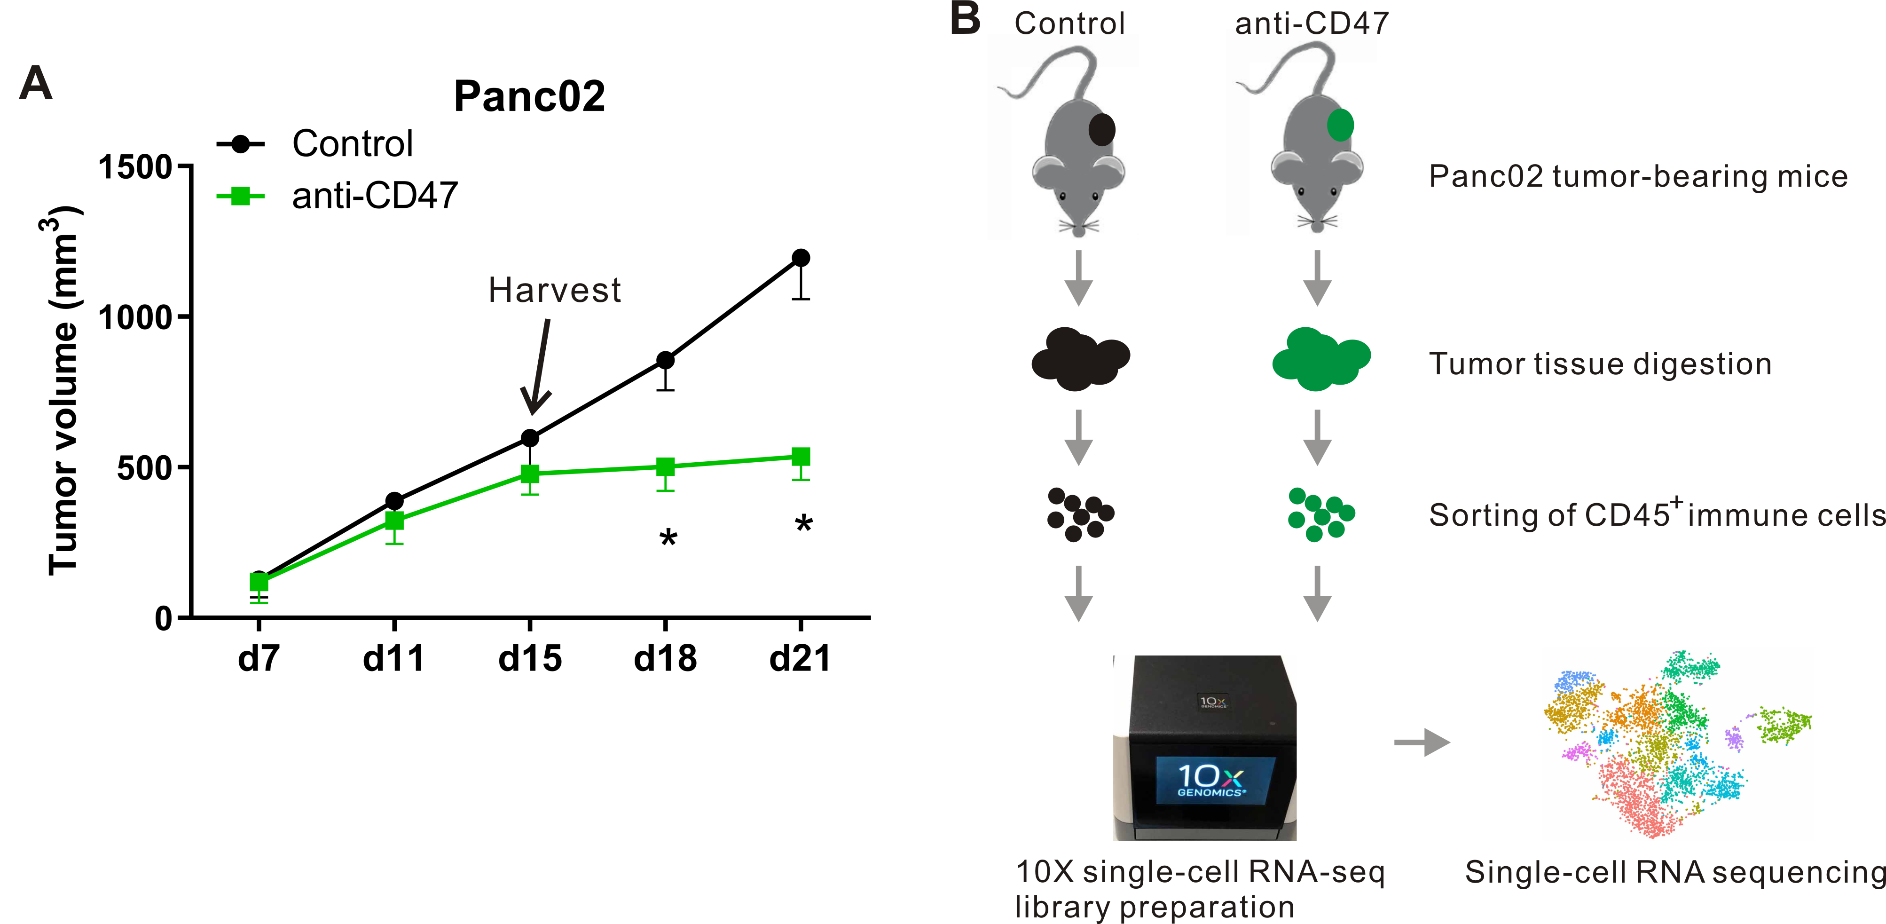

Figure S1. Tumor-infiltrating CD45⁺ immune cells in Panc02 tumor-bearing mice for single-cell analysis. (A) Panc02 tumor growth in mice treated with control or anti-CD47 mAb. (B) Experimental schematic. Panc02 cells were subcutaneously implanted into 10 C57BL/6 mice. When the tumor reached 100 mm³, tumor-bearing mice were randomly divided into two groups. Then, tumor-bearing mice were treated with mouse IgG (200 μg/day i.p.), or an anti-mouse CD47 in vivo mAb (200 μg/day i.p.). Tumors were harvested on day 15 after tumor transplant, digested and stained for CD45 and sorted. CD45⁺ immune cells were subjected to scRNA-seq by using the 10x Genomics pipeline. Immune cells from 5 mice from control or anti-CD47 group were pooled before sorting.

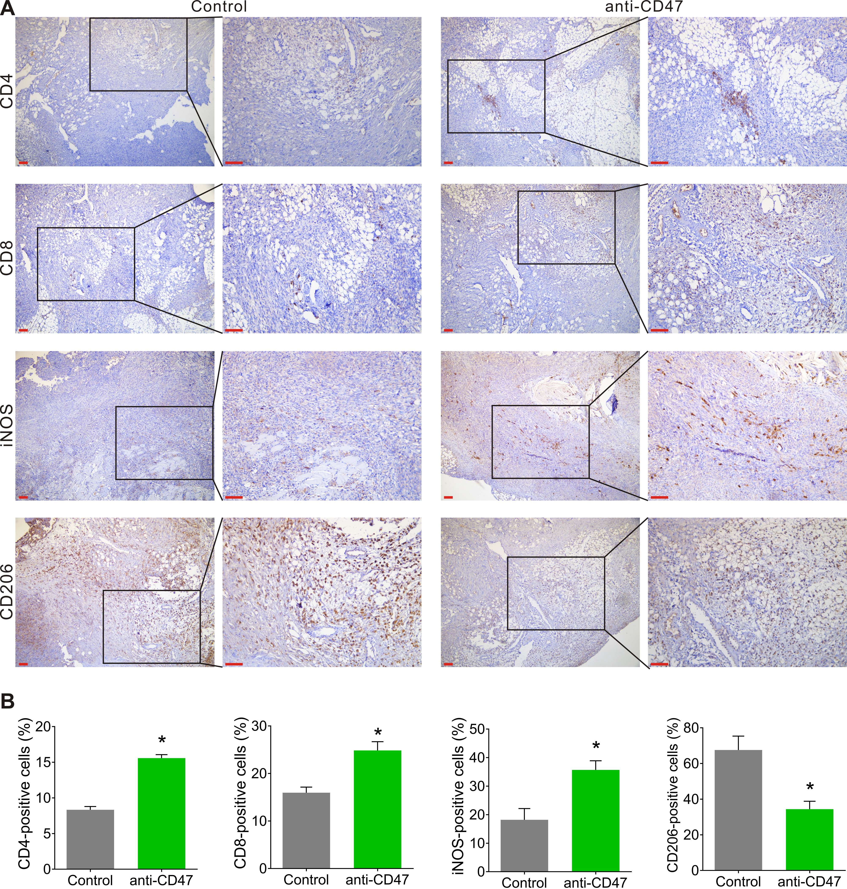

Figure S2. Immunostaining of CD4, CD8, iNOS, and CD206 in Panc02 tumors. (A) Staining with an anti-CD4, anti-CD8, anti-iNOS, and anti-CD206 antibody in tumor tissue samples of Panc02 tumor-bearing mice. Low magnification (100×) and high magnification (200×) images were obtained. Scale bar = 100 µm (red line at the bottom left). (B) Positive cells (brown) were analyzed by performing a Student’s t-test. Data represent the mean ± SD. *P < 0.05 when compared with the control group.

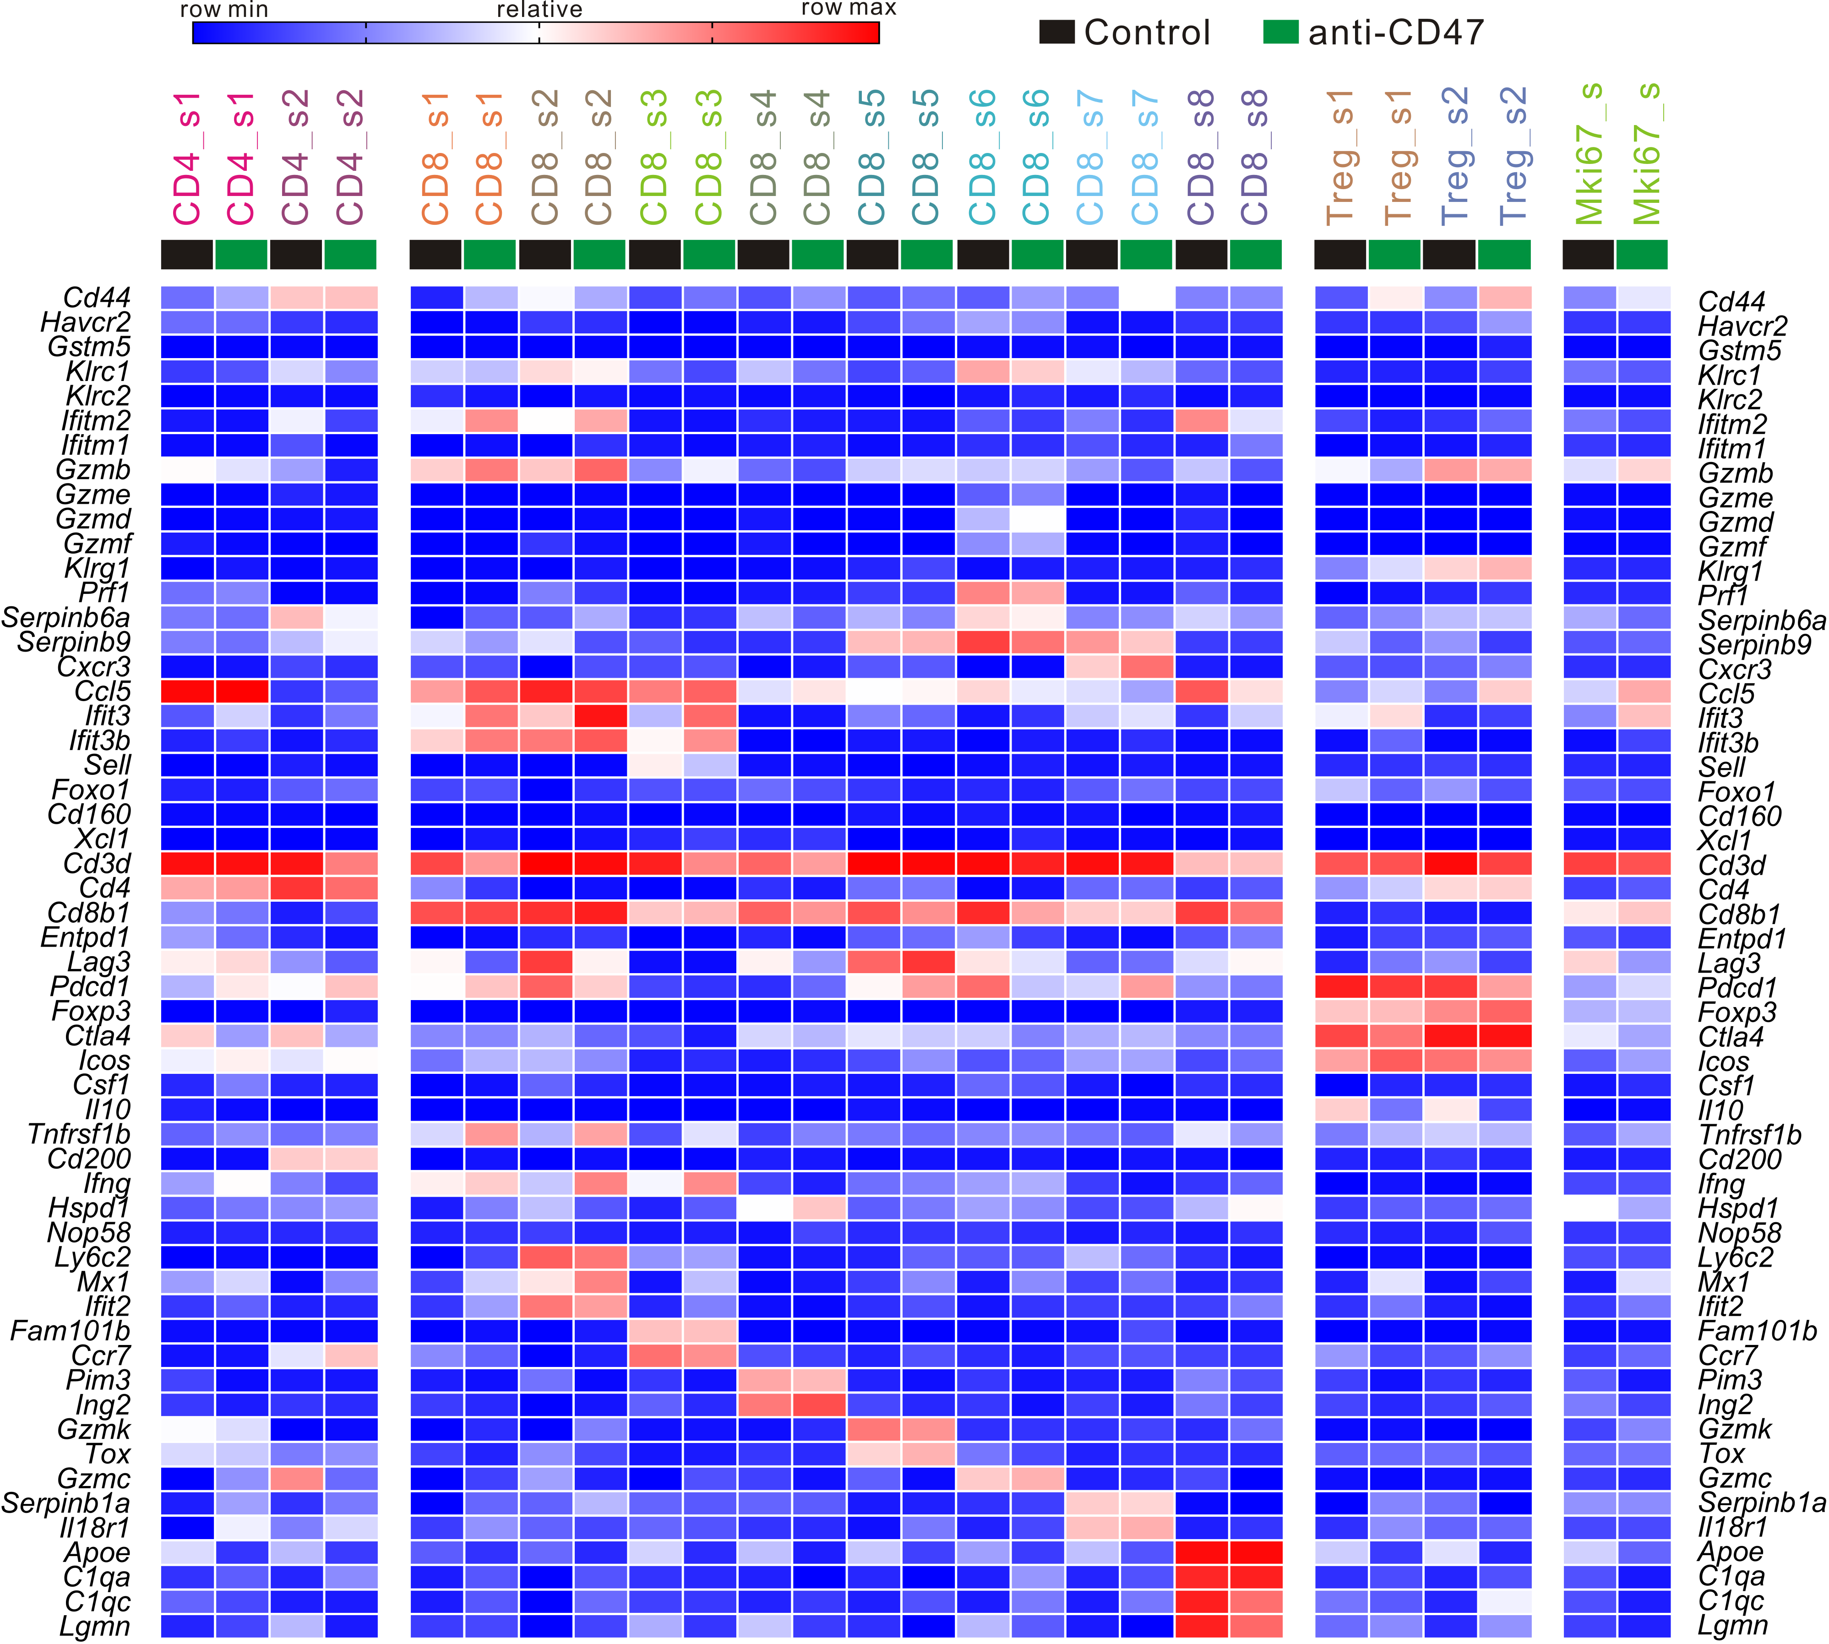

Figure S3. Heatmap from scRNA-seq displaying expression of select genes in each lymphoid cell subpopulation.

