Figure S4
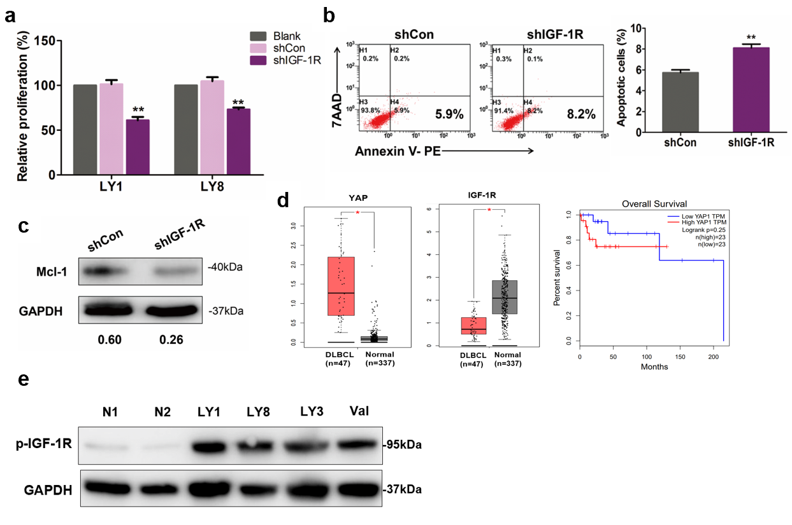
Figure S4. Knockdown of IGF-1R expression inhibited the growth of DLBCL cells. a. LY1 and LY8 cells were treated with either sh-IGF-1R or shCon, and cell proliferation of cells was assessed by CCK-8 assay (**p<0.01). b. Flow cytometry assay indicated that treatment with shIGF-1R significantly induced cell apoptosis in DLBCL (**p<0.01). c. Decreased expression of Mcl-1 was detected in cells transfected with shIGF-1R. d. An analysis of data from TCGA database evaluated the mRNA levels of YAP and IGF-1R in DLBCL samples (*p<0.05). e. p-IGF-1R expression was increased in DLBCL cells compared to normal B cells. *The GAPDH blots are shared with Figure 1c.

