Title: Impact of frontline treatment approach on outcomes in patients with secondary AML with prior hypomethylating agent exposure

Supplementary Information

Supplementary Table 1. Frontline treatment regimens

Supplementary Table 2. Standardized effect size for pretreatment covariates in the propensity score weighted and unweighted data

Supplementary Figure 1. Overall survival patients with treated secondary AML by treatment approach and molecular mutation(s). (A) NPM1, IDH1, and/or IDH2-mutated AML, (B) ASXL1-mutated AML, (C) RUNX1-mutated AML, and (D) TP53-mutated AML

Supplementary Figure 2. Overall survival of patients with treated secondary AML who received frontline intensive chemotherapy (age <60 years only) or a hypomethylating agent plus venetoclax (all ages)

Supplementary Figure 3. Overall survival in patients who underwent HSCT for treated secondary AML by frontline treatment approach

Supplementary Table 1. Frontline treatment regimens

Type | Regimen | N (%)
Intensive Chemotherapy  (N=271) | 7+3 ± other agent | 7 (3)
Intensive Chemotherapy  (N=271) | BIDFA ± other agent | 82 (30)
Intensive Chemotherapy  (N=271) | CIA ± other agent | 28 (10)
Intensive Chemotherapy  (N=271) | CLIA ± other agent | 33 (12)
Intensive Chemotherapy  (N=271) | CPX-351 ± other agent | 53 (20)
Intensive Chemotherapy  (N=271) | FIA ± other agent | 9 (3)
Intensive Chemotherapy  (N=271) | IA ± other agent | 42 (16)
Intensive Chemotherapy  (N=271) | Other high-dose cytarabine regimen | 17 (6)
Low-Intensity Therapy without Venetoclax  (N=237) | Clofarabine ± other agent | 16 (7)
Low-Intensity Therapy without Venetoclax  (N=237) | Investigational agent ± HMA | 73 (31)
Low-Intensity Therapy without Venetoclax  (N=237) | LDAC ± other agent | 148 (62)
Hypomethylating Agent plus Venetoclax (N=54) | HMA + venetoclax | 30 (55)
Hypomethylating Agent plus Venetoclax (N=54) | HMA + venetoclax + other agent | 24 (45)

Abbreviations: BIDFA, twice daily fludarabine and cytarabine; CIA: clofarabine, idarubicin and cytarabine; CLIA, cladribine, idarubicin and cytarabine; FIA, fludarabine, idarubicin and cytarabine; IA, idarubicin and cytarabine; HMA, hypomethylating agent; LDAC, low-dose cytarabine

Supplementary Table 2. Standardized effect size for pretreatment covariates in the propensity score weighted and unweighted data

Variable | Unweighted analysis |  | Weighted analysis
Variable | Max standard effect size | Min p-value | Max standard effect size | Min p-value
Age (<60 years vs. ≥60 years) | 0.663 | <0.001 | 0.218 | 0.09
MDS vs. CMML | 0.214 | 0.204 | 0.091 | 0.561
Number of prior therapies | 0.167 | 0.185 | 0.266 | 0.081
Cytogenetics (adverse vs. others) | 0.362 | 0.064 | 0.316 | 0.159
Prior HSCT | 0.442 | 0.015 | 0.117 | 0.453
ASXL1 mutation | 0.558 | 0.07 | 0.397 | 0.543
RUNX1 mutation | 0.485 | 0.361 | 0.427 | 0.464
TP53 mutation | 0.455 | 0.023 | 0.22 | 0.713

Supplementary Figure 1. Overall survival patients with treated secondary AML by treatment approach and molecular mutation(s). (A) NPM1, IDH1, and/or IDH2-mutated AML, (B) ASXL1-mutated AML, (C) RUNX1-mutated AML, and (D) TP53-mutated AML
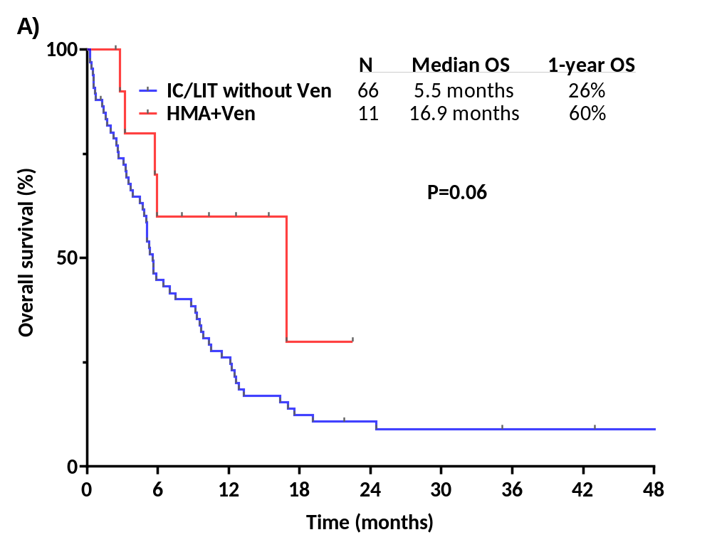
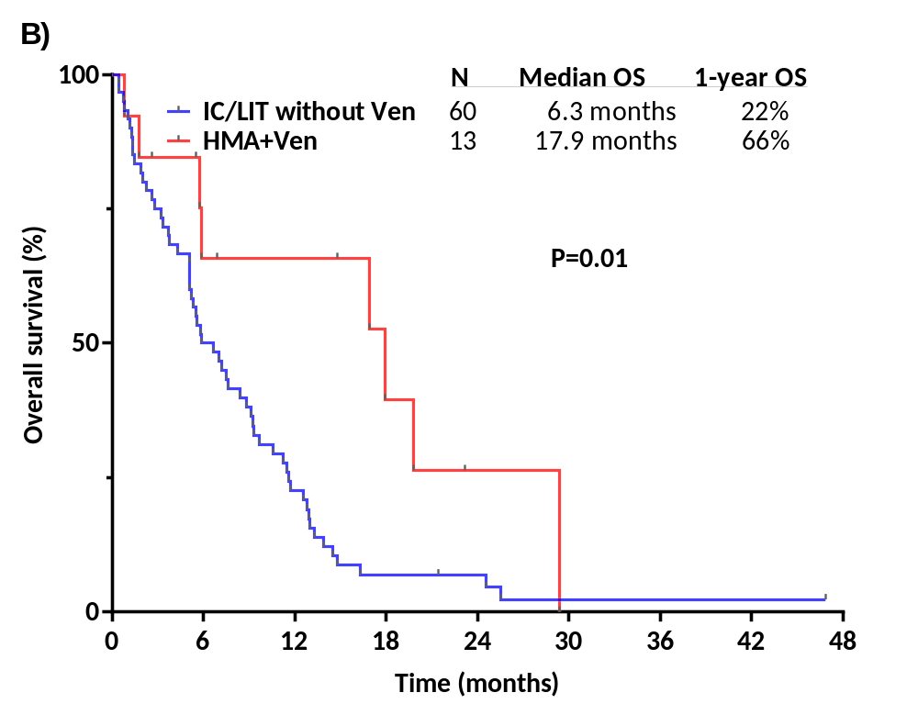

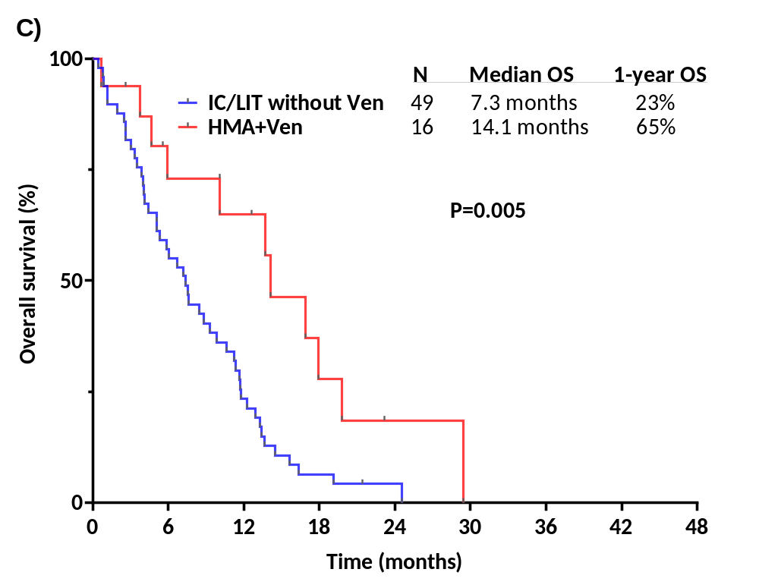
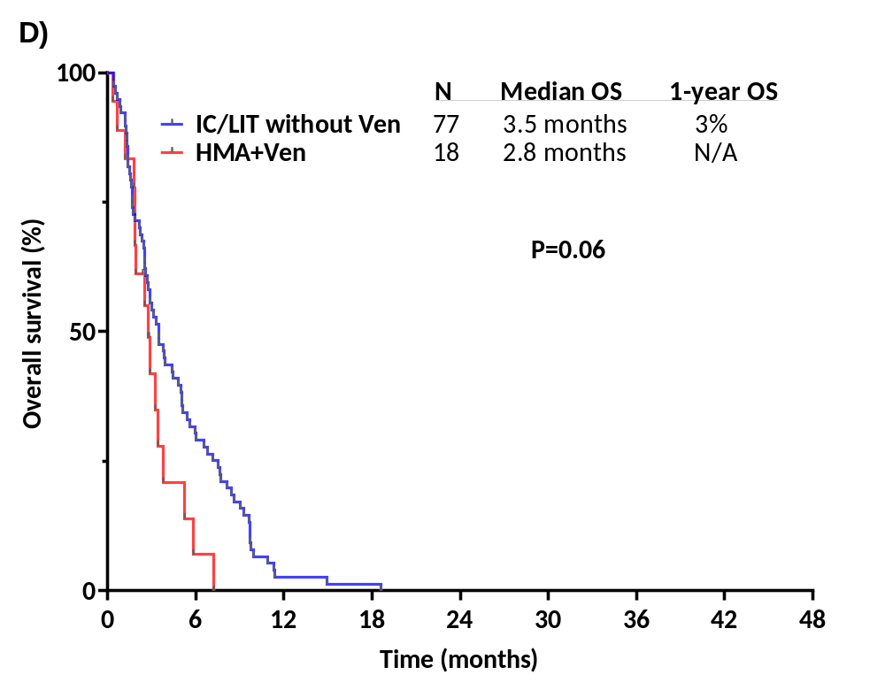

Supplementary Figure 2. Overall survival of patients with treated secondary AML who received frontline intensive chemotherapy (age <60 years only) or a hypomethylating agent plus venetoclax (all ages)

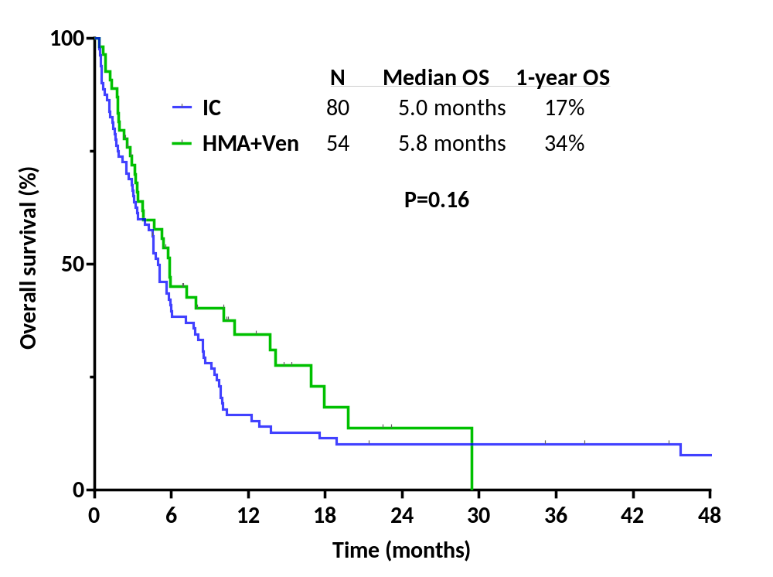

Supplementary Figure 3. Overall survival in patients who underwent HSCT for treated secondary AML by frontline treatment approach

