Supplementary Figures

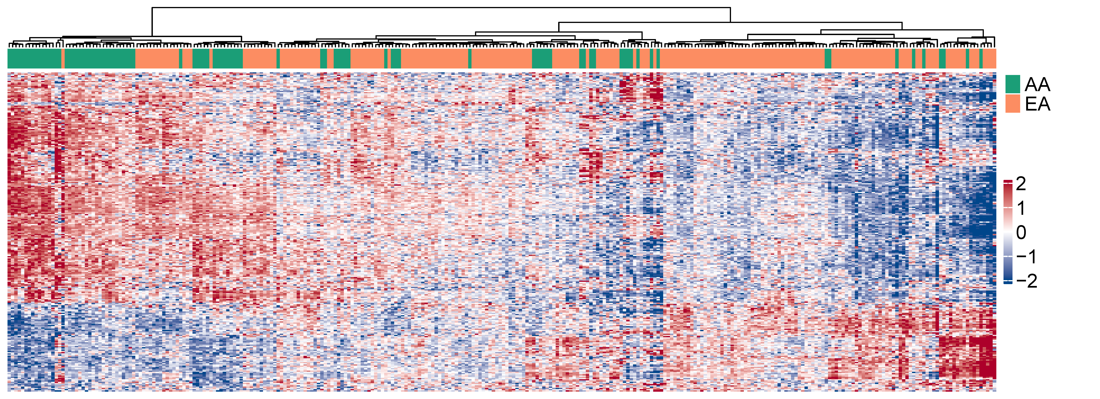
Fig. S1. Supplementary results for the differential analysis between AA and EA patients with MM. Differential analysis was performed between AA and EA patients with MM for each gene body (5hmC modification levels, i.e., the normalized 5hmC-Seal read counts), using multivariable logistic regression models, controlling for age and sex. The heat map shows the 259 differential gene bodies at 5% FDR between AA and EA patients with MM.

