Supplementary information includes:

Supplementary Figs. S1–7
Tables S1–S2

Other supplementary material for this manuscript includes:
Tables S3–S7 (Excel format)

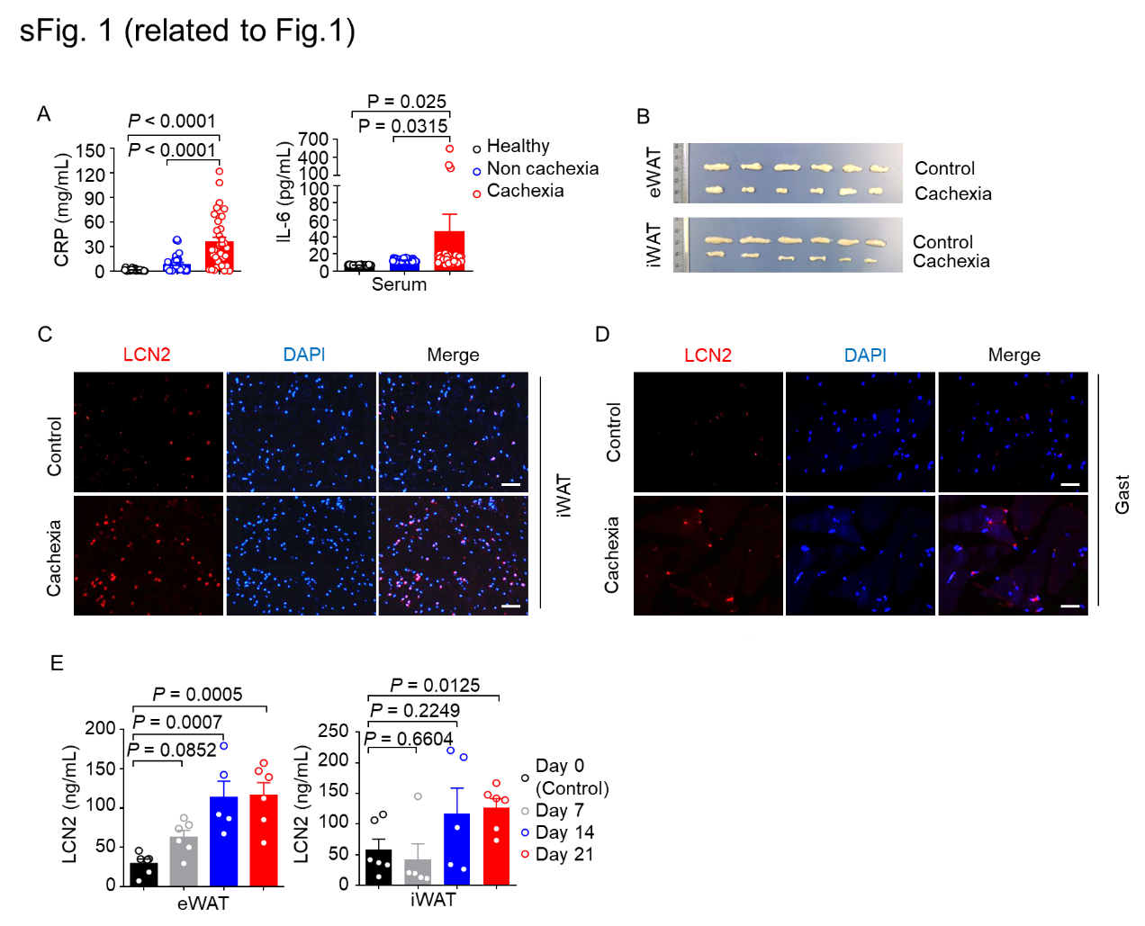

sFig. 1 LCN2 levels are increased in the wasting tissues in murine lung cancer cachexia.
A. Serum concentrations of IL-6 and CRP in lung cancer patients with (n = 31–35) and without (n = 33–34) cachexia and in healthy controls (n = 25–32). B–E. Mice were inoculated with LLC cells to induce cachexia. B. Representative images of the eWAT and iWAT in these mouse groups. C. LCN2 immunofluorescence staining in the iWAT of control and cachectic mice. Scale bars, 50 μm. D. LCN2 immunofluorescence staining in the Gast of control and cachectic mice. Scale bars, 50 μm. E. LCN2 concentrations in supernatants prepared from the eWAT and iWAT of mice bearing LLC tumors (up to 21 days). n = 5–6 per group. Data are shown as the mean ± SEM. Statistical analyses were performed using one-way ANOVA (A, E).

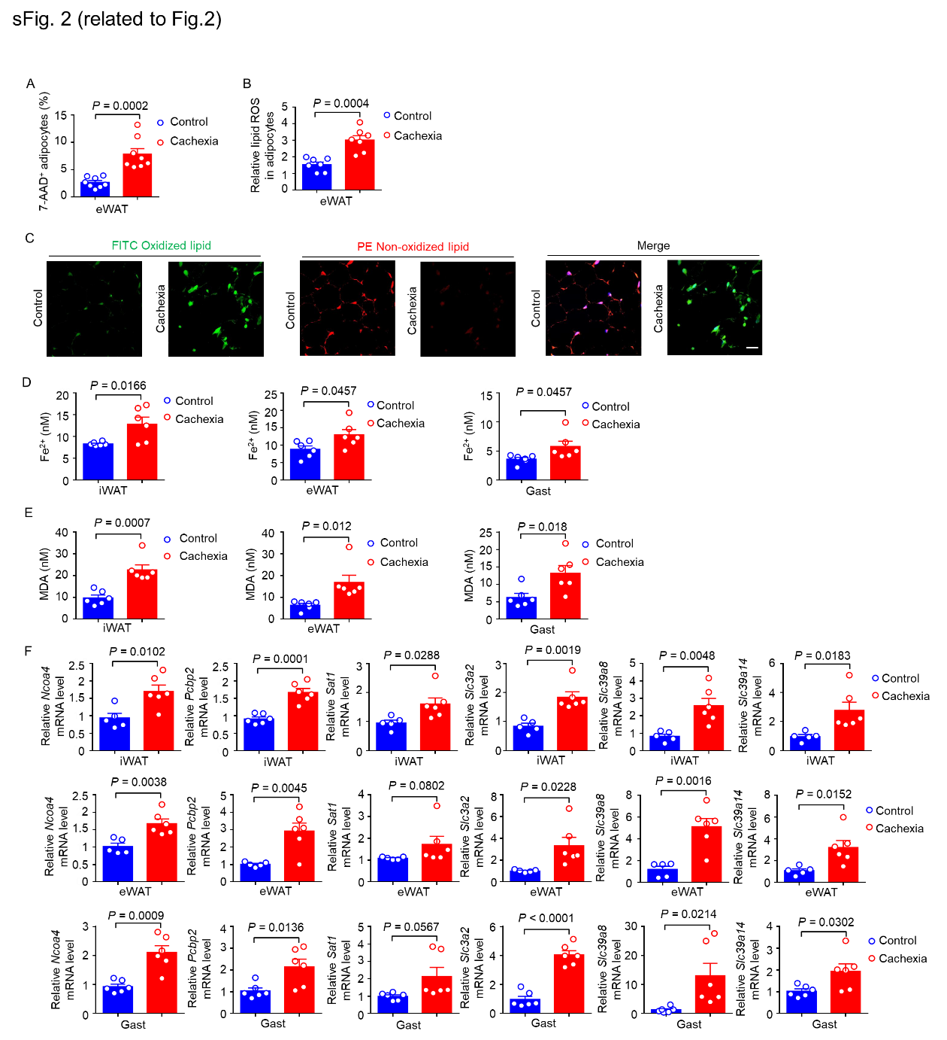

sFig. 2 Ferroptosis occurs in wasting tissues of mice with PDX-induced lung cancer cachexia.
A–C. Mice were inoculated with LLC cells to induce murine cachexia. A. Percentages of 7-AAD⁺ adipocytes purified from the eWAT, assessed using flow cytometry. n = 8 per group. B. Relative lipid ROS in adipocytes purified from the eWAT, determined by flow cytometry. n = 7 per group. C. Immunofluorescence staining of lipid peroxidation in the iWAT (using the Lipid Peroxidation Assay Kit, Abcam, Cat number ab243377). Scale bars, 50 μm. D. Chemiluminescence analysis of Fe²⁺ concentrations in the eWAT, iWAT, and Gast of PDX-induced cachectic model mice and control mice. n = 6 per group. E. Chemiluminescence analysis of MDA concentration in the eWAT, iWAT, and Gast of PDX-induced cachectic model mice and control mice. n = 6 per group. F. qPCR analysis of mRNA levels of the indicated ferroptosis-related genes in the eWAT, iWAT, and Gast of PDX-induced cachectic model mice and control mice. n = 6 per group. Data are shown as the mean ± SEM and were compared using the unpaired Student’s t-test.

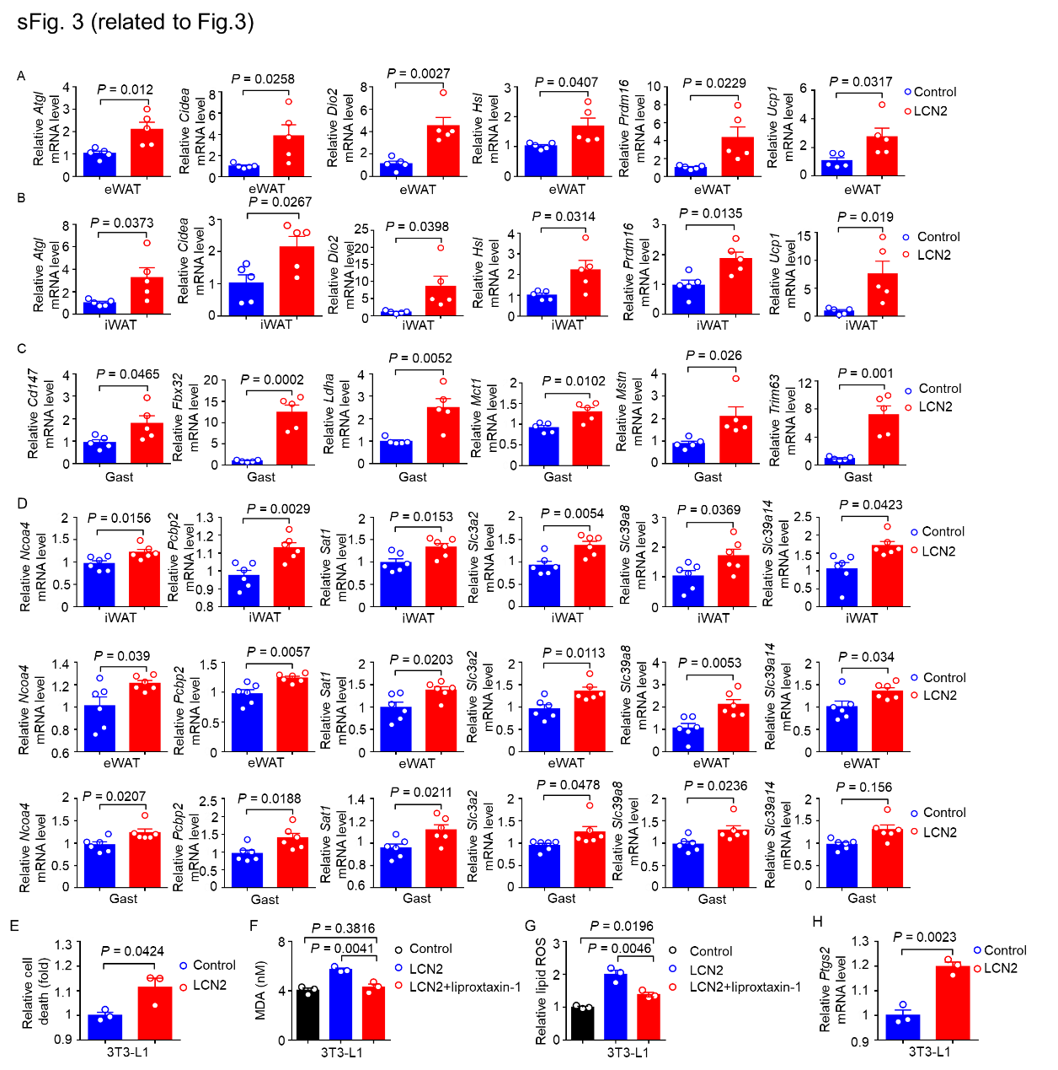

sFig. 3 LCN2 promotes tissue ferroptosis and wasting.
Mice were injected intravenously with the control or the LCN2-overexpressing lentivirus. A–C. qPCR determination of mRNA levels in the (A) eWAT, (B) iWAT, and (C) Gast. n = 5 per group. D. qPCR analysis of mRNA levels of the indicated ferroptosis-related genes in the eWAT, iWAT, and Gast from mice injected with the control or LCN2- overexpressing lentivirus. n = 6 per group. E. 3T3-L1 cells were treated with 200 ng/mL recombinant mouse Lcn2 protein for 24 h. Relative cell death was detected by flow cytometry. n = 3 per group. F–G. The 3T3-L1 cells were pretreated with 10 μM liproxstatin-1 or vehicle for 24 h. The 3T3-L1 cells were then treated with 200 ng/mL recombinant mouse Lcn2 protein for 24 h. The MDA concentration (F) and flow cytometry analysis of relative lipid ROS levels (G) in 3T3-L1 cells. n = 3 per group. H. 3T3-L1 cells were treated with 200 ng/mL recombinant mouse Lcn2 protein for 24 h. qPCR determination of Ptgs2 mRNA levels. n = 3 per group. Data are shown as the mean ± SEM and were compared using the unpaired Student’s t-test.

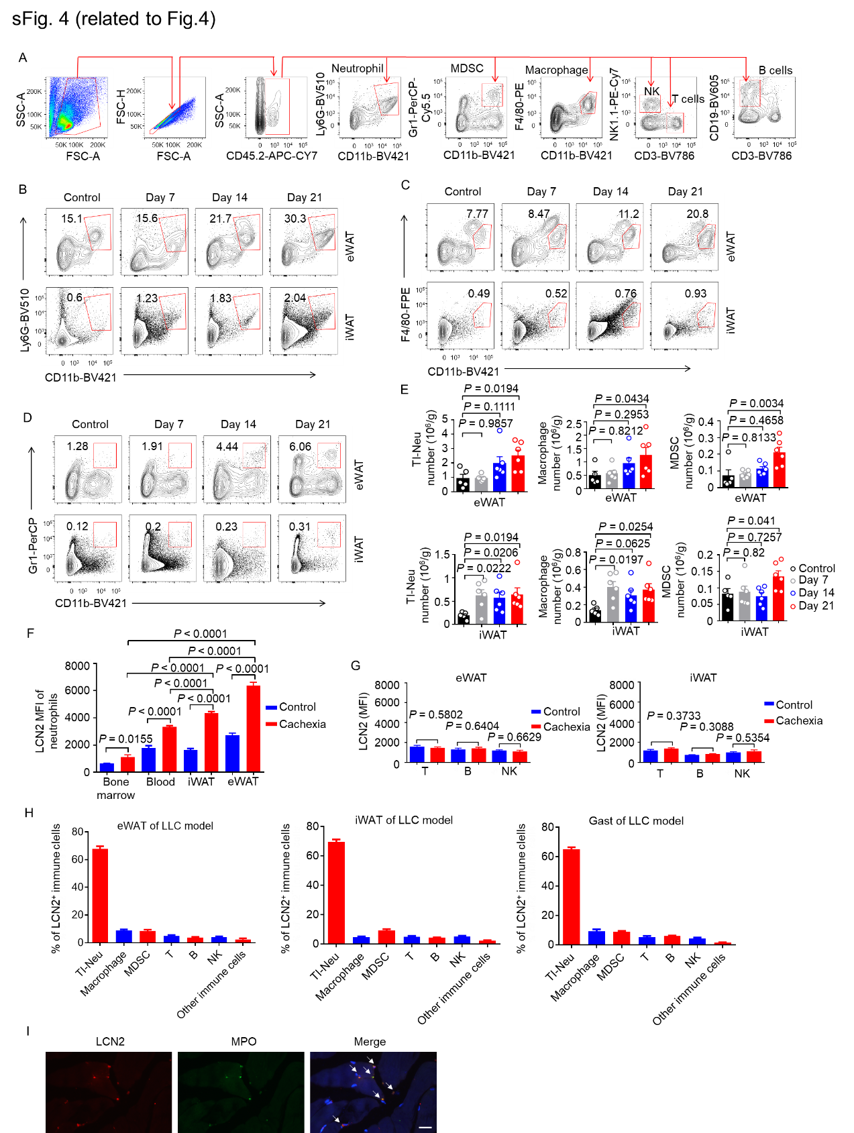

sFig. 4 Lung cancer cachectic mice have an increased number of myeloid cells and exhibit higher LCN2 expression in wasting adipose tissues.
Mice were inoculated with LLC cells to induce cachexia. A. The flow cytometry gating strategy. B–D. Representative flow cytometry plots showing (B) neutrophils, (C) macrophages, and (D) MDSCs in the eWAT and iWAT. E, Absolute numbers of neutrophils, macrophages, and MDSCs in the eWAT, iWAT, and Gast. n = 5–6 per group. F. Statistical analysis of the MFI values for LCN2 in the neutrophils of the iWAT, eWAT, blood, and bone marrow. n = 6 per group. G. Statistical analysis of the MFI values for LCN2 in the T cells, B cells, and NK cells of the iWAT and eWAT. n = 6 per group. H. Proportion of TI-Neu, Macrophage, MDSC, T cells , B cells, NK cells, and other immune cells in LCN2+ immune cells (LCN2+ CD45+) in eWAT, iWAT and Gast of LLC induced cachexia model, respectively. n = 6 per group. I. Representative immunofluorescence staining of LCN2 and MPO in the iWAT of LLC induced cachectic mice. Scale bar, 20 μm. Data are shown as the mean ± SEM. Statistical analyses were performed using one-way ANOVA (E, F) or unpaired Student’s t-test (G).

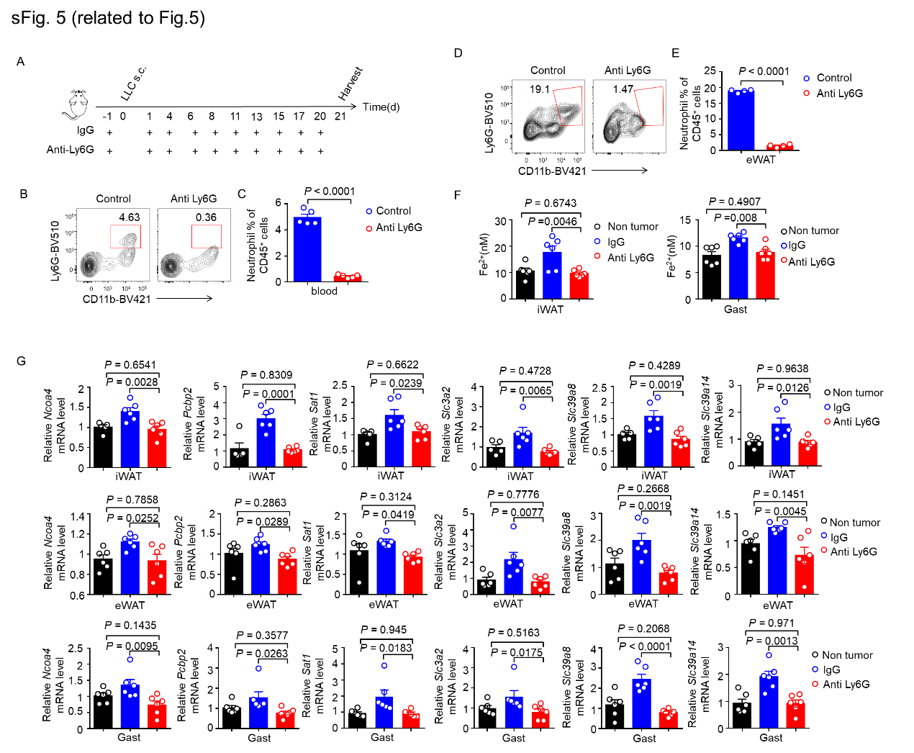

sFig. 5 Depletion of neutrophils alleviates tissue ferroptosis and wasting in lung cancer cachexia.
Mice inoculated subcutaneously with LLC cells were treated with 100 μg IgG or anti-Ly6G antibody. A. Schematic of the antibody therapy regimen. B. Representative flow cytometry plots showing neutrophils in the blood of mice 1 day after antibody treatment. C. Frequency of neutrophils in the blood of mice 1 day after antibody treatment. n = 5 per group. D. Representative flow cytometry plots showing neutrophils in the eWAT on day 21. E. Frequency of neutrophils in the eWAT on day 21. n = 4 per group. F. Fe²⁺ concentrations in the iWAT and Gast, assessed using chemiluminescence. n = 6 per group. G. qPCR of mRNA levels of the indicated ferroptosis-related genes in the eWAT, iWAT, and Gast. n = 6 per group. Data are shown as the mean ± SEM. Statistical analyses were performed using one-way ANOVA (F, G) or unpaired Student’s t-test (C, E).

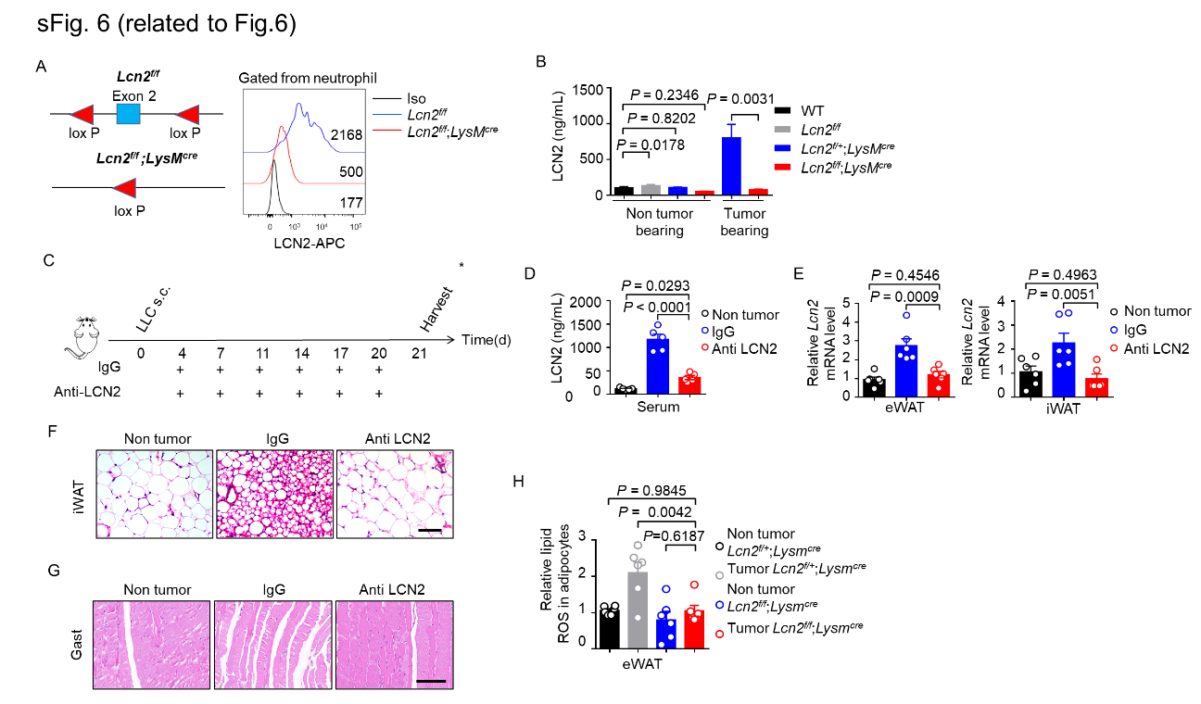

sFig.6 LCN2 knockout alleviates tissue ferroptosis and wasting in lung cancer cachexia.
A. Left, diagram showing Lcn2^{f/f};LysM^{cre} model construction. Right, representative flow cytometry plots of LCN2 expression in neutrophils of the Lcn2^{f/f} and Lcn2^{f/f};LysM^{cre} mice. B. LCN2 concentrations in the sera of Lcn2^{f/+};LysM^{cre} and Lcn2^{f/f};LysM^{cre} mice injected with LLC cells. n = 4 for each type of non-tumor-bearing mouse and n = 6 for each type of tumor-bearing mouse. C–H. Mice inoculated subcutaneously with LLC cells were administered 50 μg IgG or anti-LCN2 antibody. C. Schematic of antibody therapy. D. Serum LCN2 concentrations. n = 5 per group. E. qPCR determination of Lcn2 mRNA levels in the eWAT and iWAT. n = 6 per group. Representative H&E staining of the (F) iWAT and (G) Gast. Scale bars, 100 μm. H. Analysis of relative lipid ROS levels in the eWAT of Lcn2^{f/+};LysM^{cre} and Lcn2^{f/f};LysM^{cre} lung cancer cachexia model mice and controls. n = 6 per group. Data are shown as the mean ± SEM. Statistical analyses were performed using one-way ANOVA (B, D, E, H).

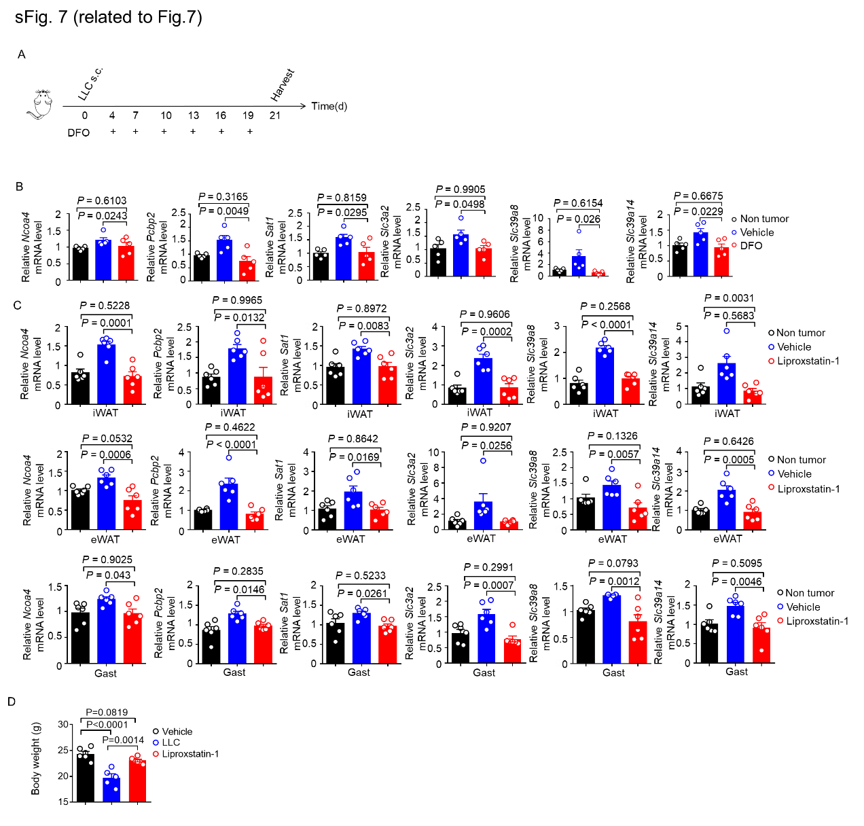

sFig. 7 Chemical inhibition of ferroptosis alleviates tissue wasting in lung cancer cachexia.
A–B. Mice inoculated subcutaneously with LLC cells were given 15 mg DFO per kg body weight. A. Schematic of DFO therapy. B. qPCR determination of mRNA levels in the eWAT. n = 5 per group. C-D. Lung cancer cachexia model mice were treated with the ferroptosis inhibitor, liproxtatin-1 (10 mg per kg body weight). C. qPCR analysis of mRNA levels of the indicated ferroptosis-related genes in the eWAT, iWAT, and Gast. n = 6 per group. D. Body weights of mice in each group. n = 5-6 per group. Data are shown as the mean ± SEM. Statistical analyses were performed using one-way ANOVA (B-D).

Table S1 Materials
Reagent | Source | Cat#
Flow cytometry materials
PE anti-mouse F4/80 | eBioscience | Cat#12-4801-80;  RRID:AB_465922
PerCP-Cy 5.5 anti-mouse Gr-1 | BioLegend | Cat# 108428;RRID:AB_893558
PE-CY7 anti-mouse NK1.1 | BioLegend | Cat# 108714, RRID:AB_389364
APC-CY7 anti-mouse CD45.2 | BioLegend | Cat# 109824, RRID:AB_830789
BV421 anti-mouseCD11b | BioLegend | Cat# 101236, RRID:AB_11203704
BV510 anti-mouse Ly6G | BD Biosciences | Cat# 740157, RRID:AB_2739910
BV605 anti-mouse Ly6C | BioLegend | Cat# 128036, RRID:AB_2562353
BV786 anti-mouse CD3 | BD Biosciences | Cat# 564379, RRID:AB_2738780
BV605 anti-mouse CD19 | BD Biosciences | Cat# 563148, RRID:AB_2732057
FITC anti-human CD66 | BD Biosciences | Cat# 551479, RRID:AB_394217
PE anti-human CD33 | BD Biosciences | Cat# 555450, RRID:AB_395843
PerCP-Cy 5.5 anti-human CD16 | BioLegend | Cat# 302028, RRID:AB_893262
PE-CY7 anti-human CD19 | BD Biosciences | Cat# 557835, RRID:AB_396893
APC-CY7 anti-human CD14 | BD Biosciences | Cat# 557831, RRID:AB_396889
BV421 anti-human CD56 | BD Biosciences | Cat# 318328, RRID:AB_11218798
BV605 anti-human CD45 | BD Biosciences | Cat# 564047, RRID:AB_2744403
BV786 anti-human CD3 | BD Biosciences | Cat# 563799, RRID:AB_2744384
Collagenase I | Sigma | Cat#C0130
RBC lysis buffer | Biolegend | Cat#420301
Percoll | GE Healthcare | Cat#17-5445-02
PMA | Sigma | Cat#P1585
Intracellular fixation & permeabilization buffer set | eBioscience | Cat#88-8824-00
Western blot materials
Lipocalin-2/NGAL antibody | Novus Biologicals | Cat# NBP2-66935
Anti-GAPDH antibody | Proteintech | Cat# 60004-1-Ig, RRID:AB_2107436
HRP conjugated goat anti-mouse IgG (H+L) | Proteintech | Cat# SA00001-1, RRID:AB_2722565
HRP conjugated goat anti-rabbit IgG (H+L) | Proteintech | Cat# SA00001-2, RRID:AB_2722564
PMSF | Beyotime | Cat#ST506
SDS-PAGE protein loading buffer | Beyotime | Cat#P0015
Blue plus II protein marker | Transgen | Cat#DM111
Supersignal west femto maximum sensitivity substrate | Thermofisher | Cat#34094
RT-qPCR materials
Random primers | Sangon Biotech | Cat#B300816
Highly pure dNTPs | Transgen | Cat#AD101
ELISA materials
Mouse lipocalin-2/NGAL quantikine ELISA kit | R＆D Systems | Cat#MLCN20
Human lipocalin-2/NGAL quantikine ELISA kit | R＆D Systems | Cat#DLCN20
Human IL-6 ELISA kit | Multiscience | Cat#70-EK106/2-96
Human CRP ELISA kit | Multiscience | Cat# 70-EK194-96
Software
Flow jo | FlowJo LLC | https://www.flowjo.com/solutions/flowjo
GraphPad Prism 5.0 | GraphPad Software | https://www.graphpad.com/
MEV v.4.8.1 | Multiple Experiment Viewer | http://mev.tm4.org/
R software | Ross Ihaka and Robert Gentleman | https://www.r-project.org/

Table S2. List of qPCR primers used in this study.
Gene name | Sequence (5'➡3’)
Atgl F | CAGCACATTTATCCCGGTGTAC
Atgl R | AAATGCCGCCATCCACATAG
Cd147 F | TTCTTATAGAGCCGCAGTGGG
Cd147 R | ACAGTGGTGCCTTGAGGAAA
Cidea F | CCGATGCACAAGCTTCAAGG
Cidea R | GTATGTGCCCGCATAGACCA
Dio2 F | GTCCGCAAATGACCCCTTT
Dio2 R | CCCACCCACTCTCTGACTTTC
Fbx32 F | TCAGAGAGGCAGATTCGCAA
Fbx32 R | GGGTGACCCCATACTGCTCT
Hsl F | GCTGGAGGAGTGTTTTTTTGC
Hsl R | AGTTGAACCAAGCAGGTCACA
Ldha F | AAGCACGTTGCTATGCCTTG
Ldha R | GAACCCCAAAAGGGGATGGT
Lipocalin2 F | AATGTCACCTCCATCCTGGTC
Lipocalin2 R | GCCACTTGCACATTGTAGCTC
Mct1 F | AGTGCAACGACCAGTGAAGT
Mct1 R | GCGATCATTACTGGACGGCT
Mstn F | AGAAGATGGGCTGAATCCCTTT
Mstn R | ATCGCAGTCAAGCCCAAAGT
Ncoa4 F | CTAAGGTCCGCTCGGATCAC
Ncoa4 R | GCCCGAAGTACTCCACCAAT
Pcbp2 F | AGTATGCCATTCCACAGCCA
Pcbp2 R | ACCTGCCCAATAGCCTTTCA
Prdm16 F | GCACGGTGAAGCCATTCATATG
Prdm16 R | TCGGCGTGCATCCGCTTGTG
Ptgs2 F | CCCATGGGTGTGAAGGGAAAT
Ptgs2 R | TCCATCCTTGAAAAGGCGCA
Sat1 F | GGACCCCTGAAGGACATAGC
Sat1 R | ATACTGCTGCAGCGACACTT
Slc3a2 F | TAAGCCGCGTGTTGATCCAT
Slc3a2 R | GCTCGTTCAGCTCCACATCT
Slc39a8 F | TCCACTTCGACACTGTCAGC
Slc39a8 R | AAGCGTGATCATCCAGGCAA
Slc39a14 F | CACTCAGTAGCTGTGTCGCC
Slc39a14 R | CCACGGATACCAGGATGGTG
Trim63 F | TCCTGATGGAAACGCTATGGAG
Trim63 R | ATTCGCAGCCTGGAAGATGT
Ucp1 F | AAGCTGTGCGATGTCCATGT
Ucp1 R | AAGCCACAAACCCTTTGAAAA
actin F | CCACTGTCGAGTCGCGTCC
actin R | ATTCCCACCATCACACCCTGG

