S1
Supplemental Figure 1. Homoharringtonine enhanced the pro-apoptotic effect of venetoclax with or without azacitidine in AML cell lines. Homoharringtonine strengthened the anti-leukemia effect of venetoclax. Combination of homoharringtonine with venetoclax presented a synergistic pro-apoptotic effect in HL60 and Molm13 cells (A,B). Combination of homoharringtonine with venetoclax with or without azacytidine significantly decreased MCL1 expression in HL60 cells treated. Western blot analysis of the expression of MCL1, BCL-2, BCL-XL, and BAX in HL60 cells treated with homoharringtonine, venetoclax, and azacitidine as indicated. Quantification of the gray level of different western bands,showing as a ratio of testing band versus control band (C-D). VH, venetoclax plus homoharringtonine; AH, azacitidine plus homoharringtonine; VA, venetoclax plus azactidine; VAH, homoharringtonine combined with venetoclax plus azacitidine (*p<0·05; **p<0·01; ***p<0·001).

S2
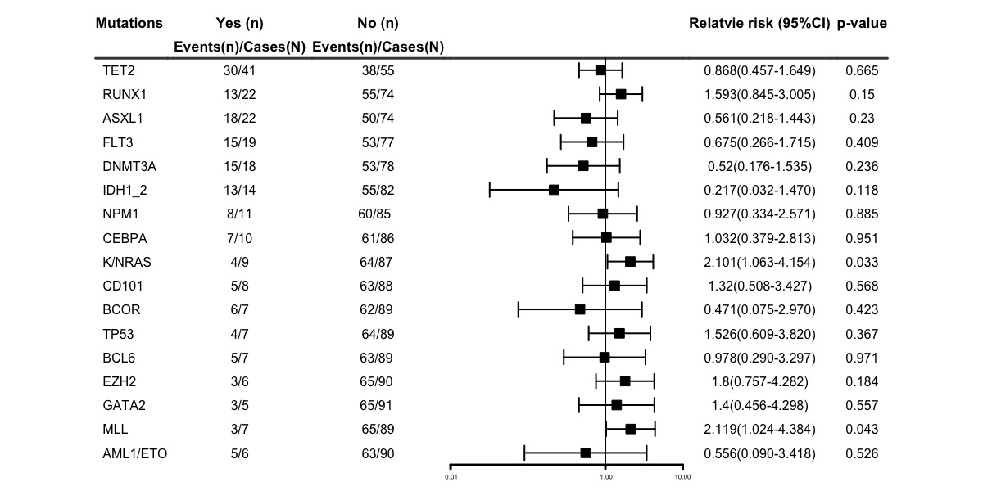

Supplemental Figure 2. Molecular mutation subgroup analysis of CRc. The relative risk of CRc between subgroups and corresponding 95% confidence Interval (CI) were calculated using binomial regression.

S3

Supplemental Figure 3. Cumulative incidence of overall survival (A), event-free survival (B), relapse(C) and disease-free survival (D) in disease subgroup.
Ref, refractory. Rel-chemo, relapsed after chemotherapy. Rel-HSCT, relapsed after HSCT. HSCT, hematopoietic stem cell transplantation.

S4
Supplemental Figure 4. Among patients reached CRc, cumulative incidence of overall survival (A) and disease-free survival (B) in patients who received or did not receive allo-HSCT.

S5
Supplemental Figure 5. Cumulative incidence of overall survival (A), event-free survival (B), relapse(C) and disease-free survival (D) among patients without FLT3^{mut} and patients with FLT3^{mut}

Supplemental Table 1. CRc rates of cytogenetic and molecular subgroups
Subgroups | CRc (CR+CRi), No. (% [95% CI])
 | All（n=96） | Refractory AML  (n=37) | Relapsed after chemotherapy AML  (n = 16) | Relapsed after allo-HSCT AML  (n =43 )
ELN classification
Favorable | 16(94.1 [66.0-99.2]) | 7(100) | 2(100) | 7(87.5 [41.1-98.6])
Intermediate | 14(63.6 [41.6-81.2]) | 7(70.0 [34.8-90.1]) | 3(60.0 [14.4-93.1]) | 4(57.1 [20.1-87.6])
Adverse | 38(66.7 [53.3-77.8]) | 15(75.0 [50.6-89.8]) | 5(55.6 [21.5-85.1]) | 18(64.3 [44.4-80.2])
Cytogenetics‡
Favorable | 6 (100 ) | 4 (100 ) | 0(0) | 2 (100 )
Intermediate | 41(77.4 [63.9-86.8]) | 16(88.9 [62.6-97.5]) | 7(70.0 [33.1-91.7]) | 18(72.0 [50.7-86.6])
Poor | 15(55.6 [36.3-73.2]) | 8(66.7 [35.4-88.0]) | 1(33.3 [2.0-92.6]) | 6(50.0 [22.8-77.2])
Unknown | 6(60.0 [28.0-85.3]) | 1(33.3 [2.3-91.3]) | 2(66.7 [7.6-98.0]) | 3(75.0 [16.9-97.8])
Molecular abnormalities
NPM1 | 8(72.7 [39.4-91.6]) | 3(100) | 1(50.0 [1.4-98.6]) | 4(66.7 [22.8-93.1])
AML1-ETO | 5(83.3 [31.6-98.2]) | 3(75.0 [16.8-97.8]) | 0(0) | 2(100)
CEBPA | 7(70.0 [35.5-90.8]) | 2(66.7 [8.7-97.7]) | 1(50.0 [1.4-98.6]) | 4(80.0 [24.3-98.0])
TET2 | 30(73.2 [57.3-84.7]) | 12(92.3 [57.1-99.1]) | 4(57.1 [18.7-88.6]) | 14(66.7 [43.4-83.9])
DNMT3A | 15(83.3 [57.9-94.8]) | 8(88.9 [45.0-98.7]) | 2(100) | 5(71.4 [28.8-93.9])
IDH1/2  FLT3  ASXL1  RUNX1  TP53  MLL | 13(92.9 [60.5-99.1]) | 8(100) | 2(66.7 [7.6-98.0]) | 3(100)
FLT3 | 15(78.9 [54.3-92.2]) | 7(100) | 0(0) | 8(80.0 [42.7-95.6])
ASXL1 | 18(81.8 [59.4-93.3]) | 7(100) | 2(50.0 [7.9-92.1]) | 9(81.8 [46.2-95.9])
RUNX1 | 13(59.1 [37.4-77.7]) | 5(83.3 [30.5-98.3]) | 2(66.7 [7.6-98.0]) | 6(46.2 [21.0-88.9])
TP53 | 4(57.1 [20.6-87.3]) | 2(50.0 [8.8-91.2]) | 0(0) | 2(66.7 [8.8-97.6])
MLL | 3(42.9 [12.7-79.4]) | 2(100) | 1(33.3 [2.0-92.6]) | 0(0)
EZH2 | 3(50.0 [14.5-85.5]) | 0(0) | 1(100) | 2(50.0 [8.9-91.1])
BCL6 | 5(71.4 [29.4-93.8]) | 1(100) | 0(0) | 4(80.0 [24.3-98.0])
BCOR | 6(85.7 [37.2-98.4]) | 5(83.3 [30.5-98.3]) | 0(0) | 1(100)
GATA2 | 3(60.0 [16.5-91.9]) | 1(100) | 0(0) | 2(50.0 [8.9-91.1])
RAS | 4(44.4 [16.3-76.7]) | 3(50.0 [14.0-86.0]) | 0(0) | 1(50.0 [1.7-98.3])
CD101 | 5(62.5 [26.1-88.7]) | 2(100) | 0(0) | 3(60.0 [16.1-92.2])

Abbreviations: CRc, composite complete remission; CR, complete remission; CRi, CR with incomplete hematological recovery; ELN, European Leukemia Net; AML, acute myeloid leukemia; Allo-HSCT, allogeneic hematopoietic stem cell transplantation.

Supplemental Table 2. Univariate and multivariate analyses for the risk factors of overall survival
 | Overall survival
Characteristics | Univariable |  | Multivariable
Characteristics | HR (95%CI) | P | HR (95%CI) | P
Age*  >45 vs ≤45 | 0.76(0.41-1.40) | 0.378
Gender  Female vs Male | 1.11(0.61-2.03) | 0.726
AML status  Refractory vs Relapsed after chemotherapy  Refractory vs Relapsed after Allo-HSCT  Relapsed after chemotherapy vs Relapsed after Allo-HSCT | 1.42(1.01-1.99)  0.55(0.22-1.34)  0.49(0.24-0.98)  0.89(0.40-1.99) | 0.046  0.185  0.044  0.777
ELN classification  Intermediate vs Favorable  Adverse vs Favorable  Adverse vs Intermediate | 1.60(1.03-2.49)  2.26(0.69-7.37)  2.95(1.04-8.39)  1.31(0.62-2.76) | 0.037  0.177  0.042  0.483 | 1.53(0.82-2.88) | 0.184
MRD  Negative vs positive | 0.31(0.11-0.82) | 0.018 | 0.35(0.13-0.93) | 0.035
Bridge to allo-HSCT  Yes vs No | 0.24(0.11-0.49) | <0·001 | 0·36(0·13–0·98) | 0·046

Abbreviations: Allo-HSCT, allogeneic hematopoietic stem cell transplantation; ELN, European Leukemia Net; MRD, minimal residual disease. *Cutoffs were the median value.

