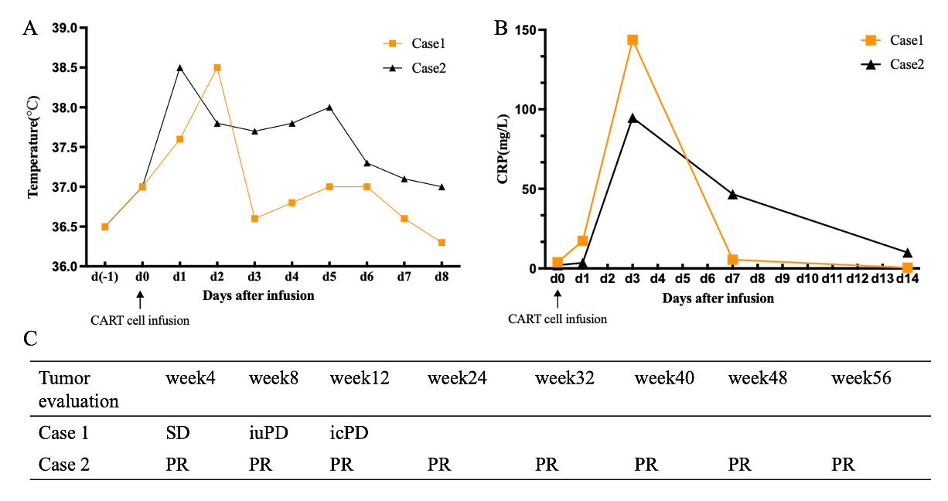
Figure S3. The body temperature(A), CRP change(B) and clinical response summary(C) of the two patients.

