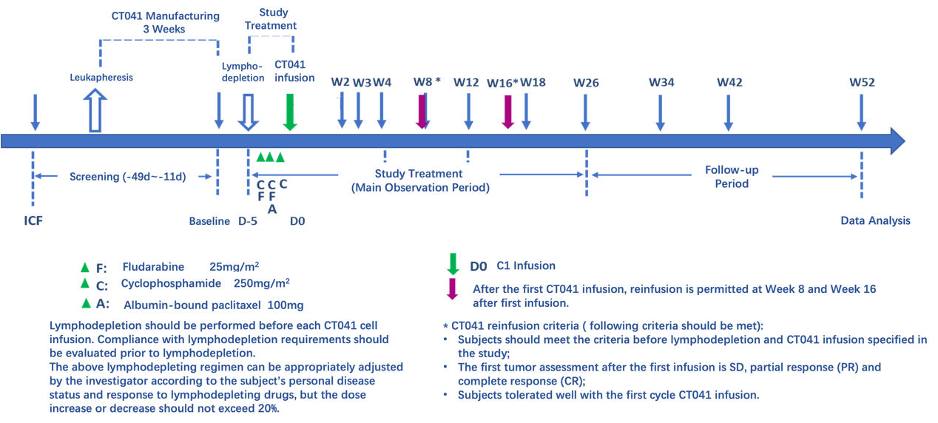
Figure S4. The diagram of patient enrollment and management for CT-041 administration.

