SUPPLEMENTAL APPENDIX

Table of Contents 1

Methods 2

CAR T-cell therapy for SCNSL: Table S1 3-4

Toxicity post CAR-T: Table S2 5

Patient characteristics based on best response of CR post CAR-T: Table S3 6-7

PFS of patients receiving CAR-T for SCNSL among subgroups: Table S4 8

OS of patients receiving CAR-T for SCNSL among subgroups: Table S5 9

Factors associated with risk of CRS: Table S6 10-11

Factors associated with risk of Neurotoxicity: Table S7 12-13

PFS and OS based on the type of CAR-T product: Figure S1 14

PFS of patients receiving CAR-T for SCNSL based on ECOG at apheresis: Figure S2 15

OS of patients receiving CAR-T for SCNSL among subgroups: Figure S3 16

OS of patients receiving CAR-T for SCNSL among CNS vs CNS and systemic relapse: Figure S4 17

Methods
Assessment of Toxicity and Response
CRS and Immune Effector Cell Associated Neurotoxicity Syndrome (ICANS) were graded according to the consensus grading system proposed by the American Society for Transplantation and Cellular Therapy²⁷. CNS disease and response to therapy were evaluated according to the local institutional guidelines. Response to CAR-T was graded as CR, partial response, stable disease, or progressive disease.
Statistical analysis
Patient demographics, disease characteristics, and clinical outcomes were summarized through descriptive statistics. The Chi-square test or Fisher’s exact test was used to evaluate the association between two categorical variables. Wilcoxon rank sum test was used to evaluate the difference in a continuous variable between patient groups. A multivariable logistic regression model was fitted to estimate the effects of important covariates on best CR post CAR-T. Kaplan-Meier method was used for time-to-event analysis including PFS and OS. Median time to event in months with a 95% confidence interval was calculated. The Log-rank test was used to evaluate the difference in time-to-event endpoints between patient groups. Cox proportional hazard models were used for multivariable analysis. The Schoenfeld residual was used to check the proportional hazards assumption. The variables that had a p-value less than 0.2 for PFS or OS from the univariate analysis were included in the initial full multivariable model. A backward selection method was used and a significant level of 0.10 was set as the criterion for a variable to stay in the model. Collinearity diagnostics were performed and indicated no collinearity problem. Statistical software SAS 9.4 (SAS, Cary, NC) and S-Plus 8.2 (TIBCO Software Inc., Palo Alto, CA) were used for all the analyses.

Table S1. CAR T-cell therapy for SCNSL (studies ≥5 patients)
Study | Study Design | CAR-T product | Patients (n) | Median age at CAR-T, years (range)
Frigault ¹ | Single-center retrospective study | Tisa-cel | 8 | 50 (17-79)
Bennani ² | Multicenter retrospective cohort | Axi-cel | 17 | 58 (48-69)
Ahmed ³ | Single-center retrospective study | Tisa-cel (n=4)  Axi-cel (n=3) | 7 | 50 (39-72)
Ghafouri⁴ | Single-center retrospective study | Axi-cel | 5 | 58 (28-76)
Karschnia⁵ | Single-center retrospective study | Tisa-cel (n=20)  Liso-cel (n=7) | 27 | 33^
Zurko⁶ | Multi-center retrospective study | NR^^ | 32^^ | 59^^
Abramson⁷ | clinical trial  TRANSCEND | Liso-cel | 7 | 63 (54-70)*
Wu⁸ | clinical trial  prospective study | Experimental** | 9 | 47 (23-65)
Liu⁹ | clinical trial  prospective study | CD19 or CD20 CAR T-cell therapy | 6 | 43 (43-66)
Abbreviations: Tisa-cel: Tisagenlecleucel; Axi-cel: Axicabtagene Ciloleucel; Liso-cel: Lisocabtagene maraleucel; NR: not reported

^only provided the mean and SD (32.7± 1.4) years
^^The details on the CNSL (including relapsed primary versus secondary CNSL) and CAR-T product for the CNSL cohort were not provided. The age is for the entire group and not specifically for the CNSL patients
*This is for the entire group and not specifically for the SCNSL patients.
**CD19/CD22 CAR T-cell therapy

References
1. Frigault MJ, Dietrich J, Martinez-Lage M, et al. Tisagenlecleucel CAR T-cell therapy in secondary CNS lymphoma. Blood. 2019;134(11):860-866.
2. Bennani NN MM, Nastoupil LJ, Jain MD, Chavez JC, Cashen AF, et al. Experience with Axicabtagene Ciloleucel (Axi-cel) in Patients with Secondary CNS Involvement: Results from the US Lymphoma CAR T Consortium. Blood. 2019;134:763.
3. Ahmed G, Hamadani M, Shah NN. CAR T-cell therapy for secondary CNS DLBCL. Blood Adv. 2021;5(24):5626-5630.
4. Ghafouri S, Timmerman J, Larson S, Mead MD. Axicabtagene Ciloleucel CAR T-cell therapy for relapsed/refractory secondary CNS non-Hodgkin lymphoma: comparable outcomes and toxicities, but shorter remissions may warrant alternative consolidative strategies? Bone Marrow Transplantation. 2021;56(4):974-977.
5. Karschnia P, Rejeski K, Winkelmann M, et al. Toxicities and Response Rates of Secondary CNS Lymphoma After Adoptive Immunotherapy With CD19-Directed Chimeric Antigen Receptor T Cells. Neurology. 2022;98(21):884-889.
6. Zurko J, Nizamuddin I, Epperla N, et al. Peri-CAR-T practice patterns and survival predictors for all CAR-T patients and post-CAR-T failure in aggressive B-NHL. Blood Adv. 2023;7(12):2657-2669.
7. Abramson JS, Palomba ML, Gordon LI, et al. Lisocabtagene maraleucel for patients with relapsed or refractory large B-cell lymphomas (TRANSCEND NHL 001): a multicentre seamless design study. Lancet. 2020;396(10254):839-852.
8. Wu J, Meng F, Cao Y, et al. Sequential CD19/22 CAR T-cell immunotherapy following autologous stem cell transplantation for central nervous system lymphoma. Blood Cancer J. 2021;11(7):131.
9. CD19 or CD20 CAR T Cell Therapy Demonstrates Durable Antitumor Efficacy in Patients with Central Nervous System Lymphoma. Human Gene Therapy. 2022;33(5-6):318-329.

Table S2. Toxicity post CAR-T
Variable | All patients  N=61 (%) | CNS only  N=20 (%) | CNS and systemic  N=41 (%)
Any grade CRS | 43 (70) | 15 (75) | 28 (68)
Grade ≥ 3 CRS* | 7 (16) | 3 (15) | 4 (10)
Any grade ICANS | 34 (57) | 13 (65) | 21 (52)
Grade ≥ 3 ICANS** | 15 (44) | 3 (15) | 12 (30)
Steroids | 32 (59) | 11 (69) | 21 (55)
Tocilizumab | 28 (47) | 10 (53) | 18 (44)
Abbreviations: CRS-cytokine release syndrome. ICANS- immune effector cell-associated neurotoxicity syndrome

*Among the patients who had CRS
** Among the patients who had ICANS

Table S3. Patient characteristics based on the best response of CR post CAR-T
Variable | All patients  N=56 (%) | CR  N=32 (%) | No CR  N=24 (%) | p-value
Age at diagnosis |  |  |  | 0.33
Median, range (yrs) | 56 (18-73) | 56 (18-70) | 56 (23-73)
>60 yrs | 16 (29) | 7 (44) | 9 (56) | 0.20
≤60 yrs | 40 (71) | 25 (62) | 15 (37)
Sex, n (%) |  |  |  | 0.70
Males | 31 (55) | 17 (53) | 14 (58)
Females | 25 (45) | 15 (47) | 10 (42)
IPI at diagnosis |  |  |  | 0.27
0 | 1 (2) | 1 (4) | 0
1-2 | 14 (29) | 6 (21) | 8 (40)
≥3 | 33 (69) | 21 (75) | 12 (60)
DHL | 15 (32) | 8 (31) | 7 (33) | 0.58
Primary refractory disease |  |  |  | 0.10
Yes | 12 (22) | 4 (13) | 8 (33)
No | 43 (78) | 27 (87) | 16 (67)
Lines of therapy prior to CAR-T |  |  |  | 0.04
≤2 | 18 (33) | 9 (29) | 9 (39)
3 | 25 (46) | 12 (39) | 13 (57)
≥4 | 11 (20) | 10 (32) | 1 (4)
Prior auto-HCT |  |  |  | 0.52
Yes | 12 (21) | 8 (25) | 4 (17)
No | 44 (79) | 24 (75) | 20 (83)
Median time from diagnosis to CAR-T, range (months) | 15.8 (3.6–257.4) | 16.8 (7.3-257.4) | 15.6 (3.6-130-3) | 0.61
CAR-T product |  |  |  | 0.76
Axi-cel | 27 (48) | 16 (50) | 11 (46)
Tisa-cel | 17 (30) | 8 (25) | 9 (37)
Liso-cel | 11 (20) | 7 (22) | 4 (17)
Brexu-cel | 1 (2) | 1 (3) | 0
Median age at apheresis, range (yrs) | 58 (18-74) | 58 (18-72) | 57 (23-74) | 0.35
ECOG PS at apheresis |  |  |  | 0.32
0-1 | 44 (79) | 27 (84) | 17 (71)
≥2 | 12 (21) | 5 (16) | 7 (29)
Type of relapse |  |  |  | 0.68
CNS only | 18 (32) | 11 (34) | 7 (29)
CNS + systemic | 38 (68) | 21 (66) | 17 (71)
Site of CNS involvement |  |  |  | 0.43
Parenchymal | 23 (42) | 12 (39) | 11 (46)
Leptomeningeal | 26 (47) | 14 (45) | 12 (50)
Both | 6 (11) | 5 (16) | 1 (4)
Disease status prior to CAR-T |  |  |  | 0.34
CR | 3 (5) | 2 (6) | 1 (4)
PR | 17 (30) | 7 (22) | 10 (42)
SD | 9 (16) | 7 (22) | 2 (8)
PD | 27 (48) | 16 (50) | 11 (46)
Bridging |  |  |  | 0.41
Chemo only | 20 (36) | 9 (28) | 11 (46)
Chemo+XRT | 5 (9) | 3 (9) | 2 (8)
XRT only | 9 (16) | 7 (22) | 2 (8)
None | 22 (39) | 13 (41) | 9 (38)
Any grade CRS |  |  |  | 0.037
Yes | 41 (73) | 27 (84) | 14 (58)
No | 15 (27) | 5 (16) | 10 (42)
Any grade ICANS |  |  |  | 0.40
Yes | 31 (56) | 19 (61) | 12 (50)
No | 24 (44) | 12 (39) | 12 (50)
Abbreviations: CNS- central nervous system, yrs-years, IPI-international prognostic index, auto-HCT-autologous hematopoietic cell transplantation, PS-performance status, CR-complete response, PR-partial response, SD-stable disease, PD-progressive disease, CRS-cytokine release syndrome. ICANS- immune effector cell-associated neurotoxicity syndrome, Axi-cel- Axicabtagene ciloleucel, Tisa-cel- Tisagenlecleucel, Liso-cel- Lisocabtagene maraleucel, Brexu-cel- Brexucabtagene autoleucel

Table S4. PFS of patients receiving CAR-T for SCNSL among the various subgroups
Variable | Level | Median PFS time in mos (95%CI) | PFS rate at 6 mos (95%CI) | p-value
Age | <=60 | 3.48 (2.56 , 7.26 ) | 0.4 (0.27 , 0.59 ) | 0.51
 | >60 | 3.02 (1.61 , 6.01 ) | 0.24 (0.1 , 0.55 )
Sex | Female | 5.35 (3.02 , 7.19 ) | 0.41 (0.25 , 0.66 ) | 0.71
 | Male | 2.64 (1.61 , 7.98 ) | 0.3 (0.17 , 0.52 )
COO | GC | 5.98 (2.73 , 14.13 ) | 0.47 (0.3 , 0.72 ) | 0.17
 | Non-GCB/ ABC | 2.56 (1.51 , 6.01 ) | 0.27 (0.14 , 0.52 )
DHL | Yes | 2.74 (1.25 , 7.26 ) | 0.19 (0.07 , 0.52 ) | 0.60
IPI at diagnosis | 0 | NA (NA , NA ) |  | 0.50
 | 1 | 1.71 (0.46 , NA ) | 0.25 (0.05 , 1 )
 | 2 | 2.33 (1.25 , NA ) | 0.3 (0.12 , 0.77 )
 | 3 | 4.96 (2.56 , 7.26 ) | 0.26 (0.12 , 0.59 )
 | 4 | 3.48 (1.74 , 15.18 ) | 0.41 (0.23 , 0.75 )
COPD | No | 3.02 (2.27 , 5.95 ) | 0.31 (0.21 , 0.47 ) | 0.37
 | Yes | 7.26 (6.27 , NA ) | 1 (1 , 1 )
Cardiac comorbidities | No | 3.45 (2.56 , 7.19 ) | 0.38 (0.26 , 0.56 ) | 0.15
 | Yes | 2.18 (0.95 , NA ) | 0.25 (0.09 , 0.67 )
Prior auto-HCT | No | 2.99 (1.74 , 6.01 ) | 0.34 (0.23 , 0.52 ) | 0.33
 | Yes | 4.42 (3.02 , NA ) | 0.37 (0.17 , 0.83 )
ECOG at apheresis | ≥2 | 1.3 (0.82 , NA ) | 0.18 (0.05 , 0.6 ) | 0.06
 | 0-1 | 3.48 (2.76 , 7.26 ) | 0.4 (0.28 , 0.58 )
Type of relapse | CNS only | 6.01 (2.07 , 11.7 ) | 0.55 (0.36 , 0.84 ) | 0.34
 | CNS and systemic | 2.99 (2.27 , 5.95 ) | 0.27 (0.16 , 0.45 )
Site of CNS involvement | Parenchymal | 3.02 (2.27 , 6.27 ) | 0.3 (0.16 , 0.56 ) | 0.47
 | Leptomeningeal | 2.76 (1.68 , 7.98 ) | 0.37 (0.22 , 0.61 )
 | Both | 5.95 (5.75 , NA ) | 0.4 (0.14 , 1 )
Bridging | Chemo only | 1.63 (1.15 , 5.75 ) | 0.13 (0.04 , 0.44 ) | 0.23
 | Chemo/XRT | 5.35 (2.99 , NA ) | 0.3 (0.06 , 1 )
 | XRT only | 5.95 (1.61 , NA ) | 0.44 (0.21 , 0.92 )
 | None | 6.01 (3.02 , 11.7 ) | 0.5 (0.33 , 0.76 )
CAR-T product | Axi-cel | 5.35 (2.56 , 7.26 ) | 0.36 (0.21 , 0.59 ) | 0.95
 | Tisa-cel | 2.99 (1.68 , 9.99 ) | 0.32 (0.16 , 0.61 )
 | Liso-cel | 4.96 (2.27 , NA ) | 0.35 (0.13 , 0.95 )

Table S5: Overall survival of patients receiving CAR-T for SCNSL among the various subgroups
Variable | Level | Median OS time in mos (95%CI) | OS rate at 6 mos (95%CI) | OS rate at 1 year (95%CI) | p-value
Age | <=60 | 7.59 (5.98 , NA ) | 0.61 (0.47 , 0.79 ) | 0.42 (0.28 , 0.63 ) | 0.73
 | >60 | 6.44 (2.07 , NA ) | 0.52 (0.33 , 0.83 ) | 0.39 (0.21 , 0.72 )
Sex | Female | 7.59 (6.44 , NA ) | 0.69 (0.53 , 0.89 ) | 0.45 (0.29 , 0.71 ) | 0.33
 | Male | 5.98 (4.37 , NA ) | 0.5 (0.35 , 0.72 ) | 0.38 (0.23 , 0.61 )
COO | GC | 10.15 (6.44 , NA ) | 0.71 (0.54 , 0.92 ) | 0.49 (0.32 , 0.77 ) | 0.23
 | Non-GCB/ ABC | 6.77 (2.79 , NA ) | 0.55 (0.39 , 0.79 ) | 0.35 (0.2 , 0.62 )
DHL | Yes | 4.47 (3.58 , NA ) | 0.34 (0.17 , 0.69 ) | 0.2 (0.07 , 0.56 ) | 0.41
IPI at diagnosis | 0 | NA (NA , NA ) |  |  | 0.77
 | 1 | 7.51 (0.89 , NA ) | 0.5 (0.19 , 1 )
 | 2 | 6.47 (2.79 , NA ) | 0.56 (0.31 , 1 ) | 0.28 (0.09 , 0.88 )
 | 3 | 6.77 (4.96 , NA ) | 0.61 (0.42 , 0.89 ) | 0.36 (0.19 , 0.69 )
 | 4 | 7.98 (3.58 , NA ) | 0.59 (0.38 , 0.91 ) | 0.44 (0.25 , 0.8 )
COPD | No | 6.77 (4.47 , 13.3 ) | 0.56 (0.44 , 0.72 ) | 0.38 (0.26 , 0.55 ) | 0.09
 | Yes | NA (NA , NA ) | 1 (1 , 1 ) | 1 (1 , 1 )
Cardiac comorbidities | No | 7.59 (6.44 , NA ) | 0.64 (0.51 , 0.8 ) | 0.5 (0.36 , 0.68 ) | 0.049
 | Yes | 4.71 (1.61 , NA ) | 0.42 (0.21 , 0.81 ) | 0.12 (0.02 , 0.68 )
Prior auto-HCT | No | 7.16 (4.47 , NA ) | 0.56 (0.43 , 0.72 ) | 0.4 (0.27 , 0.58 ) | 0.56
 | Yes | 7.59 (4.37 , NA ) | 0.7 (0.46 , 1 ) | 0.47 (0.23 , 0.94 )
ECOG at apheresis | ≥2 | 2.79 (1.58 , NA ) | 0.4 (0.21 , 0.78 ) | 0.1 (0.02 , 0.62 ) | 0.005
 | 0-1 | 12.45 (6.44 , NA ) | 0.64 (0.51 , 0.81 ) | 0.5 (0.37 , 0.69 )
Type of relapse | CNS only | NA (7.98 , NA ) | 0.77 (0.6 , 1 ) | 0.63 (0.43 , 0.92 ) | 0.07
 | CNS and systemic | 6.44 (4.01 , 13.3 ) | 0.5 (0.37 , 0.69 ) | 0.32 (0.19 , 0.52 )
Site of CNS involvement | Parenchymal | 7.85 (5.98 , NA ) | 0.66 (0.49 , 0.89 ) | 0.41 (0.24 , 0.68 ) | 0.39
 | Leptomeningeal | 4.96 (3.02 , NA ) | 0.46 (0.3 , 0.7 ) | 0.31 (0.17 , 0.58 )
 | Both | NA (13.53 , NA ) | 0.8 (0.52 , 1 ) | 0.8 (0.52 , 1 )
Bridging | Chemo only | 3.63 (1.68 , NA ) | 0.38 (0.21 , 0.67 ) | 0.23 (0.1 , 0.57 ) | 0.20
 | Chemo/XRT | 6.77 (5.98 , NA ) | 0.53 (0.21 , 1 ) | 0.27 (0.05 , 1 )
 | XRT only | 13.53 (6.47 , NA ) | 0.76 (0.52 , 1 ) | 0.51 (0.26 , 1 )
 | None | 12.45 (6.44 , NA ) | 0.72 (0.55 , 0.94 ) | 0.55 (0.37 , 0.83 )
CAR-T product | Axi-cel | 7.98 (4.47 , NA ) | 0.64 (0.48 , 0.85 ) | 0.42 (0.26 , 0.67 ) | 0.93
 | Tisa-cel | 4.37 (2.56 , NA ) | 0.41 (0.23 , 0.71 ) | 0.41 (0.23 , 0.71 )
 | Liso-cel | 7.85 (6.44 , NA ) | 0.78 (0.55 , 1 ) | 0.39 (0.16 , 0.94 )

Table S6. Factors associated with the risk of CRS
Variable | All patients  N=61 (%) | CRS  N=43 (%) | No CRS  N=18 (%) | p-value
Age at diagnosis |  |  |  | 0.54
Median, range (yrs) | 56 (18-82) | 55 (18-82) | 59 (29-71)
>60 yrs | 17 (28) | 11 (26) | 6 (33)
≤60 yrs | 44 (72) | 32 (74) | 12 (67)
Sex, n (%) |  |  |  | 0.27
Males | 34 (56) | 22 (51) | 12 (67)
Females | 27 (44) | 21 (49) | 6 (33)
IPI at diagnosis |  |  |  | 0.38
0 | 1 (2) | 1 (3) | 0
1-2 | 15 (29) | 9 (24) | 6 (46)
≥3 | 35 (69) | 28 (74) | 7 (54)
DHL | 16 (31) | 10 (28) | 6 (37) | 0.56
Primary refractory disease |  |  |  | 0.42
Yes | 15 (25) | 10 (23) | 5 (29)
No | 45 (75) | 33 (67) | 12 (71)
Median lines of therapy prior to CAR-T, range | 3 (1-5) | 3 (1-5) | 3 (1-4) | 0.41
Prior auto-HCT |  |  |  | 0.74
Yes | 14 (23) | 9 (21) | 5 (28)
No | 47 (77) | 34 (79) | 13 (72)
CAR-T product |  |  |  | 0.016
Axi-cel | 30 (49) | 26 (61) | 4 (22)
Tisa-cel | 19 (31) | 9 (21) | 10 (56)
Liso-cel | 11 (18) | 7 (16) | 4 (22)
Brexu-cel | 1 (2) | 1 (2) | 0
Median age at apheresis, range (yrs) | 58 (18-83) | 57 (18-83) | 61 (29-71) | 0.34
ECOG PS at apheresis |  |  |  | 1.00
0-1 | 47 (77) | 33 (77) | 14 (78)
≥2 | 14 (23) | 10 (23) | 4 (22)
Type of relapse |  |  |  | 0.77
CNS only | 20 (33) | 15 (35) | 5 (28)
CNS + systemic | 41 (67) | 28 (65) | 13 (72)
Site of CNS involvement |  |  |  | 0.30
Parenchymal | 25 (42) | 17 (41) | 8 (44)
Leptomeningeal | 29 (48) | 19 (45) | 10 (56)
Both | 6 (10) | 6 (14) | 0
Disease status prior to CAR-T |  |  |  | 0.46
CR | 3 (5) | 3 (7) | 0
PR | 19 (31) | 15 (35) | 4 (22)
SD | 9 (15) | 5 (12) | 4 (22)
PD | 30 (49) | 20 (46) | 10 (56)
Bridging |  |  |  | 0.97
Chemo only | 23 (38) | 16 (37) | 7 (39)
Chemo+XRT | 5 (8) | 4 (9) | 1 (6)
XRT only | 9 (15) | 7 (16) | 2 (11)
None | 24 (39) | 16 (37) | 8 (44)
Abbreviations: CRS-cytokine release syndrome, CNS- central nervous system, yrs-years, IPI-international prognostic index, auto-HCT-autologous hematopoietic cell transplantation, PS-performance status, CR-complete response, PR-partial response, SD-stable disease, PD-progressive disease, Axi-cel- Axicabtagene ciloleucel, Tisa-cel- Tisagenlecleucel, Liso-cel- Lisocabtagene maraleucel, Brexu-cel- Brexucabtagene autoleucel

*Among the evaluable patients (n=56)

Table S7. Factors associated with the risk of Neurotoxicity
Variable | All patients  N=60 (%) | NT  N=34 (%) | No NT  N=26 (%) | p-value
Age at diagnosis |  |  |  | 0.43
Median, range (yrs) | 56 (18-82) | 56 (23-82) | 56 (18-73)
>60 yrs | 17 (28) | 11 (32) | 6 (23)
≤60 yrs | 43 (72) | 23 (68) | 20 (77)
Sex, n (%) |  |  |  | 0.71
Males | 33 (55) | 18 (53) | 15 (58)
Females | 27 (45) | 16 (47) | 11 (42)
IPI at diagnosis |  |  |  | 0.36
0 | 1 (2) | 1 (4) | 0
1-2 | 15 (30) | 6 (23) | 9 (37)
≥3 | 34 (68) | 19 (73) | 15 (63)
DHL | 15 (29) | 6 (19) | 9 (45) | 0.12
Primary refractory disease |  |  |  | 0.55
Yes | 15 (25) | 10 (29) | 5 (19)
No | 45 (75) | 24 (71) | 21 (81)
Median lines of therapy prior to CAR-T, range | 3 (1-5) | 3 (1-5) | 3 (1-5) | 0.81
Prior auto-HCT |  |  |  | 0.97
Yes | 14 (23) | 8 (23) | 6 (23)
No | 46 (77) | 26 (77) | 20 (77)
CAR-T product |  |  |  | 0.09
Axi-cel | 30 (50) | 21 (62) | 9 (35)
Tisa-cel | 19 (32) | 8 (23) | 11 (42)
Liso-cel | 10 (17) | 4 (12) | 6 (23)
Brexu-cel | 1 (2) | 1 (3) | 0
Median age at apheresis, range (yrs) | 58 (18-83) | 59 (23-83) | 58 (18-74) | 0.49
ECOG PS at apheresis |  |  |  | 0.56
0-1 | 46 (77) | 25 (74) | 21 (81)
≥2 | 14 (23) | 9 (26) | 5 (19)
Type of relapse |  |  |  | 0.36
CNS only | 20 (33) | 13 (38) | 7 (27)
CNS + systemic | 40 (67) | 21 (62) | 19 (73)
Site of CNS involvement |  |  |  | 0.03
Parenchymal | 25 (42) | 11 (32) | 14 (56)
Leptomeningeal | 28 (48) | 17 (50) | 11 (44)
Both | 6 (10) | 6 (18) | 0
Disease status prior to CAR-T |  |  |  | 0.32
CR | 3 (5) | 3 (9) | 0
PR | 19 (32) | 9 (26) | 10 (38)
SD | 8 (13) | 6 (18) | 2 (8)
PD | 30 (50) | 16 (47) | 14 (54)
Bridging |  |  |  | 0.87
Chemo only | 22 (37) | 13 (38) | 9 (35)
Chemo+XRT | 5 (8) | 3 (9) | 2 (8)
XRT only | 9 (15) | 6 (18) | 3 (11)
None | 24 (40) | 12 (35) | 12 (46)
Abbreviations: NT-neurotoxicity, CNS- central nervous system, yrs-years, IPI-international prognostic index, auto-HCT-autologous hematopoietic cell transplantation, PS-performance status, CR-complete response, PR-partial response, SD-stable disease, PD-progressive disease, Axicabtagene ciloleucel, Tisa-cel- Tisagenlecleucel, Liso-cel- Lisocabtagene maraleucel, Brexu-cel- Brexucabtagene autoleucel

Figure S1. PFS and OS based the type of CAR-T product
- PFS based on the type of CAR-T product
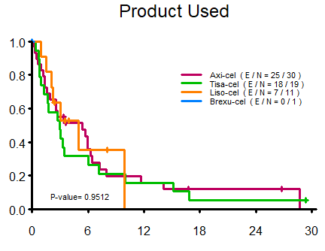

- OS based on the type of CAR-T product

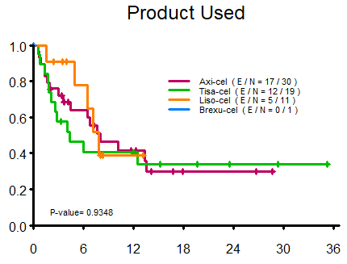

Figure S2. PFS of patients receiving CAR-T for SCNSL among those with ECOG of 0-1 versus ≥2 at apheresis

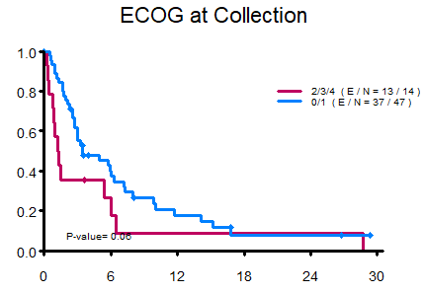

Figure S3. OS of patients receiving CAR-T for SCNSL among those A) with or without cardiac co-morbidities B) ECOG of 0-1 versus ≥2 at apheresis
- OS based on presence or absence of cardiac co-morbidities
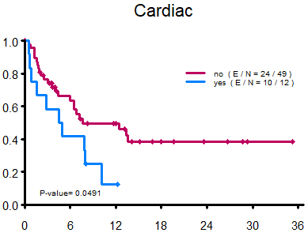

- OS based on ECOG of 0-1 versus ≥2 at apheresis
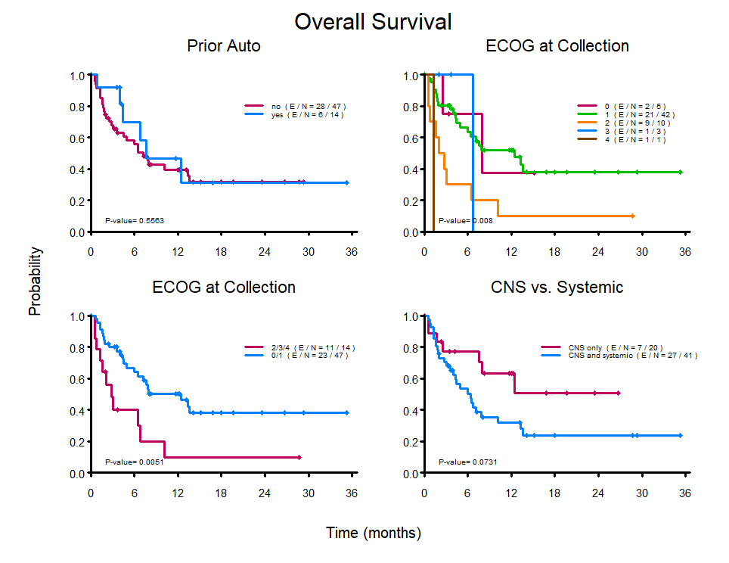
Figure S4. OS of patients receiving CAR-T for SCNSL among those with CNS only versus CNS and systemic relapse

