ADDITIONAL FILE 10

Figure S4. Kaplan-Meier curves for PFS among diabetic and non-diabetic patients (A). Kaplan Meier curves for PFS in normoglycemic, pre-diabetic and diabetic patients (B).

A B
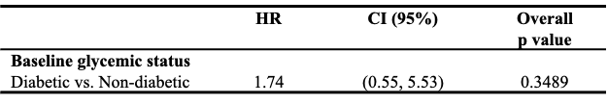
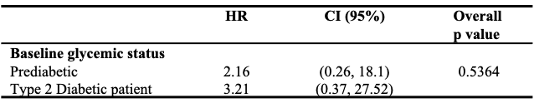
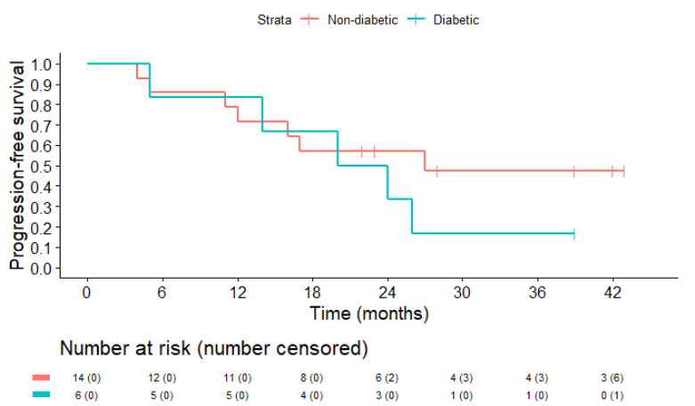
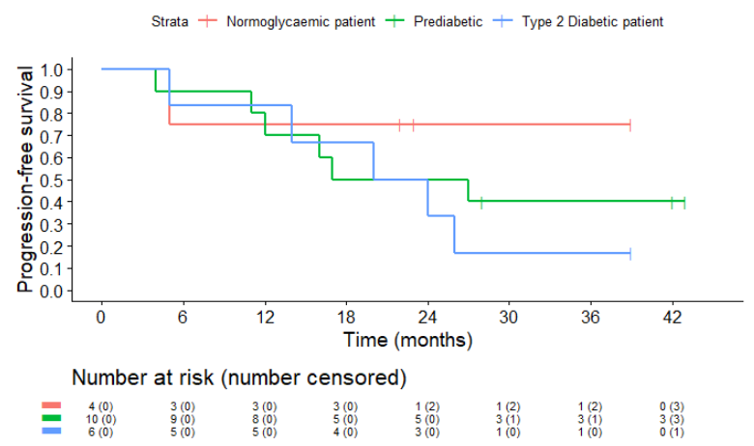

Legend: HR: Hazard Ratio; CI: Confidence Interval

