ADDITIONAL FILE 14

Figure S6. Kaplan-Meier curves for PFS according to the presence of alterations in genes involved in DNA repair (ARID1A, ATM, SETD2, PRKDC) (A), FGFR4 gene polymorphism rs351855 (B), ATM allelic variants: A/A vs. A/C vs. C/C (C), or A/A vs. A/C or C/C (D).

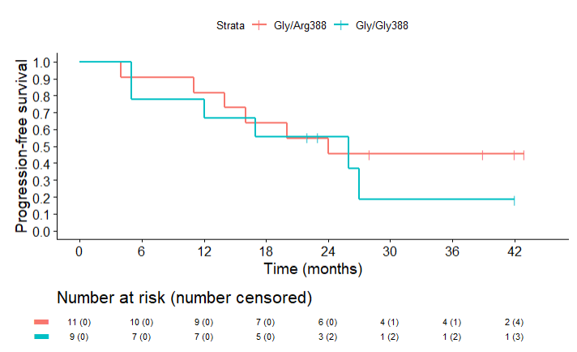
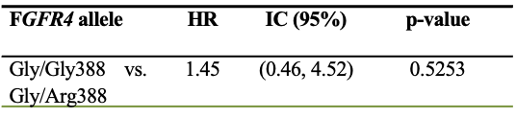
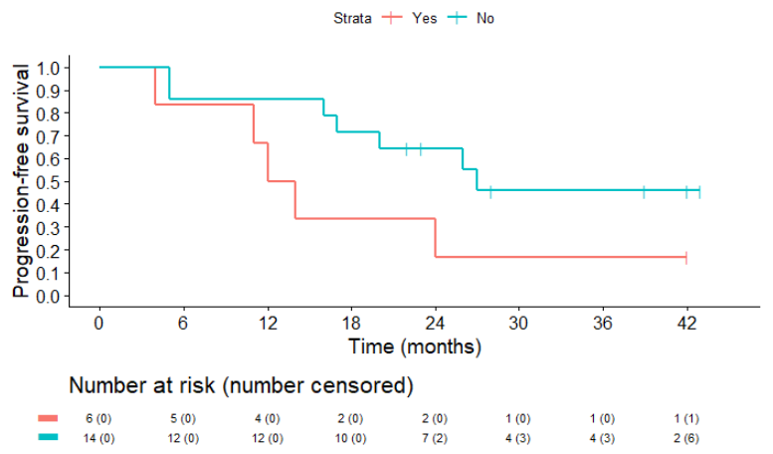
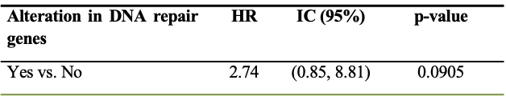
A B

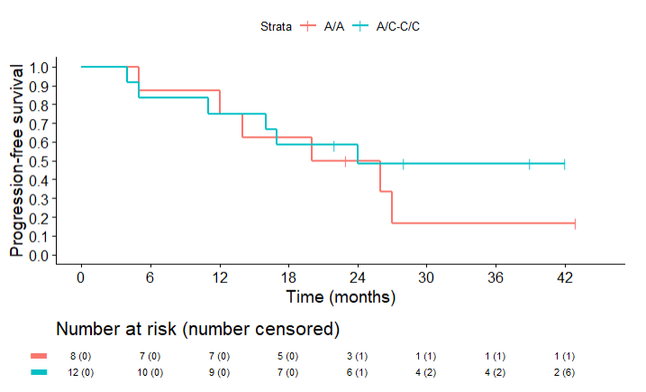
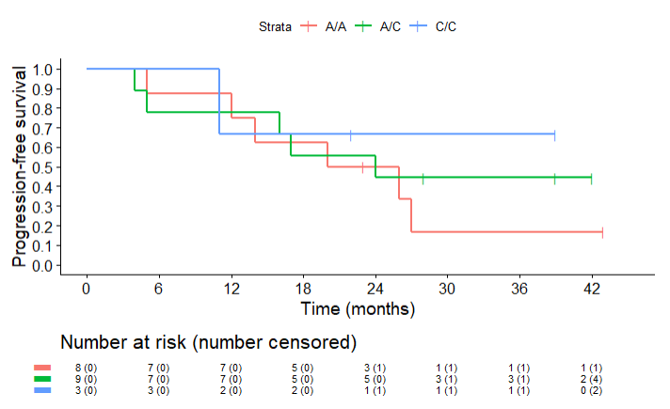
C D

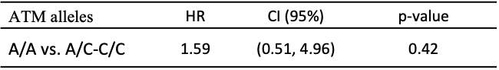
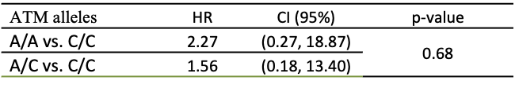

Legend: HR: Hazard Ratio; CI: Confidence Interval

