Supplementary Material to:
Zanwar, S, Sidana, S, Shune, L, et al. Impact of Extramedullary Multiple Myeloma on Outcomes with Idecabtagene Vicleucel.’

Table of Contents
Supplementary Table 1 | Predictors of inferior Day 90 ORR | Page 2
Supplementary Table 2. | Univariate analysis of predictors for inferior progression free survival with Ide-cel | Page 3
Supplementary Table 3. | Prognostic markers for patients treated with ide-cel | Page 4
Supplementary Table 4. | Toxicity profile and utilization of mitigation strategies among patients with and without EMD | Page 5
Supplementary Table 5 | Comparison of factors potentially associated with higher stem cell boost requirement | Page 6
Supplementary Figure 1 | Comparison of progression-free and overall survival among patients with extramedullary, paraskeletal and no extramedullary disease. | Page 7
Supplementary Figure 1. | Median Progression-free survival for patients with extramedullary disease with a PET response at day 90 | Page 8
Supplementary Figure 2. | Impact of radiation therapy to extramedullary site on PFS with ide-cel | Page 9
Supplementary Figure 3. | Prognostic markers in patients with EMD infused with ide-cel | Page 10

Supplementary Table 1. Logistic regression analysis for markers associated with Day 90 ORR
Parameter | Univariate Odds Ratio (95% CI) | p-value | Multivariable Odds Ratio (95% CI) | p-value
Extramedullary Disease | 0.24 (0.13-0.4) | <0.001 | 0.24 (0.1-0.4) | <0.001
Prior BCMA exposure | 0.53 (0.3-0.94) | 0.03 | 0.48 (0.26-0.9) | 0.02
Serum Ferritin >400 µg/L at LD | 0.52 (0.31-0.9) | 0.01 | 0.8 (0.4-1.3) | 0.2
Use of bridging therapy | 1.01 (0.6-1.8) | 0.96
Response to Bridging Therapy | 1.44 (0.6-4.1) | 0.43
ECOG PS>1 at LD | 0.53 (0.3-1.1) | 0.09
Age >70 years | 1.35 (0.8-2.5) | 0.3
Race | 1.5 (0.9-2.6) | 0.09
Revised ISS Stage 3 | 1.7 (0.8-4.5) | 0.2
High-risk Cytogenetics | 0.65 (0.37-1.2) | 0.14
Plasma cell leukemia | 1.04 (0.3-4.7) | 0.94
High BMPC (>50%) at LD | 1.2 (0.66-2.3) | 0.53
Penta-drug refractory | 0.91 (0.54-1.6) | 0.74
Prior lines of therapy, median | 0.94 (0.85-1.03) | 0.22
Median cell dose >400 x10⁶/mL | 1.1 (0.65-1.8) | 0.7
BCMA: B-cell membrane antigen; CRP: c-reactive protein; ECOG: Eastern Cooperative Oncology Group ISS: international staging system; * refractory to bortezomib, carfilzomib, lenalidomide, pomalidomide and CD38 antibody.

Supplementary Table 2. Univariate analysis of predictors for inferior progression free survival with Ide-cel
Parameter | Hazard Ratio (95% CI) | P value
Extramedullary Disease | 2.1 (1.6-2.7) | <0.001
Revised ISS Stage 3 | 1.5 (1.1-2.1) | 0.02
Use of Bridging Therapy | 1.6 (1.2-2.1) | 0.003
Response to Bridging therapy (ORR) | 1.1 (0.7-1.7) | 0.7
Age >70 years at ide-cel infusion | 0.8 (0.6-1.07) | 0.13
Race (white vs. non-white) | 1.02 (0.8-1.3) | 0.82
Multiple myeloma subtype (intact Immunoglobulin vs. other) | 1.2 (0.9-1.7) | 0.13
Plasma cell leukemia | 2.2 (1.3-3.7) | 0.003
Median lines of therapy prior to Ide-cel | 1.2 (0.9-1.6) | 0.1
High-risk cytogenetics | 1.2 (0.9-1.6) | 0.17
Penta-refractory disease* | 1.3 (1.03-1.7) | 0.03
Prior BCMA exposure | 1.6 (1.2-2.1) | 0.002
ECOG Performance Status >1 at lymphodepletion | 1.8 (1.3-2.5) | 0.0007
Median cell dose >400 x10⁶/mL | 1 (0.8-1.3) | 0.94
Serum ferritin >400 µg/L at lymphodepletion | 1.9 (1.5-2.4) | <0.0001
CRP >5 mg/L at lymphodepletion | 1.3 (0.99-1.7) | 0.06
High bone marrow plasma cell burden (>50%) at lymphodepletion | 1.4 (1.1-1.9) | 0.01
Lymphodepleting regimen (Flu/Cy vs. others) | 1.3 (0.73-2.2) | 0.4
BCMA: B-cell membrane antigen; CRP: c-reactive protein; ECOG: Eastern Cooperative Oncology Group ISS: international staging system; Flu/Cy: fludarabine/cyclophosphamide * refractory to bortezomib, carfilzomib, lenalidomide, pomalidomide and CD38 antibody.

Supplementary Table 3. Prognostic markers for overall survival patients treated with ide-cel.
Parameter | Univariate Analysis Hazard Ratio (95% CI) | Univariate analysis  p-value | Multivariable Analysis Hazard Ratio  (95% CI), n=217 | Multivariable Analysis  p-value
Extramedullary Disease | 1.6 (1.1-2.4) | 0.007 | 1.01 (0.6-1.7) | 0.95
Revised ISS Stage 3 | 1.9 (1.2-2.9) | 0.003 | 2 (1.1-3.5) | 0.02
Use of Bridging Therapy | 2 (1.3-3.1) | 0.002 | 1.8 (0.94-3.4) | 0.07
ECOG Performance Status >1 at LD | 2.1 (1.4-3.2) | 0.0004 | 1.8 (0.95-3.4) | 0.07
Serum ferritin >400 µg/L at LD | 2.3 (1.6-3.2) | <0.0001 | 1.8 (1.1-2.9) | 0.03
≥PR at Day 90 | 0.36 (0.24-0.53) | <0.0001 | 0.3 (0.17-0.51) | <0.001
Plasma Cell Leukemia | 2.3 (1.2-4.2) | 0.008 | 2.8 (1.2-6.7) | 0.02
High BMPC (>50%) at LD | 1.5 (1.1-2.2) | 0.02 | 0.84 (0.5-1.5) | 0.55
CRP >5 mg/L at lymphodepletion | 1.4 (0.99-2) | 0.06
Age >70 years at ide-cel infusion | 0.84 (0.55-1.2) | 0.4
Race (white vs. non-white) | 0.9 (0.6-1.3) | 0.5
Median lines of therapy prior to Ide-cel | 1.05 (0.99-1.1) | 0.09
High-risk cytogenetics | 1.1 (0.8-1.5) | 0.5
Penta-refractory disease | 1.3 (0.9-1.8) | 0.17
Prior BCMA exposure | 1.3 (0.9-1.9) | 0.17
Lymphodepleting regimen (Flu/Cy vs. others) | 1.3 (0.6-2.6) | 0.5
BCMA: B-cell membrane antigen; BMPC: bone marrow plasma cells; ECOG: Eastern Cooperative Oncology Groung ISS: international staging system; LD: lymphodepletion
Supplementary Table 4. Toxicity profile and utilization of mitigation strategies among patints with and without EMD
Parameter | EMD | No EMD | P value
Grade ≥3 CRS, n (%) | 2 (2) | 4 (1.5) | 0.58
Grade ≥2 CRS, n (%) | 24 (29) | 59 (22) | 0.23
Grade ≥3 ICANS, n (%) | 1 (1) | 13 (5) | 0.13
Grade ≥2 ICANS, n (%) | 8 (10) | 20 (8) | 0.58
Tocilizumab Use, n (%) | 57 (68) | 187 (70) | 0.7
Steroid use, n(%) | 32 (38) | 83 (31) | 0.23
Anakinra, n(%) | 7 (8) | 15 (6) | 0.38
Infection, n(%) | 36 (43) | 87 (33) | 0.09
Intensive Care Unit Admission, n (%) | 6 (7) | 17 (6) | 0.82
GCSF use, n (%) | 61 (73) | 209 (78) | 0.46
TPO receptor agonist use, n(%) | 13 (15) | 36 (13) | 0.58
Stem Cell Boost, n% | 12 (14) | 11 (4) | 0.001
ANC day 30, median | 1.6 (0.9-2.6) | 1.5 (0.9-3.1) | 0.58
Day 30 Neutropenia, %  Any grade  Grade ≥3 | 69  34 | 67  33 | 0.8  0.84
Hemoglobin day 30, median (IQR) | 8.9 (7.9-10.4) | 9.8 (8.2-10.2) | 0.003
Day 30 Anemia, %  Any grade  Grade ≥3 | 92  26 | 86  19 | 0.1  0.23
Platelet Count day 30, median (IQR) | 59 (23-127) | 64 (26-118) | 0.74
Day 30 Thrombocytopenia, %  Any grade  Grade ≥3 | 91  54 | 87  43 | 0.3  0.09
ANC day 90, median (IQR) | 1.9 (1.2-3.8) | 2.5 (1.6-3.9) | 0.07
Day 90 Neutropenia, %  Any grade  Grade ≥3 | 51  21 | 39  9 | 0.07  0.009
Hemoglobin day 90, median (IQR) | 9.8 (8.6-11.2) | 10.9 (9.5-12.3) | 0.003
Day 90 Anemia, %  Any grade  Grade ≥3 | 83  9 | 68  8 | 0.01  0.8
Platelet Count day 90, median (IQR) | 107 (46-204) | 131 (64-182) | 0.4
Day 90 Thrombocytopenia, %  Any grade  Grade ≥3 | 74  30 | 62  19 | 0.05  0.07
ANC: absolute neutrophil count; CRS: cytokine release syndrome; EMD: extramedullary disease; GCSF: granulocyte colonoy stimulating factor; ICANS: immune effector-cell associted neurologic syndrome; TPO: thrombopoietin

Supplementary Table 5. Comparison of factors potentially associated with higher stem cell boost requirement
Parameter | EMD | No EMD | P value
Alkylator use in bridging therapy, % | 57 | 63 | 0.47
Bone marrow plasma cell burden, median % | 30 | 28 | 0.66
ASCT rates prior to LD, % | 81 | 82 | 0.9
Grade ≥3 neutropenia immediately prior to LD, % | 9 | 9 | 0.96
Grade ≥3 thrombocytopenia immediately prior to LD, % | 19 | 15 | 0.39
Grade ≥3 anemia immediately prior to LD, % | 18 | 13 | 0.11
LD: lymphodepletion

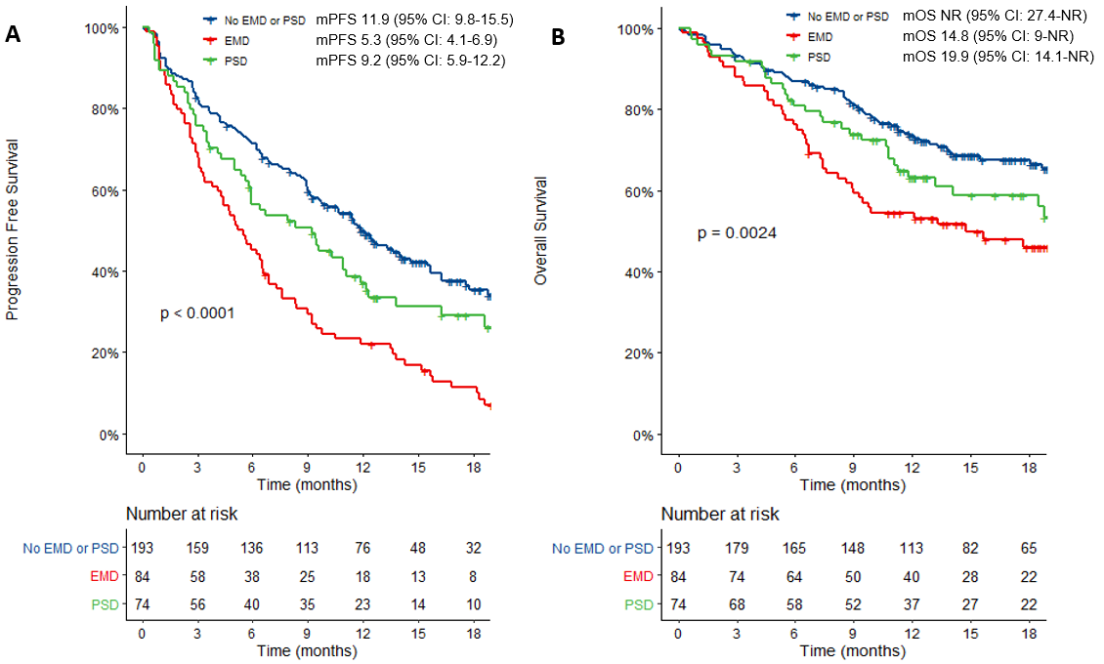

Supplementary Figure 1. Extramedullary (EMD) and Paraskeletal Disease (PSD): A. Patients with EMD demonstrated significantly inferior progression-free survival (mPFS) compared to both patients with PSD and non- EMD/PSD cohort. B. Patients with and without EMD demonstrate significantly discrepant median overall survival (mOS), although the difference in OS for EMD vs. PSD did not reach statistical significance.

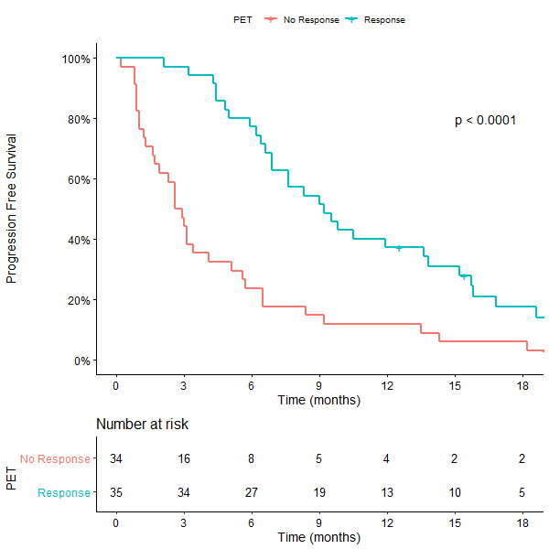
Supplementary Figure 2. The PFS was significantly longer for patients with a PET response at day 90 [median PFS 9.2 months (95% CI: 96.9-15.2)] versus non-responders [median PFS 2.7 months (95% CI: 1.9-5.1)] among patients with evidence of extramedullary disease.
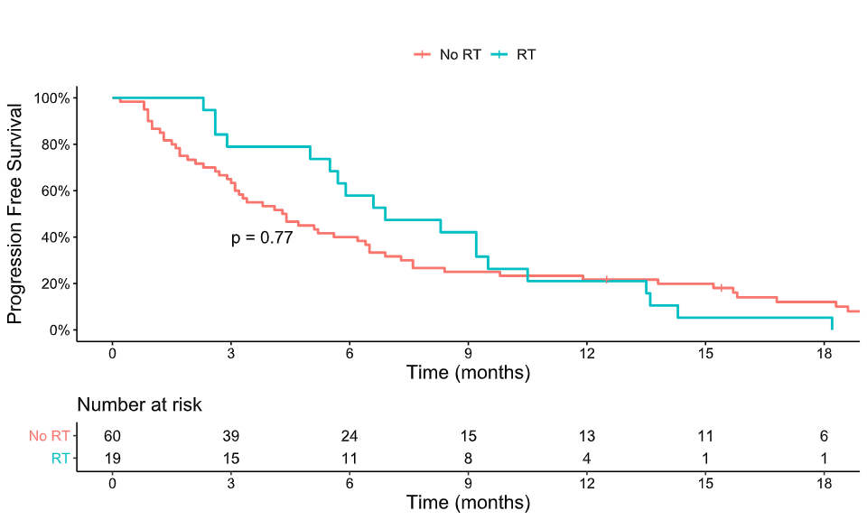
Supplementary Figure 3. The median PFS was 6.9 months (95% CI: 5.7-13.6) for patients receiving radiation versus 4.3 months (95% CI: 3.1-6.5) without radiation prior to ide-cel (p=0.77).
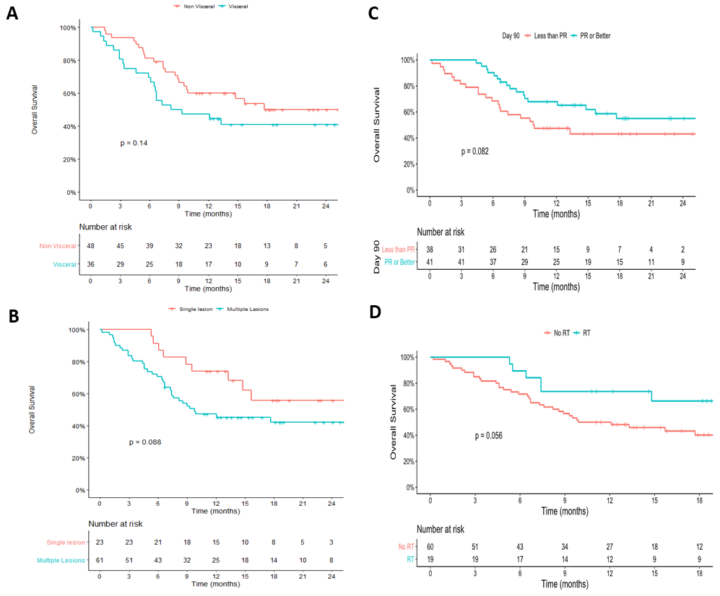

Supplementary Figure 4: Prognostic markers for patients with extramedullary disease (EMD) treated with ide-cel. A: Presence of visceral disease [hazard ratio (HR) 1.6 (95% CI: 0.9-2.8), p=0.14)] demonstrated a trend toward inferior OS. B: Multi-site disease (>1 EMD lesion) also demonstrated a trend toward inferior OS [HR 1.9 (95% CI: 0.9-3.9); p=0.09]. C: Achieving an objective response at Day 90 of ide-cel infusion demonstrated a trend toward improved OS [HR 0.57 (0.3-1.08), p=0.08]. D: Radiation therapy for EMD site prior to ide-cel infusion demonstrated a trend toward improved OS [HR 0.44 (95% CI: 0.2-1.04), p=0.056].

