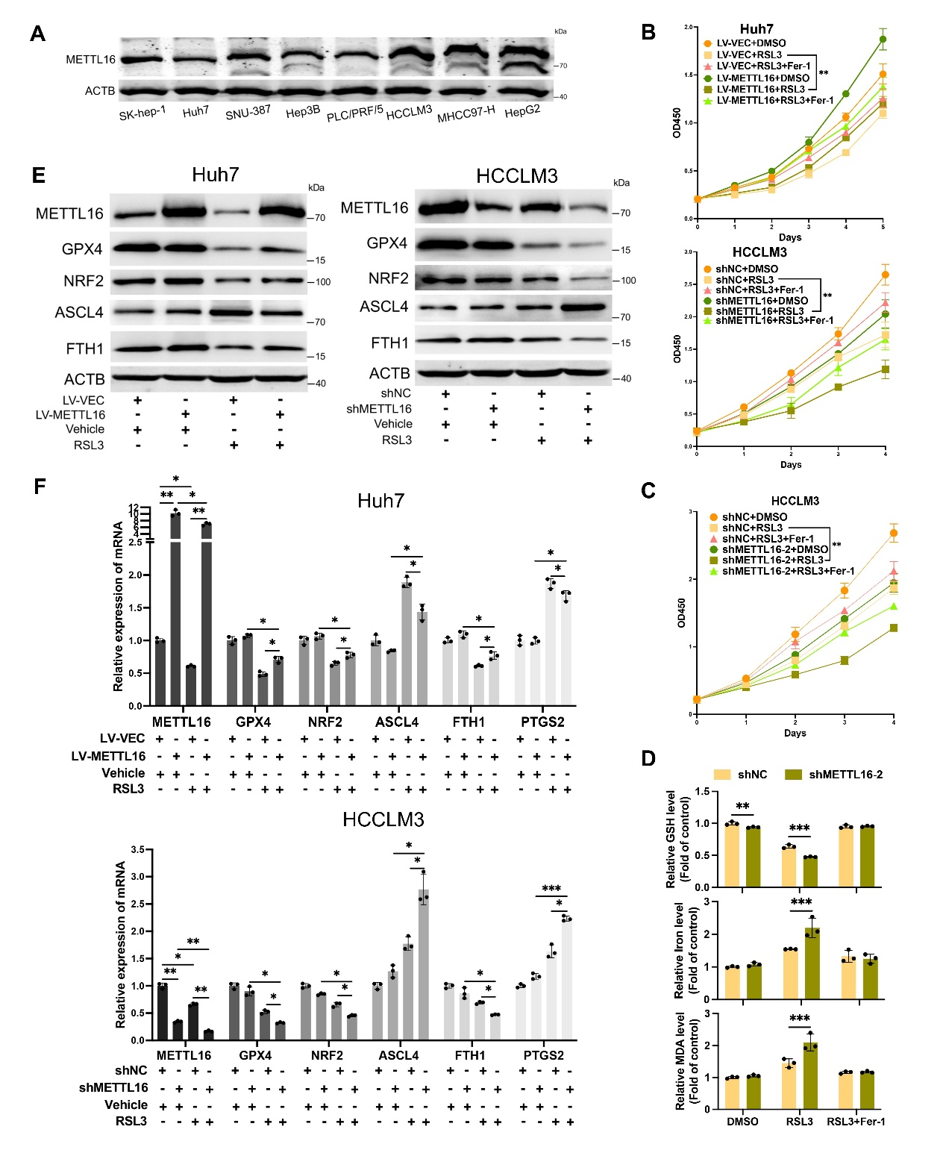
FigS1. METTL16 has been screened out and identified as the crucial repressor of ferroptosis in HCC. (A) The endogenous METTL16 expression in various HCC cell lines was determined by western blotting. (B) Cell viabilities of Huh7 and HCCLM3 (RSL3: 0.25μM, Fer-1: 1μM) were measured by the CCK-8 assay. (C) Cell viabilities of HCCLM3 (shNC V.S. shMETTL16-2) were measured by the CCK-8 assay (RSL3: 0.25μM). (D) Intracellular GSH levels, Iron content, and MDA levels of HCCLM3 (shNC V.S. shMETTL16-2) were measured by corresponding assay kits (RSL3: 2 μM). (E) The protein expression of ferroptosis-related markers was detected in indicated cells with or without ferroptosis induction. (F) The mRNA expression levels of ferroptosis-related genes were detected in indicated cells with or without ferroptosis induction. Statistical significance was analyzed using two-way ANOVA with Tukey’s test (B-D, n=3) and one-way ANOVA with Tukey’s test (F, n=3)
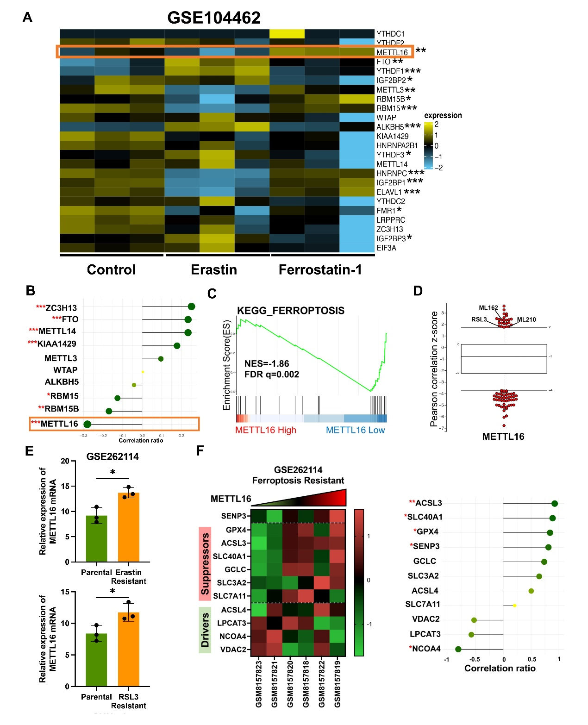
FigS2. METTL16 might be a ferroptosis suppressor in HCC. (A) The heatmap of relative mRNA fold change of m6A regulatory factors from GSE104462. (B) The correlation coefficients between the Ferroptosis signature score and m6A regulatory factors expression from the TCGA-LIHC database shown by the lollipop chart. The Ferroptosis-correlation ratio was represented below the chart. (C) The enrichment plots of KEGG_FERROPTOSIS terms were analyzed by GSEA between the low- (n=185) and the high-METTL16 groups (n=186) derived from the TCGA-LIHC database. (D) Pearson correlation of METTL16 expression in cancer cells with compounds AUC from the CTRP database. Ferroptosis inducers (ML210, ML162 and RSL3) were marked and each dot represented a certain anti-tumor compound. (E) METTL16 mRNA expression in the GSE262114. (F) The normalized expression levels of ferroptosis-related markers and SENP3 were analyzed and visualized by heatmap chart ranked by METTL16 expression in the ferroptosis-resistant gastric cancer cells from GSE262114 (left). The correlation coefficients were depicted by the lollipop chart (right). Statistical significance was analyzed using Pearson correlation analysis (A, B, D and F) and two-tailed Student’s t test (E).
FigS3. METTL16 deletion facilitates ferroptosis and attenuates hepatic tumorigenesis. (A) Schematic diagram of Hepa1-6 subcutaneous xenograft tumor model establishment. (B-D) Representative images (B) and statistical data of weights (C) and volumes (D) of xenografts from Hepa1-6 with or without the treatment of RSL3 (n = 5 mice per group). (E) The relative MDA levels in xenografts. (F) The Mettl16 expression in the indicated mice livers. (G-I) The representative liver pictures (G), body/liver weight (H), serum ALT, AST, CHO, TG, CHE and γ-GT levels (I) of 8-week-old indicated mice (n = 9 mice). Scale bar, 1cm. (J) Schematic diagram of hepatocyte-specific Mettl16 knockout mice constructed using AAV8-TBG-Cre virus. (K) Representative images of livers (n = 9 mice per group) from the murine MYC/Trp53^{-/-} HCC model. Scale bar, 1cm. (L) The liver weight (Mann-Whitney test), liver weight/body weight ratio (Mann-Whitney test), tumor number per liver (Mann-Whitney test) and max tumor diameter in the indicated mice. (M) AST and ALT levels in mice serum. (N) The MDA concentration in mice livers. Statistical significance was analyzed using one-way ANOVA with Tukey’s test (C and E), two-way ANOVA with Tukey’s test (D) and two-tailed Student’s t test (H, I, L, M and N).
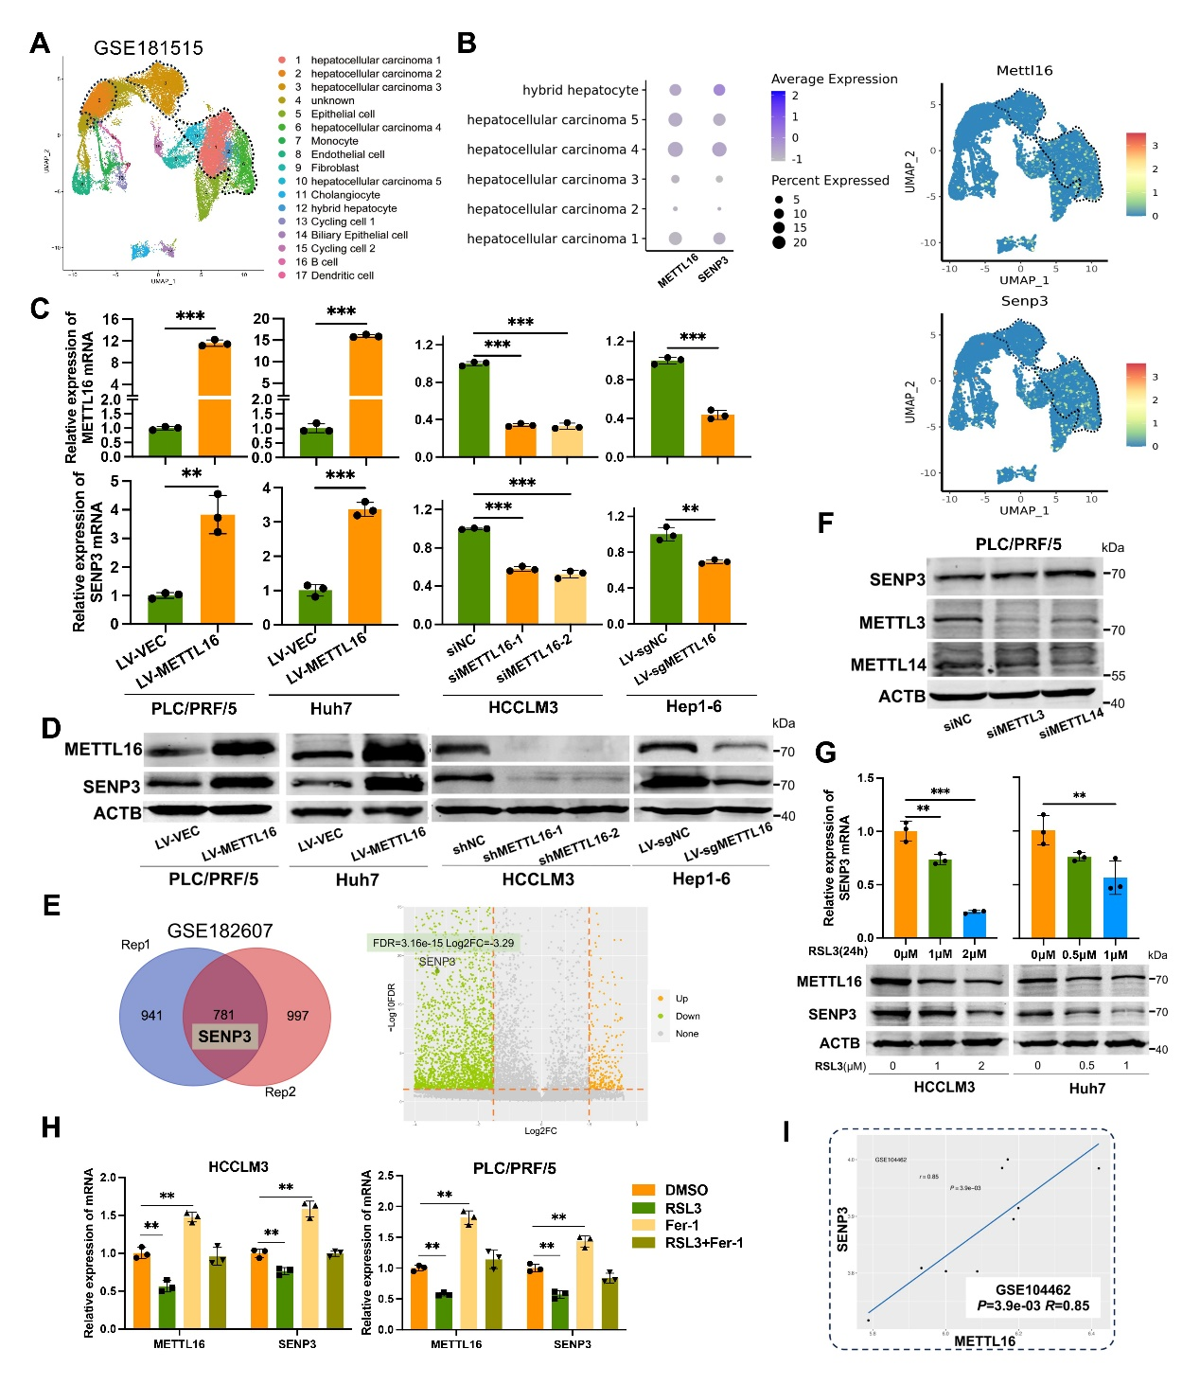
FigS4. METTL16 expression correlates with SENP3 levels in HCC. (A) The UMAP plot showing the distribution of different cell types in the single-cell RNA sequencing dataset (GSE181515), colored by cell types. (B) The average expression and the percentage of cells expressing Mettl16 and Senp3 in different cell types were visualized by Dot plot (left) and the expression of Mettl16 and Senp3 in low-dimensional space of different cell types were visualized by Dimensional reduction plot (right), colored by gene expression. The region of HCC was delineated by black dashed lines. (C-D) The METTL16 and SENP3 expression in the indicated cells. (E) The differential genes (|Log2(FC)|≥1.5 and FDR <0.05) in MeRIP-seq of GSE182607 were shown by the volcano diagram, where SENP3 was specifically marked. (F-H) The METTL16 and SENP3 expression in the indicated cells. (I) Correlation between the expression levels of METTL16 and SENP3 in GSE104462. Statistical significance was analyzed using two-tailed Student’s t test (C, n=3), one-way ANOVA with Tukey’s test (C, G, and H, n=3) and Pearson correlation analysis (I).
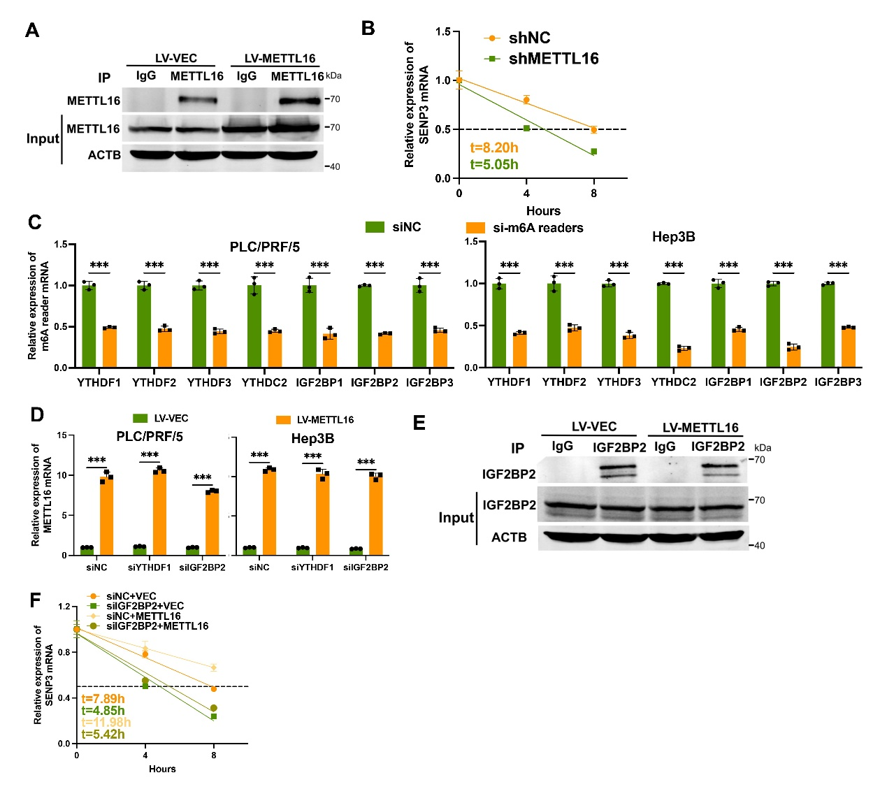
FigS5. METTL16/IGF2BP2/SENP3 axis facilitates the mRNA stability of SENP3 in an m6A-dependent manner. (A) The immunoprecipitated METTL16 protein detection from the control or METTL16 overexpression cells in RIP assays with METTL16 antibody. (B) The decay rate of SENP3 mRNA upon ActD (5μg/mL) treatment at the indicated time points in HCCLM3. (C) The mRNA expression levels of 7 mRNA stability-related readers in the indicated cells. (D) The METTL16 level was detected after multiply silencing different m6A readers in the indicated cells. (E) The immunoprecipitated IGF2BP2 protein detection from the control or METTL16 overexpression cells in RIP assays with IGF2BP2 antibody. (F) The decay rate of SENP3 mRNA upon ActD treatment at the indicated time points in Hep3B. Statistical significance was analyzed using two-tailed Student’s t test (C and D, n=3).
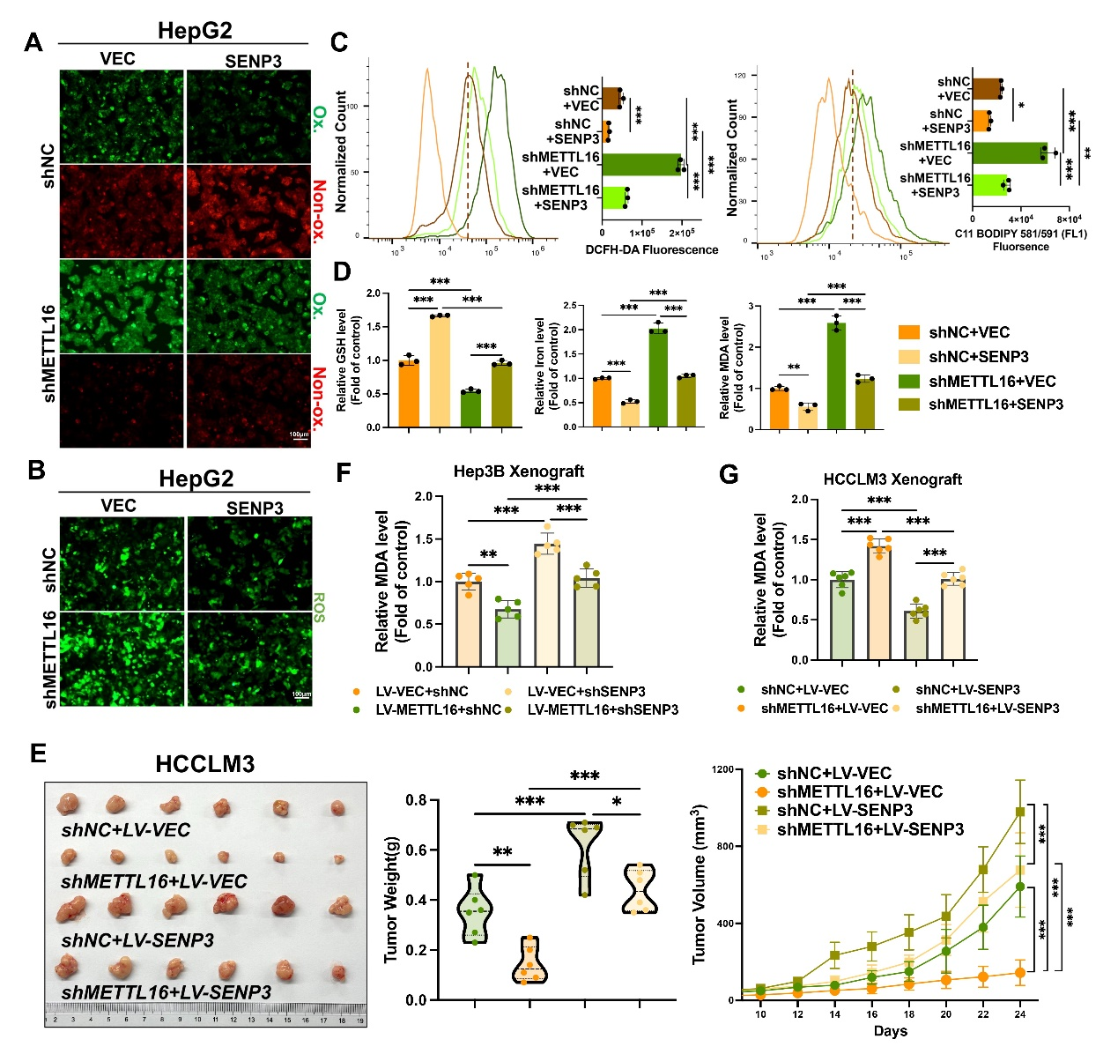
FigS6. METTL16 exerts its anti-ferroptotic effect through SENP3. (A) Intracellular lipid peroxidation content of HepG2 (RSL3: 2 μM) was analyzed by fluorescence microscope with C11-BODIPY staining. (B) Intracellular ROS content of HepG2 (RSL3: 2 μM) was observed using ROS Assay Kit by fluorescence microscope. (C) Intracellular lipid peroxidation (right) and ROS content (left) of HepG2 were quantified (RSL3: 2 μM). (D) Intracellular GSH levels, Iron content, and MDA levels of HepG2 cells (RSL3: 2 μM). (E) Representative images and statistical data of weights and volumes of xenografts derived from HCCLM3 cells (n = 6 mice per group). (F) The relative MDA levels in Hep3B xenografts were measured. (G) The relative MDA levels in HCCLM3 xenografts were measured. Statistical significance was analyzed using one-way ANOVA with Tukey’s test (C (n=3), D (n=3), E (n=6), F (n=5) and G (n=6)) and two-way ANOVA with Tukey’s test (E, n=6).
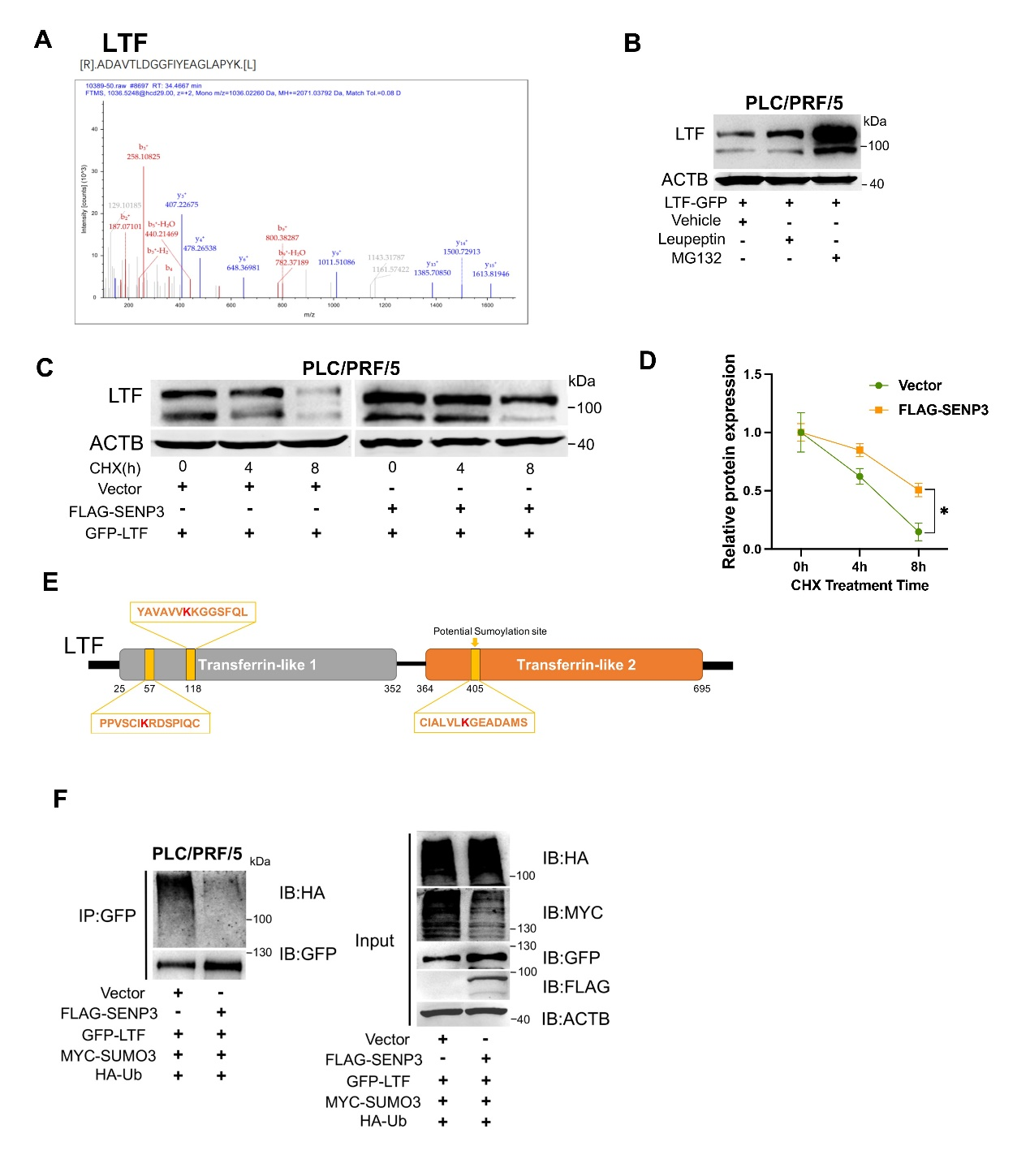
FigS7. SENP3 de-SUMOylates Lactotransferrin (LTF) and blocks its proteasome-dependent degradation. (A) The LTF peptides identified through mass spectrometry are shown. (B) The LTF expression was detected under MG132 (10μM) or Leupeptin (100μM) treatment. (C-D) The LTF expression was detected and quantified under CHX (10μg/mL) treatment. (E) Schematic representation of the potential SUMOylation sites on the acid amino sequence of LTF. (F) The ubiquitination of GFP-LTF was determined using GFP-beads and western blotting using antibody against HA. Statistical significance was analyzed using two-way ANOVA with Tukey’s test (D, n=3).
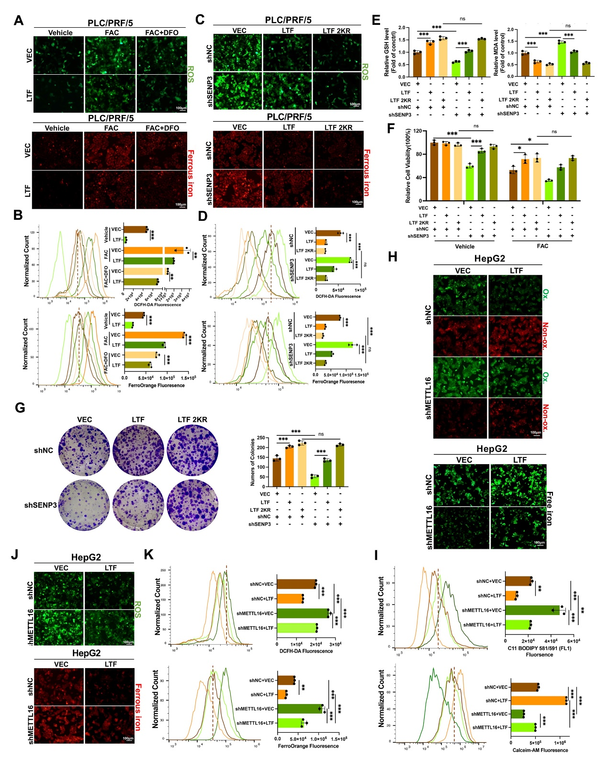
FigS8. METTL16/SENP3 axis inhibits ferroptosis via regulating the iron-chelation function of LTF. (A and B) Intracellular ROS content (above) and Fe²⁺ level (below) of PLC/PRF/5 (FAC: 100 μg/mL, DFO: 100μM) were observed using ROS Assay Kit and FerroOrange probe by fluorescence microscope and quantified by flow cytometry. (C and D) Intracellular ROS content (above) and Fe²⁺ level (below) of PLC/PRF/5 (FAC: 100 μg/mL) were observed. (E) Intracellular GSH levels and MDA levels of PLC/PRF/5 were measured by corresponding assay kits (FAC: 100 μg/mL). (F) The relative cell viabilities of PLC/PRF/5 were measured after FAC (50 μg/mL) or Vehicle treatment for 48h. (G) Cell growth capacities of PLC/PRF/5 were measured by the colony formation assay after FAC (25 μg/mL) treatment. (H-I) Intracellular lipid peroxidation content (above) and liable iron pool level (below) of HepG2 (FAC: 150 μg/mL) were observed. (J-K) Intracellular ROS content (above) and Fe²⁺ level (below) of HepG2 (FAC: 150 μg/mL) were observed. Statistical significance was analyzed using one-way ANOVA with Tukey’s test (B, D, E, G, I and K, n=3) and two-way ANOVA with Tukey’s test (F, n=3).

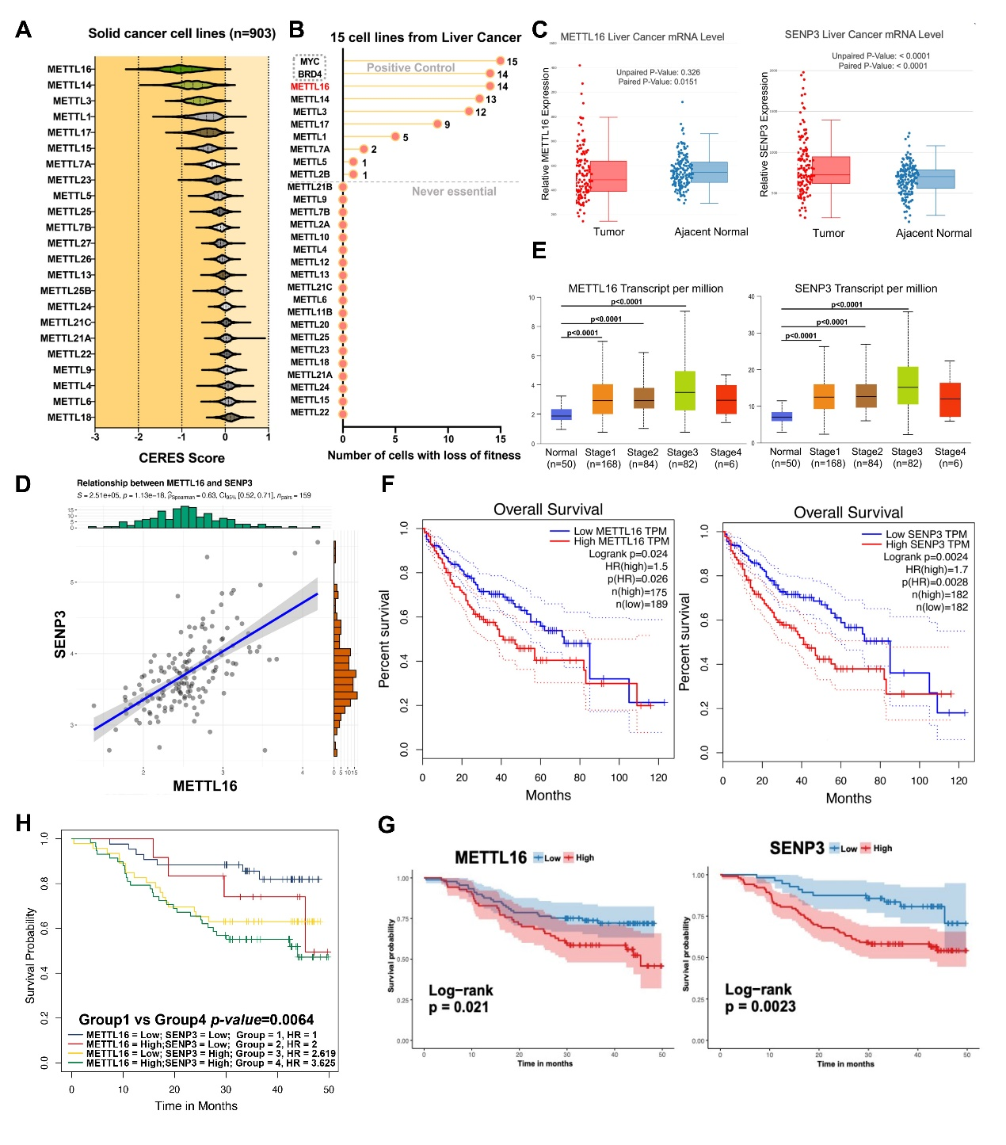
FigS9. METTL16 and SENP3 are elevated and clinically relevant with poor survival in HCC patients. (A) CERES scores of a series of METTL family members from CRISPR Cas9 knockout screening datasets across 903 human cell lines from DepMap. (B) Another CRISPR Cas9 knockout screening datasets across 15 human HCC cell lines were analyzed. MYC and BRD4 were identified as the positive control, which was recognized as the promising cancer therapeutic target. (C) METTL16 and SENP3 mRNA expression in the CHCC cohort. (D) Correlational analysis of METTL16 and SENP3 mRNA in the CHCC cohort. (E) Expression of METTL16 and SENP3 in the TCGA-LIHC cohort based on individual cancer stages from UALCAN. (F) The difference in Overall Survival between patients with high and low METTL16 or SENP3 expression in TCGA-LIHC patients. (G) The difference in Overall Survival between patients with high and low METTL16 or SENP3 expression in the CHCC cohort. (H) Overall survival analysis using combinations of METTL16 and SENP3 expression levels. Statistical significance was analyzed using (paired) two-tailed Student’s t test (C), Spearman correlation analysis (D) , one-way ANOVA with Tukey’s test (E) and Log-rank test (F, G and H).
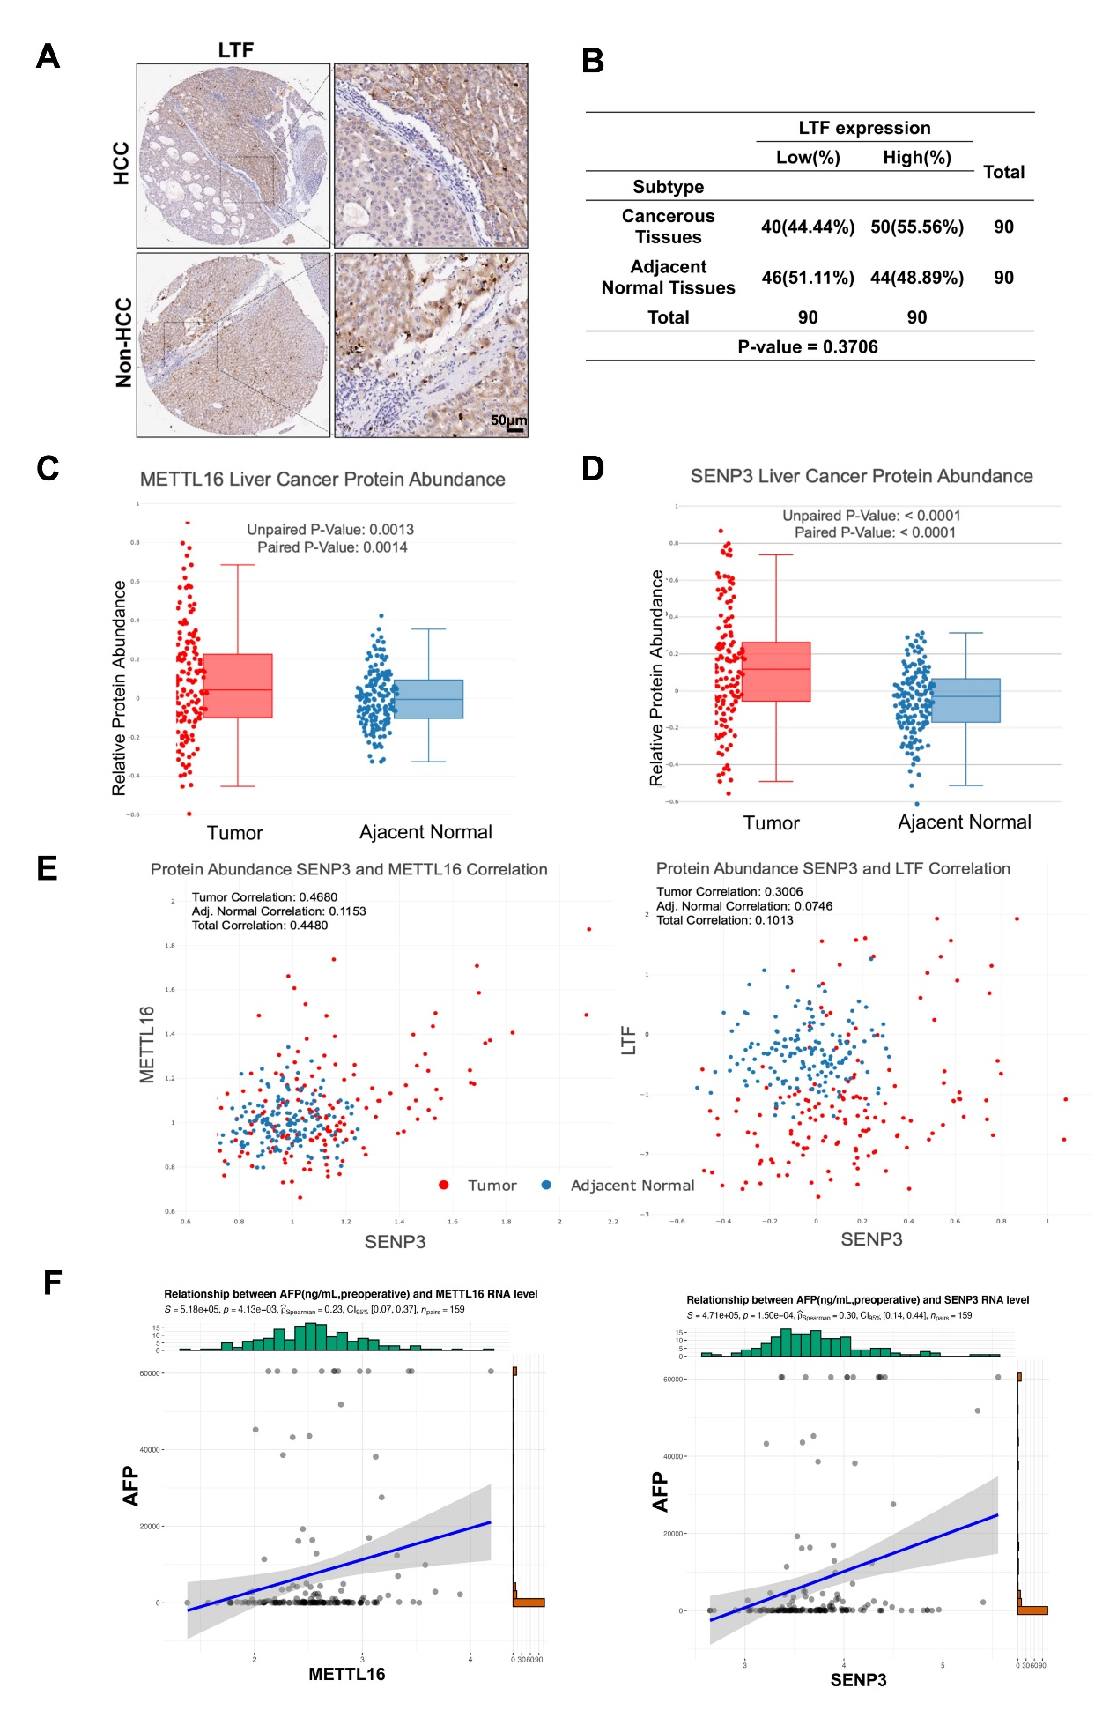 FigS10. The expression of METTL16, SENP3 and LTF is elevated in HCC patients. (A) Representative images of IHC staining of LTF expression in human normal liver tissues and HCC specimens (n = 90 per group) from Tissue Microarray. Scar bar: 50μm. (B) Quantification study of LTF expression levels in liver tissues. (C-D) METTL16 and SENP3 protein expression in the CHCC cohort. (E) Correlational analysis of METTL16, SENP3 and LTF protein in the CHCC cohort. (F) Correlational analysis of METTL16 and SENP3 with preoperative AFP in the CHCC cohort. Statistical significance was analyzed using Chi-square test (B), (paired) two-tailed Student’s t test (C and D), Pearson correlation analysis (E) and Spearman correlation analysis (F).

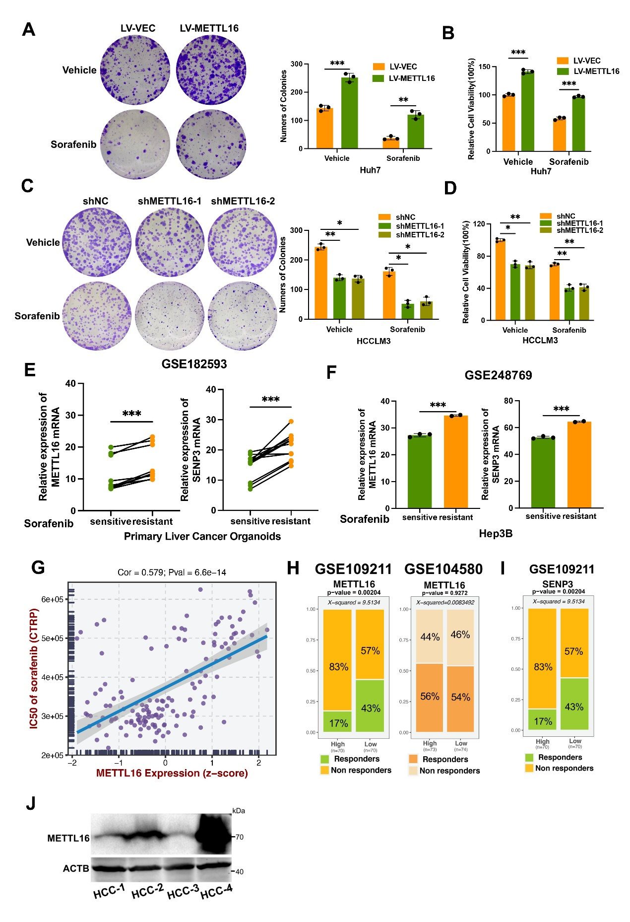
FigS11. METTL16 increases the sorafenib resistant of HCC. (A) The cell growth capacities of Huh7 (Sorafenib: 5 μM) with or without METTL16 overexpression were measured by the colony formation assay. (B) The relative cell viabilities of Huh7 were measured via CCK-8 assay after Sorafenib (5 μM) or Vehicle treatment for 48h. (C) The cell growth capacities of HCCLM3 (Sorafenib: 10 μM) with or without METTL16 knockdown were measured by the colony formation assay. (D) The relative cell viabilities of HCCLM3 were measured after Sorafenib (10 μM) or Vehicle treatment for 48h. (E) Paired line scatter plot showing METTL16 and SENP3 mRNA expression in Sorafenib-sensitive (green dot) versus Sorafenib-resistant (orange dot) primary liver cancer organoids from GSE182593. (F) The METTL16 and SENP3 mRNA expression levels in Sorafenib-sensitive clones versus Sorafenib-resistant clones of Hep3B from GSE248769. (G) The correlation of METTL16 expression with Sorafenib IC50 from the CTRP database in GSE109211. (H-I) Stacked bar graphs show the proportion of "responder" or "non-responder" patients with populations stratified by METTL16 (H) or SENP3 (I) expression level. (J) The METTL16 expression in the indicated HCC organoids. Statistical significance was analyzed using (paired) two-tailed Student’s t test (A, B, E and F), two-way ANOVA with Tukey’s test (C and D), Pearson correlation analysis (G) and Chi-square test (H and I).

