Supplementary figures
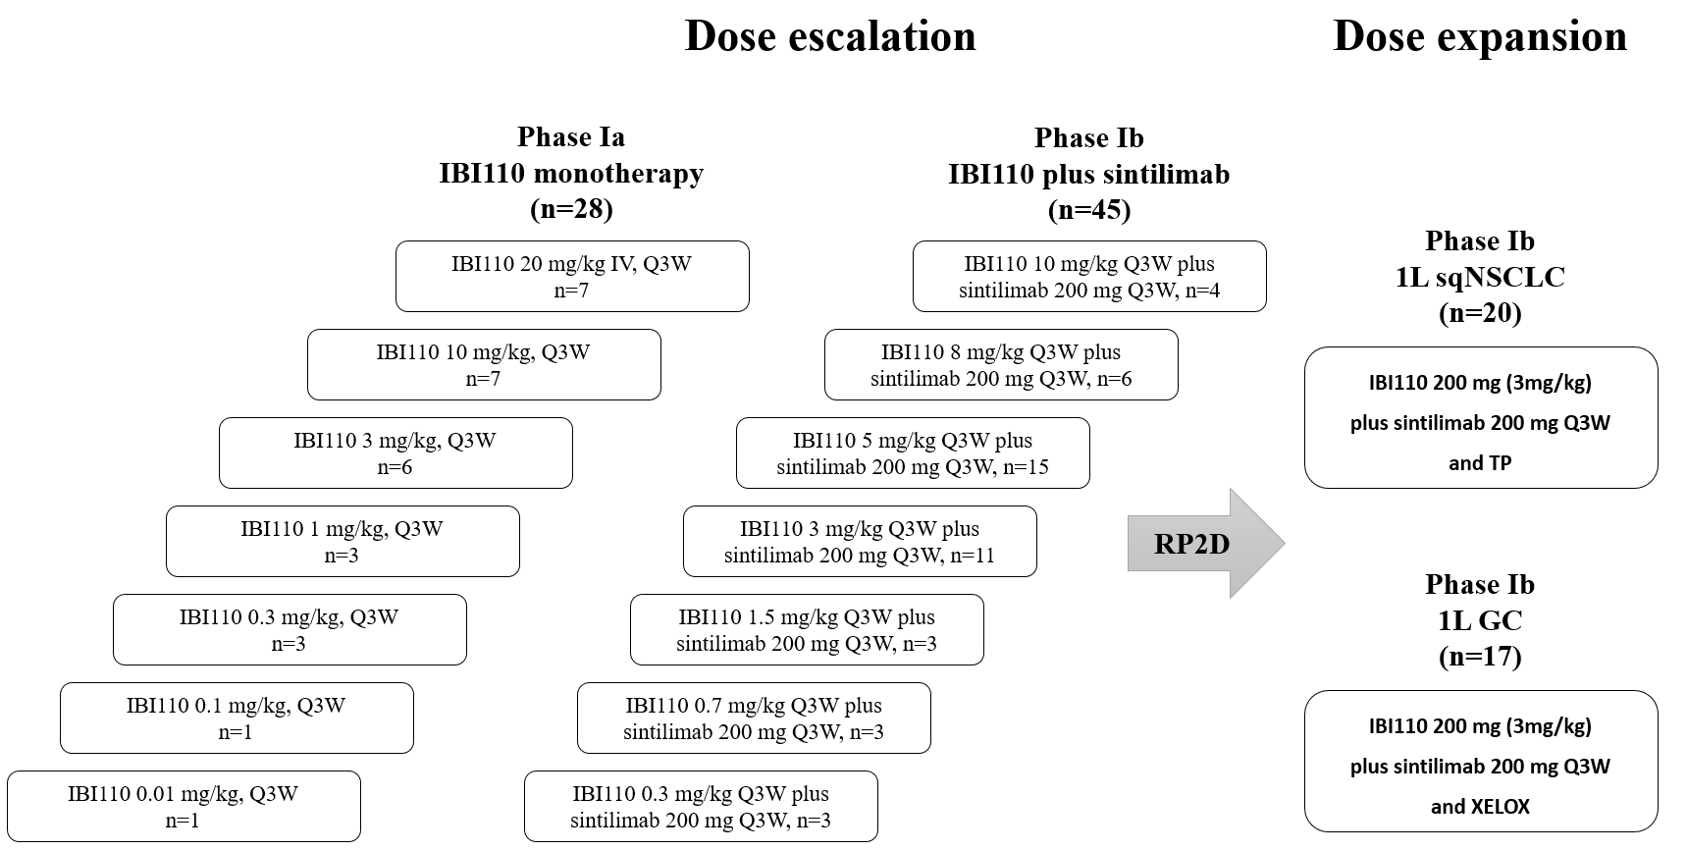
- Supplementary Figure S1. The study design. Abbreviations: First-line treatment (1L), squamous non-small cell lung cancer (sqNSCLC), gastric cancer (GC), paclitaxel and carboplatin (TP), capecitabine and oxaliplatin (XELOX).

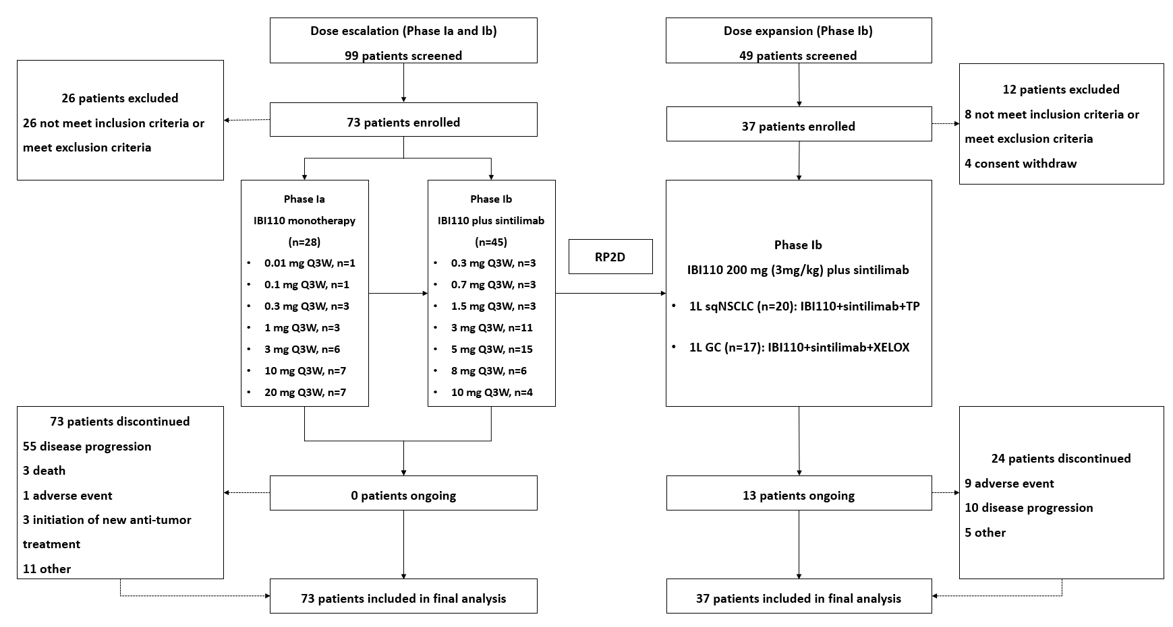
- Supplementary Figure S2. The CONSORT diagram. Abbreviations: First-line treatment (1L), squamous non-small cell lung cancer (sqNSCLC), gastric cancer (GC), paclitaxel and carboplatin (TP), capecitabine and oxaliplatin (XELOX).

- Supplementary Figure S3. Serum concentration of IBI110 as monotherapy and in combination with sintilimab during phase Ia/Ib dose escalation.

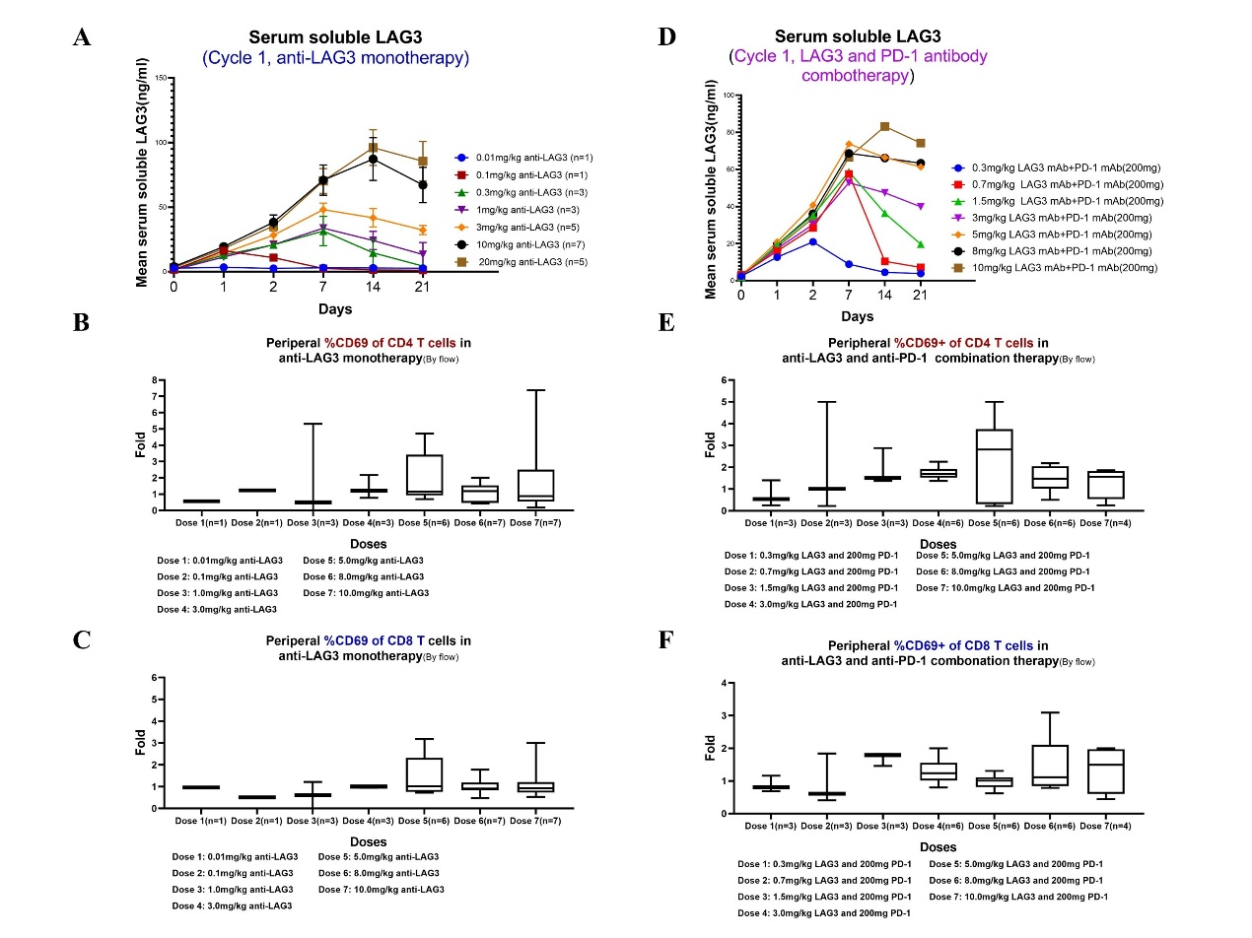
- Supplementary Figure S4. PD analysis of IBI110. Soluble LAG-3 in serum after first cycle of IBI110 monotherapy (A) and combination treatment (D). Change of CD4 and CD8 T cells in IBI110 monotherapy (B-C) and combination treatment (E-F).

