supplementary materials
Table S1
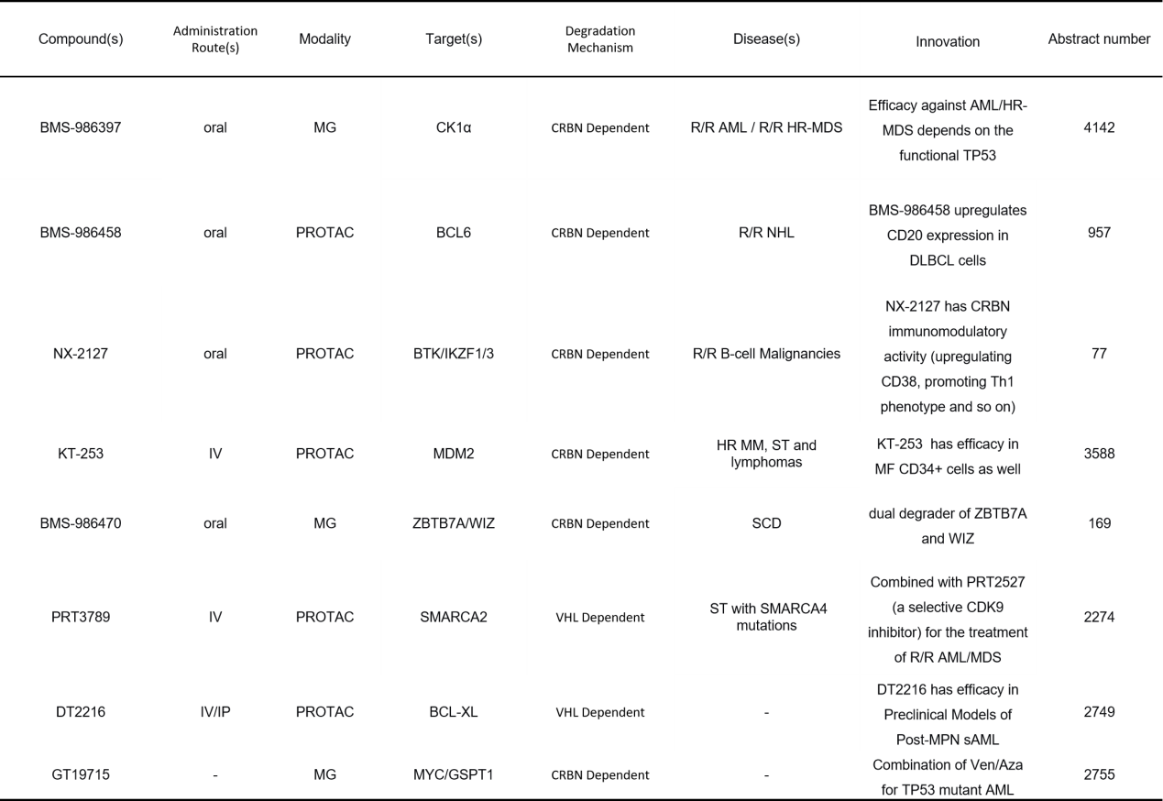
BCL6: B-cell Lymphoma 6; DLBCL: Diffuse Large B-cell Lymphoma; MDM2: Mouse Double Minute 2 Homolog; SCD: Sickle Cell Disease; WIZ: Widely Interspaced Zinc Finger Protein; SMARCA2: SWI/SNF Related, Matrix Associated, Actin Dependent Regulator of Chromatin, Subfamily A, Member 2; CDK9: Cyclin-Dependent Kinase 9; BCL-XL: B-cell Lymphoma-Extra Large; Post-MPN sAML : Post-Myeloproliferative Neoplasm Secondary Acute Myeloid Leukemia; Ven/Aza: Venetoclax/Azacitidine; TP53: Tumor Protein p53

