Supplemental Material

Supplemental Table 1. Treatment-Related Adverse Events with Incidence ≥ 10%
Overall
(N=31)
Preferred Term | n (%)
Any Related TEAEs | 26 (83.9%)
Nausea | 16 (51.6%)
Vomiting | 12 (38.7%)
Hypokalemia | 5 (16.1%)
Diarrhea | 4 (12.9%)
Fatigue | 4 (12.9%)
Oral pain | 4 (12.9%)
Alanine aminotransferase increased | 4 (12.9%)

Supplemental Table 2. Treatment-Related Adverse Events of grades 3 or 4

Overall
(N=31)
Preferred Term | n (%)
Any Grade 3 or Higher Related TEAEs | 6 (19.4%)
Anemia | 2 (6.7%)
Blood bilirubin increased | 2 (6.7%)
Aspartate aminotransferase increased | 1 (3.2%)
Alanine aminotransferase increased | 1 (3.2%)
Thrombocytopenia | 1 (3.2%)
Acute hepatic failure | 1 (3.2%)
Gamma-glutamyl transferase increased | 1 (3.2%)
Hypoxia | 1 (3.2%)
Platelet count decreased | 1 (3.2%)
Stomatitis | 1 (3.2%)
Supplemental Table 3. Summary of BTX-A51 Pharmacokinetics
 |  | Cmax (ng/mL) * |  | AUC (ng*hr/mL)* |  | Half-life (hrs)
Dose (mg) | N | Day 1 | Day 5 | Day 1 | Day 5 | Day 5
1 | 1 | 1.14 | 1.86 | 36.1 | 43.0 | 17.7
3 | 1 | 4.72 | 20.5 | 125 | 600 | 24.8
5 | 3 | 10.7 (45) | 25.7 (22) | 233 (58) | 702 (69) | 18.3
8 | 3 | 18 (6.4) | 37.1 (51) | 573 (15) | 937 (4.1) | 45
11 | 3 | 27.8 (26) | 52.3 (79) | 828 (26) | 1820 (77) | 30.8
21 | 8 | 120 (64) | 130 (46) | 2137 (50) | 3773 (48) | 38
42 | 5 | 99 (79) | 155 (22) |  | 4773 (30) | 21

Mg, milligrams; N, number; Cmax, maximum serum concentration of BTXA51; ng, nanogram; mL, milliliter; hr, hour; AUC, area under the curve; hrs, hours; * Mean (%CV)

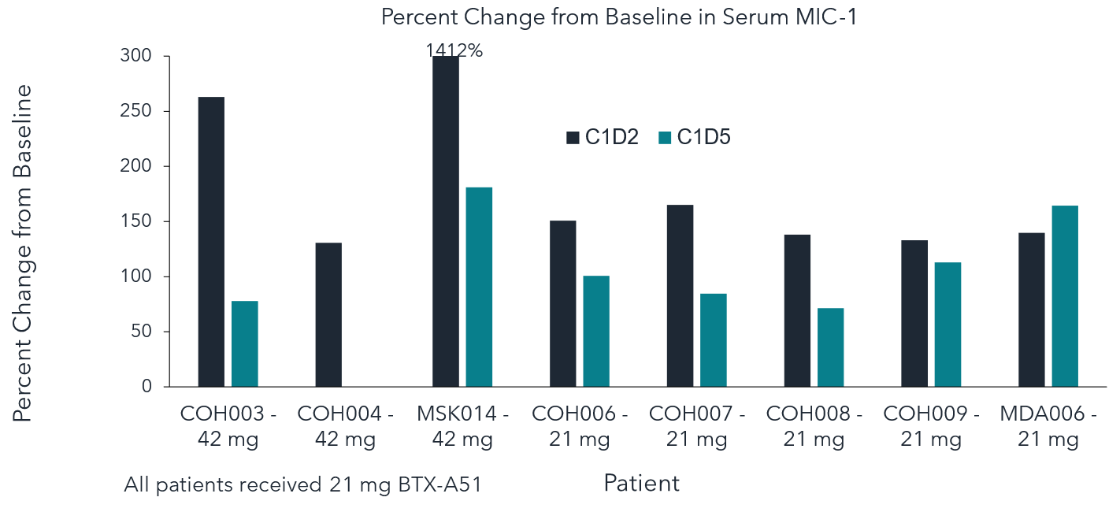
Supplemental Figure 1. Pharmacodynamic studies of BTX-A51
Changes in P53 activation as measured by serum macrophage inhibitor cytokine 1 (MIC-1) levels before and after treatment with BTX-A51. Serum MIC-1 levels increased before and on cycle 1 day 2 and day 5 after treatment with BTX A51. MIC-1, macrophage inhibitor cytokine 1, C1D2, cycle 1 day 2, C1D5, cycle 1 day 5, mg, milligrams.

Eligibility Criteria

Inclusion Criteria
To be eligible for participation in this study, a patient must meet all of the following inclusion criteria:
- Demonstration of understanding and voluntarily signing of an informed consent form (ICF)
- ≥18 years of age at the time of signing the ICF
- Documented diagnosis of AML or MDS according to the World Health Organization (WHO) classification (Arber, Orazi, et al., 2016) and, with respect to MDS, that is high risk (high or very high risk by the Revised IPSS, Greenberg, Tuechler, et al., 2012). Patients must have refractory or relapsed disease and be ineligible for or have exhausted standard therapeutic options that would otherwise be likely to provide clinical benefit.
- Eastern Cooperative Oncology Group (ECOG) performance status ≤2 (Appendix 26.1) and a life expectancy ≥6 weeks at study entry as determined by study Investigator
- Adequate organ function defined as:
- Serum creatinine ≤1.5 × ULN, i.e., Grade 1
- Total bilirubin ≤1.5 × ULN, i.e., Grade 1; higher levels are acceptable if these can be attributed to ineffective erythropoiesis, leukemia organ involvement (when other causes of hepatic toxicity have been ruled out), or Gilbert's syndrome
- AST and/or ALT ≤2 × ULN, unless considered due to leukemic organ involvement (when other causes of hepatic toxicity have been ruled out)
- Female participants of childbearing potential may participate provided they have a negative serum pregnancy test at Screening and a negative serum pregnancy test within 72 hours prior to starting on treatment; they also must agree to either abstain from sexual intercourse or use a highly effective method of contraception (for up to 3 months after the last dose of study drug) such as:
- Established use of oral or long-acting injected or implanted hormonal methods of contraception for at least 90 days prior to Cycle 1 Dose 1;
- Placement of an intrauterine device or intrauterine system;
- Barrier methods: condom, diaphragm, or cervical/vault cap with spermicidal foam/gel/film/cream/suppository;
- Male partner sterilization (with the appropriate postvasectomy documentation of the absence of spermatozoa in the ejaculate [the vasectomized partner should be the sole partner for that patient]); or
- True abstinence (when this is in line with the preferred and usual lifestyle of the patient)
- Male participants sexually active with a woman of childbearing potential (even those who have had a vasectomy) must agree to use a barrier method of birth control (see above) during and after the study (up to 3 months after the last dose of study drug); all men must not donate sperm during the study and for 3 months after receiving the last dose of study drug.

Exclusion Criteria
A patient will be excluded from participation if he/she meets any of the following:
- Diagnosis of acute promyelocytic leukemia
- White blood cell count (WBC) >25 × 10⁹/L at Screening (hydroxyurea may be used to bring the WBC count below the threshold; patients may be retested within the 28-day screening period following treatment)
- Receipt of cancer chemotherapy (other than hydroxyurea) within 2 weeks prior to the start of study drug (Cycle 1, Day 1)
- In participants who have undergone autologous or allogeneic stem cell transplantation:
- Transplantation within the 3 months prior to Screening;
- Active graft-versus-host disease requiring anything other than topical corticosteroids and budesonide;
- Treatment with systemic immunosuppressive medications including high-dose steroids (≥20 mg prednisolone or equivalent per day), calcineurin inhibitors (e.g., cyclosporine, tacrolimus), sirolimus, mycophenylate mofetil, azathioprine, or ruxolitinib for at least 1 week prior to Screening. Use of topical steroids and oral budesonide will be permitted as will systemic steroid use as premedication for transfusions or treatment of any anaphylactic event
- Immediate life-threatening severe complications of leukemia such as uncontrolled bleeding, pneumonia with hypoxia or shock, and/or disseminated intravascular coagulation
- Persistent toxicities from prior treatment of Grade 2 or higher
- Active uncontrolled systemic fungal, bacterial, mycobacterial, or viral infection (defined as ongoing signs/symptoms related to the infection without improvement despite appropriate antibiotics, antiviral therapy, and/or other treatment)
- Clinically significant cardiac disease, including:
- Myocardial infarction within 6 months before Cycle 1, Day 1 or unstable or uncontrolled disease/condition related to or affecting cardiac function (e.g., unstable angina, congestive heart failure [New York Heart Association Class III or IV] [Appendix 26.2])
- Screening 12-lead ECG showing a Baseline average QT interval as corrected by Fridericia’s formula (QTcF) >470 msec. Patients with left or right bundle branch block, where QT cannot be accurately assessed, will be allowed into the study with the approval of the Medical Monitor
- Left ventricular ejection fraction (LVEF) <40%
- Known dysphagia, short-gut syndrome, gastroparesis, or other conditions that limit the ingestion or gastrointestinal absorption of drugs administered orally
- Any other concurrent medical condition or disease that is likely to interfere with study procedures or results, or that, in the opinion of the Investigator, would constitute a hazard for participating in this study
- If female, pregnant or breastfeeding

