Supplemental information includes 20 figures and 2 tables.

Contents
- Figure S1. Generation of 1F-NKs from PBMCs via BCL11B Knockdown.
- Figure S2. Comparative transcriptomic profiling of 1F-NKs.
- Figure S3. Transcriptional comparison of NK lineage- and function-associated genes across distinct NK cell types.
- Figure S4. Flow cytometry comparison of chemokine receptor expression in 1F-NKs and pNKs.
- Figure S5. Generation and cytolytic assessment of MSLN-CAR-engineered NK-92 cells.
- Figure S6. Generation and assessment of mesothelin-CAR binding in NK cells.
- Figure S7. Antibody-dependent cellular cytotoxicity (ADCC) of 1F-NKs and pNKs.
- Figure S8. Functional role of NKG2D signaling in 1F-NK cytotoxicity.
- Figure S9. RP6306 induces cytotoxicity and DNA damage in PDAC cells in a dose-dependent manner.
- Figure S10. PKMYT1 inhibition enhances MSLN-1F-NK-mediated cytotoxicity.
- Figure S11. PKMYT1 knockdown enhances NK-mediated cytotoxicity against PDAC cells.
- Figure S12. Raw data corresponding to main figures.
- Figure S13. RP6306 treatment upregulates CX3CL1 and promotes 1F-NK migration.
- Figure S14. 1F-NK-mediated cytotoxicity in a 3D spheroid model.
- Figure S15. Tumor progression in subcutaneous and orthotopic PDAC models.
- Figure S16. Tumor burden and body weight monitoring in subcutaneous and orthotopic PDAC models.
- Figure S17. Enhanced in vivo persistence of 1F-NKs.
- Figure S18. Comparison of tumor infiltration of pNKs, 1F-NKs and MSLN-1F-NKs.
- Figure S19. Anti-NKG2D antibody reduces in vivo antitumor activity of 1F-NKs.
- Figure S20. PKMYT1 inhibition potentiates MSLN-1F-NK antitumor activity in vivo.

- Supplementary Table 1. List of antibodies used in this study.
- Supplementary Table 2. Sequence of MSLN-CAR construct

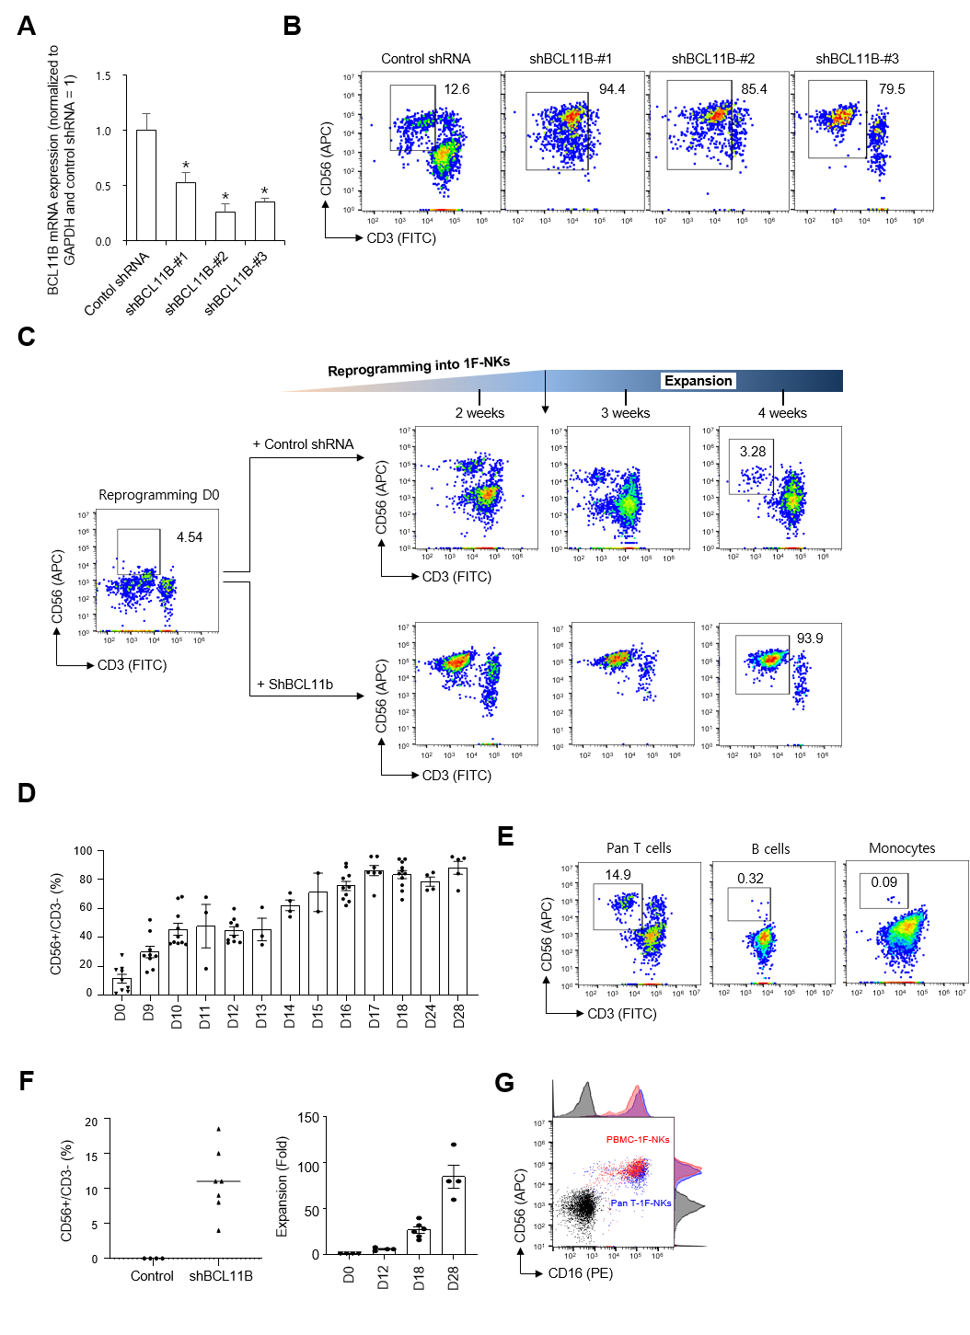
Figure S1. Generation of 1F-NKs from PBMCs via BCL11B Knockdown. (A) Quantitative RT-PCR analysis of BCL11B mRNA expression in peripheral blood mononuclear cells (PBMCs) 24 h after lentiviral transduction with BCL11B-targeting shRNA (shBCL11B, MOI 10). Non-silencing shRNA was used as control (shCon). GAPDH served as the internal reference. Data are presented as mean ± SD of three independent experiments. Two-tailed Student’s t-test; *P < 0.001 vs control in 1F-RM condition. (B) Representative flow cytometry dot plots showing induction of CD56⁺CD3⁻ NK-like cells at day 18 post-reprogramming using three different shBCL11B constructs (#1, #2, #3) or control. (C) Time-course analysis showing representative flow cytometry dot plots of CD56⁺CD3⁻ cell production at various reprogramming time points under 1F-NK reprogramming conditions. (D) Reprogramming efficiency (% of CD56⁺CD3⁻ NK cells) over time under 1F-NK conditions. Data are expressed as mean ± SD. (E) Flow cytometry dot plots of lineage conversion efficiency at day 18 after shBCL11B transduction in isolated human Pan T cells, B cells, and monocytes cultured under 1F-NK condition. (F) Time-course quantification of reprogramming efficiency from Pan T cells using shBCL11B vs control. Fold expansion of reprogrammed NK cells is shown on the right. Data are mean ± SD. (G) Comparative flow cytometry analysis of CD56 and CD16 expression in 1F-NKs derived from whole PBMCs (red, PBMC-1F-NKs) versus Pan T cells (blue, Pan T-1F-NKs). Representative dot plots and histograms are shown.
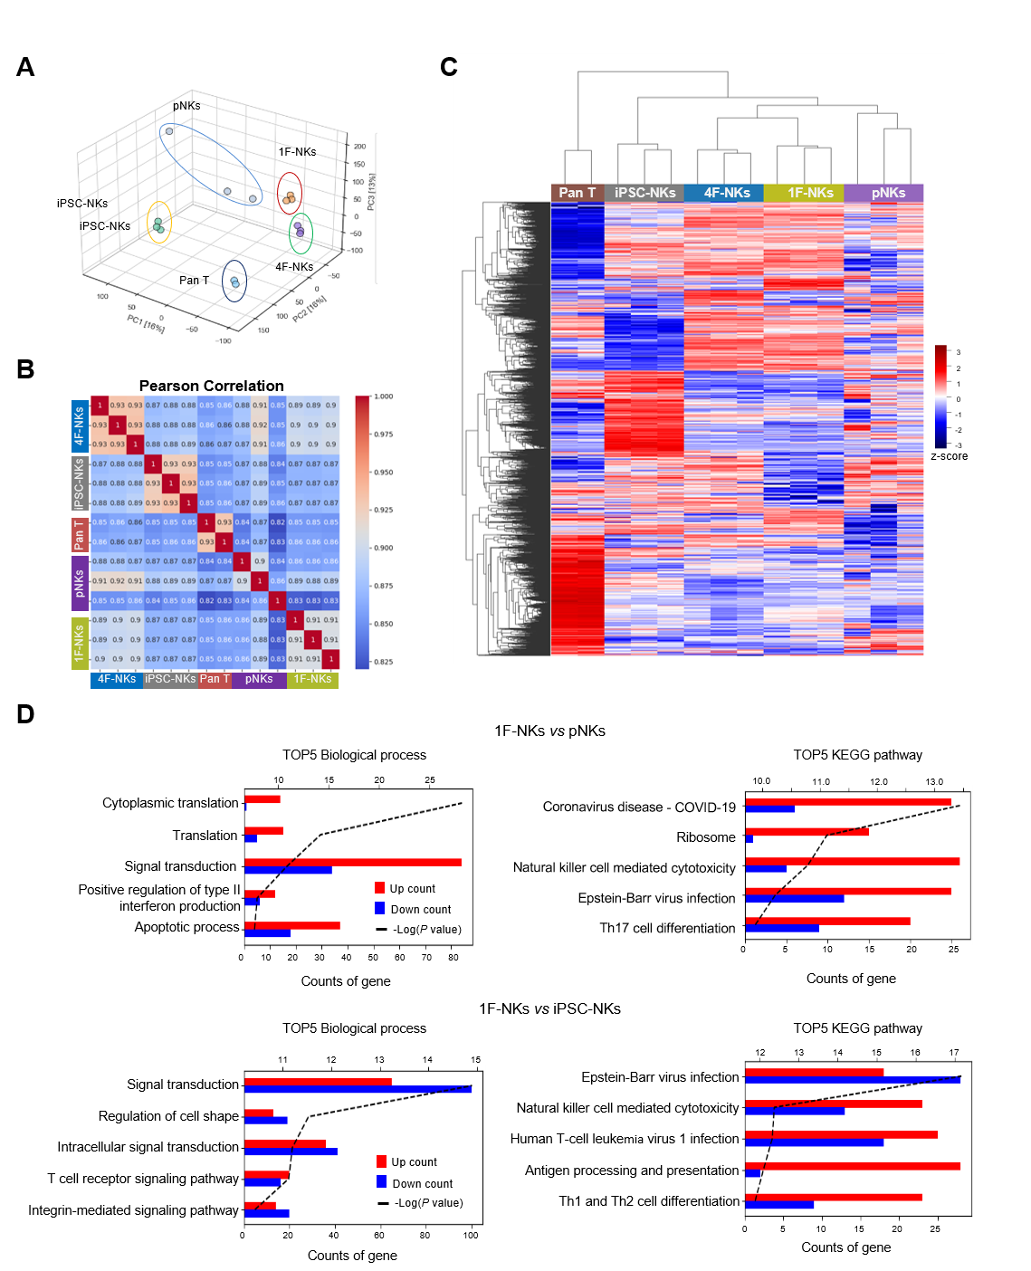
Figure S2. Comparative transcriptomic profiling of 1F-NKs. (A) Principal component analysis (PCA) of transcriptomic profiles of 1F-NKs, 4F-NKs, iPSC-derived NKs (iPSC-NKs), PBMC-derived NKs (pNKs), and Pan T cells. 1F-NKs form a distinct cluster, indicating a unique transcriptional identity. (B) Pearson correlation matrix based on expression of genes with counts per million (CPM) >10 after normalization. High intra-group similarity among 1F-NKs and their distinctness from T cells are evident. (C) Hierarchical clustering heatmap of differentially expressed genes (DEGs) (fold change > 2, adjusted P < 0.05) among the five NK cell types, highlighting distinct lineage-specific transcriptional programs. (D) Gene Ontology (GO) and Kyoto Encyclopedia of Genes and Genomes (KEGG) pathway enrichment analysis of significantly upregulated and downregulated DEGs in 1F-NKs, showing the top five biological processes and pathways enriched in immune effector and NK cytotoxicity-related functions.
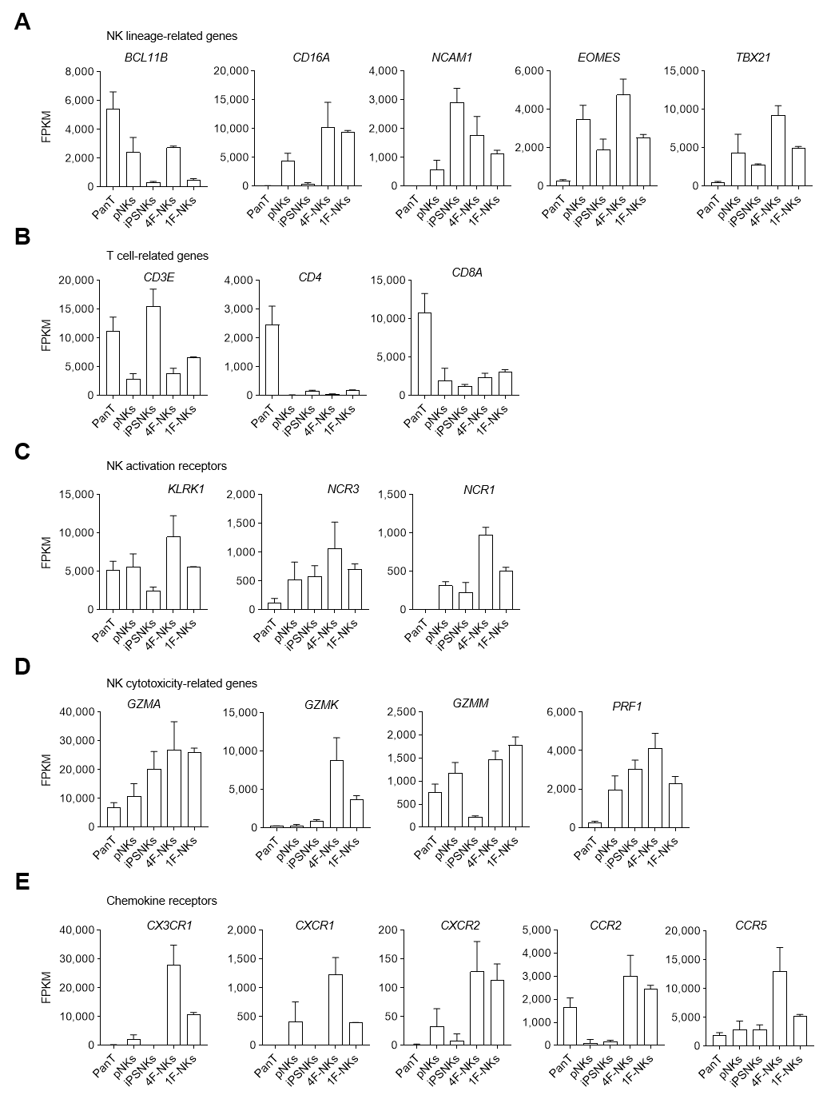
Figure S3. Transcriptional comparison of NK lineage- and function-associated genes across distinct NK cell types. (A–E) Fragments per kilobase per million mapped reads (FPKM) values depicting gene expression profiles in 1F-NKs, 4F-NKs, pNKs, iPSC-NKs, and Pan T cells. (A) Expression of key NK lineage-specifying transcription factors (EOMES, TBX21, BCL11B) and surface receptors (NCAM1, CD16A). (B) Expression of T cell-associated transcripts, including CD3E, CD4, and CD8A. (C) Expression of NK-activating receptors, including KLRK1, NCR3, and NCR1. (D) Expression of cytotoxic effector molecules, including GZMA, GZMK, GZMM, and PRF1. (E) Expression of chemokine receptor genes, including CX3CR1, CXCR1, CXCR2, CCR2, and CCR5.
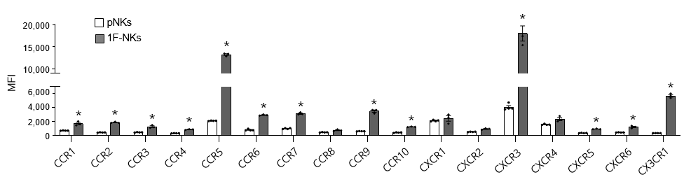
Figure S4. Flow cytometry comparison of chemokine receptor expression in 1F-NKs and pNKs. Chemokine receptor expression was analyzed by flow cytometry in 1F-NKs and pNKs. Mean fluorescence intensity (MFI) values are presented for each chemokine receptor. Data represent mean ± standard deviation (SD) from 3-4 biologically independent replicates per group. Two-tailed Student’s t-test; *P < 0.001 vs pNKs.
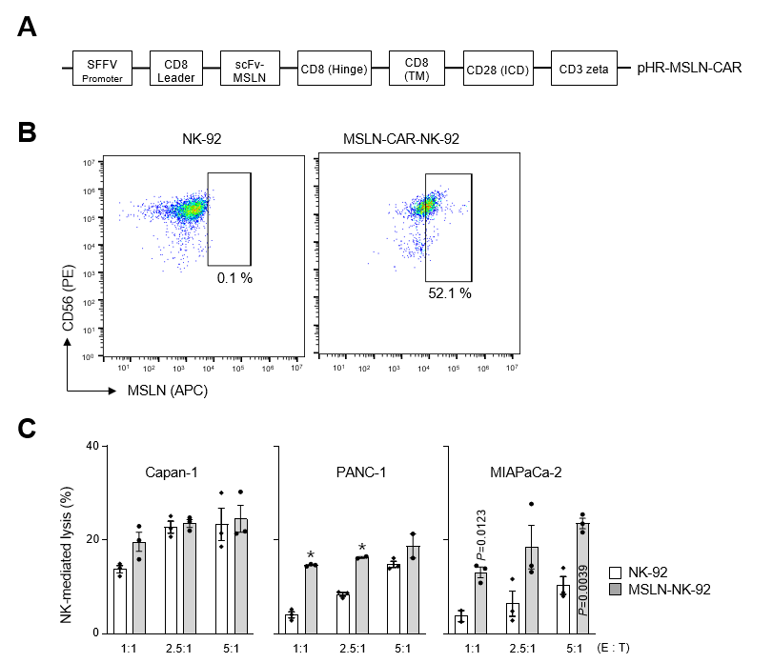
Figure S5. Generation and cytolytic assessment of MSLN-CAR-engineered NK-92 cells. (A) Schematic representation of the mesothelin-specific chimeric antigen receptor (MSLN-CAR) encoded by the pHR-MSLN-CAR lentiviral vector. The construct includes an SFFV promoter, a CD8 leader peptide, an anti-MSLN single-chain variable fragment (scFv-MSLN), a CD8 hinge region, a CD8 transmembrane (TM) domain, a CD28 intracellular signaling domain (ICD), and a CD3ζ signaling domain. (B) Representative flow cytometry dot plots showing surface expression of MSLN-CAR in NK-92 cells. (C) Calcein-AM-based cytotoxicity assays assessing lysis of MSLN⁺ cancer cell targets by MSLN-CAR-NK-92 and parental NK-92 cells. Target lysis was evaluated at effector-to-target (E:T) ratios of 1:1, 2.5:1, and 5:1) after 4 h co-culture. Data are shown as mean ± SD (n=3). Two-tailed Student’s t-test; *P < 0.001 vs NK-92.
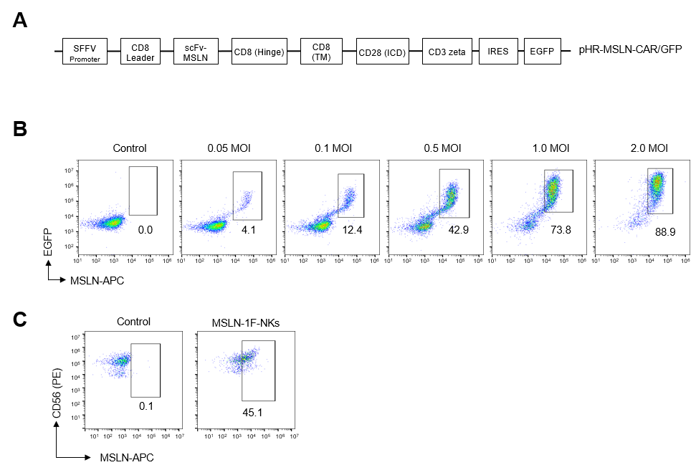
Figure S6. Generation and assessment of mesothelin-CAR binding in NK cells. (A) Schematic of the MSLN-CAR encoded by the pHR-MSLN-CAR lentiviral vector. The construct includes an SFFV promoter, a CD8α signal peptide, an anti-MSLN single-chain variable fragment (scFv), a CD8α hinge region, a CD8 transmembrane domain, CD28 and CD3ζ intracellular signaling domains, an internal ribosome entry site (IRES), and EGFP. (B) Flow cytometric analysis of EGFP⁺ HEK293T cells transduced with MSLN-CAR lentivirus at increasing MOIs and incubated with APC-labeled recombinant human mesothelin (APC-MSLN). Representative dot plots show a dose-dependent increase in double-positive EGFP⁺APC-MSLN⁺ cells, indicating successful scFv surface expression and target engagement. (C) Flow cytometric analysis of MSLN-1F-NKs incubated with APC-MSLN protein. Binding was evaluated in the CD56⁺ population, showing detectable levels of scFv-mediated mesothelin binding.
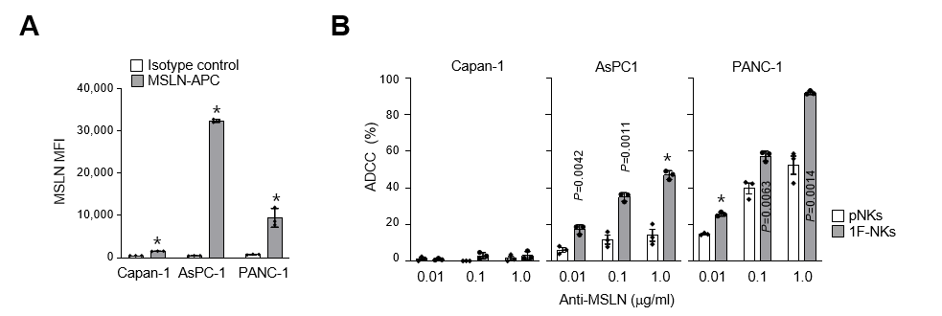
Figure S7. Antibody-dependent cellular cytotoxicity (ADCC) of 1F-NKs and pNKs. (A) Surface mesothelin (MSLN) expression in PDAC cell lines (Capan-1, AsPC-1, and PANC-1) as measured by flow cytometry. Data are presented as MFI ± SD (n = 3). Two-tailed Student’s t-test; *P < 0.001 vs isotype control. (B) ADCC assays performed by co-culturing MSLN-high (PANC-1 and AsPC-1) and MSLN-low (Capan-1) PDAC cells with 1F-NKs or pNKs in the presence of the anti-MSLN antibody (Misitatug). Calcein-AM–based cytotoxicity assays were conducted for 4 h at an E:T ratio of 1:1. Data are shown as mean ± SD (n = 3). Two-tailed Student’s t-test; *P < 0.001 vs pNKs.
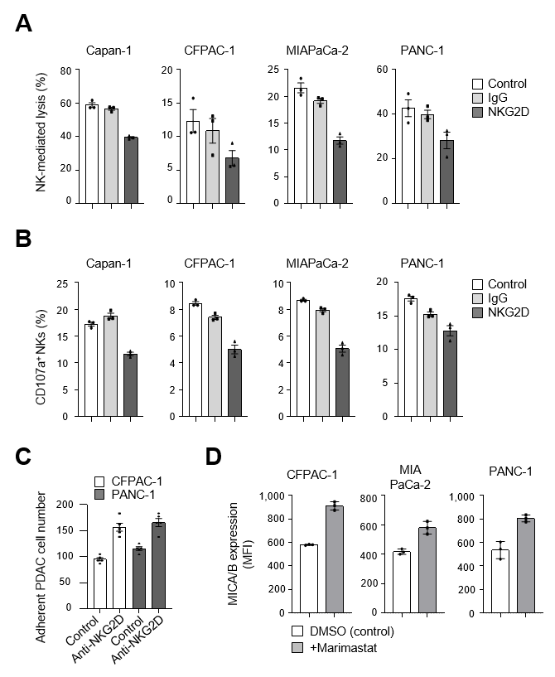
Figure S8. Functional role of NKG2D signaling in 1F-NK cytotoxicity. (A–D) Raw (non-normalized) values corresponding to results shown in Fig. 3. (A) CD107a degranulation assay (related to Fig. 3D). (B) Cytotoxicity assay (related to Fig. 3E). (C) Tumor cell adhesion after NK cell co-culture (related to Fig. 3I). (D) Flow cytometric analysis of MICA/B surface expression (related to Fig. 3J). Data represent mean ± SD (n = 3).
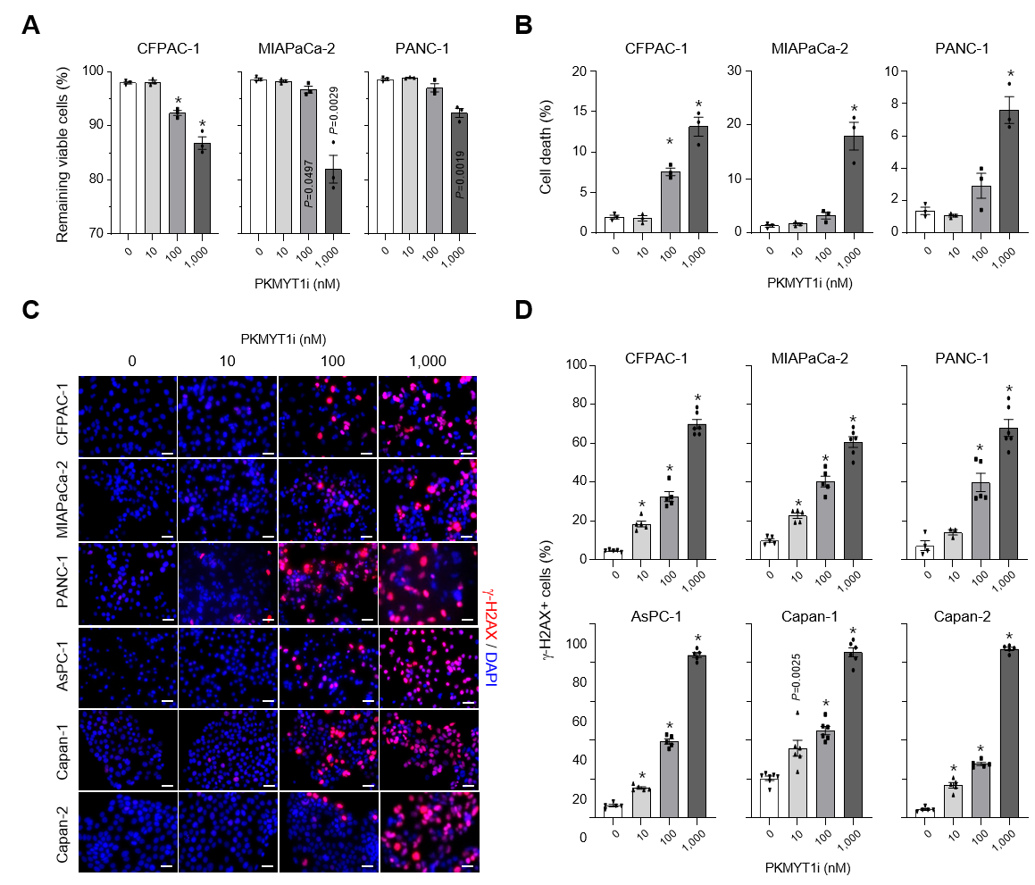
Figure S9. RP6306 induces cytotoxicity and DNA damage in PDAC cells in a dose-dependent manner. (A-B) Effects of PKMYT1 inhibition using RP6306 (PKMYT1i) on apoptosis and viability in PDAC cell lines (CFPAC-1, MIAPaCa-2, and PANC-1). Cells were treated for 48 h and analyzed by flow cytometry using an apoptosis detection kit. DMSO-treated cells served as controls. (C) Immunofluorescence images showing γ-H2AX foci formation in PDAC cells following RP6306 treatment. Nuclei were counterstained with DAPI (blue). (D) Quantification of γ-H2AX foci per nucleus. At least 100 nuclei were analyzed per condition. Data are shown as mean ± SD (n = 3). Two-tailed Student’s t-test; *P < 0.001 vs control.
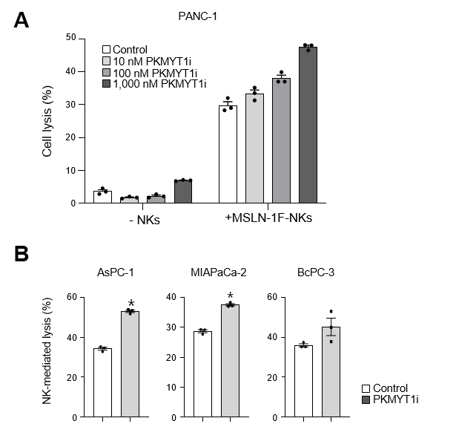
Figure S10. PKMYT1 inhibition enhances MSLN-1F-NK-mediated cytotoxicity. A) Dose-dependent enhancement of NK cytotoxicity by PKMYT1i. PANC-1 cells were pretreated with DMSO or increasing doses of PKMYT1i (RP6306) for 48 h and then co-cultured with MSLN-1F-NKs (E:T = 1:1, 4 h). (B) Broad enhancement of NK cytotoxicity across PDAC cell lines. AsPC-1, MIAPaCa-2, and BxPC-3 cells pretreated with PKMYT1i were co-cultured with MSLN-1F-NKs (E:T = 1:1, 4 h). NK-mediated lysis was assessed by PI staining. Data are presented as mean ± SD (n = 3). *P < 0.001 vs control.
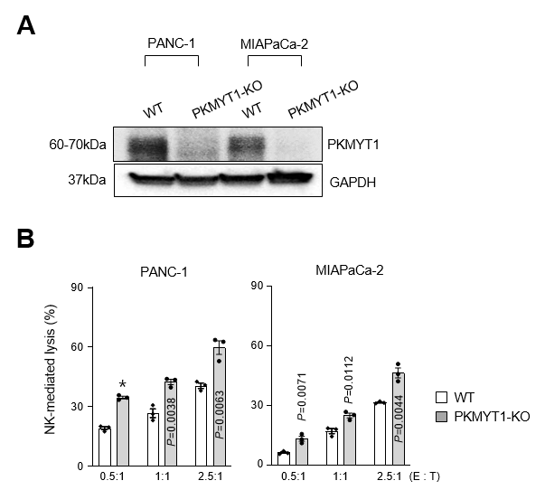
Figure S11. PKMYT1 knockdown enhances NK-mediated cytotoxicity against PDAC cells. (A) Validation of CRISPR/Cas9-mediated knockout (KO) of PKMYT1 using dual sgRNAs in MIAPaCa-2 and PANC-1 cells, confirmed by western blotting. (B) Cytolytic activity of 1F-NKs against wild-type (WT) and PKMYT1-deficient PDAC cells. 1F-NKs were co-cultured with WT or PKMYT1-KO PDAC cells at the indicated E:T ratios for 4 h. Cytotoxicity was measured by calcein-release assay. Data represent mean ± SD (n = 3). Two-tailed Student’s t-test; *P < 0.001 vs WT.
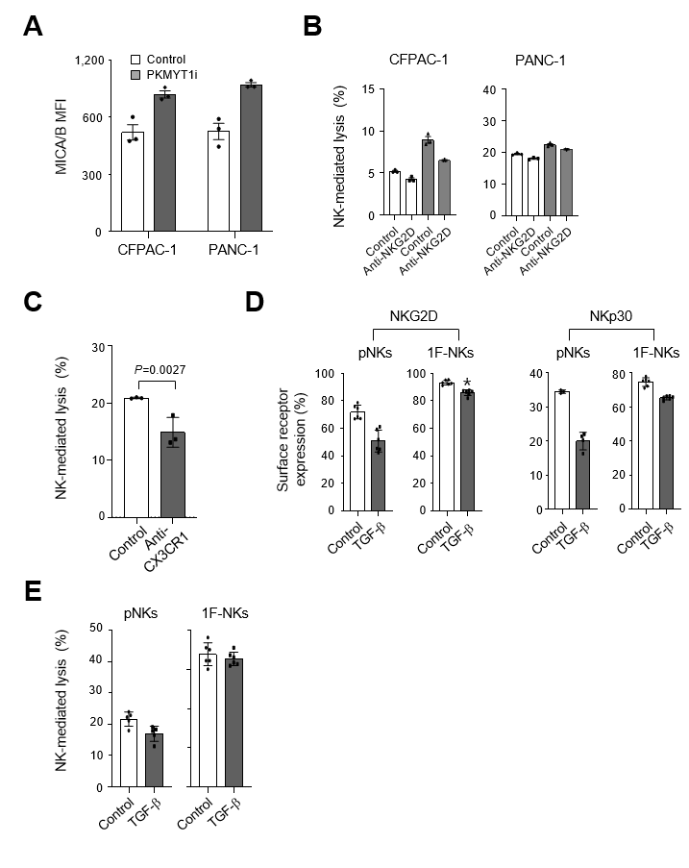
Figure S12. Raw data corresponding to main figures. (A–E) Unnormalized individual values for main figure panels: Fig. 4J (A), Fig. 4K (B), Fig. 4Q (C), Fig. 4P (D), and Fig. 4R (E).
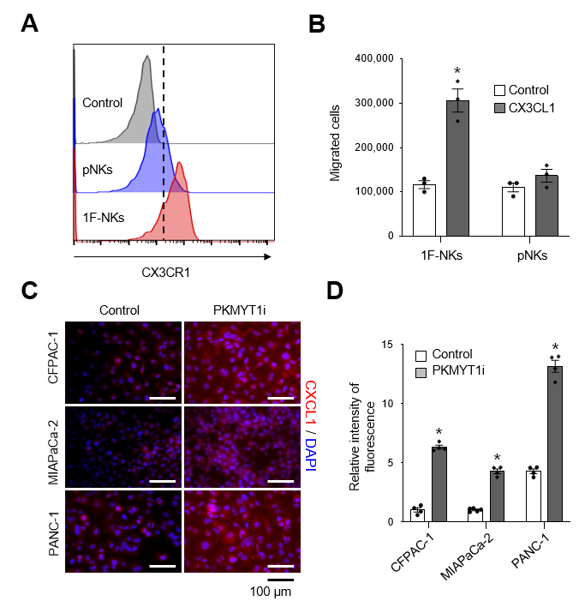
Figure S13. RP6306 treatment upregulates CX3CL1 and promotes 1F-NK migration. (A) Flow cytometry histograms comparing CX3CR1 surface expression between 1F-NKs and pNKs. (B) Transwell migration assay showing enhanced chemotaxis of 1F-NKs toward CX3CL1 (5 µm pores, 4 h incubation). (C) Immunofluorescence images showing upregulation of CX3CL1 in PDAC cells treated with DMSO or RP6306 (100 nM) for 48 h. Nuclei stained with DAPI (blue). (D) Quantification of CX3CL1 fluorescence intensity. Data shown as mean ± SD (n = 3). Two-tailed Student’s t-test; *P < 0.001 vs control. Scale bar, 100 μm.
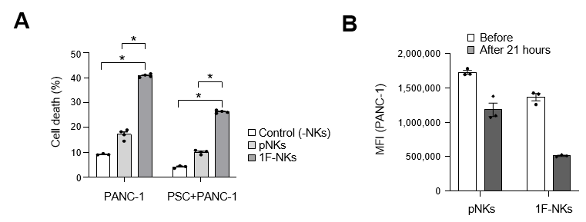
Figure S14. 1F-NK-mediated cytotoxicity in a 3D spheroid model. (A) Flow cytometric analysis of Annexin V/PI staining in 3D spheroids formed by PANC-1 or PANC-1⁺ PSC after 21 h co-culture with pNKs or 1F-NKs at an E:T ratio of 2:1. (B) Quantification of mean fluorescence intensity (MFI) of PANC-1⁺ cells before and after co-culture. Data shown as mean ± SD (n = 3). Two-tailed Student’s t-test; *P < 0.001 vs control.
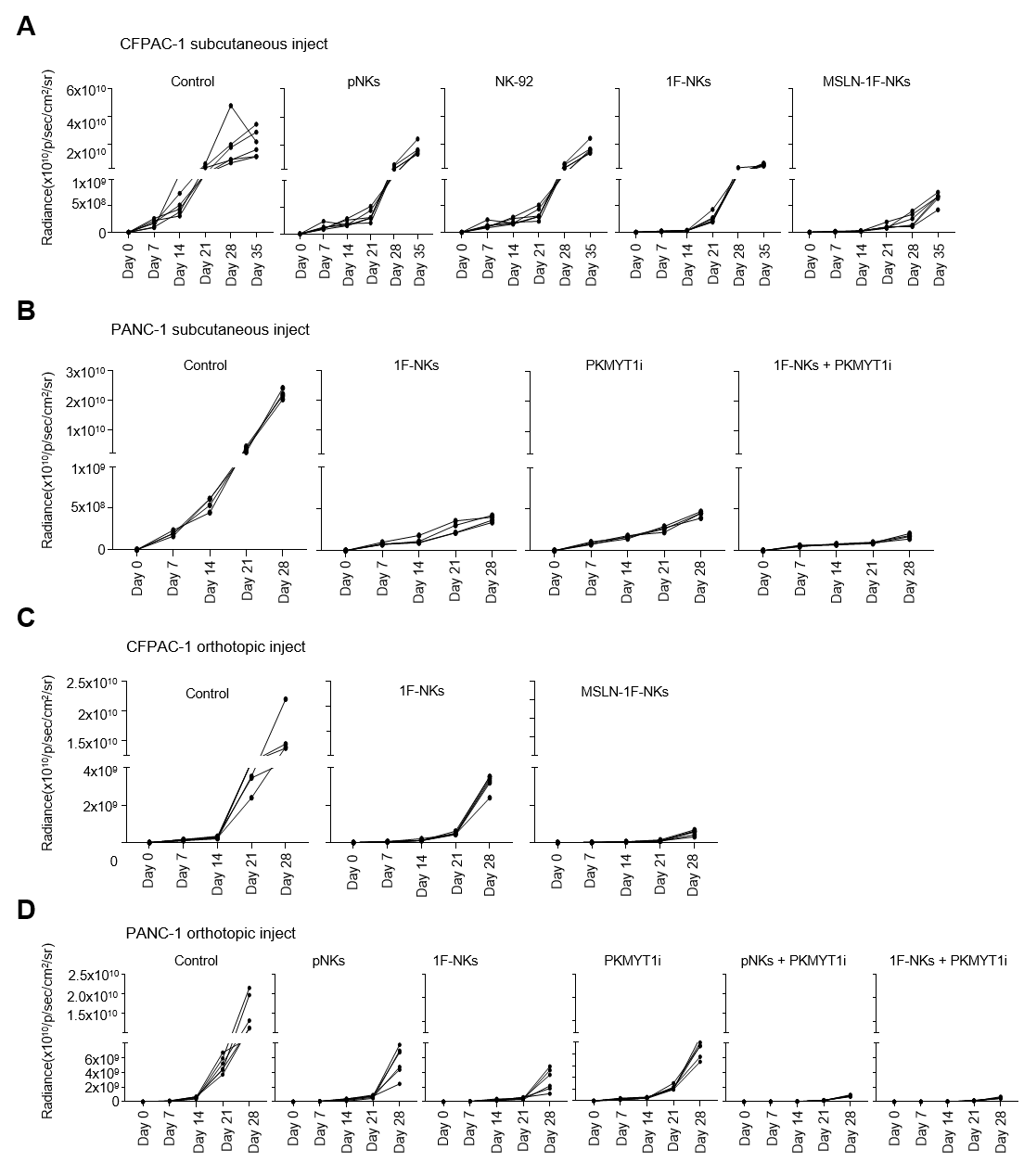
Figure S15. Tumor progression in subcutaneous and orthotopic PDAC models. (A) BLI monitoring of CFPAC-1 subcutaneous tumors treated with PBS (Control), pNKs, NK-92, 1F-NKs, or MSLN-1F-NKs at day 0, 7, 14, 21, and 35. (B) Time-course BLI data of PANC-1 subcutaneous xenografts treated with Control, 1F-NKs, PKMYT1 inhibitor (PKMYT1i), or 1F-NKs in combination with PKMYT1i. (C) Tumor progression in orthotopic CFPAC-1-Luc xenografts monitored over time following treatment with Control, 1F-NKs, or MSLN-1F-NKs. (D) Orthotopic PANC-1-Luc xenograft tumor progression in mice receiving Control, pNKs, 1F-NKs, PKMYT1i, or combinations (pNKs + PKMYT1i, 1F-NKs + PKMYT1i). BLI signals (radiance, photons/s/cm²/sr) were measured at indicated time points. Each line represents an individual mouse.
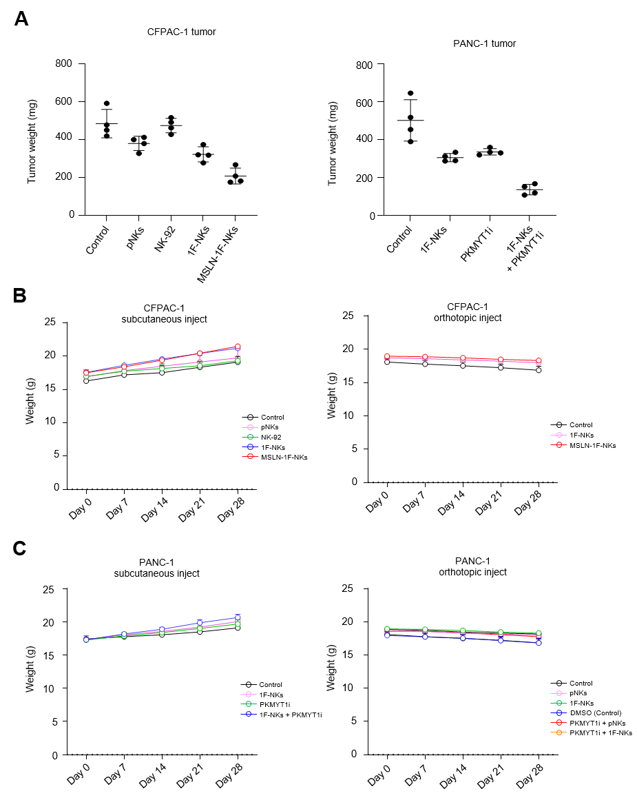
Figure S16. Tumor burden and body weight monitoring in subcutaneous and orthotopic PDAC models. (A) Tumor weights from CFPAC-1 (left) and PANC-1 (right) xenografts measured at day 28 after the indicated treatments. (B) Body weights of mice bearing CFPAC-1 tumors (subcutaneous and orthotopic) were monitored over time. (C) Body weights of PANC-1 xenograft-bearing mice (subcutaneous and orthotopic) under the indicated treatment conditions. Data are presented as mean ± SD.

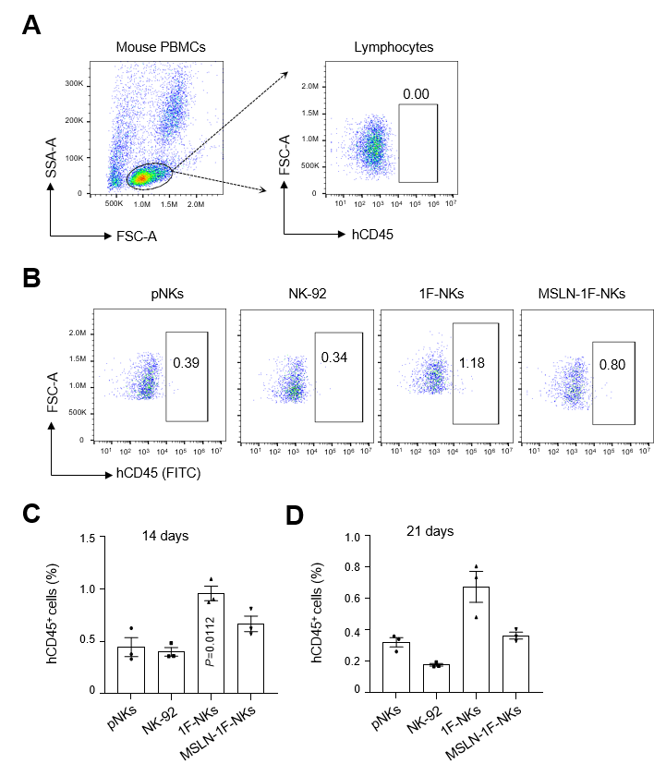
Figure S17. Enhanced in vivo persistence of 1F-NKs. (A) Gating strategy for detection of human CD45⁺ NK cells in mouse peripheral blood. (B) Representative flow cytometry plots at day 14 post-NK infusion. (C–D) Quantification of human CD45⁺ NK cells in peripheral blood on days 14 and 21 post-infusion of pNKs, NK-92, 1F-NKs, or MSLN-1F-NKs. Data shown as mean ± SD (n = 3). Two-tailed Student’s t-test vs pNKs.
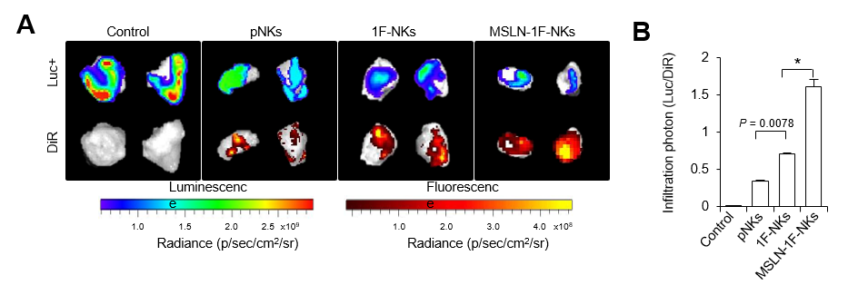
Figure S18. Comparison of tumor infiltration of pNKs, 1F-NKs and MSLN-1F-NKs. (A) Ex-vivo imaging of isolated tumors on day 3 post-inoculation. Tumors were assessed for NK infiltration using DiR-labeled NKs and luciferase signal from CFPAC-1-Luc cells. (B) Quantification of the relative infiltration based on DiR and Luc signal ratios from panel (A).

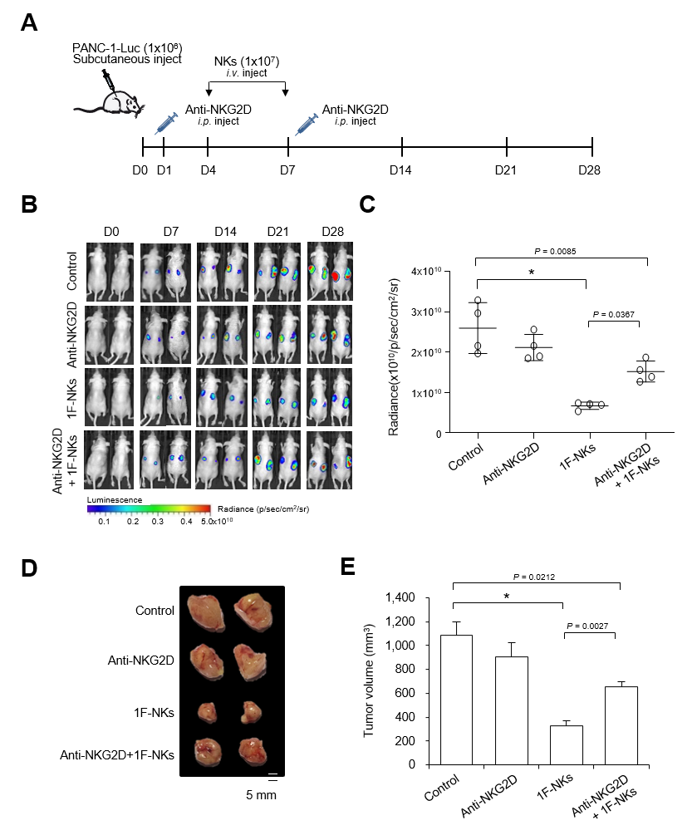
Figure S19. Anti-NKG2D antibody reduces in vivo antitumor activity of 1F-NKs. (A) Experimental scheme for assessing anti-NKG2D antibody effects in PANC-1-Luc xenografts. (B) Representative in vivo bioluminescence images at indicated time points. (C) Quantification of tumor radiance on day 28. One-way ANOVA followed by multiple comparisons. (D) Gross images of tumors resected on day 28. Scale bar = 10 mm. (E) Tumor volume quantification. One-way ANOVA followed by multiple comparisons. *P < 0.001.
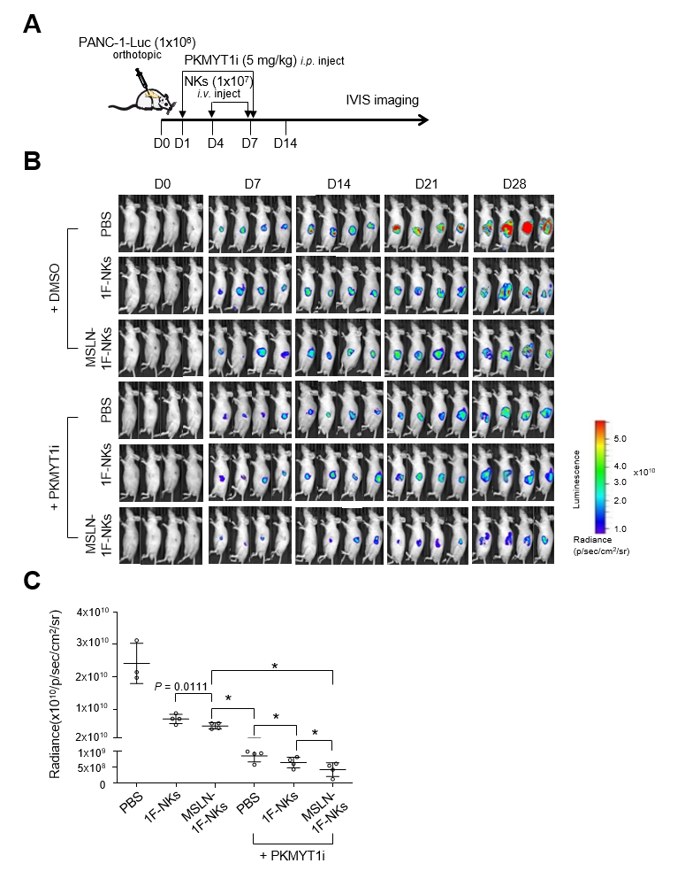
Figure S20. PKMYT1 inhibition potentiates MSLN-1F-NK antitumor activity in vivo. (A) Schematic of treatment regimens in orthotopic PANC-1-Luc model. Mice were administered PBS, 1F-NKs, MSLN-1F-NKs, PKMYT1i, or combinations. (B) Bioluminescence images at specified time points. (C) Quantification of bioluminescence signals at day 28. One-way ANOVA with multiple comparisons. *P < 0.001.

Table S1. List of antibodies used in this study
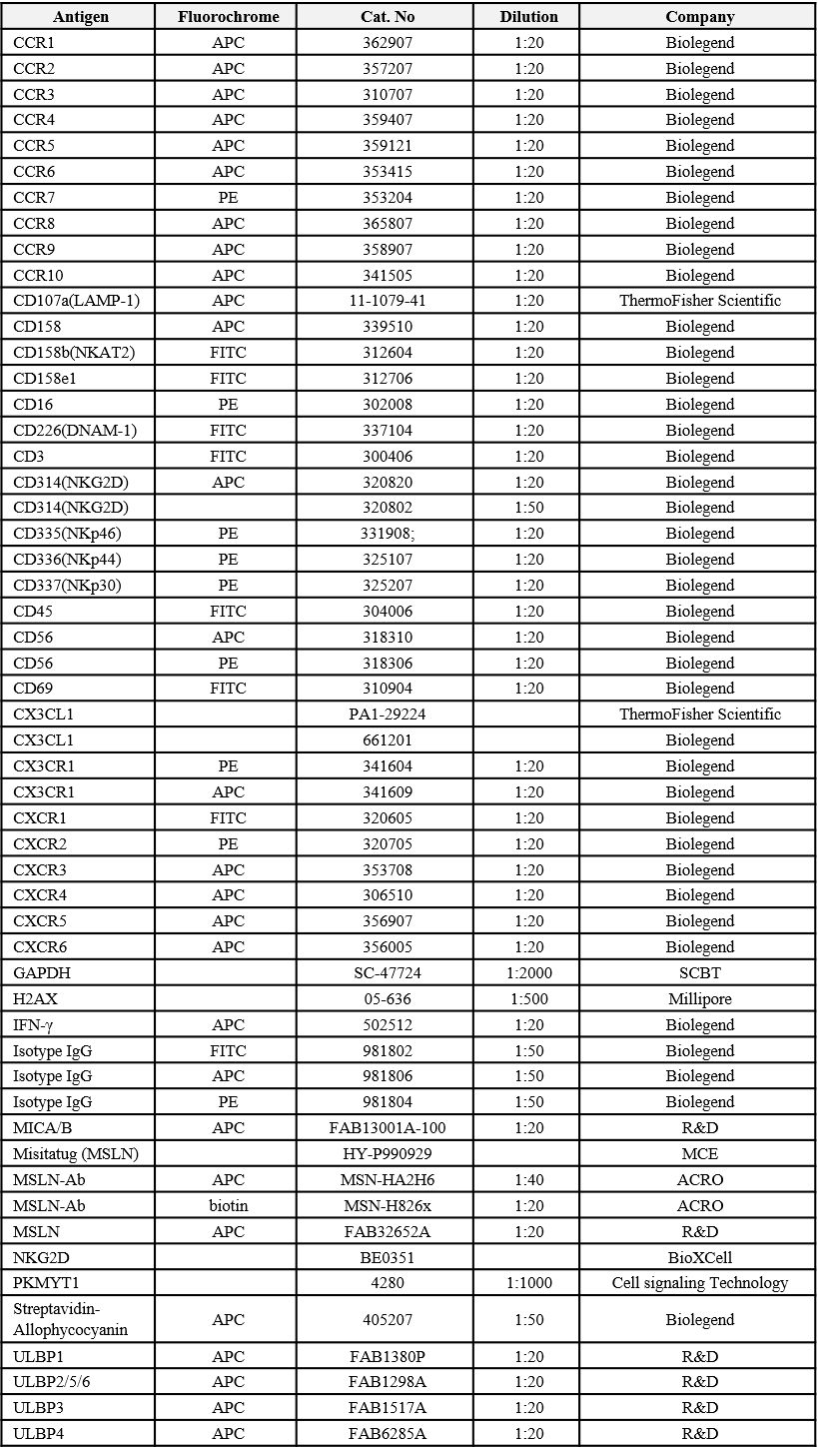
Table S2. Sequence of MSLN-CAR construct
